RESUME (BIO-DATA)
RAHUL YADAV 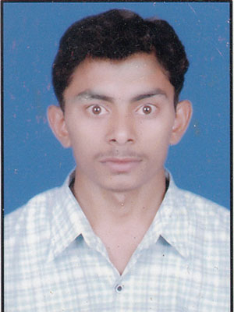
S/O Sri RAJ BAHADUR YADAV
Address:- VILL UDPUR POST NAUPERWA
DIST JAUNPUR PIN CODE 222109

Mob.-9793703774

Career Objective:-
.Seeking a challenge position where the knowidge I have gained can utilized for the development.
Of the organization. Aim to the be enhanced my skills to better to serve for the progress of the Organization.

Personal Profile:-

Father’s Name .. Sri Rajbahadur Yadav
Nationality .. Indian
Language .. Hindi & English
Marital status .. Unmarried
Date of Birth .. 11/06/1994
Category .. OBC
Sex .. Male
Educational Qualification

* High school from U.P.Board Allahabad in 2009 with First Division(67%).
*Intermediate from U.P.Board Allahabad in 2011 with First Division(72%).

*BCA From P T U Jalandhar.[75.88%] In 2015
.C, C++, JAVA.
Extra Qualification
*A D C A( Advance of distance computer application )
.Ms.office, corel draw, photo shop, Tally etc.
CFA(Certificate of financial Account)
Work Experience-
1. One Year Experience works in NIT in Delhi Computer Operator.
2. Typing is English word & Hindi word.
3. Adhar card in work certificate.
Date………………..
Place………………………..

(Rahul Yadav)

