Supermarket Sales Analysis

1. Business Problem
The objective of this project is to analyze supermarket sales data to identify sales trends, customer purchasing behaviour, and profitable product categories. The project helps understand customer preferences, sales performance, and business growth opportunities using data analysis techniques.

2. Dataset Description
The Supermarket Sales dataset contains transaction records from a supermarket. It includes information such as invoice ID, branch, city, customer type, gender, product line, unit price, quantity, tax, sales, payment method, gross income, rating, date, and time. The dataset is used to analyze sales trends and customer behaviour.

3. Data Cleaning
During data preprocessing, the following cleaning steps were performed:
- Removed duplicate records.
- Checked for missing values.
- Converted the Date column into datetime format.
- Verified the data types of all columns.
- Created a Month column from the Date column for monthly sales analysis.

4. Exploratory Data Analysis
The following business questions were analyzed using Pandas:
- Which branch has the highest sales?
- Which product line is the most profitable?
- Which payment method is the most popular?
- Which month has the highest sales?
- Which day has the highest sales?
- What is the total revenue?
- What is the average sales amount?
- What is the average customer rating?
- What are the total sales by city?

5. Visualizations
The following visualizations were created using Matplotlib:

- Sales by Branch (Bar Chart)

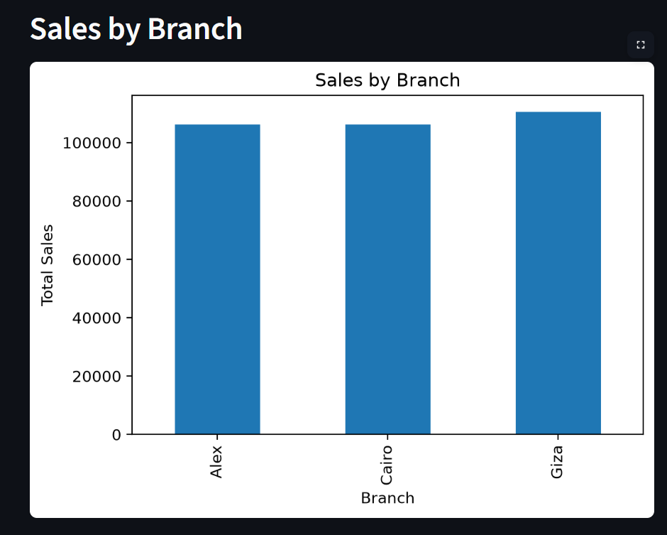

- Payment Methods (Pie Chart)

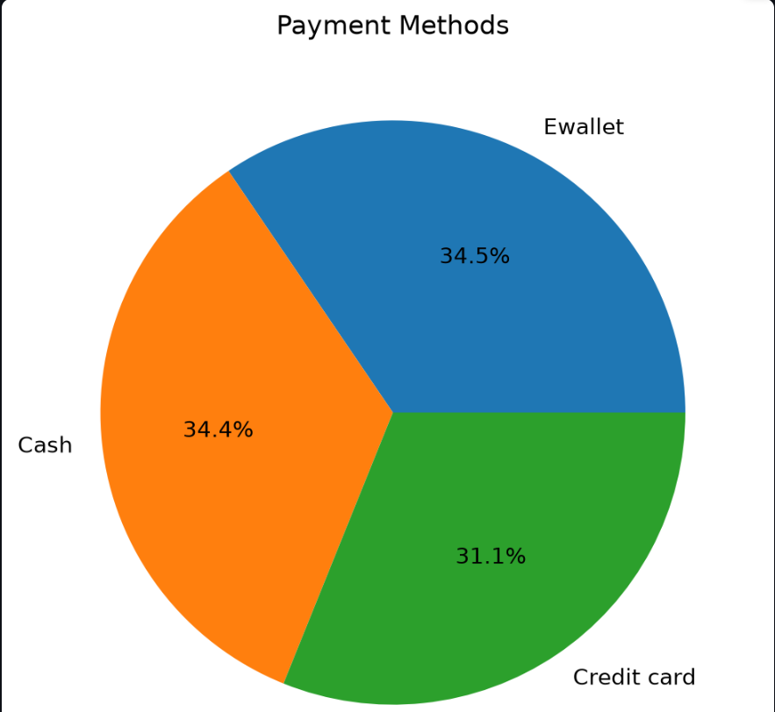

- Monthly Sales Trend (Line Chart)

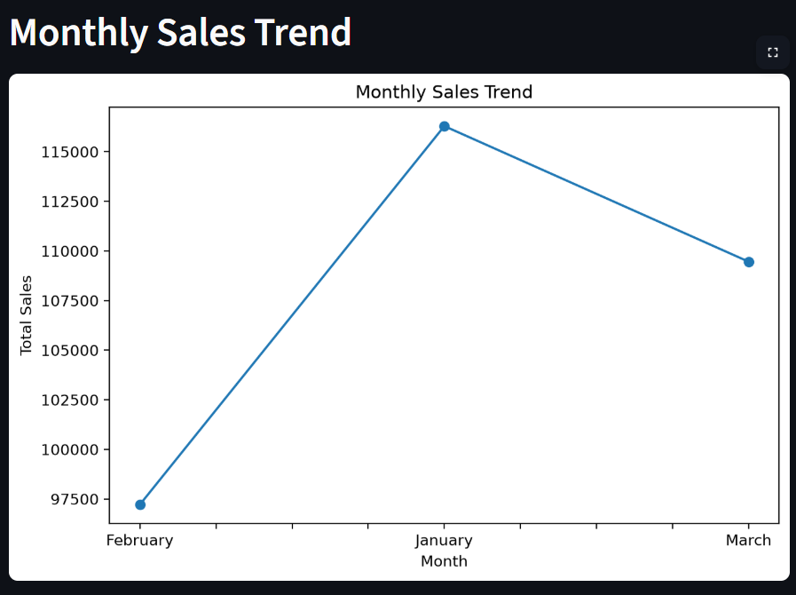

- Customer Ratings Distribution (Histogram)

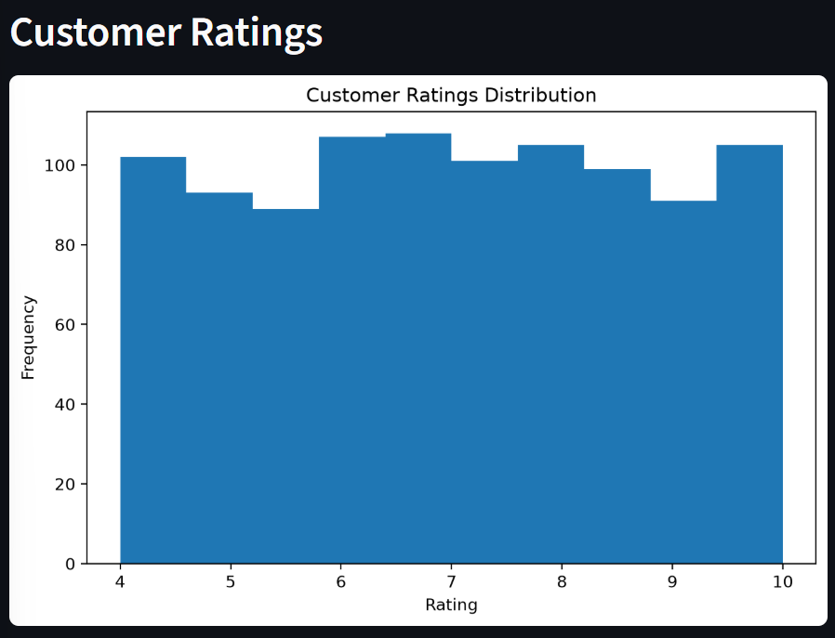

- Product Line Profit (Bar Chart)

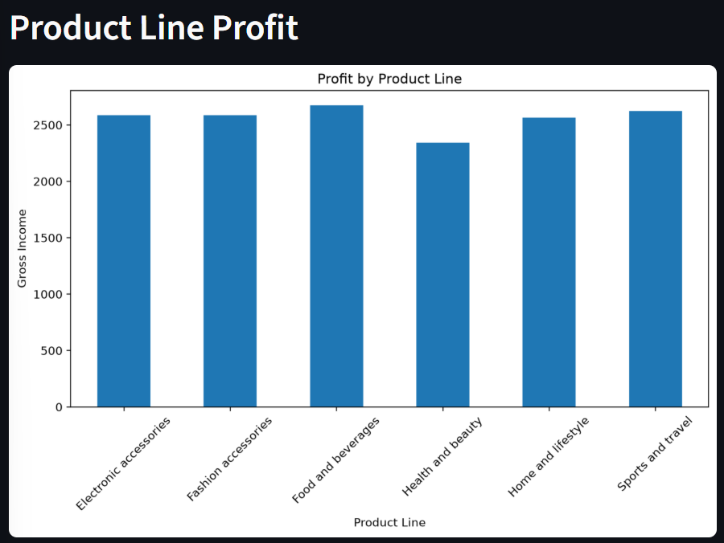

6. Streamlit Dashboard
An interactive dashboard was developed using Streamlit to display important business insights. The dashboard provides:
- Total Revenue
- Total Customers
- Best Performing Branch
- Most Profitable Product Line
- Highest Revenue Month
- Interactive Charts

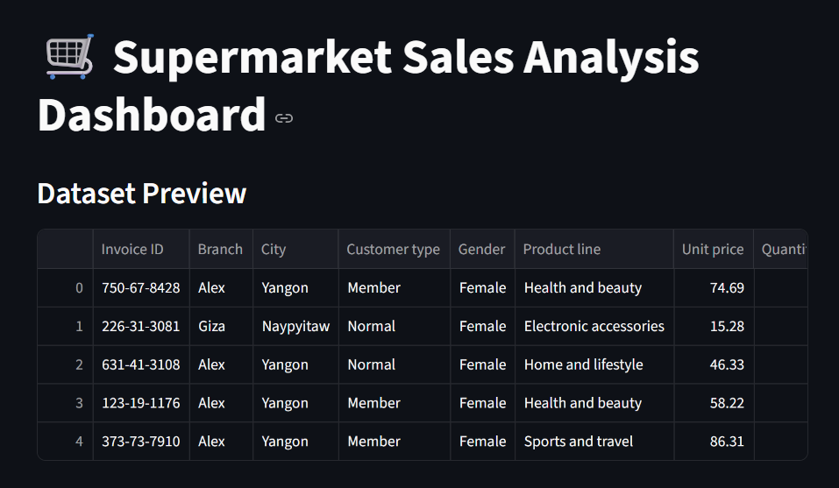
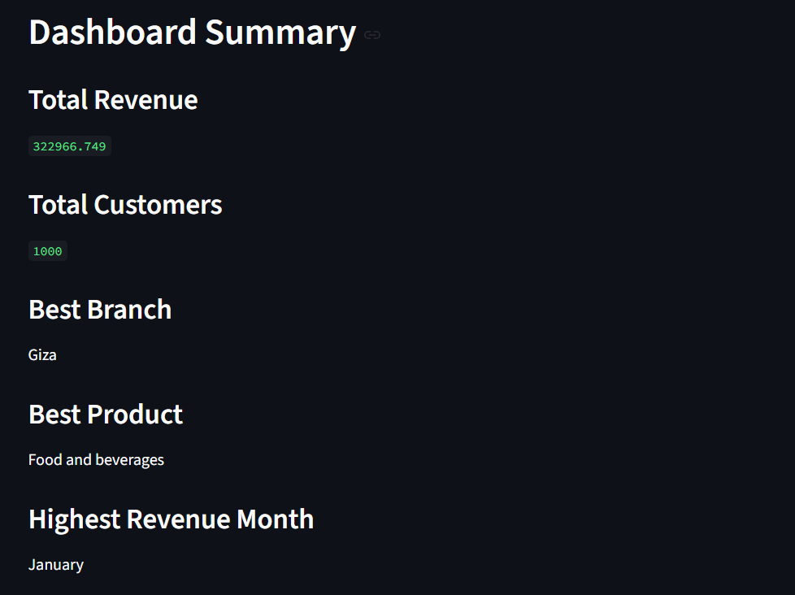

7. SQL Analysis
SQL queries were written to perform the following analyses:
- Total Revenue
- Highest Sales Branch
- Most Profitable Product Line
- Most Popular Payment Method
- Monthly Sales
- Average Customer Rating
- Total Sales by City
- Average Sales
- Total Customer Transactions
- Highest Rated City

8. Key Findings
- Branch Giza recorded the highest sales.
- Food and Beverages generated the highest gross income.
- Ewallet was the most frequently used payment method.
- Monthly sales analysis identified the highest-performing month is January.
- Customer ratings were generally high, indicating good customer satisfaction.

9. Recommendations
- Increase inventory for high-performing product lines.
- Focus marketing campaigns during high-sales months.
- Encourage the use of popular payment methods.
- Monitor customer feedback to improve service quality.
- Use sales trends for better inventory and business planning.

10. Conclusion
This project successfully analyzed supermarket sales data using Python, Pandas, Matplotlib, SQL, and Streamlit. The analysis identified valuable business insights related to sales trends, customer preferences, and profitable product categories. The developed dashboard and visualizations provide an easy way to monitor business performance and support data-driven decision-making.

