**POD**: K8s creates a layer on top of container to maintain abstraction is called POD. A POD encapsulation to the container/containers.

Whenever we use **kubectl run nginx**(POD name) **--name=nginx**(image name), it first creates a POD and then nginix container will be created under this POD.

It’s best practice to follow single container POD, use Multi-container PODs where your container need another container to do a small favor like processing files being uploaded to the main container.

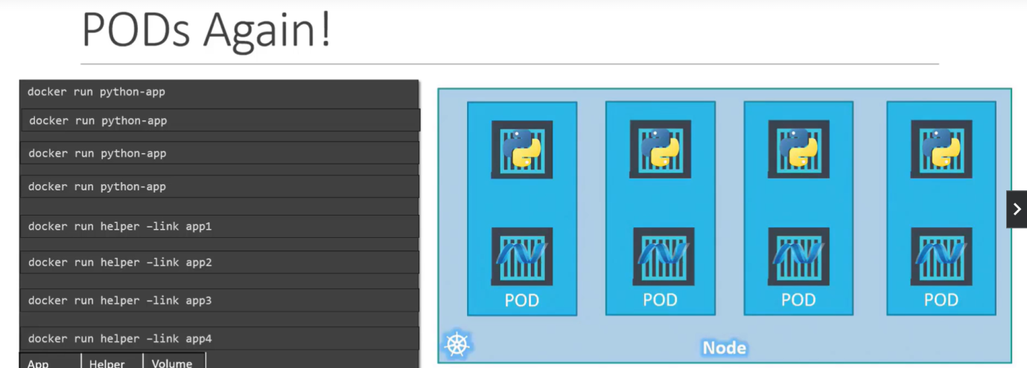

K8s Commands:

* **Kubectl get pods**
* **Kubectl get nodes**
* **Kubectl run <podName> --name=<imageName>**
* **Kubectl describe pod <podName>** (entire information from scratch of the POD creation)
* **Kubectl get pods –o wide**( additional info Node, IP)
* **Kubectl edit pod <podName>**

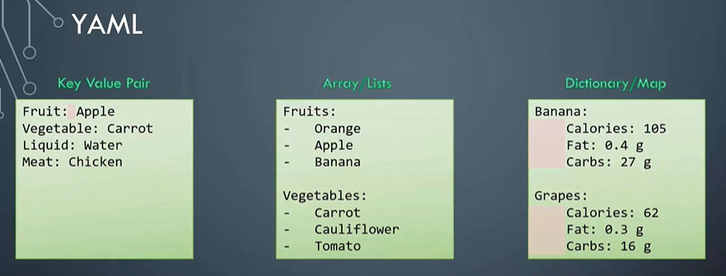

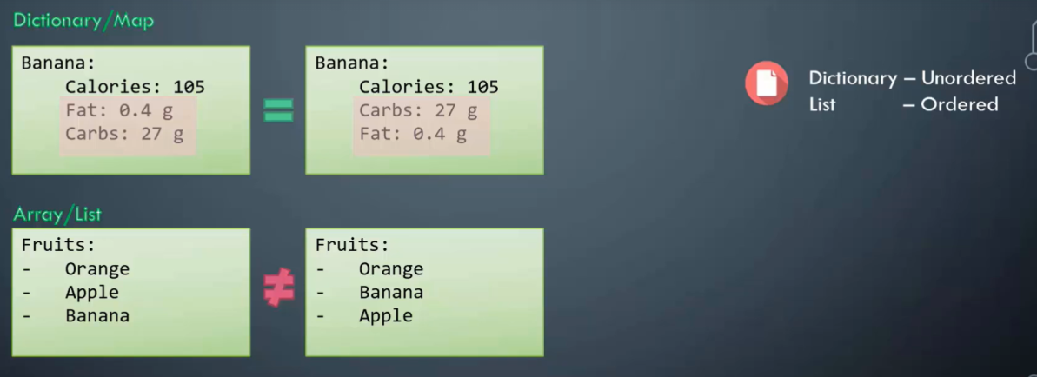

POD is the least possible object we can create in kubernetes.

Kubernetes needs YAML files to creates objects like PODS, services, nodes, replicaset, deployment etc..

***POD1.YAML***

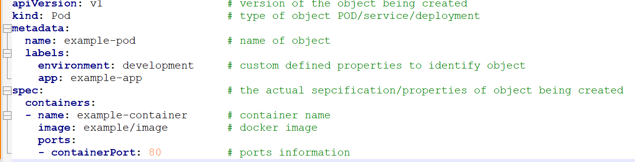

* ***Kubectl create –f POD.yaml*** - creates a POD through YAML file, if object already exists, gives error
* ***Kubectl apply –f POD.yaml***  - crates a POD though YAML file, if object exists already, will not error

­­­