**1. ReplicaSet:**

A **ReplicaSet** ensures that a specified number of identical pods are running at any given time. If the number of pods drops below the specified number (due to failure or deletion), the ReplicaSet will create new pods to meet the desired state. This helps maintain high availability and fault tolerance for applications.

**Key Features:**

* Ensures a fixed number of replicas of the pod are running.
* Provides scalability: you can easily scale the number of replicas up or down.
* Uses label selectors to match the pods that it manages.

**Use Cases:**

* **Stateless applications**: ReplicaSets are best used for stateless applications where each pod is identical and independent.
* Example: Microservices like **Nginx**, **API services**, or **frontend web apps** that don't need to retain any state.

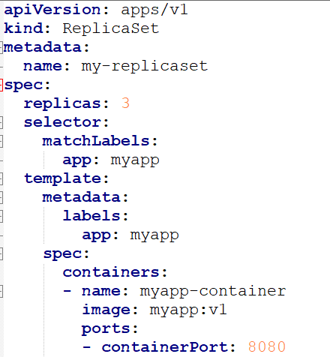

* **replicas: 3** ensures that there will always be 3 pods running.
* The matchLabels ensures that the ReplicaSet selects pods with the app: myapp label.

**Disadvantages:**

1. **Pod Identity**:

* **ReplicaSet** Pods are **stateless** and do not maintain any stable unique identity across rescheduling. ReplicaSets simply ensure that a certain number of pods are running at all times, but they don’t provide any unique identity for each pod.
* **No stable storage** is automatically provided. Any volume attached to a pod in a ReplicaSet is ephemeral and doesn’t persist if the pod is rescheduled.

### 2. ****Persistent Storage****:

### You can attach ****PVs**** and ****PVCs**** to a pod within a ReplicaSet, but there is no inherent guarantee that the same volume will be reattached if the pod is rescheduled.

* The volume is **not tied to a specific pod** or its identity, the volume can be reattached to any pod. If a pod is rescheduled, it may get a different PVC or volume.

### 3. ****Pod Lifecycle and Scaling****:

* **Pods are created in parallel**, and there is no guaranteed order for pod startup or termination. All pods in a ReplicaSet are interchangeable and do not have a specific identity (other than labels).
* Scaling up or down doesn’t maintain any predictable order, and there is no concept of a **sequential identity** for the pods.
* Scaling is done **without any specific order**, as all pods are treated equally in a ReplicaSet. This is fine for stateless applications where no particular sequence is needed.

### 4. ****Volume Binding and Behavior****:

* Volumes can be attached to pods, but the pod identity is **not tied** to the volume. If a pod is rescheduled to another node, it may get a different volume, unless manually configured.
* If you use a PVC within a ReplicaSet, the **PVC** is still shared across pods. The **volume binding** may be different with each pod restart.

### 5. ****Use Cases****:

* Suitable for **stateless applications** where you don’t need persistent storage or a stable identity for each pod.
* **Web applications**
* **API servers**
* **Stateless backend services**

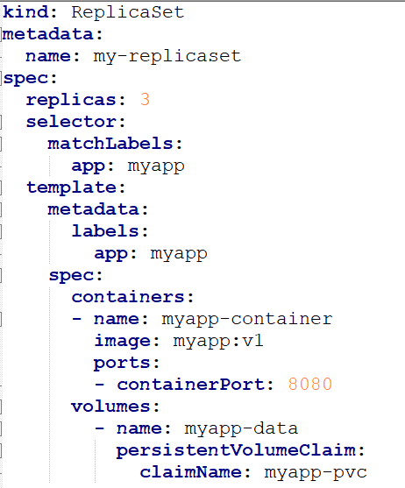 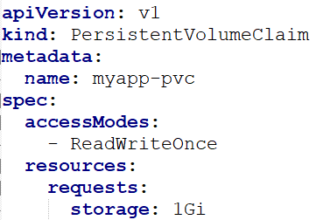

* In the above case, the volume “**myapp-data**” should be shared all 3 PODs, but due to access modifier “**RWO**”, only the **first POD** gets a chance to bind the volume and remaining 3 cannot use it.
* Use “RWM” or “ROM” to use same volumes by all PODs.

**Generally, it is not advisable to use Persistent storages with replicasets due to above drawbacks.**

**Recommeded to use Statefulsets instead.**