1. **Empty Dir:**

|  |  |
| --- | --- |
| **Temporary Storage** | Created fresh when Pod starts, destroyed when Pod dies |

|  |  |
| --- | --- |
| **Pod-scoped** | Exists only for the lifetime of the Pod, not container |

|  |  |
| --- | --- |
| **Shared between containers** | Can be shared by multiple containers inside the same Pod |

|  |  |
| --- | --- |
| **Node-local** | Data is on the node’s disk (either ROM or physical disk) |
|  |  |
| **Use Cases:** |  |
| **Shared Scratch Space** | Temporary files shared between containers (like processing intermediate files) |
| **Buffer/Cache** | Web server caching files temporarily |
| **Log Sharing** | One container writes logs, another container (log collector) reads logs |
| **Temporary Storage** | Database processes using it for temporary tables |
| **Sidecar Communication** | Main app and sidecar (like Fluentd, log shipper) share a volume |

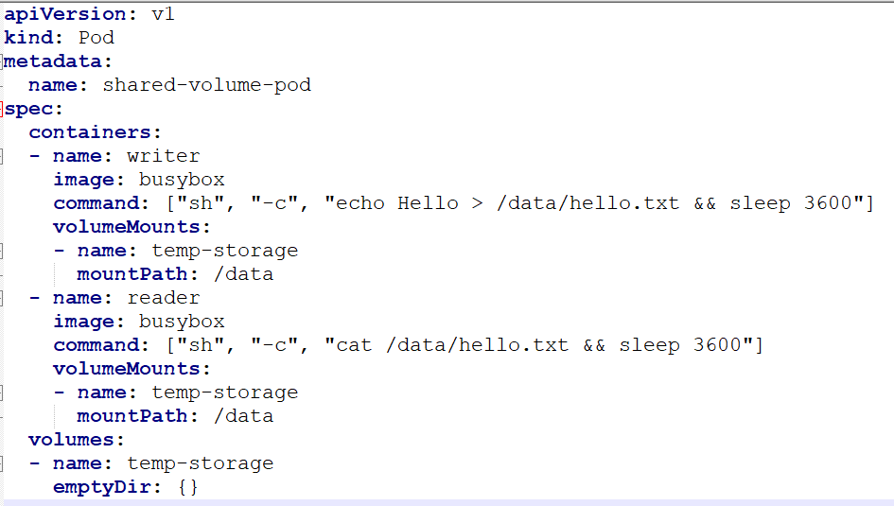

### What’s happening here?

* writer container writes "Hello" to /data/hello.txt
* reader container reads from /data/hello.txt
* They **share** the same emptyDir volume.



| **Medium** | **Meaning** |
| --- | --- |
| (empty) | Store on the Node's disk (default) |
| Memory | Store in the Node’s RAM (tmpfs) |

**Memory option** is useful when:

* You need **high-speed** temporary data access (RAM disk).
* Sensitive data that should **not be stored on disk**.

# Important Points to Remember

* If the **Pod is evicted**, data is lost.
* Not recommended for **persistent data** (like DB files).
* Great for **scratch space**, **cache**, or **inter-container communication**.
* Not replicated across nodes — **node-local only**.
* Cannot be backed up unless you build your backup mechanism.

# Real-World Practical Examples

| **Scenario** | **How emptyDir Helps** |
| --- | --- |
| Web servers like Nginx buffering uploads before sending to backend | Store temporary upload chunks in emptyDir |
| Machine Learning app storing intermediate feature sets | Use fast RAM-backed emptyDir |
| App writing logs to a shared path and sidecar pushing them to S3 | Both containers mount emptyDir and share logs |