A **hostPath** volume in Kubernetes is a type of volume that mounts a file or directory from the **host node's filesystem** into a Pod. It allows you to use a specific path on the node as the storage for your containerized application.

**Key Concepts of hostPath Volume:**

* **Mounts a host's directory or file** into a Pod.
* The directory or file must exist on the **node** where the Pod is running.
* **Used for development, debugging, and local testing** in Kubernetes.
* **Not ideal for production use** as it's tied to a specific node, meaning it doesn't support **Pod rescheduling** on other nodes easily.

**Why hostPath is used:**

* To provide access to **node-specific resources** or files (e.g., log files, configuration files) that are **local** to the host node.
* It can be used in situations where you want the application in a container to interact with the **host system** for various needs such as storage, debugging, or custom file requirements.

**Common Use Cases for hostPath:**

1. **Logging**: If you want your Pod to store logs on the host machine, you can mount the /var/log directory from the host into the container.
2. **Persistent storage for Dev/Test Environments**: If you want to persist data for your application on the node itself, such as for testing purposes or temporary storage.
3. **Accessing Host Resources**: Sometimes, your application may need access to the host machine's specific resources, such as configuration files or custom binaries.

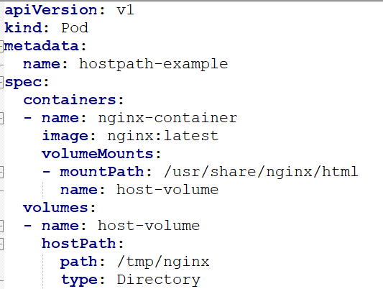 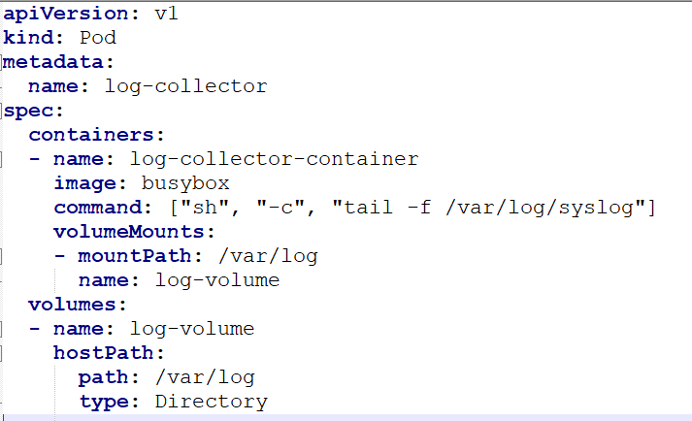

**Example of Use Case for hostPath:**

You have a Kubernetes cluster where you want to store logs for debugging purposes. You can mount the host's /var/log directory into your Pod so that the Pod has access to the logs on the node directly.

**Limitations of hostPath:**

1. **Node Specific**: The volume is tied to the node, meaning if the Pod is scheduled on another node, it won't have access to that hostPath unless that path exists on the new node.
2. **Not Suitable for Production**: As hostPath exposes the host filesystem to containers, it's not a good option for production environments due to the potential for security risks and lack of portability across nodes.
3. **Risk of Data Corruption**: If multiple Pods use the same hostPath volume on different nodes, there could be data corruption or conflicts if the data isn’t managed carefully.