**2. DaemonSet:**

A **DaemonSet** ensures that a copy of a pod is running on all nodes (or a subset of nodes) in a cluster. This is particularly useful for running cluster-wide services like monitoring agents, log collectors, or network plugins, which need to run on every node.

**Key Features:**

* Ensures one pod per node (or specific nodes, based on a nodeSelector).
* Pods run on **all nodes** or a subset of nodes.
* When a new node is added to the cluster, the DaemonSet automatically creates a pod on that node.

**Use Cases:**

* **Cluster-wide services** that need to run on every node:
  + **Logging agents** (e.g., Fluentd, Logstash).
  + **Monitoring agents** (e.g., Prometheus Node Exporter).
  + **Security agents** (e.g., antivirus scanning, intrusion detection).

**Example YAML for DaemonSet:**

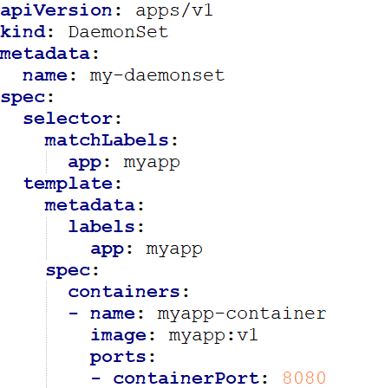

* This **DaemonSet** will run the **myapp:v1** pod on **all nodes in the cluster**.
* The pod will be scheduled based on node availability and labels.

**When to Use Which One?**

* **Use a ReplicaSet** when you have **stateless applications** that need to be scaled up or down easily and do not require stable identities or persistent storage.(eg: Web servers,)
* **Use a DaemonSet** when you need to run a pod on **every node** in the cluster (e.g., for monitoring, logging, or other cluster-wide services).
* **Use a StatefulSet** when you have **stateful applications** that require **persistent storage**, **stable network identities**, and **ordered deployment** (e.g., databases or distributed systems like Cassandra, Zookeeper).