**Namespaces in Kubernetes**

In Kubernetes, **Namespaces** are a way to logically partition resources within a cluster. They provide a mechanism for isolating resources such as Pods, Services, and ConfigMaps, making it easier to manage large clusters with many teams or applications.

**Key Points to Remember**

* **Namespaces provide logical separation** between different environments, teams, or services within a single Kubernetes cluster.
* They help **prevent naming collisions**, especially when multiple teams are working in the same cluster.
* You can use **ResourceQuotas** to limit the resource consumption of different namespaces.
* **RBAC** can be applied at the namespace level to ensure appropriate access control.
* Namespaces can be used in various **multi-tenancy scenarios**, where different applications, services, or teams need isolated environments.

Namespaces are primarily used in multi-tenant environments, CI/CD pipelines, development environments, and large-scale production environments to ensure clear separation and resource control.

**Use Cases for Namespaces**

1. **Environment Isolation (Dev, QA, Prod)**
   * In a multi-environment setup, you can create separate namespaces for dev, qa, and prod to isolate the resources related to each environment.
   * Example:
     + dev-namespace: For development environment.
     + qa-namespace: For quality assurance and testing environment.
     + prod-namespace: For the production environment.
2. **Multi-Tenancy / Multi-Team Setup**
   * When multiple teams or tenants are using the same Kubernetes cluster, namespaces can be used to isolate their workloads.
   * Example:
     + team-a: For Team A's application.
     + team-b: For Team B's application.
   * Each team can have separate namespaces to manage their resources without conflicts.
3. **Resource Quotas and Limitations**
   * Namespaces allow administrators to apply resource quotas (e.g., CPU, memory) to limit the amount of resources a namespace can consume. This is useful when you want to control resource usage per application, team, or environment.
   * Example:
     + Set CPU and memory limits for the dev namespace to avoid excessive resource consumption during testing or development.
4. **Access Control and Security**
   * Namespaces provide logical isolation, making it easier to apply **Role-Based Access Control (RBAC)**. You can define roles and permissions at the namespace level, granting users or services only the necessary permissions within specific namespaces.
   * Example:
     + Developers may only have read access to the dev namespace and write access to qa, while admins may have full access to all namespaces.
5. **CI/CD Pipelines**
   * Each environment (e.g., development, staging, and production) in a CI/CD pipeline can be managed using namespaces. For instance, after deploying to dev and testing, you can promote the application to the qa namespace and finally to the prod namespace once it's ready for production.
   * Example:
     + ci-dev: For Continuous Integration builds and deployments.
     + ci-staging: For Staging environment for testing before going live.
     + ci-prod: For Production deployments.
6. **Application Isolation**
   * You may want to isolate certain applications or microservices from one another for performance or security reasons. With namespaces, you can achieve this.
   * Example:
     + payment-service: A namespace for the Payment service.
     + user-service: A namespace for the User service.

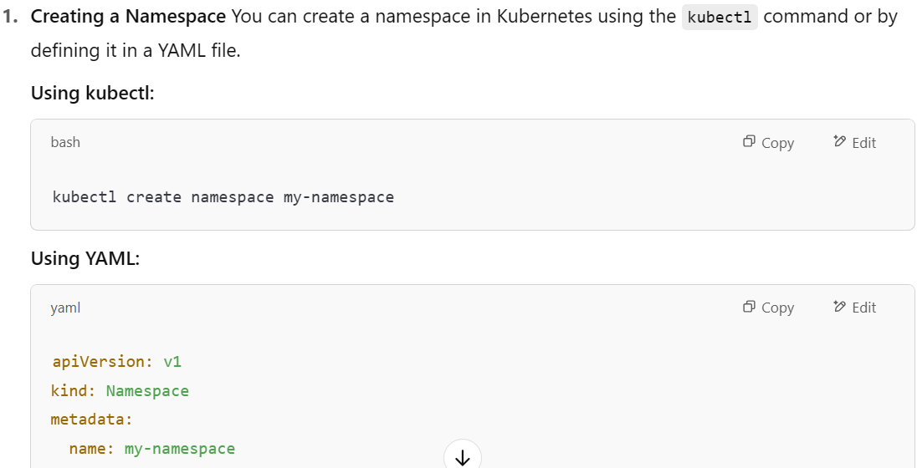 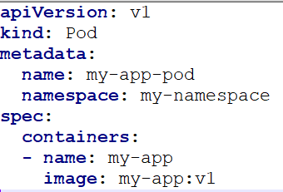

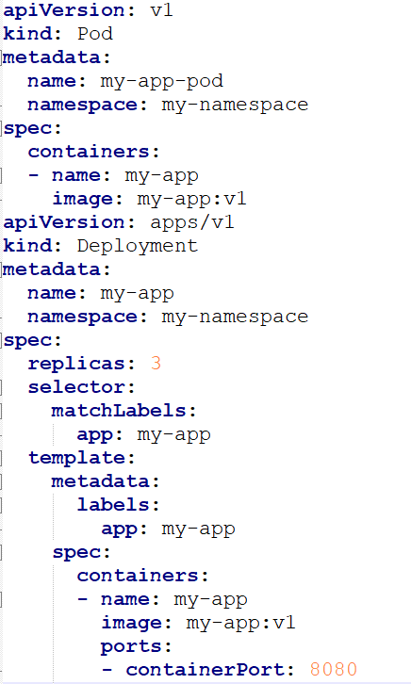 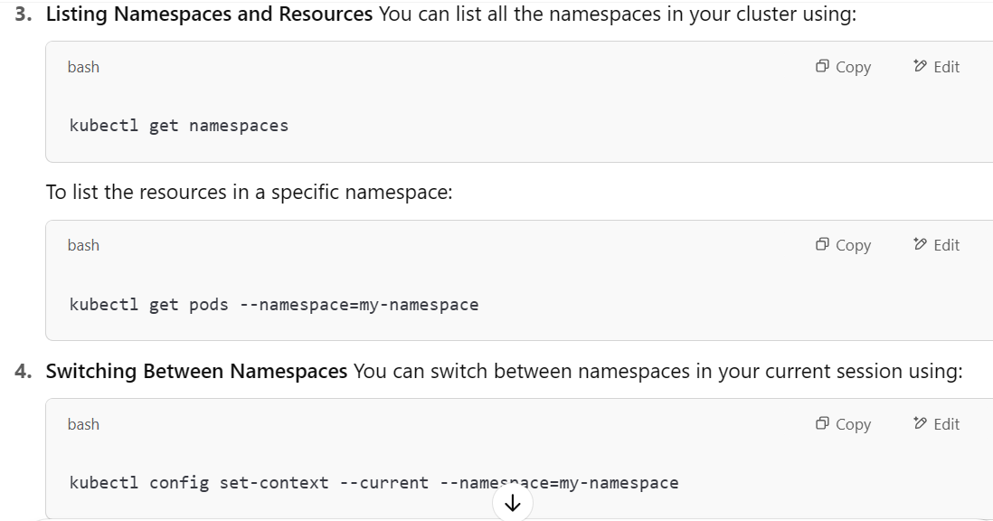

**Namespace Resource Quotas**

Resource quotas can be used to **limit the resources** (**like CPU, memory**) a **namespace** can consume. This is important in a multi-tenant scenario to ensure that no one application can over-consume resources.

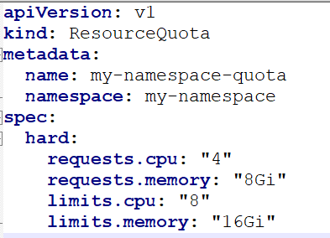

**Namespace and RBAC (Role-Based Access Control)**

You can use RBAC to control access to resources in specific namespaces. This is especially useful in multi-tenant environments.

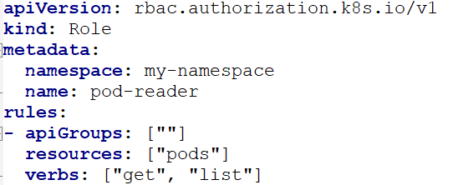 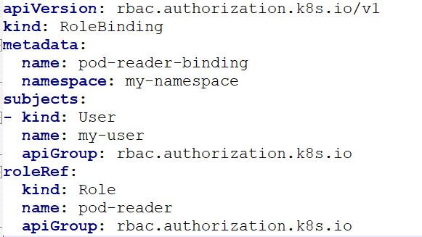

A **Pod in one namespace can communicate with a Pod in another namespace** in Kubernetes. By default, Kubernetes allows communication between Pods across different namespaces, as long as the network policies do not block it.

**How it works:**

1. **DNS resolution**:
   * Every Kubernetes service is assigned a DNS name that follows the pattern: <service-name>.<namespace>.svc.cluster.local.
   * For example, if you have a service my-service running in the namespace-a, it can be accessed from any Pod in any namespace as my-service.namespace-a.svc.cluster.local.
2. **Direct Pod Communication**:
   * You can also communicate directly between Pods, though this is typically not recommended in large environments. Each Pod has an IP address and can be accessed directly using its IP, regardless of which namespace it belongs to. However, using IPs directly isn't recommended because IPs can change when Pods are rescheduled or recreated.

**Example Use Case:**

Suppose you have a scenario where:

* **Pod A** is in namespace-a, and it wants to communicate with **Pod B** in namespace-b.

Here’s how it can happen:

1. **Pod A in namespace-a** wants to connect to a service my-service in **namespace-b**. The DNS entry would be my-service.namespace-b.svc.cluster.local.
2. **Accessing via Service (Recommended)**:
   * You can define a Service in namespace-b to expose Pod B and then access it from namespace-a using the DNS name my-service.namespace-b.svc.cluster.local.

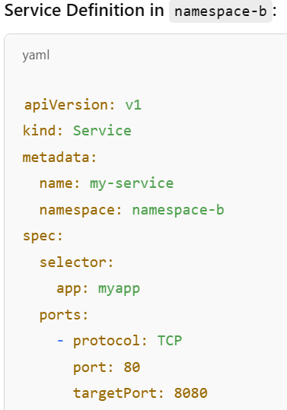 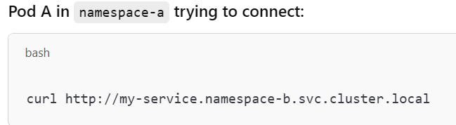

**Network Policies:**

While communication is allowed by default, **Network Policies** can be configured to restrict or allow traffic between Pods in different namespaces. If a **NetworkPolicy** is configured to restrict ingress or egress traffic, Pods in other namespaces might not be able to communicate with the Pods in the restricted namespace.

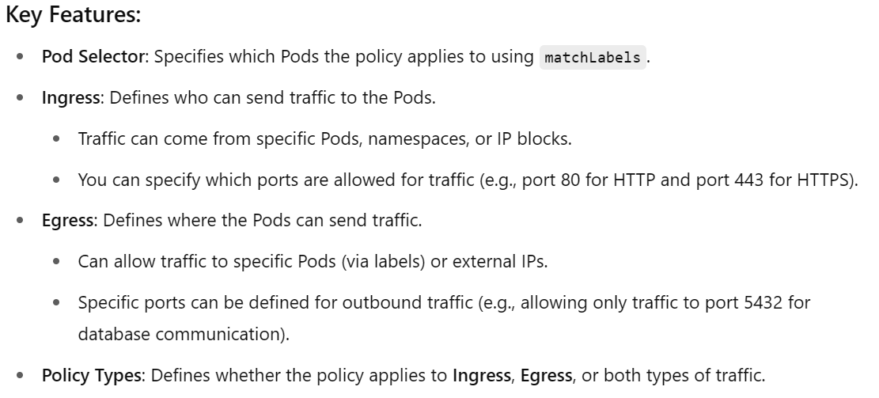

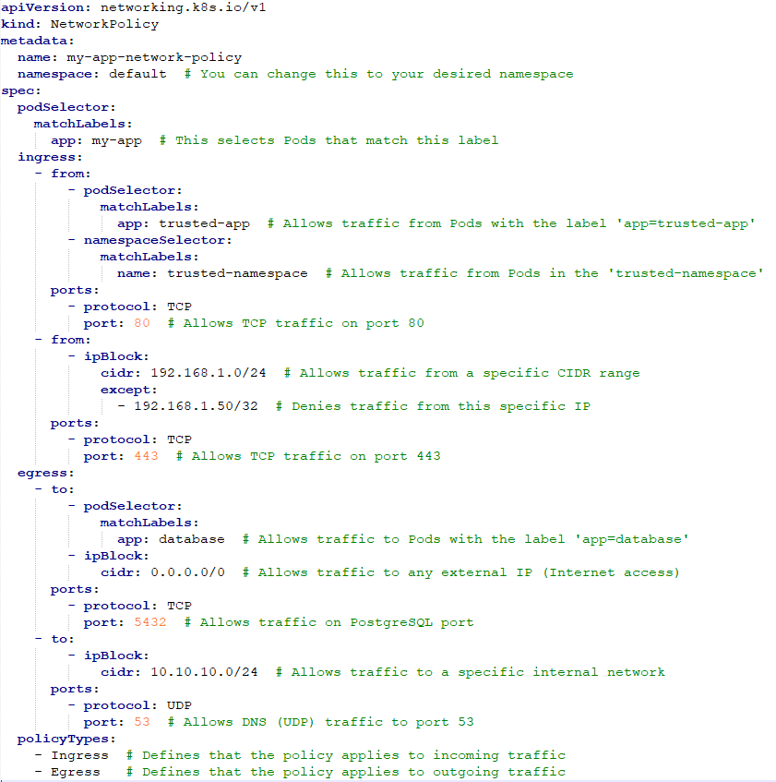

**Use Cases:**

1. **Restricting Ingress Access**:
   * You might want to restrict access to your Pods only to certain trusted sources (e.g., allowing only specific internal applications or IP addresses to access your application).
2. **Controlling Egress Traffic**:
   * You might want to limit which services your Pods can communicate with. For example, restricting database Pods to only be able to communicate with a database server or restricting internet access for Pods.
3. **Enforcing Least Privilege Networking**:
   * With NetworkPolicy, you can enforce the principle of least privilege by restricting unnecessary communications between Pods. This minimizes the attack surface in case of a compromise.
4. **Isolation Between Teams or Applications**:
   * When you have multiple teams or services within a single Kubernetes cluster, using NetworkPolicy can isolate their communication. For instance, a development team's Pods could be restricted from accessing production services.

**Default Namespaces in Kubernetes**

1. **default**:
   * This is the default namespace for objects that are not explicitly assigned to a different namespace.
   * If you don’t specify a namespace when creating resources like Pods, Deployments, or Services, they are created in the **default** namespace.
   * It is commonly used for general workloads, and typically, all user applications will be deployed in this namespace unless specific namespace segregation is implemented.

If no namespace field is specified in the metadata section, it will default to the default namespace.

1. **kube-system**:
   * This namespace is used for Kubernetes system components and objects managed by the cluster itself.
   * It contains essential system pods such as **kube-dns**, **kube-proxy**, **etcd**, **kubernetes-dashboard**, and other components critical for the proper functioning of the Kubernetes cluster.
   * Users should not typically deploy their own workloads in this namespace because it is reserved for infrastructure components.

Example:

* + Pods running the **kube-dns** service that provides DNS resolution for the cluster are placed in the **kube-system** namespace.

1. **kube-public**:
   * This namespace is readable by all users (even users who don’t have explicit access to other namespaces).
   * It's intended to store public resources that should be globally accessible across the cluster, such as cluster-wide configurations, policies, or publicly accessible ConfigMaps.
   * An example use case could be a ConfigMap that stores information that every user or application should be able to access, like a public registry URL.

apiVersion: v1

kind: ConfigMap

metadata:

name: my-config

namespace: kube-public

data:

PUBLIC_KEY: "some-public-key"

1. **kube-node-lease**:
   * This namespace is used for managing **Lease objects**, which are used to track the health of nodes in the Kubernetes cluster.
   * The **NodeLease** API is part of the **Kubelet** system to manage node heartbeat and monitor node availability, preventing it from being marked as unhealthy unnecessarily.