**1. Horizontal Pod Autoscaler (HPA)**

The **Horizontal Pod Autoscaler (HPA)** automatically adjusts the number of Pods in a deployment, replica set, or stateful set based on observed CPU utilization or with custom metrics like memory usage, request count, or response time.

HPA is useful for scaling out the application to handle more load and scaling down when the load decreases.

**How it works:**

* The HPA watches the metrics like CPU usage, memory usage, or custom metrics from Prometheus, and automatically adjusts the number of Pods based on those metrics.
* It requires a metric server to be running in the cluster for gathering and reporting metrics (such as CPU and memory usage).

**When to use:**

* When you want to automatically scale the number of replicas in a deployment to meet changing traffic or load demands.
* Ideal for stateless applications where scaling out with more replicas can improve performance or availability.

**Example Use Case:**

If you have a web application that experiences traffic spikes during business hours, you can configure an HPA to automatically scale the application Pods based on CPU or memory usage.

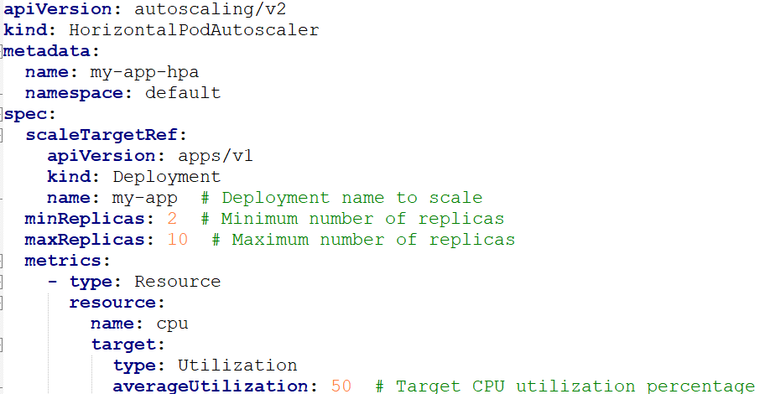

**2. Vertical Pod Autoscaler (VPA)**

The **Vertical Pod Autoscaler (VPA)** automatically adjusts the CPU and memory resource requests and limits for Pods in a Deployment, StatefulSet, or ReplicaSet based on observed usage. This is different from the HPA, which scales the number of Pods, whereas the VPA adjusts the resources allocated to individual Pods.

**How it works:**

* The VPA monitors the resource usage of Pods and suggests or applies resource adjustments.
* It works by continuously observing the resource usage of Pods and then adjusting the requests and limits based on the observed usage.

**When to use:**

* When you need to ensure Pods have enough CPU and memory to handle their workloads but without having to manually adjust resource requests and limits.
* Ideal for applications where the resource demand may change dynamically but the number of Pods doesn't need to be scaled.

**Example Use Case:**

If your Pods are consistently using more memory than the requested limit and are being throttled, VPA can increase the memory request and limit to prevent throttling without manual intervention.

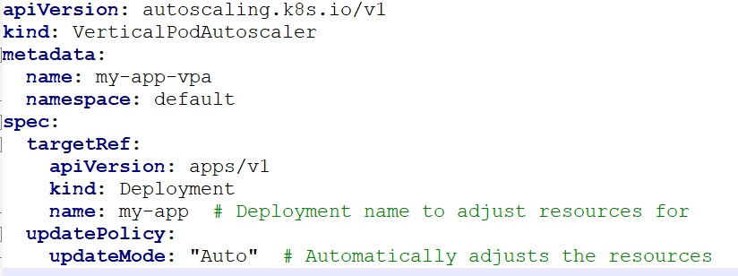

**3. Cluster Autoscaler (CA)**

The **Cluster Autoscaler (CA)** automatically adjusts the number of nodes in a Kubernetes cluster based on the resource requests of the Pods. If the scheduler cannot place a Pod because there aren’t enough resources, the Cluster Autoscaler will add nodes to the cluster. Similarly, if there are underutilized nodes, the Cluster Autoscaler will remove them.

**How it works:**

* The Cluster Autoscaler works by continuously monitoring the available resources in the cluster and the Pods that are pending scheduling due to insufficient resources.
* If the cluster runs out of resources to schedule Pods, CA will increase the number of nodes in the cluster.
* If the cluster has nodes that are underutilized (i.e., Pods can be rescheduled), CA will scale down the number of nodes to save costs.

**When to use:**

* Ideal for clusters running in cloud environments (like AWS, GCP, Azure) where the infrastructure is flexible and you want to optimize costs by scaling the number of nodes automatically.
* Perfect for managing workloads with unpredictable demand.

**Example Use Case:**

If you are running a batch processing job that only runs once a day, the Cluster Autoscaler can scale down the cluster during idle hours and scale up when the job starts.

**Example CA Configuration (on Cloud Providers like AWS):**

The Cluster Autoscaler is typically deployed as a deployment in your Kubernetes cluster. Here's an example of how you can deploy it.

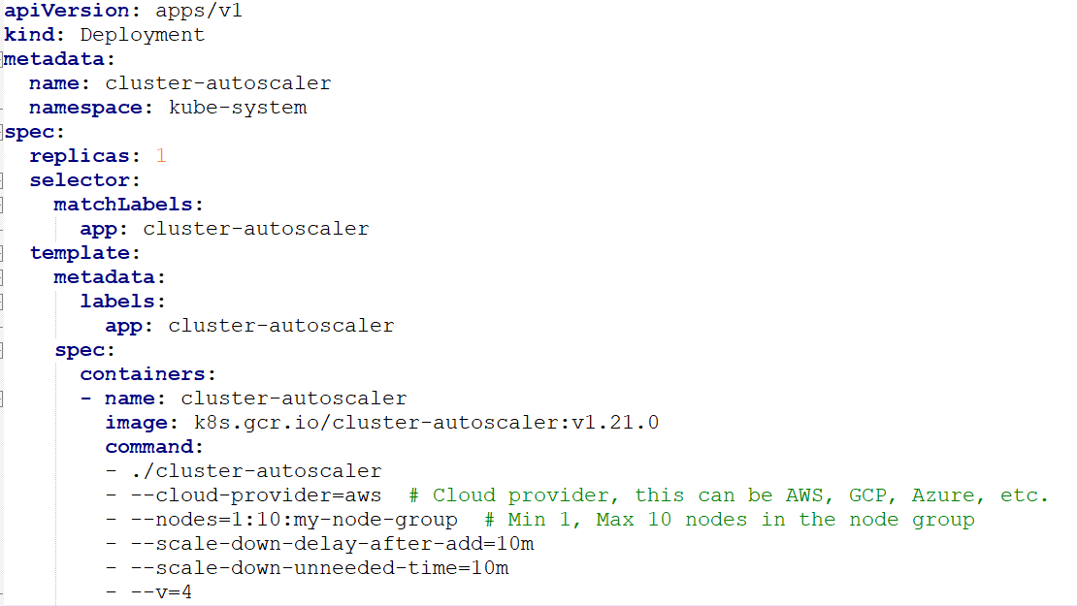

| **Feature** | **Horizontal Pod Autoscaler (HPA)** | **Vertical Pod Autoscaler (VPA)** | **Cluster Autoscaler (CA)** |
| --- | --- | --- | --- |
| **Purpose** | Scales the number of Pods based on metrics (e.g., CPU, memory). | Adjusts resource requests/limits for Pods. | Scales the number of nodes in a cluster. |
| **Scope** | Works at the Pod level (deployment, replica set, stateful set). | Works at the Pod level (deployment, replica set, stateful set). | Works at the node level (scales entire cluster). |
| **Metrics Used** | CPU, memory, or custom metrics (e.g., HTTP requests). | Resource usage (CPU, memory). | Resource availability and scheduling constraints. |
| **Scaling Type** | Horizontal (scale Pods out/in). | Vertical (adjust resource requests/limits). | Horizontal (scale nodes up/down). |
| **Best Use Case** | Stateless applications with fluctuating loads. | Resource-bound applications with fluctuating resource needs. | Dynamic environments with unpredictable workloads. |
| **Configuration** | Easy to configure using Kubernetes YAML files with resource metrics. | Requires monitoring resources and applying changes. | Typically configured as a deployment running in the kube-system namespace. |
|  |  |  |  |

**Conclusion**

* **HPA** is suitable for stateless applications where you want to scale the number of Pods based on resource usage.
* **VPA** is best for applications where Pods' resource usage may change dynamically, and you need to adjust the allocated CPU and memory accordingly.
* **CA** is useful for scaling the cluster itself (i.e., adding/removing nodes based on demand) in environments where node resources are limited or change frequently.