**Road-Map : Day-34 : Database : MySql – Day-2 : Tasks**

**MySql queries for creating database and tables with its Constraints:**

**Creating dbs and using the dbs :**

* create database guvi_zen_class;
* use guvi_zen_class;

**Creating tables and describing the table :**

* create table batches(batch_id int primary key, batch_name varchar(50));
* desc batches;
* create table mentors(mentor_id int primary key, mentor_name varchar(50), batch_id int, foreign key (batch_id) references batches(batch_id));
* desc mentors;
* create table courses(course_id int primary key, course_name varchar(50), batch_id int, foreign key (batch_id) references batches(batch_id));
* desc courses;
* create table tasks(task_id int primary key, task_name varchar(50), course_id int, foreign key (course_id) references courses(course_id));
* desc tasks;
* create table students(student_id int primary key, student_name varchar(50), mentor_id int, batch_id int, foreign key (mentor_id) references mentors(mentor_id), foreign key (batch_id) references batches(batch_id));
* desc students;
* create table marks(mark_id int primary key, student_id int, task_id int, marks int, foreign key (student_id) references students(student_id), foreign key (task_id) references tasks(task_id));
* desc marks;
* create table queries(query_id int primary key, student_id int, query_name varchar(50), query_description varchar(50), foreign key (student_id) references students(student_id));
* desc queries;
* create table mock_interviews(mock_interview_id int primary key, student_id int, mentor_id int, mock_interview_score int, foreign key (student_id) references students(student_id), foreign key (mentor_id) references mentors(mentor_id));
* desc mock_interviews;
* create table leader_board(leader_board_id int primary key, student_id int, batch_id int, leader_board_score int, foreign key (student_id) references students(student_id), foreign key (batch_id) references batches(batch_id));
* desc leader_board;

**Guvi Zen Class – Basic MySql DB Design Diagram :**

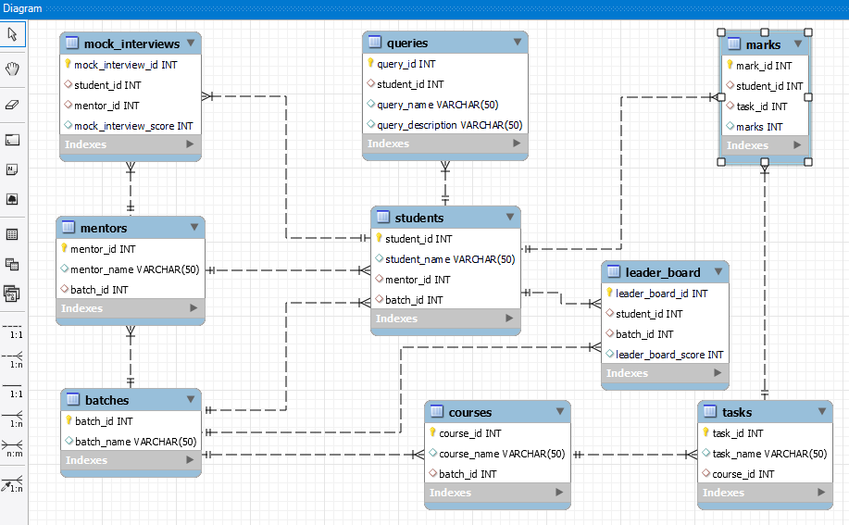

------------ End -----------