Test Case Report

# TC_001 – Book_Appointment

Feature Tested: Book Consultation

Tested By: Batch1_TA

Test Date: 07-08-2025

Objective: Verify that the user can successfully book an appointment through the “Book Consultation” feature.

Preconditions: User is on the homepage of the application.

Test Steps: 1. Go to the homepage  
2. On the left sidebar, click on 'Book Consultation'  
3. On the Book Appointment page, fill in the required details  
4. Submit the form and verify appointment booking

Test Data: Name: Batch1_TA  
Date: 07-08-2025  
Additional Validation: Special Characters in fields (e.g., Name = MAS@@!#, Address = @@@@)

Expected Result: Appointment should be booked successfully.

Actual Result: Appointment booked successfully.

Status: Pass

Severity: High

Priority: High

Tested By Team: QA

Additional Notes: Ensure to test with special characters in input fields:  
- Name = MAS@@!#  
- Number = 123@!#$$@*%%%  
- Address = @@@@

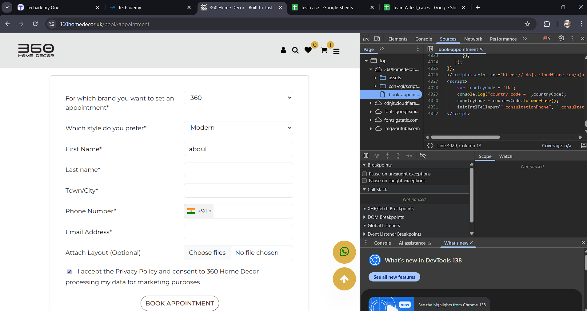

# TC_002 – Product_Review

Feature Tested: Product Details

Tested By: Batch1_TA

Test Date: 07-08-2025

Objective: Validate the availability and functionality of the product review and rating feature.

Preconditions: User is on the homepage of the application.

Test Steps: 1. Go to the Home page  
2. Select any product  
3. Check for existing user reviews  
4. Try to provide a review with rating and comment

Test Data: Ratings: 5 star, 4 star, etc.  
Review Text: “Excellent, but Expensive”

Expected Result: Review option should be available to write a review and view others' reviews.

Actual Result: Review option is not available.

Status: Fail

Severity: Medium

Priority: High

Tested By Team: QA

Additional Notes: Review functionality is missing on the product details page. It should allow users to rate and comment.

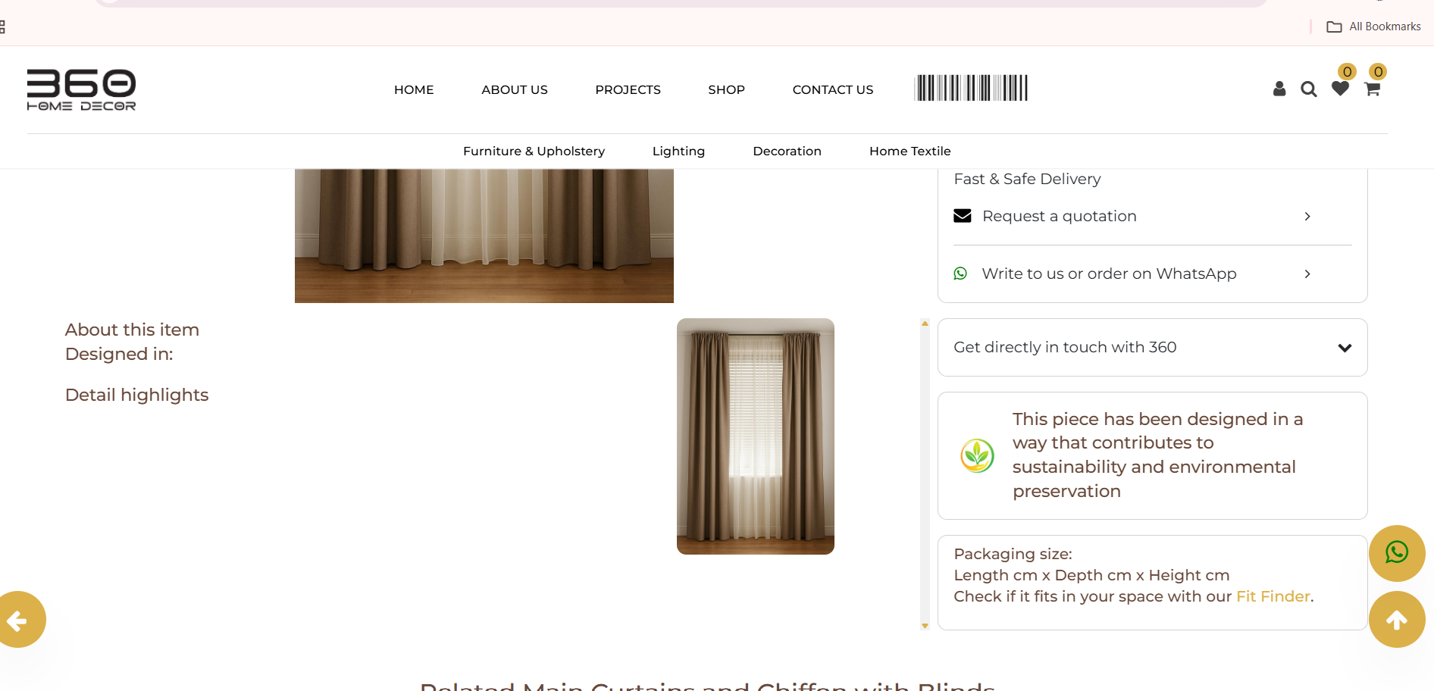

# TC_003 – Return_Policy

Feature Tested: Product Details

Tested By: Batch1_TA

Test Date: 07-08-2025

Objective: Verify if return or exchange policy details are displayed on the product details page.

Preconditions: User is on the homepage of the application.

Test Steps: 1. Go to the Home page  
2. Select a product  
3. Check whether return/exchange policy is shown on the product details page

Test Data: Not Applicable

Expected Result: Policy such as “15 days return” or “15 days exchange only” should be visible.

Actual Result: Return policy is not available.

Status: Fail

Severity: Medium

Priority: High

Tested By Team: QA

Additional Notes: Return/exchange policy must be visible clearly on every product detail page to ensure customer transparency.



# TC_004 – Product Details Curtains

Feature Tested: Product Details Curtains

Tested By: Batch1_TA

Test Date: 07-08-2025

Objective: Validate the availability and functionality of the product review and rating feature.

Preconditions: User is on shop page.

Test Steps: 1. Go to the Home page  
2. Select any product in curtains  
3. Enter the curtain size(width and breadth)

Test Data: 122344,233002,1222 , 100000000000 (accept size out of range like 10000000000000000)  
Review Text: NA

Expected Result: Total size of curtain l*b , and total cost

Actual Result: Total size of curtain l*b , and total cost in some case it will get, some case server error shows

Status: Fail

Severity: Medium

Priority: High

Tested By Team: QA

Additional Notes: NA

