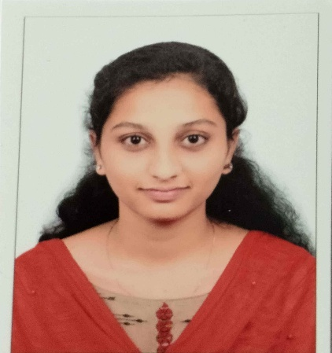 **SHAIK AFREEN**

Bharath Institute of Higher Education and Research

Chennai, Tamil Nadu

[shaikafreen002005@gmail.com](mailto:shaikafreen002005@gmail.com)

+91 7013266021

___________________________________________________________________

**SUMMARY**

Computer Science student with a strong academic foundation in programming and

AI/ML. Proficient in Python and familiar with HTML, CSS, and JavaScript. Quick learner

With excellent problem-solving skills and a collaborative attitude, dedicated to

Contributing to team success through innovation and continuous improvement.

___________________________________________________________________

**EXPERIENCE**

AI & ML Intern

K | SPACE APR 2025 – MAY 2025

- Worked on Customer Churn Prediction using ML models like Logistic Regression

Random Forest, and Neural Networks  
 - Analyzed customer demographics and behavior data.  
 - Evaluated performance using Accuracy, Precision, and Recall.

___________________________________________________________________

**SKILLS**

Python  
 Machine Learning

HTML, JAVASCRIPT, CSS

_____________________________________________________________

**EDUCATION**

BTECH Graduate: Computer Science & Engineering

Bharath Institute of Higher Education and Research, Chennai, Tamil Nadu Expected 2026

Intermediate – Telangana Minority Residential Institute of Education and Society Girls

College - 94.6%

Schooling – Telangana Minority Residential Institute of Education and Society Girls

School-100%

____________________________________________________________________

**PROJECTS**

E-commerce Website Using Python & Flask

- Created a web app with product listing, cart, user login, and admin dashboard.  
 - Integrated backend functionality using Flask.

Portfolio Website Using HTML, CSS & JavaScript

- Designed a responsive personal website to showcase skills and projects.  
 - Implemented interactive UI with JavaScript.