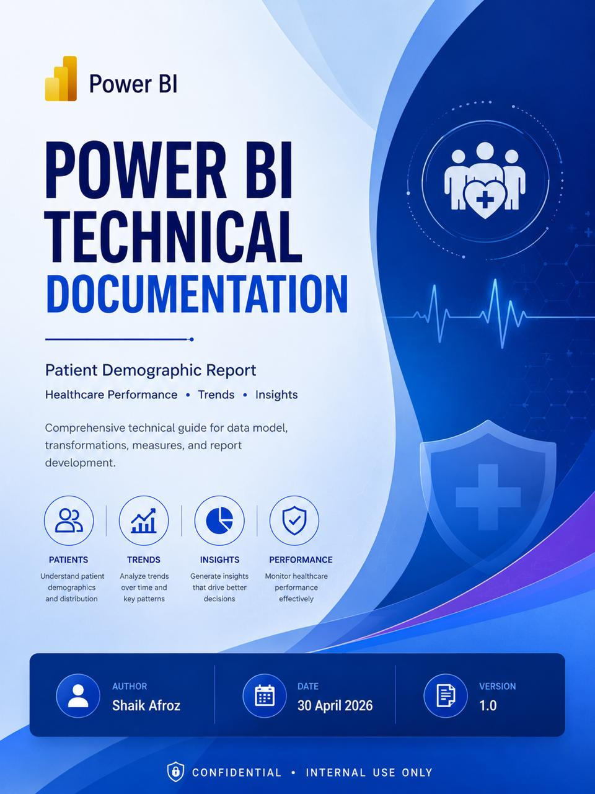

1. Report Theme

1.1 Canvas Background
All report pages use a canvas background color of #A0D1FF (Light Sky Blue) applied in Power BI Desktop under View → Page Background. This provides a clean, clinical look consistent with healthcare analytics.

1.2 Canvas Configuration
Patient Demographic Insights Dashboard Canvas
Property | Configuration
Canvas Height | 1225 px
Canvas Width | 1525 px

1.3 Color Palette
The following color palette is applied consistently across all visual elements — charts, slicers, cards, and table formatting — to maintain brand identity and visual hierarchy throughout the report.

Swatch | Hex Code | Color Name | Usage
 | #A0D1FF | Light Sky Blue | Canvas / page background color
 | #118DFF | Bright Blue | Primary accent — links, highlights, icons
 | #12239E | Deep Royal Blue | Primary brand — headings, KPI cards, borders
 | #E044A7 | Vibrant Pink | Chart series — gender, categorical splits
 | #6B007B | Dark Purple | Chart series — contrast color, secondary segments
 | #E66C37 | Burnt Orange | Warning / negative trend indicators
 | #744EC2 | Medium Purple | Tertiary accent — filters, badges, hover states
 | #D9B300 | Golden Yellow | Emphasis — alerts, positive trend indicators

1.4 Typography
Segoe UI is the standard font family used throughout the report for all text elements.

Element | Font Family | Size & Style
Dashboard Title | Segoe UI | 18pt, Bold
Chart Title | Segoe UI | 10pt, Bold
Chart Subtitle | Segoe UI | 9pt, Italic
Slicer Header | Segoe UI Semibold | 10–12pt, Bold
Slicer Values | Segoe UI | 8–10pt, Regular
Data Labels | Segoe UI | 9pt, Bold
KPI Card Value | Segoe UI Semibold | 20pt, Bold

2. Data Sources

2.1 Loaded Tables
The following tables are loaded directly from the source system into the Power BI data model:

# | Table Name | Type
1 | Patients | Fact Table (F)
2 | Branches | Dimension Table (D)
3 | Countries | Dimension Table (D)

2.2 Created / Reference Tables
The following dimension and reference tables were created within Power BI to enrich the data model:

2.2.1 Calendar Table (DimDate)
A date dimension table generated programmatically from the Patients table using the minimum and maximum values of the RegistrationDate column. It provides date hierarchies (Year, Quarter, Month Name, Day) to support time-intelligence analysis.

2.2.2 Blood Group Description Table

ID | Blood Group
0 | O-
1 | O+
2 | A-
3 | A+
4 | B-
5 | B+
6 | AB-
7 | AB+

2.2.3 Insurance Description Table

ID | Insurance Company
1 | GULF UNION AL AHLIA COOPERATIVE INSURANCE
2 | SAUDI ARABIAN COOPERATIVE INSURANCE CO. (SAICO)
3 | BUPA Insurance Company
4 | Medgulf Life
5 | United Cooperative Assurance
6 | Metlife AIG ANB Cooperative Insurance Company
7 | Al-Etihad Co-operative Insurance Co - TCS
0 | Cash

2.2.4 Source of Awareness Table

ID | Description
1 | Doctor Referral
2 | Medical Representative Referral
3 | Police Referral
4 | Ambulance Service
5 | Hospital Website
6 | Family / Friend Referral
7 | Google Search
8 | Walk-in
9 | Other
10 | Corporate Tie-up
11 | Snapchat
12 | LinkedIn
13 | Instagram
14 | Discord
15 | Twitter

3. Data Transformations
All transformations are applied in Power Query (M language) before data is loaded into the model.

3.1 Branches Table
- Removed blank rows to ensure data integrity.
- Applied Title Case capitalization to the BranchNameEn column.
- Removed unnecessary columns not relevant to the analytical model.

3.2 Countries Table
- Applied Title Case capitalization to the CountryNameEn column.
- Removed unnecessary columns not relevant to the analytical model.

3.3 Patients Table (Fact Table)

3.3.1 Gender Column — Value Replacement

Original Value | Replaced With
1 | Male
2 | Female

3.3.2 Billing Type Column — Value Replacement

Original Value | Replaced With
0 | Cash
1 | Insurance
2 | Charity

3.3.3 ResidencyType Column — Value Replacement

Original Value | Replaced With
1 | Citizen
2 | Resident
3 | Visitor

3.3.4 Calculated Column: Age
A calculated Age column is derived by subtracting the patient's date of birth (DOB column) from today's date, yielding the patient's current age in years.

3.3.5 Calculated Column: Age Group
An Age Group classification column is derived from the Age column using the following conditional logic:

Condition | Age Group Label
Age <= 2 | Infants
Age <= 12 | Children
Age <= 19 | Teens
Age <= 35 | Young Adults
Age <= 59 | Adults
Age >= 60 | Seniors

- Removed unnecessary columns not required by the analytical model.

4. Data Modelling
The data model follows a star schema design, with the Patients fact table at the centre connected to multiple dimension tables. All relationships use One-to-Many cardinality with Single cross-filter direction to optimise query performance and maintain data lineage.

From Table | From Column | To Table | To Column | Cardinality | Cross Filter
Branches | BranchId | Patients | BranchId | One-to-Many | Single
Countries | CountryId | Patients | CountryID | One-to-Many | Single
Blood Group Description | Id | Patients | Blood Group | One-to-Many | Single
Insurance Description | Id | Patients | InsuranceCompanyId | One-to-Many | Single
DimDate | Date | Patients | Registration Date | One-to-Many | Single
Source of Awareness | Id | Patients | Source_of_Awareness | One-to-Many | Single

5. Key Performance Indicators (Measures)
The following DAX measures are defined in the data model and are used across all report pages:

Measure | DAX Expression | Description
Total Patients | CALCULATE(COUNT(Patients[PatientID])) | Count of all patients
Male Patients | CALCULATE(COUNT(Patients[PatientID]), Patients[Gender] = "Male") | Count of male patients
Female Patients | CALCULATE(COUNT(Patients[PatientID]), Patients[Gender] = "Female") | Count of female patients

6. Report Pages & Visualizations

6.1 Patient Demographic Insights Dashboard

6.1.1 Dashboard Header (Text Card)
Text Card Configuration
Property | Configuration
Title Text | Patient Demographic Insights
Title Font | Segoe UI (Bold), 18pt, Black
Subtitle Font | Segoe UI, 12pt, Black

6.1.2 Container Shapes
Rounded rectangle shapes are used to visually group and align related visuals on the canvas, creating a modern card-based dashboard layout.

Shape 1 — Slicer Container
Property | Configuration
Size (H x W) | 116 x 451 px
Position | 1069 x 5 px
Purpose | Groups and aligns Branch and Year slicers
Fill Color | #EEF3FA
Border Color | #CFC7F7
Corner Style | Rounded corners for smooth UI appearance
Effects | Border shadow and glow effects enabled
Layer Order | Set behind slicers for proper alignment

Shape 2 — Donut Chart Container
Property | Configuration
Size (H x W) | 725 x 475 px
Position | 5 x 121 px
Purpose | Aligns Patients by Gender, Total Patients card, and Demographic donut chart
Fill Color | #FFFFFF
Corner Radius | 25 px
Effects | Shadow and glow effects enabled
Layer Order | Set behind visuals

Shape 3 — Analytics Container
Property | Configuration
Size (H x W) | 725 x 1040 px
Position | 480 x 121 px
Purpose | Aligns Line Chart, Stacked Bar Chart, and Stacked Column Chart
Fill Color | #FFFFFF
Corner Radius | 25 px
Effects | Shadow and glow effects enabled
Layer Order | Set behind visuals

Shape 4 — Insights Container
Property | Configuration
Size (H x W) | 449 x 1515 px
Position | 5 x 846 px
Purpose | Aligns two stacked bar charts and one donut chart
Fill Color | #FFFFFF
Corner Radius | 25 px
Effects | Shadow and glow effects enabled
Layer Order | Set behind visuals

6.1.3 Slicers
Branch Slicer
Property | Configuration
Size (H x W) | 80 x 216 px
Position | 1093 x 25 px
Field | Branches[BranchNameEn]
Header Font | Segoe UI, 12pt, Black, Bold
Value Font | Segoe UI, 10pt, Black

Year Slicer
Property | Configuration
Size (H x W) | 81 x 170 px
Position | 1322 x 22 px
Field | DimDate[Year]
Header Font | Segoe UI, 12pt, Black
Value Font | Segoe UI, 10pt, Black

6.1.4 KPI Card
Total Patients (Name Card)
Property | Configuration
Size (H x W) | 73 x 136 px
Measure | Total Patients
Font | Segoe UI Semibold, 20pt, Black

6.1.5 Charts
Patients by Gender (Donut Chart)
Property | Configuration
Size (H x W) | 350 x 450 px
Legend Field | Patients[Gender]
Values Field | Total Patients (measure)
Data Labels | On — Outside, All Detail Labels, Segoe UI 9pt #605E5C
Title | Segoe UI, 10pt, Black, Bold
Subtitle | Segoe UI, 9pt, Black, Italic

Patients Demographic / Residency (Donut Chart)
Property | Configuration
Size (H x W) | 350 x 450 px
Legend Field | Patients[ResidenceTypeID]
Values Field | Total Patients (measure)
Data Labels | On — Outside, All Detail Labels, Segoe UI 9pt #605E5C
Title | Segoe UI, 10pt, Black, Bold
Subtitle | Segoe UI, 10pt, Black, Italic

Patients Trend (Line Chart)
Property | Configuration
Size (H x W) | 350 x 915 px
X-Axis Fields | DimDate[Year], DimDate[Quarter], DimDate[MonthName]
Y-Axis Field | Total Patients (measure)
Axis Titles / Y Values | Off
Data Labels | On — Segoe UI 9pt Black Italic
Title | Segoe UI, 10pt, Black, Bold
Subtitle | Segoe UI, 9pt, Black, Italic

Patients by Age Group (Stacked Bar Chart)
Property | Configuration
Size (H x W) | 350 x 507 px
X-Axis Field | Total Patients (measure)
Y-Axis Field | Patients[Age Group]
Tooltips | Male Patients, Female Patients
Y-Axis Values | On
Data Labels | On — Segoe UI 9pt Black Bold
Title | Segoe UI, 10pt, Black, Bold
Subtitle | Segoe UI, 9pt, Black, Italic
Header Icons / Tooltips | Enabled

Patients by Blood Group (Stacked Column Chart)
Property | Configuration
Size (H x W) | 350 x 507 px
X-Axis Field | Blood Group Description[Description]
Y-Axis Field | Total Patients (measure)
Tooltips | Male Patients, Female Patients
X-Axis Values | On
Data Labels | On — Segoe UI 9pt Black
Title | Segoe UI, 10pt, Black, Bold
Subtitle | Segoe UI, 9pt, Black, Italic
Header Icons / Tooltips | Enabled

How Do You Know About Us (Stacked Bar Chart)
Property | Configuration
Size (H x W) | 420 x 498 px
X-Axis Field | Total Patients (measure)
Y-Axis Field | Source of Awareness[Description]
Tooltips | Male Patients, Female Patients
Y-Axis Values | On
Data Labels | On — Segoe UI 9pt Black Bold
Title | Segoe UI, 10pt, Black, Bold
Subtitle | Segoe UI, 9pt, Black, Italic
Header Icons / Tooltips | Enabled

Patients by Country (Stacked Bar Chart)
Property | Configuration
Size (H x W) | 420 x 498 px
X-Axis Field | Total Patients (measure)
Y-Axis Field | Countries[CountryNameEN]
Tooltips | Male Patients, Female Patients
Y-Axis Values | On
Data Labels | On — Segoe UI 9pt Black Bold
Title | Segoe UI, 10pt, Black, Bold
Subtitle | Segoe UI, 9pt, Black, Italic
Header Icons / Tooltips | Enabled

Patients by Billing Segment (Donut Chart)
Property | Configuration
Size (H x W) | 420 x 498 px
Legend Field | Patients[BillingType]
Values Field | Total Patients (measure)
Data Labels | On — Outside, All Detail Labels, Segoe UI 9pt Black
Title | Segoe UI, 10pt, Black, Bold
Subtitle | Segoe UI, 9pt, Black, Italic

6.2 Patients Registration Trend Dashboard

6.2.1 Dashboard Header (Text Card)
Text Card Configuration
Property | Configuration
Title Text | Patients Registration Trend
Title Font | Segoe UI, 18pt, Black, Bold
Subtitle Font | Segoe UI, 10pt, Black

6.2.2 Container Shapes
Shape 5 — Slicer Container
Property | Configuration
Size (H x W) | 84 x 484 px
Position | 1034 x 5 px
Purpose | Groups and aligns Branch and Year slicers
Fill Color | #EEF3FA
Border Color | #0D6ABF
Effects | Shadow and glow effects enabled
Layer Order | Set behind slicers for proper alignment

Shape 6 — Filter Container
Property | Configuration
Size (H x W) | 84 x 600 px
Position | 920 x 86 px
Purpose | Groups Gender, Blood Group, and Source of Awareness slicers
Fill Color | #EEF3FA
Border Color | #0D6ABF
Effects | Shadow and glow effects enabled
Layer Order | Set behind slicers for proper alignment

Shape 7 — Trend Analysis Container
Property | Configuration
Size (H x W) | 374 x 1515 px
Position | 5 x 170 px
Purpose | Aligns Stacked Column Chart and Clustered Column Chart
Fill Color | #FFFFFF
Border Color | #0D6ABF
Effects | Shadow and glow effects enabled
Layer Order | Set behind visuals

Shape 8 — Monthly Trend Container
Property | Configuration
Size (H x W) | 375 x 1515 px
Position | 5 x 545 px
Purpose | Aligns Monthly Patients Registration Clustered Column Chart
Fill Color | #FFFFFF
Border Color | #0D6ABF
Effects | Shadow and glow effects enabled
Layer Order | Set behind visuals

Shape 9 — Daily Trend Container
Property | Configuration
Size (H x W) | 375 x 1515 px
Position | 5 x 871 px
Purpose | Aligns Daily Patients Registration Clustered Column Chart
Fill Color | #FFFFFF
Border Color | #0D6ABF
Effects | Shadow and glow effects enabled
Layer Order | Set behind visuals

6.2.3 Slicers
Branch Slicer
Property | Configuration
Size (H x W) | 57 x 287 px
Position | 1052 x 18 px
Field | Branches[BranchNameEn]
Header Font | Segoe UI Semibold, 10pt, Black
Value Font | Segoe UI, 8pt, Black

Year Slicer
Property | Configuration
Size (H x W) | 57 x 159 px
Position | 1340 x 18 px
Field | DimDate[Year]
Header Font | Segoe UI Semibold, 10pt, Black, Bold
Value Font | Segoe UI, 8pt, Black

Gender Slicer
Property | Configuration
Size (H x W) | 54 x 125 px
Position | 937 x 101 px
Field | Patients[Gender]
Header Font | Segoe UI Semibold, 10pt, Black
Value Font | Segoe UI, 8pt, Black

Blood Group Slicer
Property | Configuration
Size (H x W) | 54 x 180 px
Position | 1062 x 102 px
Field | Blood Group Description[Description]
Header Font | Segoe UI, 10pt, Black, Bold
Value Font | Segoe UI, 8pt, Black

Source of Awareness Slicer
Property | Configuration
Size (H x W) | 56 x 256 px
Position | 1243 x 102 px
Field | Source of Awareness[Description]
Header Font | Segoe UI Semibold, 10pt, Black
Value Font | Segoe UI, 8pt, Black

6.2.4 Charts
Annual Registration Trend (Stacked Column Chart)
Property | Configuration
Size (H x W) | 350 x 747 px
X-Axis Field | DimDate[Year]
Y-Axis Field | Total Patients (measure)
X-Axis Values | On
Data Labels | On — Segoe UI 9pt Black Bold
Title | Segoe UI, 10pt, Black, Bold
Subtitle | Segoe UI, 9pt, Black, Italic
Header Icons / Tooltips | Enabled

Quarterly Registration Trend (Clustered Column Chart)
Property | Configuration
Size (H x W) | 350 x 747 px
Legend Field | DimDate[Year]
X-Axis Field | DimDate[Quarter]
Y-Axis Field | Total Patients (measure)
X-Axis Values | On
Data Labels | On — Segoe UI 9pt Black Bold
Title | Segoe UI, 10pt, Black, Bold
Subtitle | Segoe UI, 9pt, Black, Italic
Header Icons / Tooltips | Enabled

Monthly Registration Trend (Clustered Column Chart)
Property | Configuration
Size (H x W) | 351 x 1496 px
Legend Field | DimDate[Year]
X-Axis Field | DimDate[Month Name]
Y-Axis Field | Total Patients (measure)
X-Axis Values | On
Data Labels | On — Segoe UI 9pt Black Bold
Title | Segoe UI, 10pt, Black, Bold
Subtitle | Segoe UI, 9pt, Black, Italic
Header Icons / Tooltips | Enabled

Daily Registration Trend (Clustered Column Chart)
Property | Configuration
Size (H x W) | 351 x 1496 px
X-Axis Fields | DimDate[Year], DimDate[Quarter], DimDate[Month Name], DimDate[Day]
Y-Axis Field | Total Patients (measure)
X-Axis Values | On
Data Labels | On — Segoe UI 9pt Black
Title | Segoe UI, 10pt, Black, Bold
Subtitle | Segoe UI, 9pt, Black, Italic
Header Icons / Tooltips | Enabled

