21. Perform the basic configuration setup for installing HADOOP 2.x like creating the HDUSER and SSH localhost.

Note: the sudo code will be run in Ubuntu terminal….

1. sudo apt-get update

<<this command is useful for update the system.>>



2.sudo apt install default-jdk default-jre –y

<<this command is used for installing the java because of “the hadoop can be run by the java”>>



1. java –version

<< this command is for checking the java version if it is installation completed>>

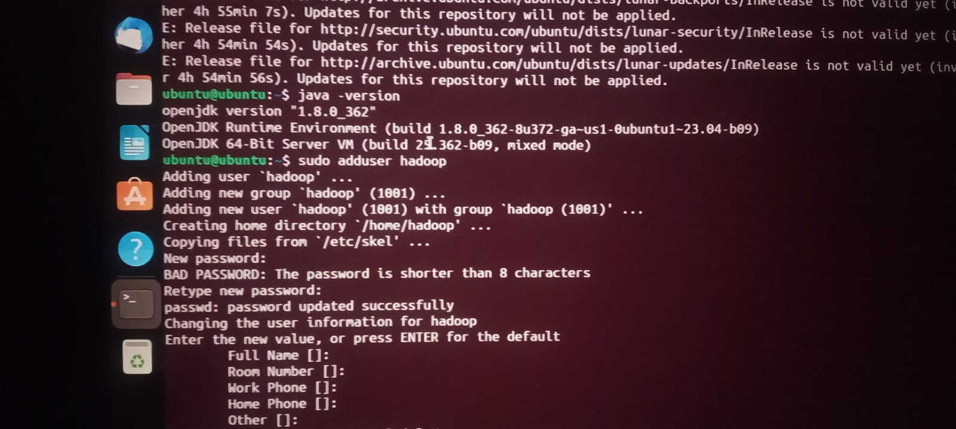

1. sudo adduser Hadoop

<<this command is for creating the user name as “Hadoop” ,after running this command to create a new password & conform the password.>>

“your password is not appear but you need to remember.”

Then after press “enter” for the details and conform (Y).7.



1. sudo usermod –aG sudo Hadoop

<<this is for their requirements>>

1. sudo su

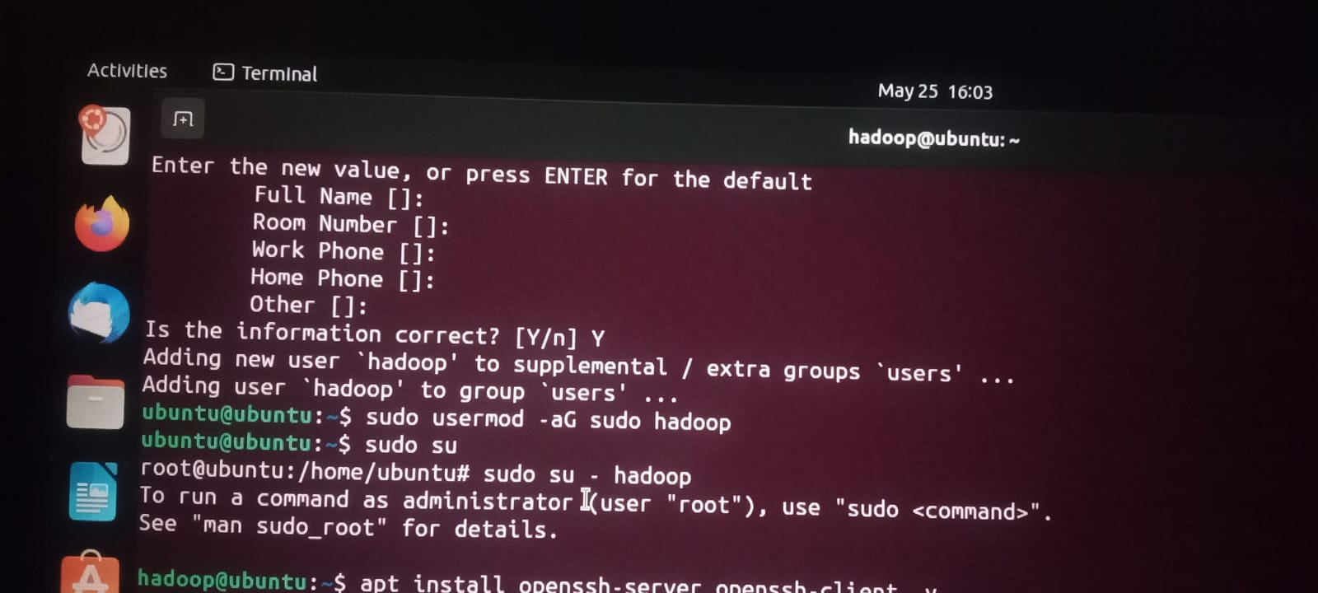

7.apt install openssh-server openssh-client –y

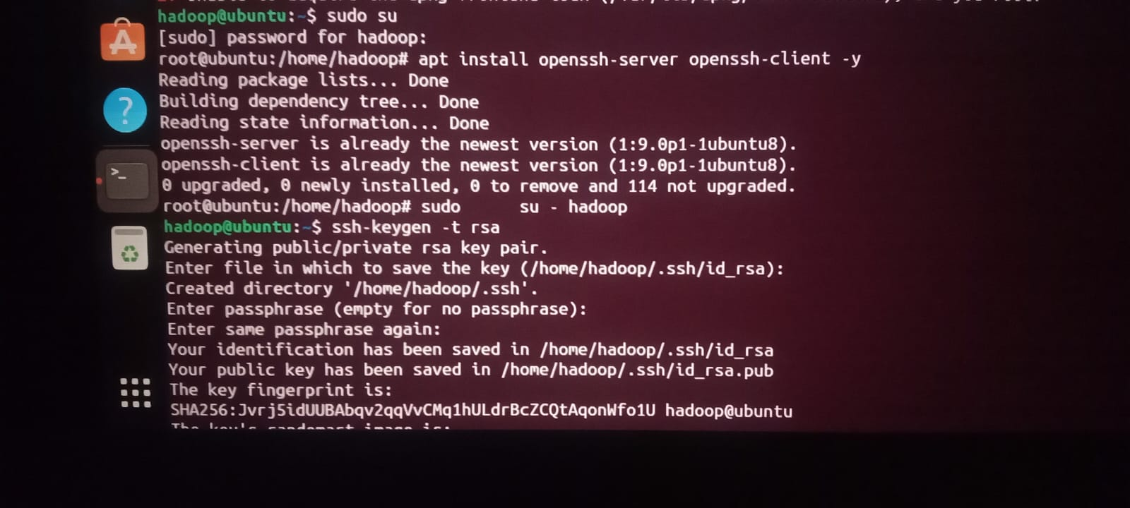

<<now we install the ssh client server with the root>>

1. sudo su – hadoop
2. ssh-keygen –t rsa

<<This command is used for generating the key>>

Give “enter”due to default ….

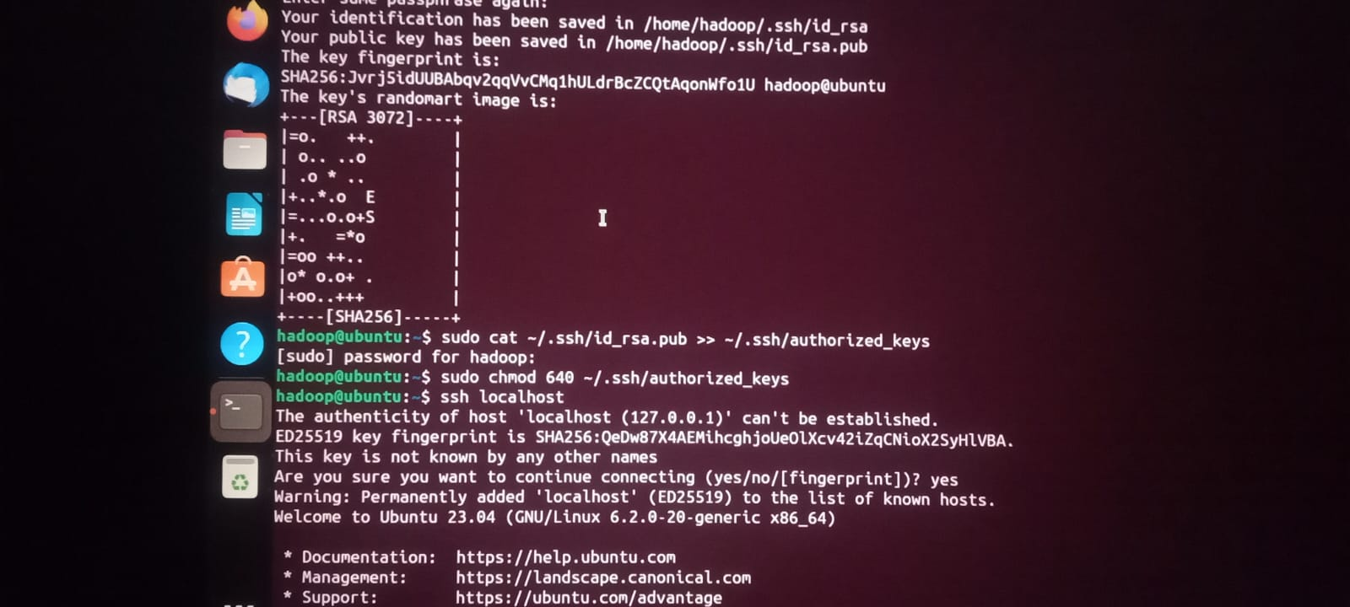

10.sudo cat ~/.ssh/id_rsa.pub >>~/.ssh/authorized_keys

<<enter password>>

11.sudo chmod 640 ~/.ssh/authorized_keys

12.ssh localhost