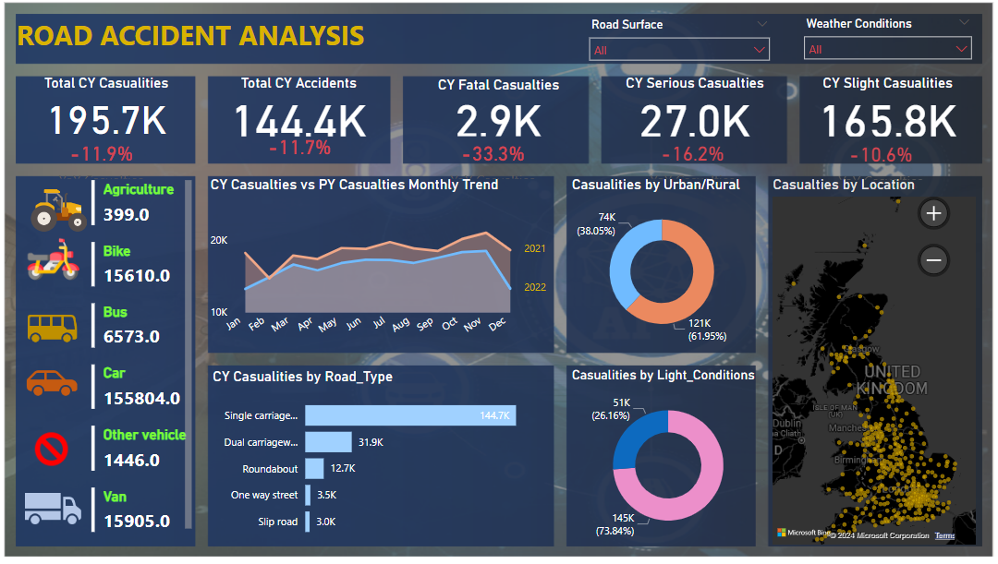**Project Title: Road Accident Dashboard**

**Objective:** Design and develop a comprehensive dashboard using Excel to analyze and visualize road accident data for better understanding and decision-making by stakeholders.

**Key Responsibilities and Achievements:**

1. **Data Collection and Preparation:**
   * Gathered raw data from various sources including traffic authorities, police records, and accident reports.
   * Cleaned and standardized the data to ensure consistency and accuracy in analysis.
   * Organized the data into relevant categories such as accident type, location, time, and severity.
2. **Dashboard Design and Development:**
   * Utilized Excel's advanced features and functionalities to create an interactive dashboard.
   * Designed an intuitive user interface for easy navigation and data exploration.
   * Implemented dynamic charts, graphs, and tables to visualize accident trends over time and by location.
   * Incorporated slicers and filters to allow users to drill down into specific subsets of data.
3. **Statistical Analysis and Insights:**
   * Conducted statistical analysis to identify patterns, trends, and correlations within the accident data.
   * Generated summary statistics and metrics to measure accident frequency, severity, and distribution.
   * Extracted actionable insights to help stakeholders understand the underlying causes of accidents and formulate targeted interventions.
4. **Report Generation and Documentation:**
   * Created detailed documentation outlining the methodology, data sources, and analysis techniques used in the project.
   * Generated periodic reports summarizing key findings and recommendations for relevant stakeholders.
   * Provided training and support to end-users on how to effectively use the dashboard for decision-making purposes.

**Technologies Used:**

* Microsoft Excel (including PivotTables, PivotCharts, Formulas, Conditional Formatting, etc.)

**Outcome:** The Road Accident Dashboard project resulted in a user-friendly tool that provides valuable insights into road accident patterns and trends. Stakeholders can now make data-driven decisions to improve road safety measures, allocate resources more effectively, and ultimately reduce the incidence of accidents.

**Key Skills Demonstrated:**

* Data Collection and Preparation
* Data Visualization and Dashboard Design
* Statistical Analysis and Interpretation
* Documentation and Reporting
* Stakeholder Engagement and Training

**Conclusion:** The Road Accident Dashboard project not only showcased my proficiency in Excel but also demonstrated my ability to analyze complex datasets and translate them into actionable insights. This project highlights my commitment to leveraging technology for the betterment of society, particularly in areas such as public safety and transportation management.