1. Display the employee name and job name of all the employees

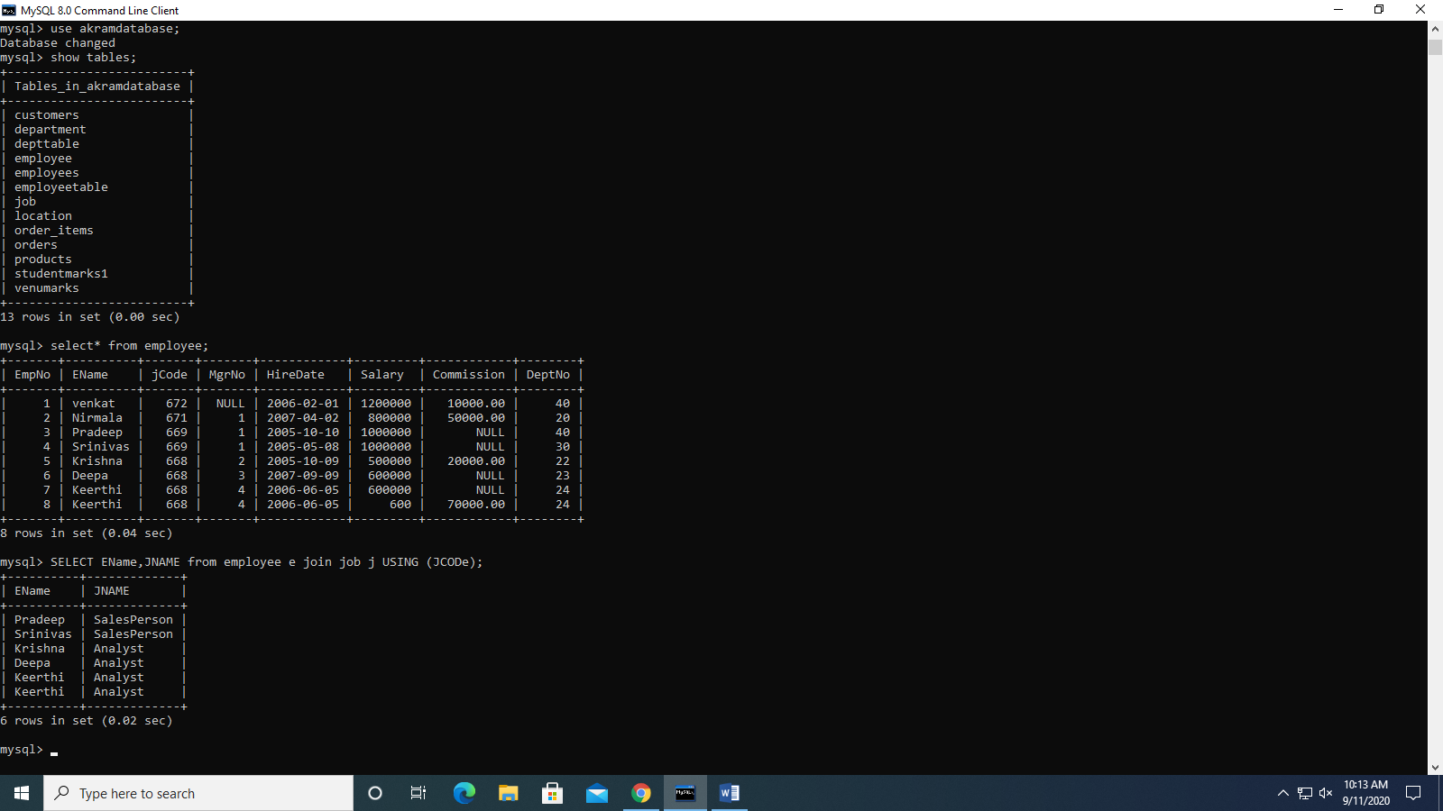

1. Display department name and its location name for all departments

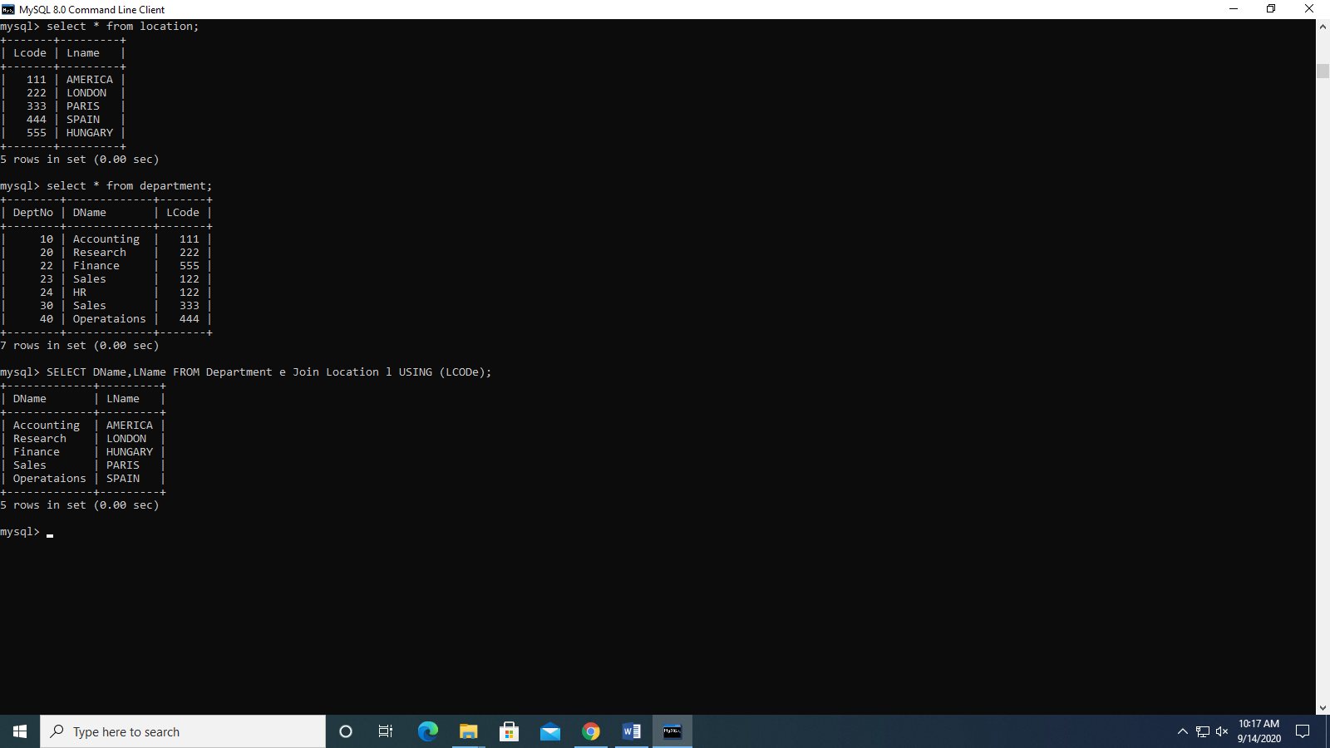

1. Display the employee name and job name of all the employees in department number 30

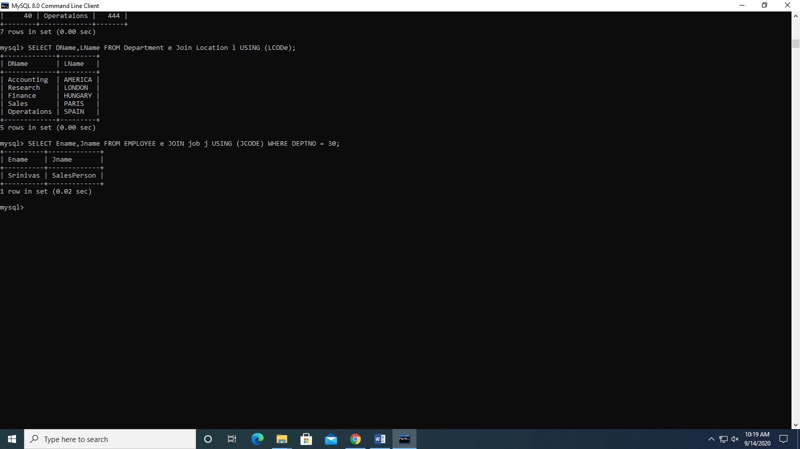

1. Display employee name and department name for all analysts

