1. Write a query to display all department & their location names.

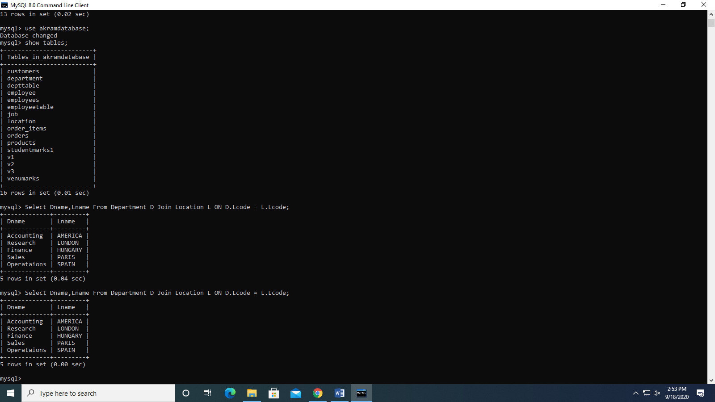

1. Write a query to display the name,JobName,Department name and Location of every Employee.

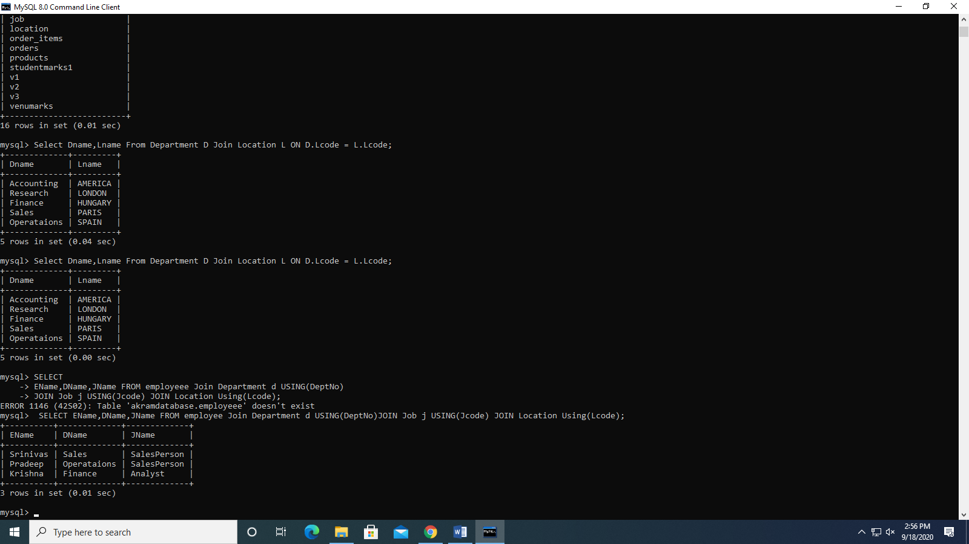

1. Write a query to display list of departments with at least one ‘analyst’ along with their location name.

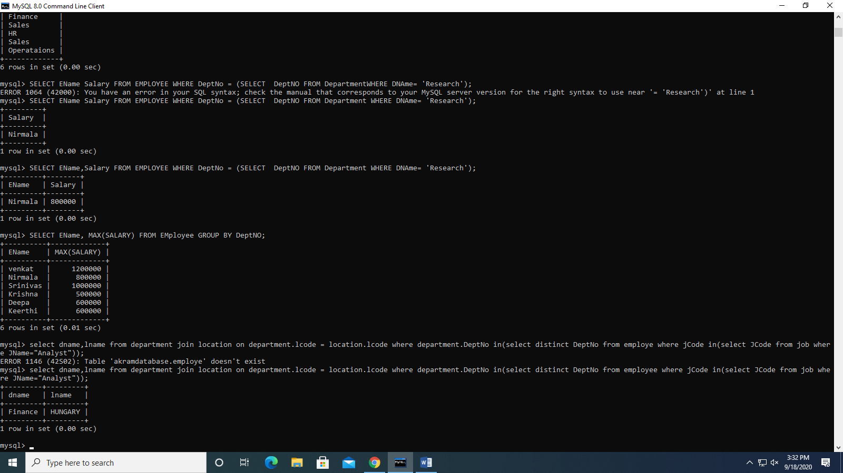

1. Display list of employees working under either Pradeep or Srinivas

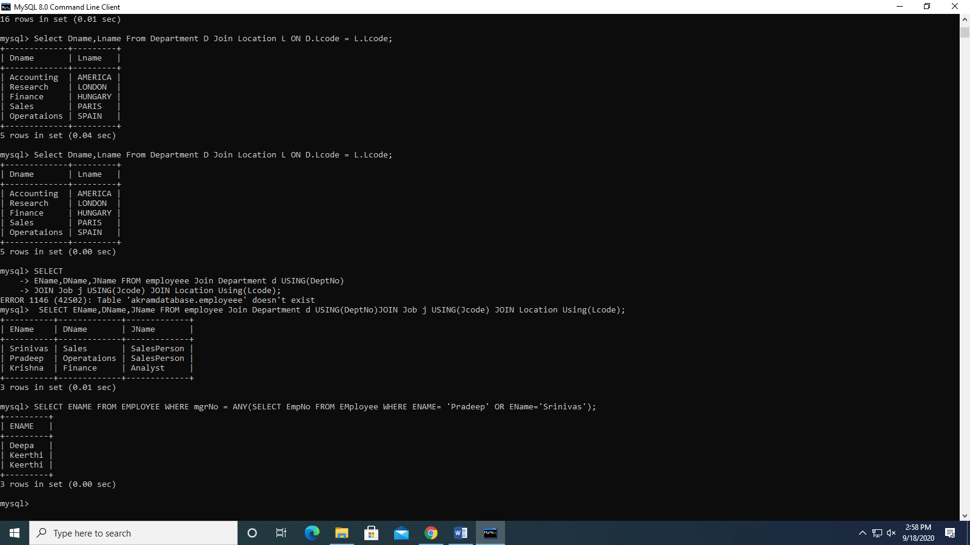

1. Display list of employees are in accounts department.

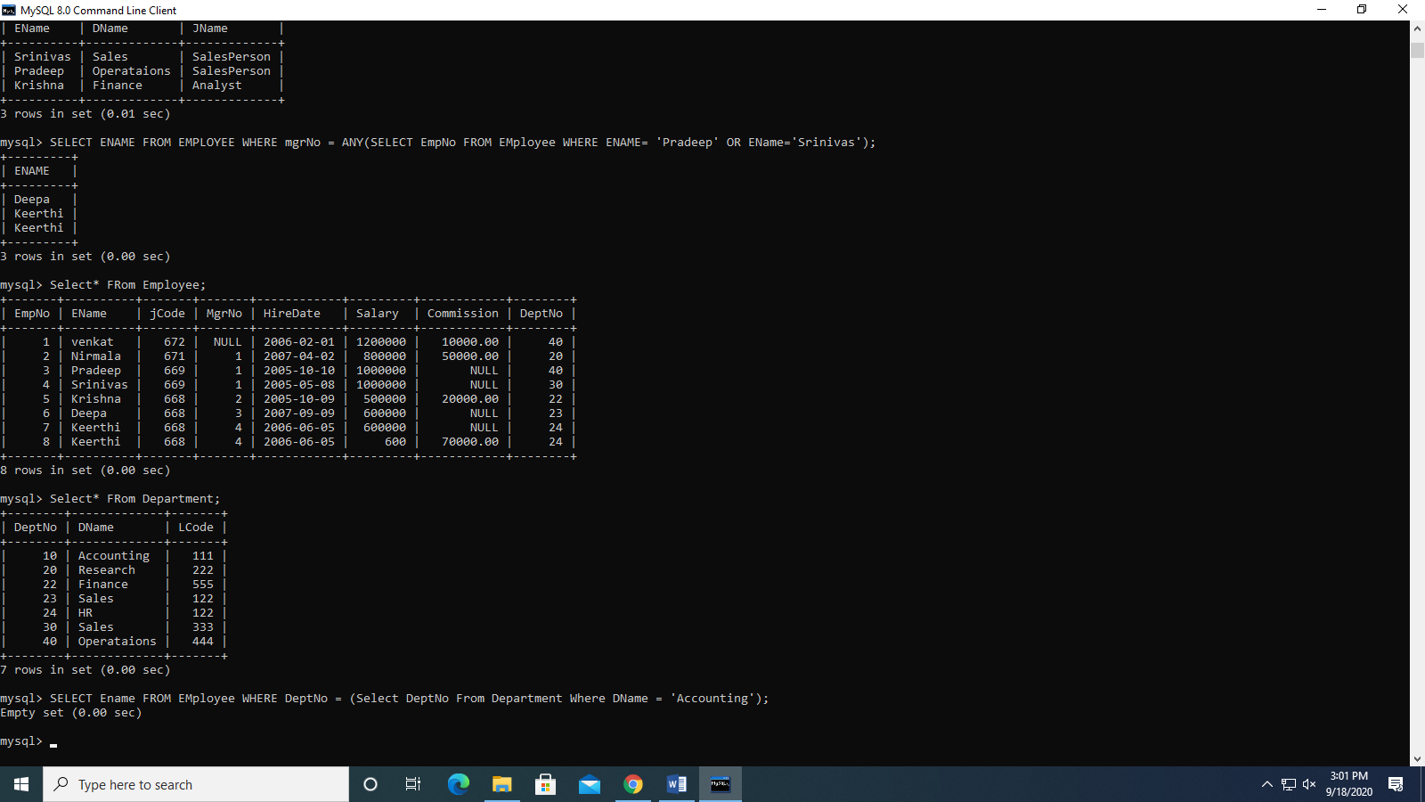

1. Find the names of department that has at least one employee.

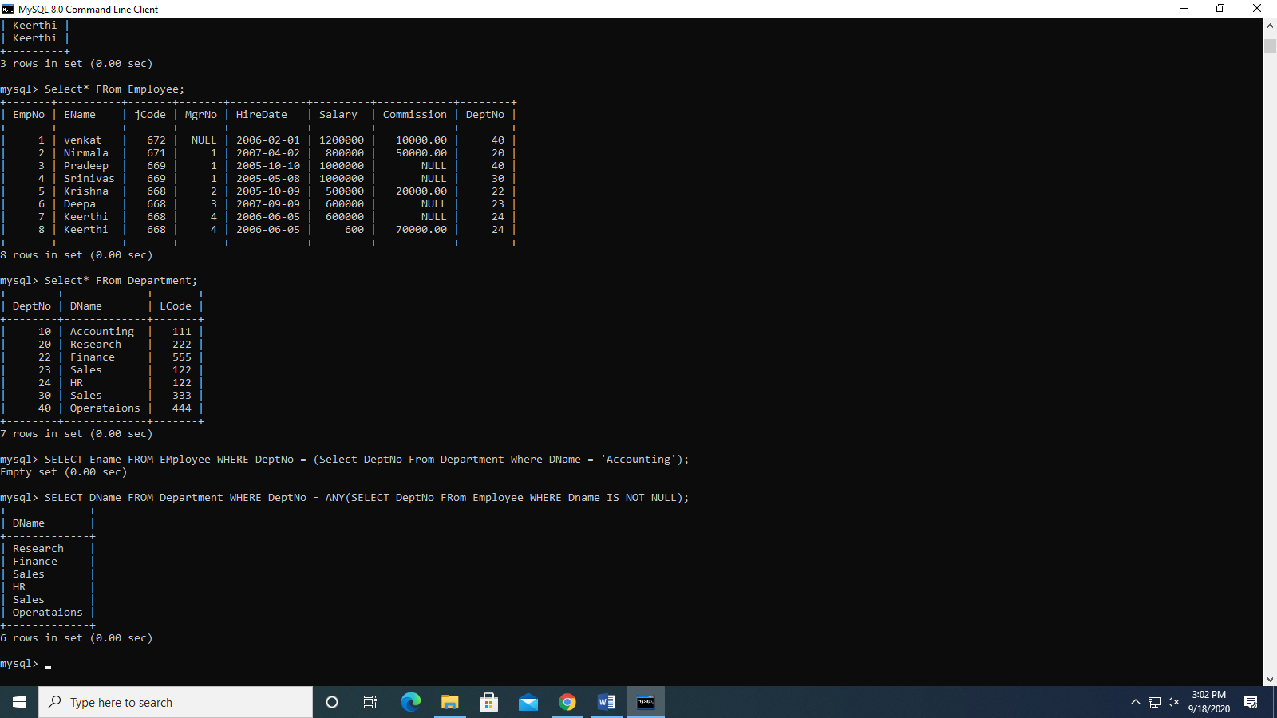

1. Write a query to display the names and salaries of employees in Research Department.

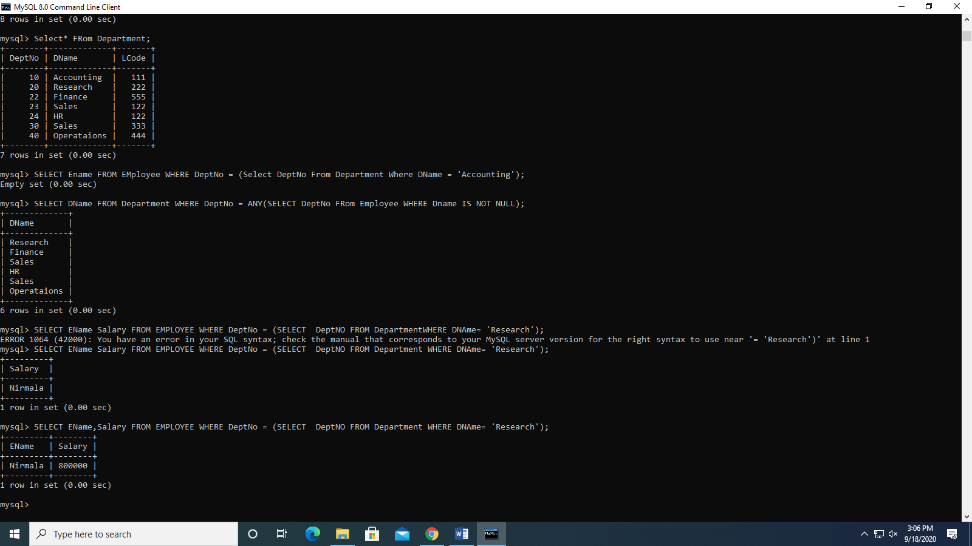

1. Find the employees who are getting maximum salary in their respective job.

