1. Insert the following data in to the employee table by using two different commands

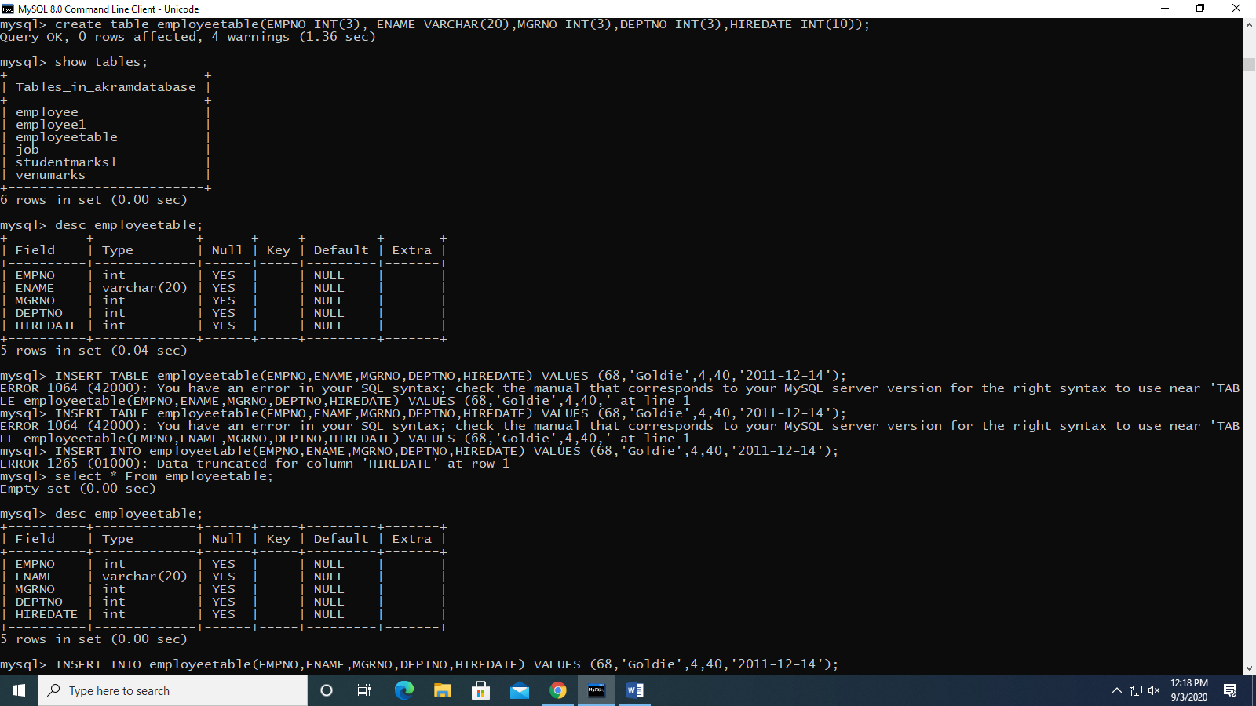

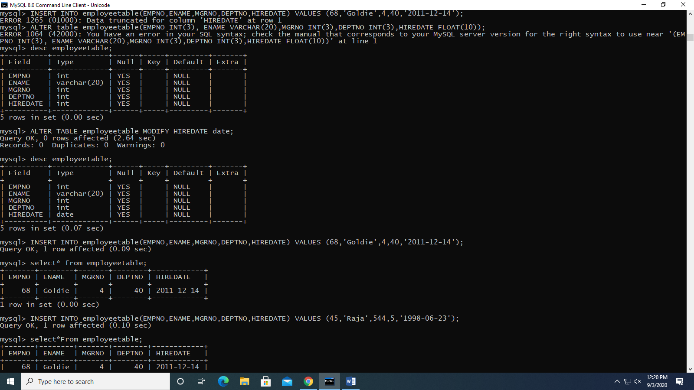

1. Write Update Command to change the department no of all the table employee table to 60.

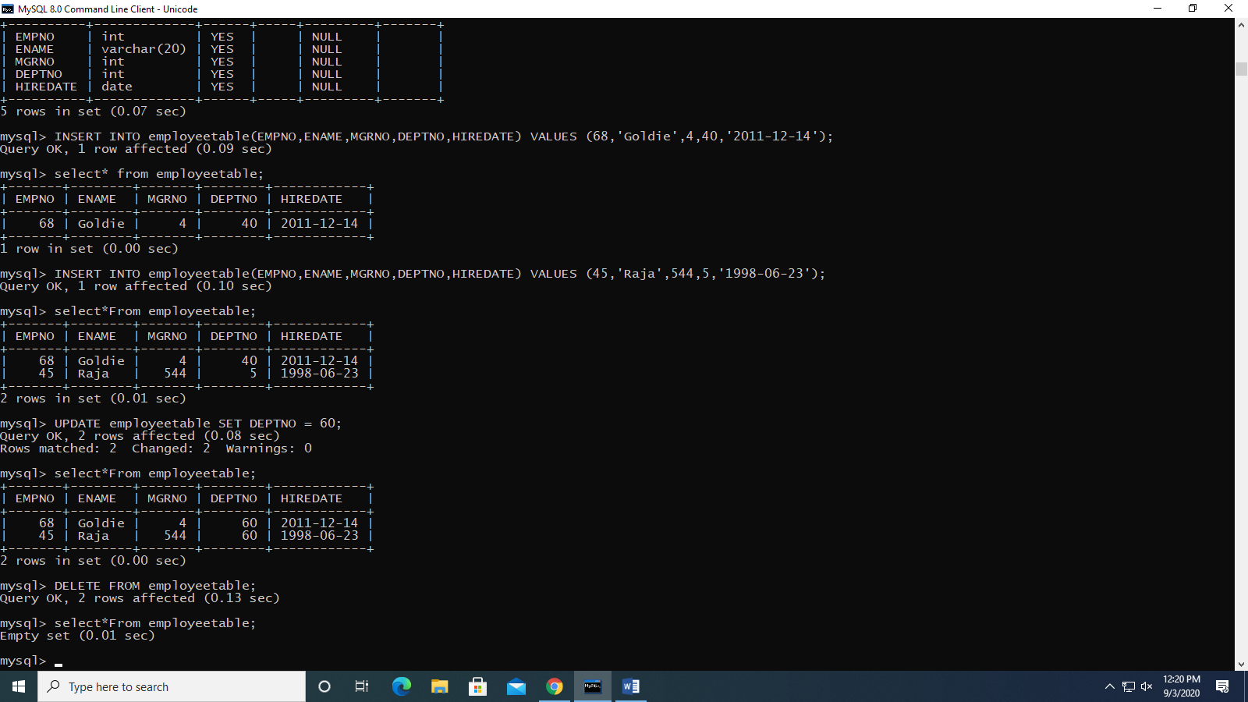

1. Delete command to delete all the records from the job table.

