1.Return all the products Name, Unit price, New Price (Unit price *1.5).

Select name,unit_price(unit_price * 1.5) AS TotalPrice from Products;

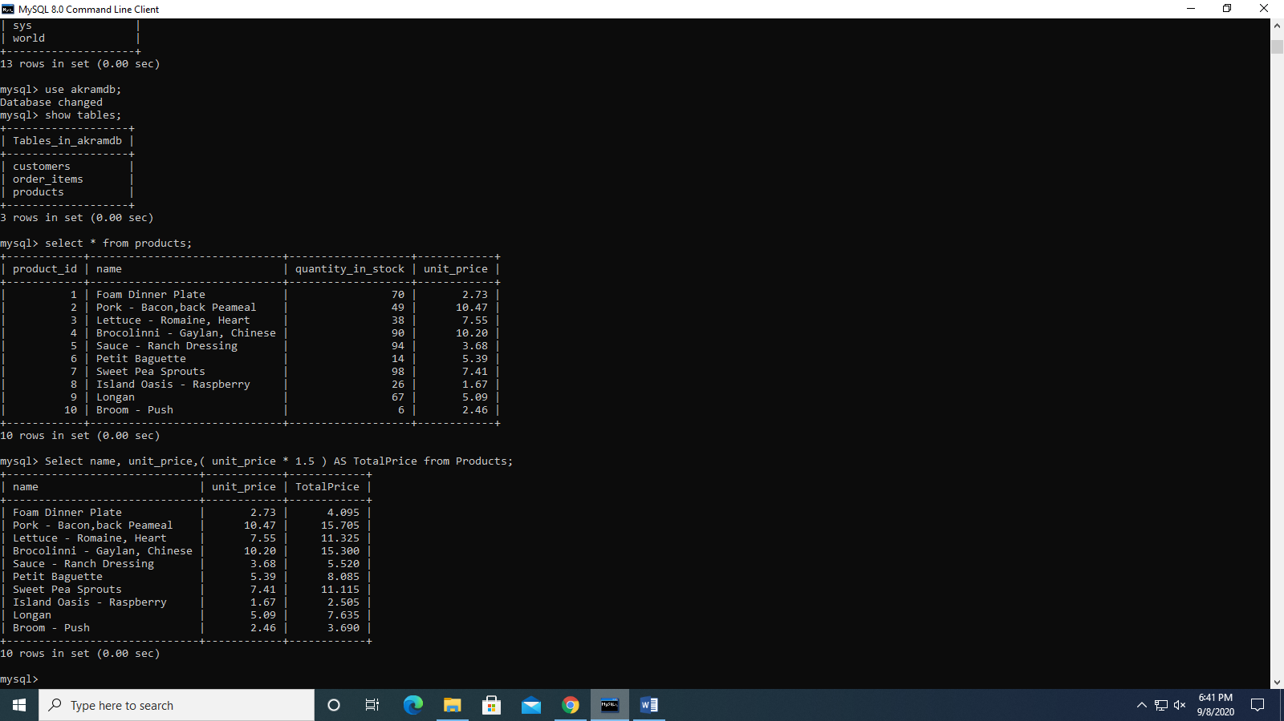

2. Get the orders placed this year

Select * from orders where order_year = '2020-01-01';

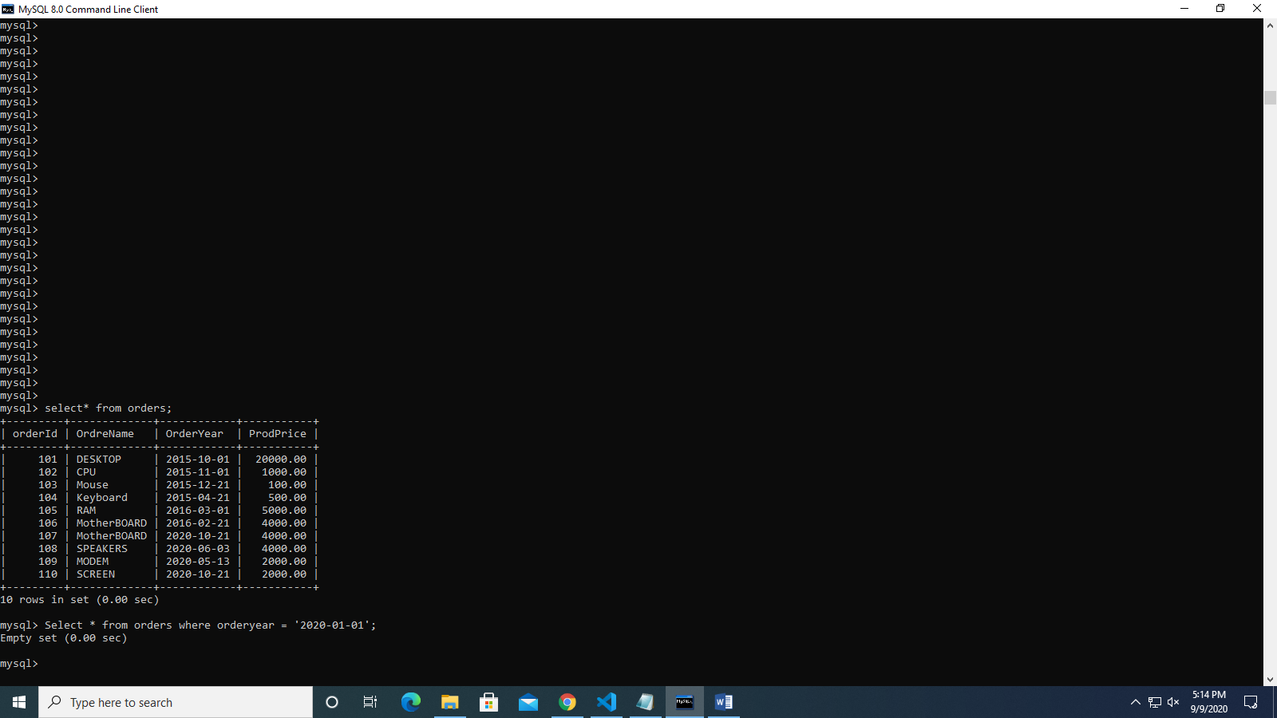

3. From the order items table get the item order #6, where the total price is greater than 30.

Select order_id, quantity * unit_price AS total_price from order_items where order_id = 6 AND quantity * unit_price > 30;

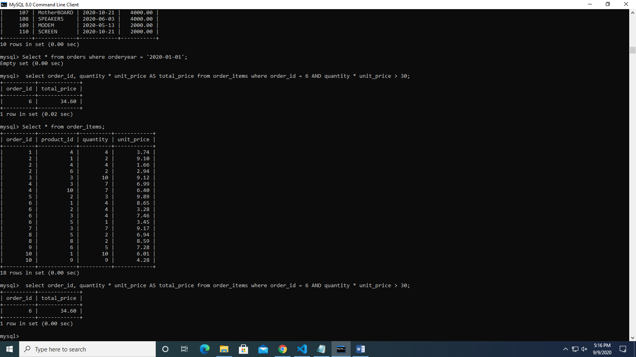

4. Return products with quantity in stock equal to 49, 38, 72.

SELECT * FROM products where quantity_in_stock IN (49, 38, 72);

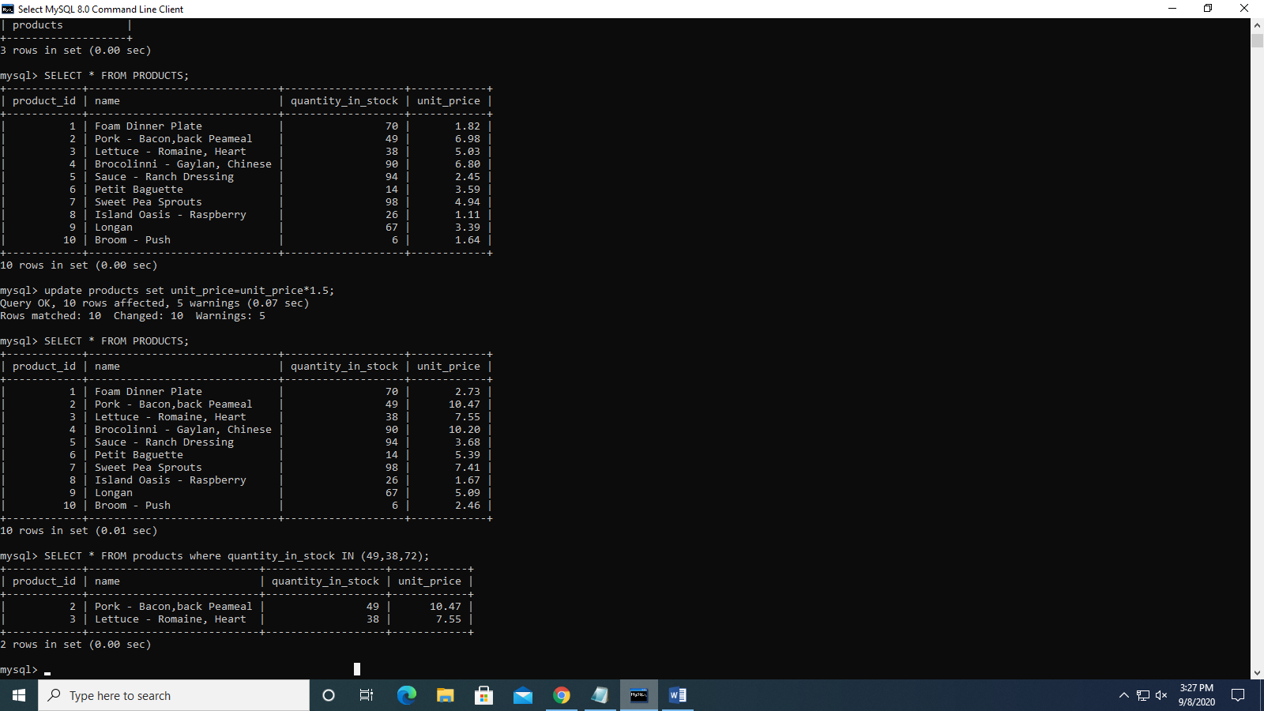

5. Return customers born between 01/01/1990 and 01/01/2000.

SELECT first_name from customers where birth_date between "1990-05-03" and "2000-05-03";

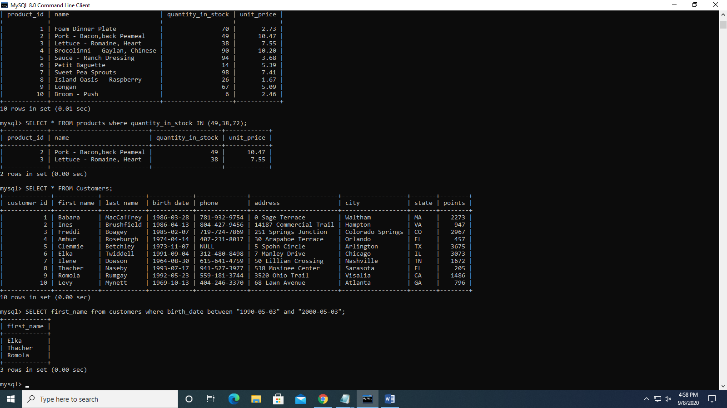

6. Get the customers whose phone Number ending with 9.

SELECT * FROM Customers where phone like '9%';

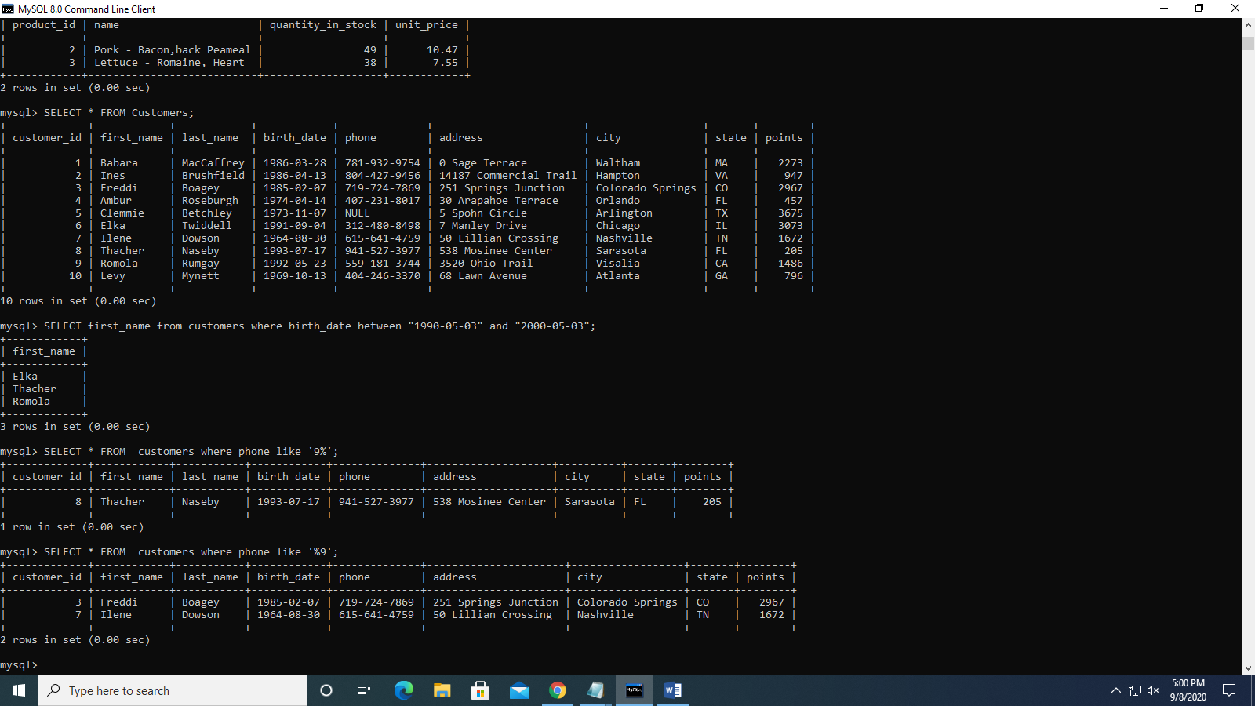

7. Get the customers whose last name End with EP or HI.

SELECT * FROM customers where first_name like 'ep% or hi%';

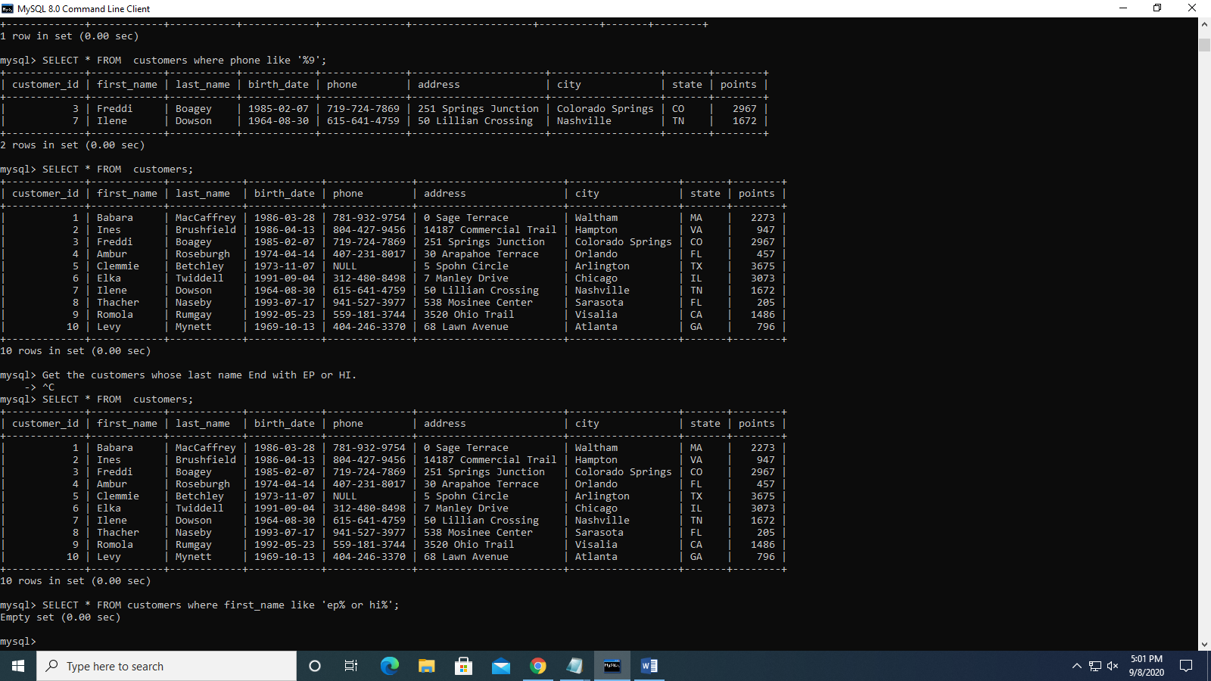

8. Get the customers whose last names start with MA or contain NI.

SELECT * FROM customers where first_name like '%ma or %ni%';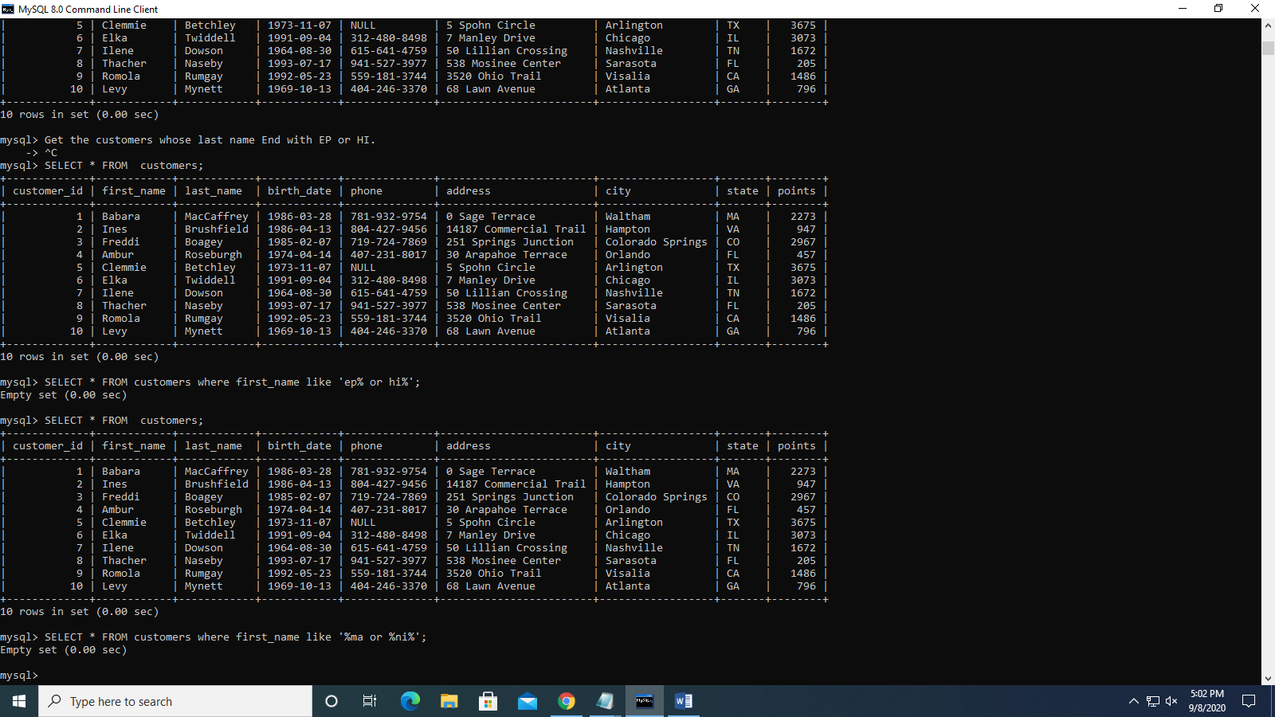

9. Get the customers where last names contain R followed by I or M

SELECT * FROM customers where first_name like 'ri% or rm%';

