1. Find the employees whose job code is 679;

SELECT \* FROM employees where jcode=679;

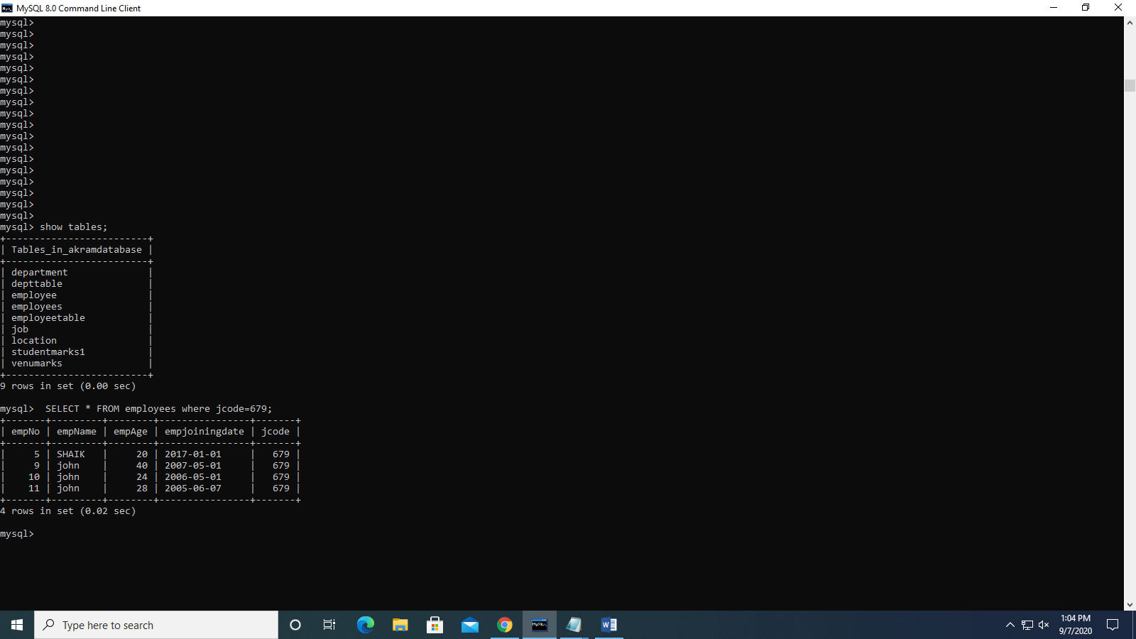

1. Find the employees joining before 2017?

SELECT \* FROM employees where empjoiningdate<'2017-05-03';

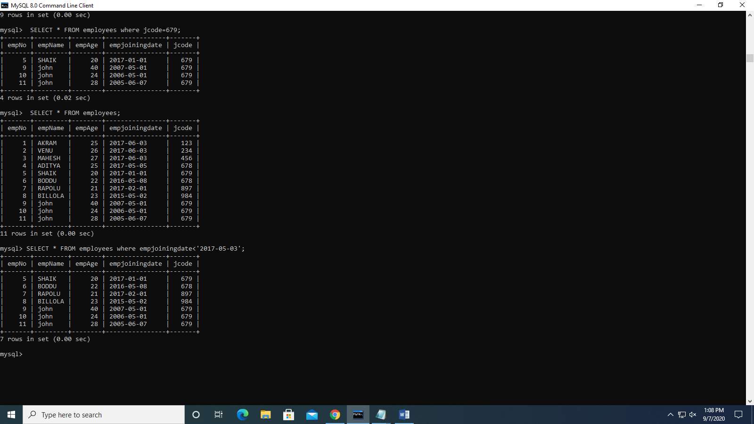

1. Find the details of employees whose names contain ‘John’?

SELECT \* from employees where empname LIKE '%john%';

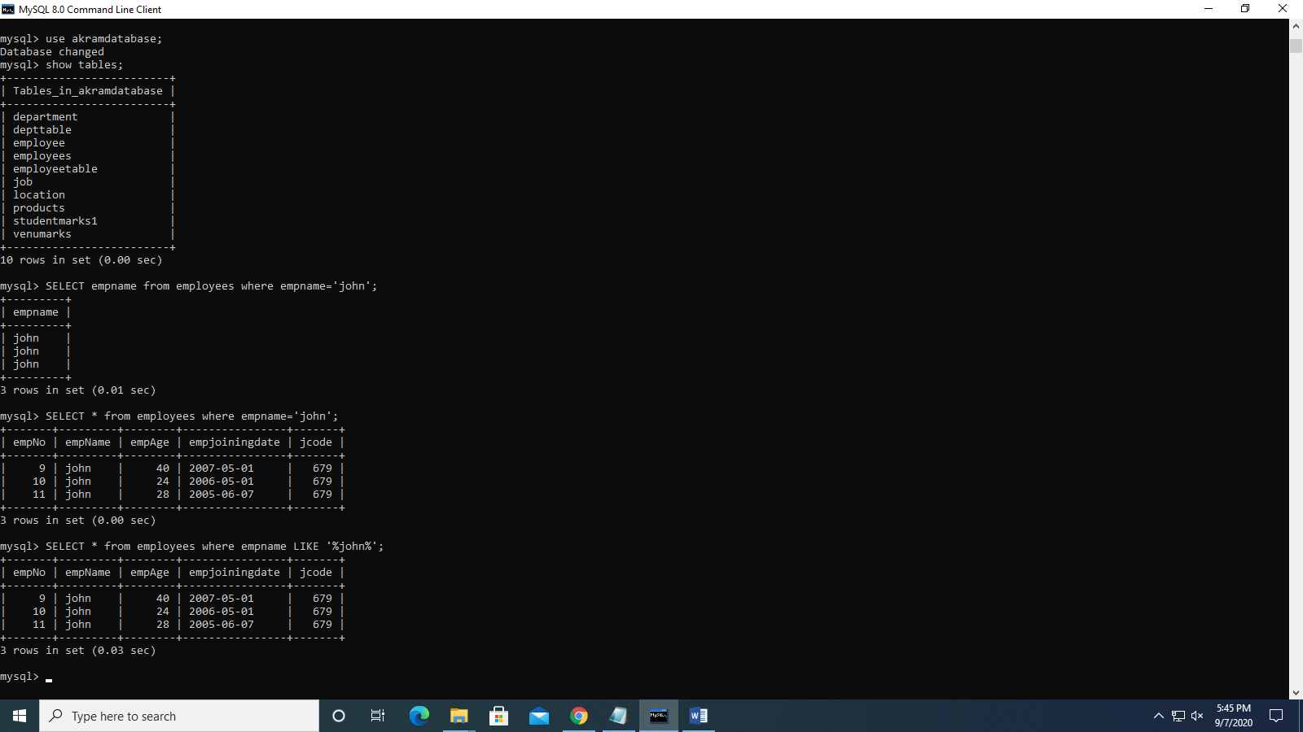

1. Find the details of employees whose commission is more than their salary.

SELECT \* FROM employee where commission>salary;

