1. Find the list of employees who do not have managers.

SELECT \* FROM employee WHERE MgrNo = NULL; 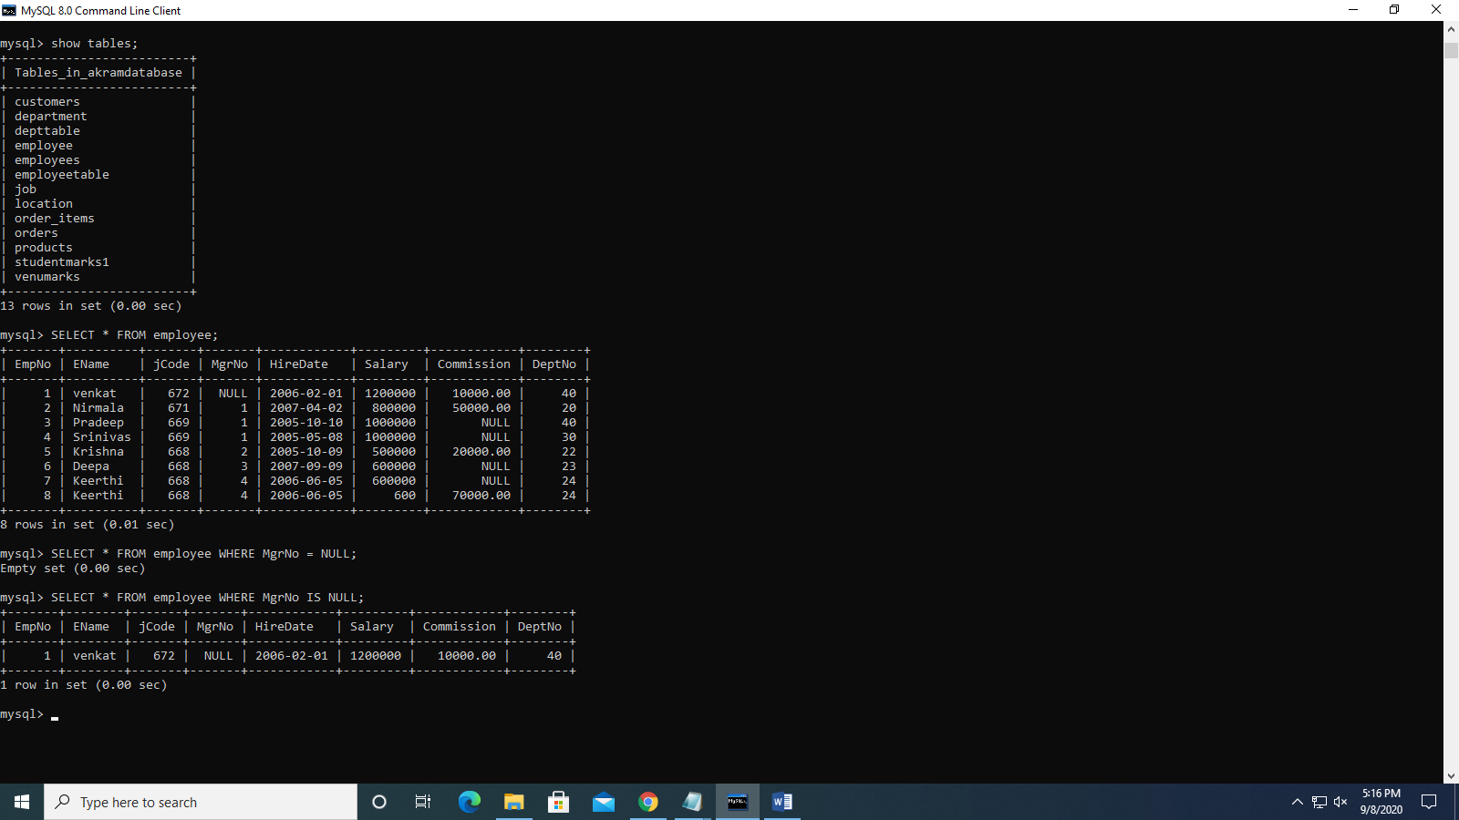

1. Find employees having more than 1 year of experience and still a trainee.

select \* from employee e, job j where e.jcode = j.jcode;

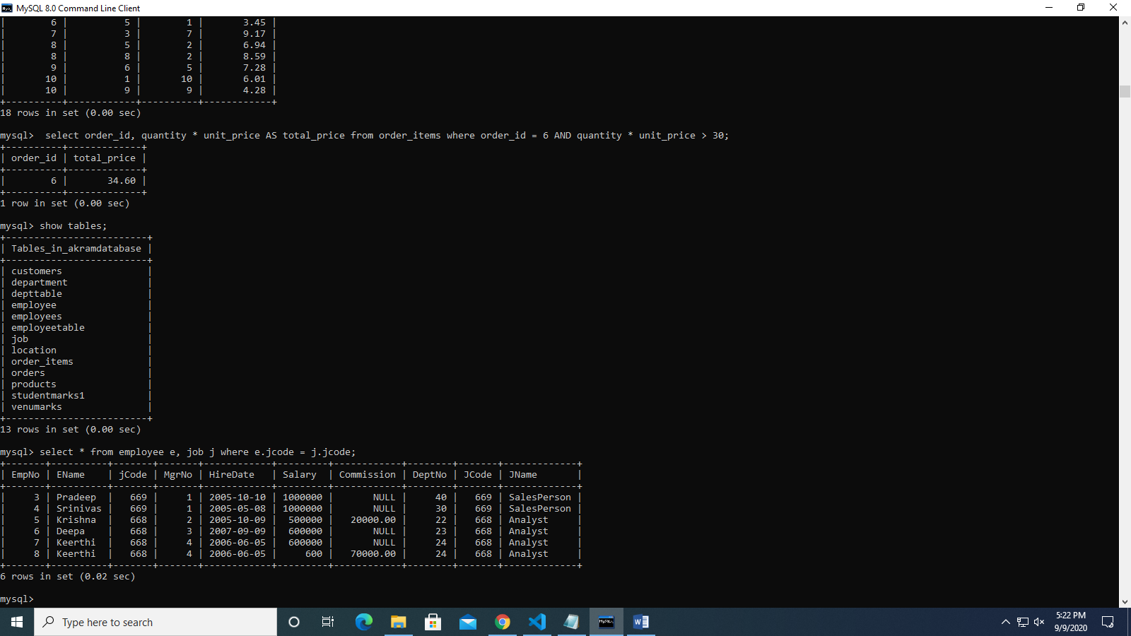

1. Display list of employees who receive commission or is in sales department.

SELECT\* from employee e, job j where e.commission IS NOT NULL AND j.jname = 'salesperson';

