1. Get the orders that are not shipped.

SELECT * from orders where shipper_id IS null;

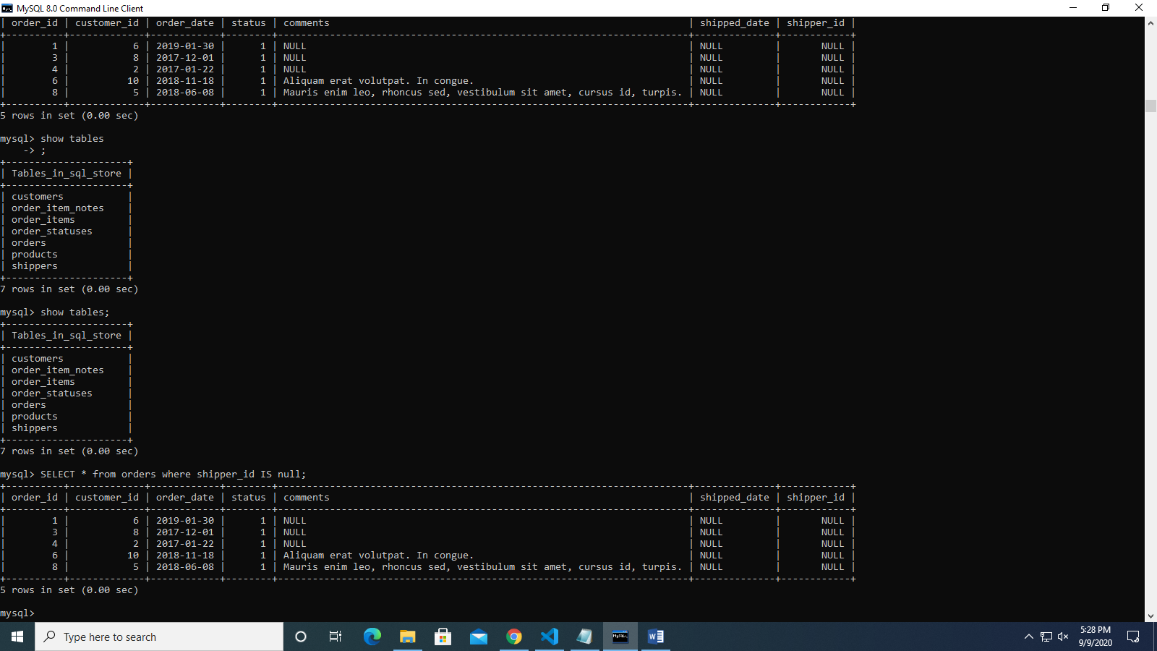

1. Get the orders where orders Id equals 2 and total price in descending order.

select order_id, quantity*unit_price as totalprice from order_items where order_id=2 ORDER BY order_id desc;

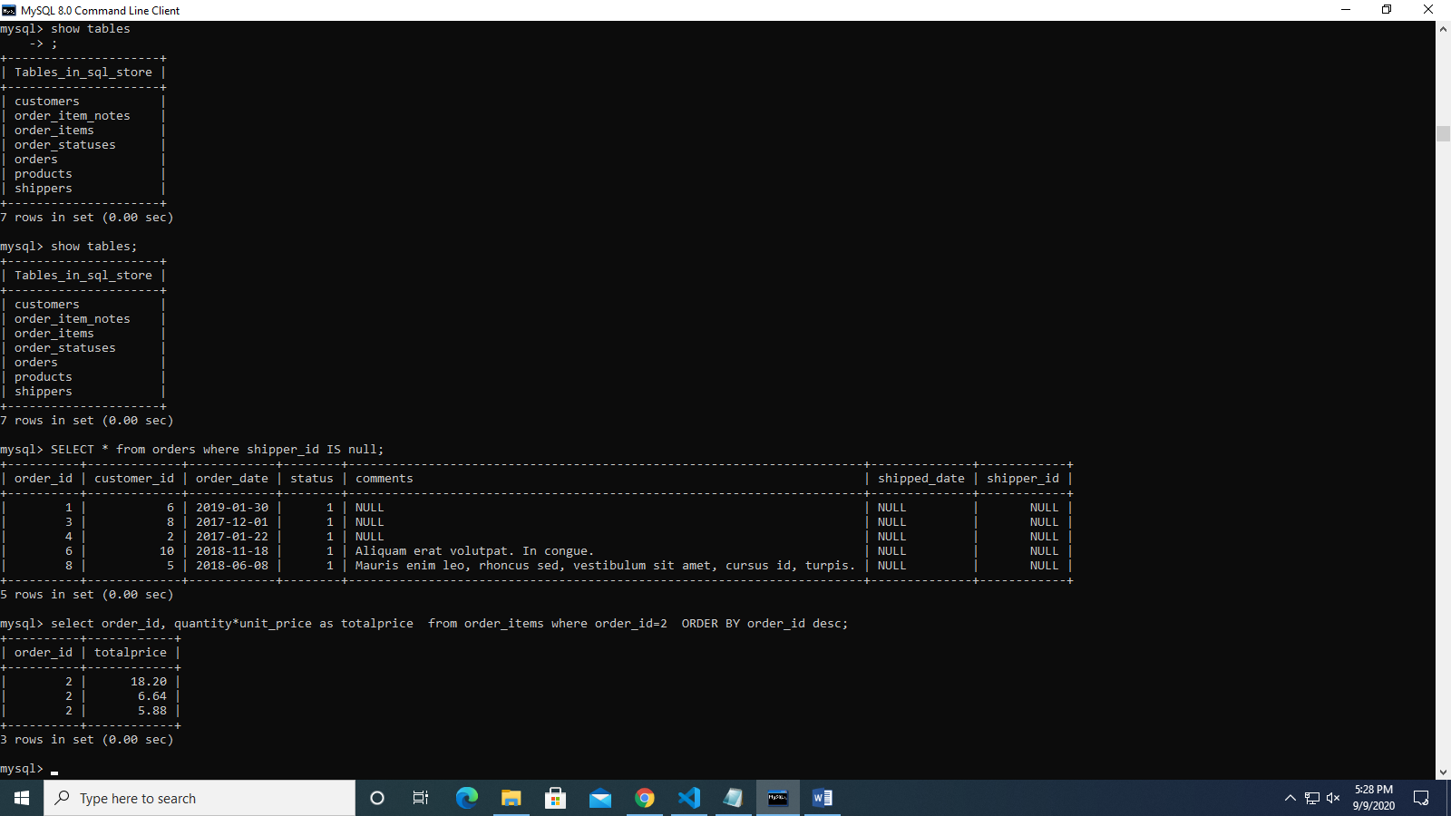

1. Get the top three loyal customers.

SELECT first_name from customers ORDER BY points desc limit 0,3;

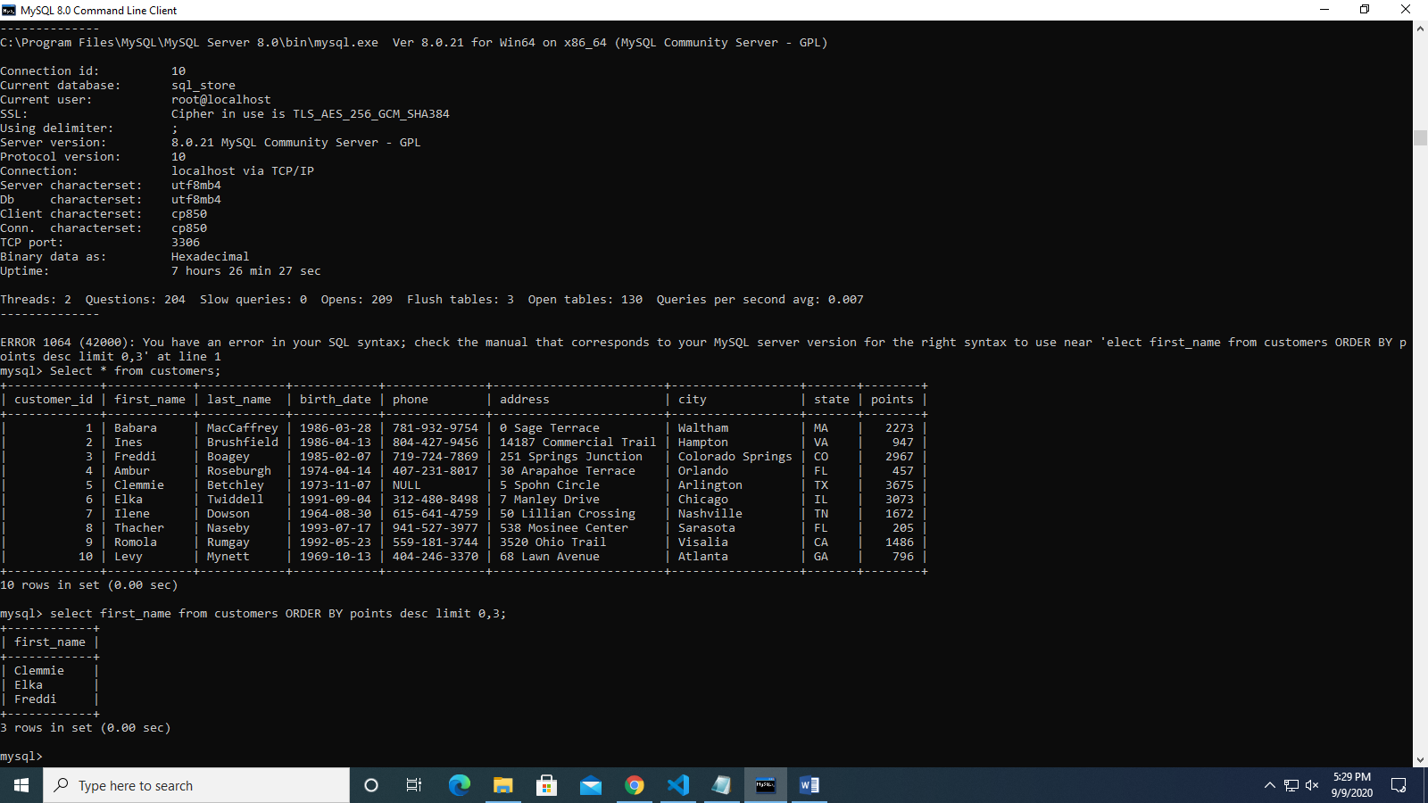

1. Get the orders and Name from product followed by product ID, quantity then unit Price.

select order_id, name, quantity_in_stock,products.unit_price from order_items , products where order_items.product_id= products.product_id;