Web Development Activity-Based Learning

NAME : Shaik Apsha

BRANCH : CSD

SECTION : 1

- Movie Review and Rating Website
Create a movie website featuring film posters, genres, release dates, cast information, synopsis, critic reviews, and rating displays. Use responsive grids and visually appealing movie cards.
Output :
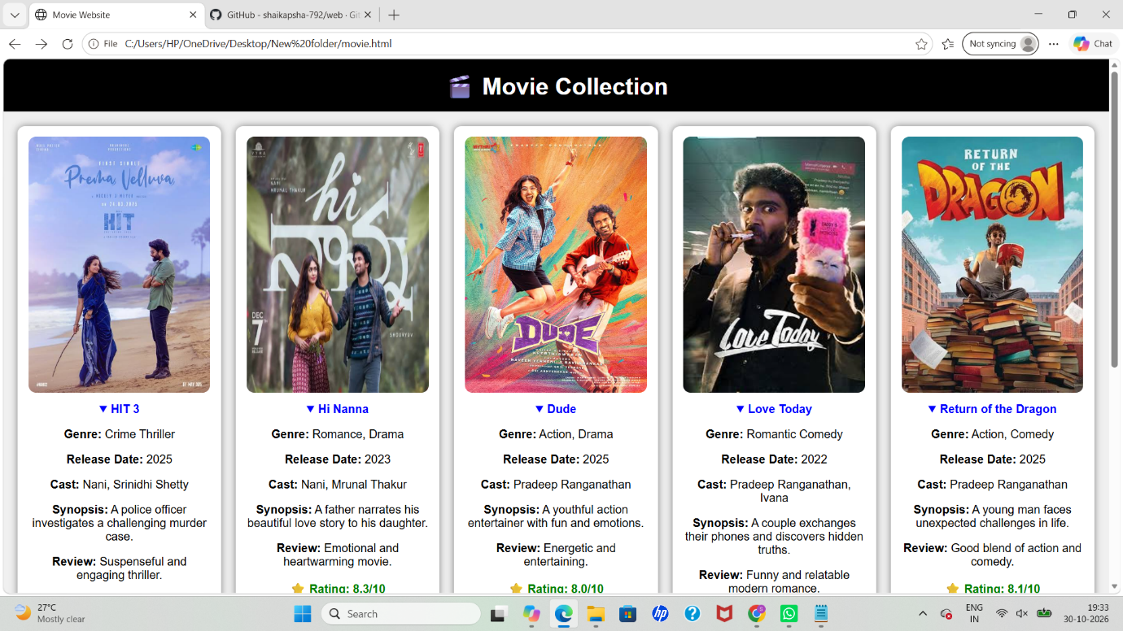

- Adventure and Trekking Website
Build a website showcasing trekking routes, camping trips, difficulty levels, trip schedules, equipment checklists, safety guidelines, and package prices. Use image overlays and visually distinct information panels.

Output :

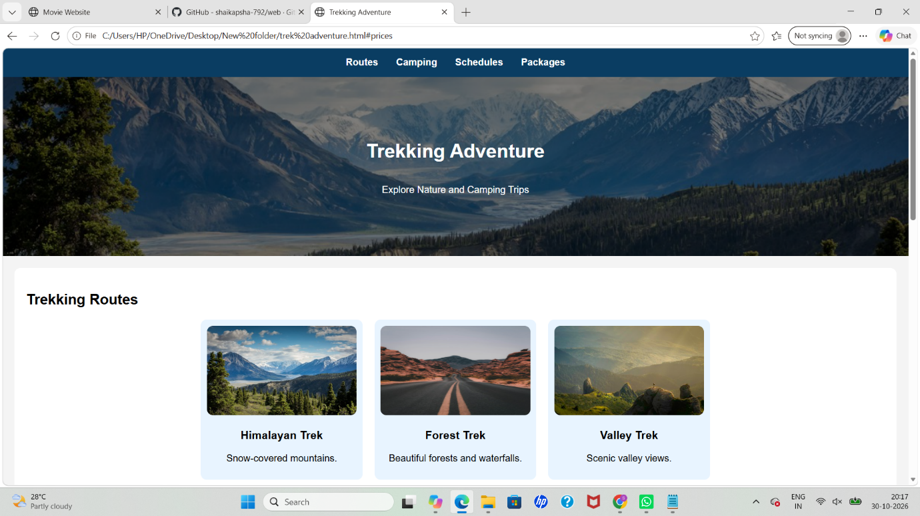

- Conference and Seminar Registration Website
Develop an event website featuring event themes, keynote speakers, session schedules, venue information, registration forms, and participation guidelines. Use speaker cards and a structured agenda layout.

Output :



