**#1**. Entity Name is showing as NA in TC application

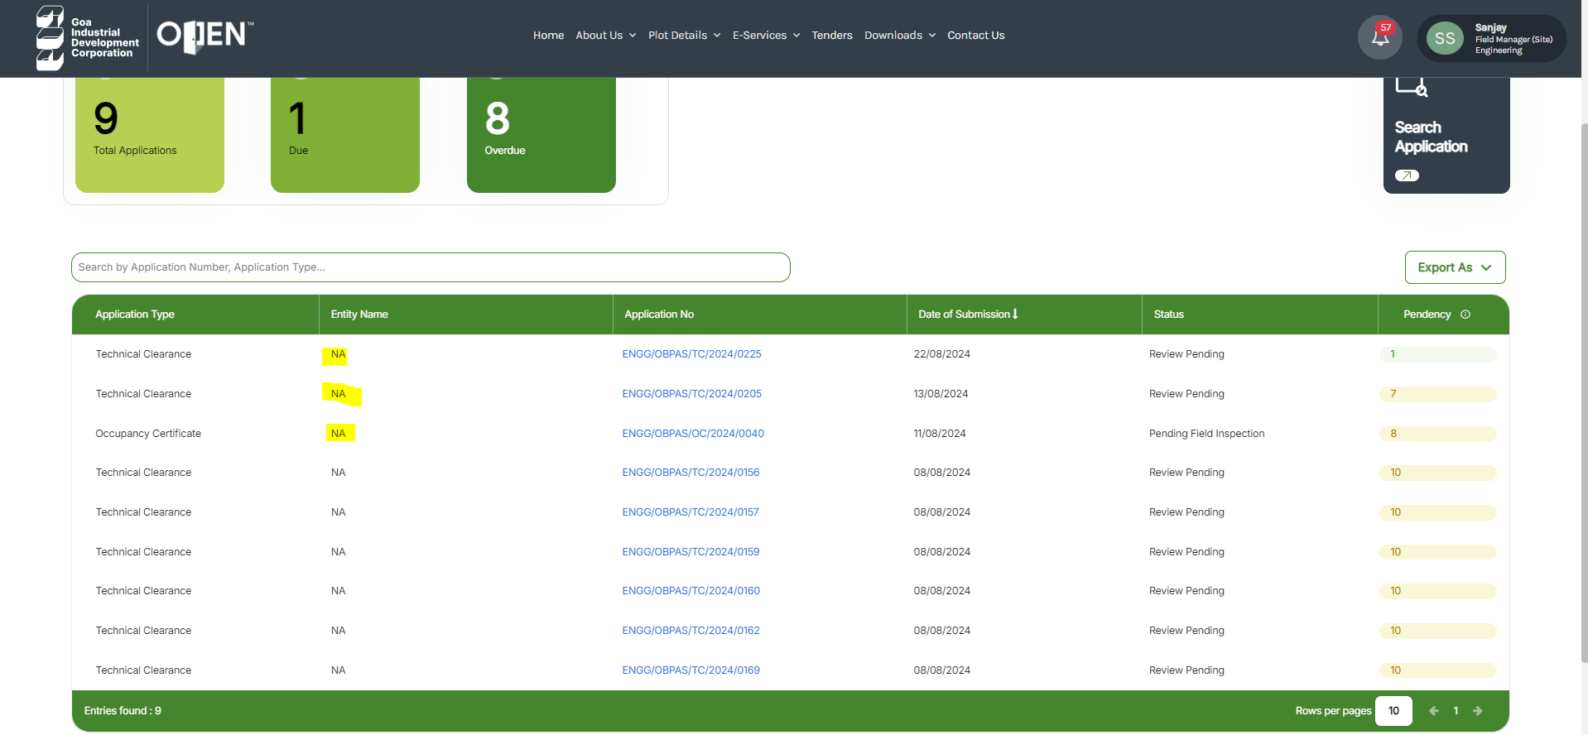

**#2.** Signed copy of consolidated document (submitted by Lessee) is not coming in correspondence of Employee

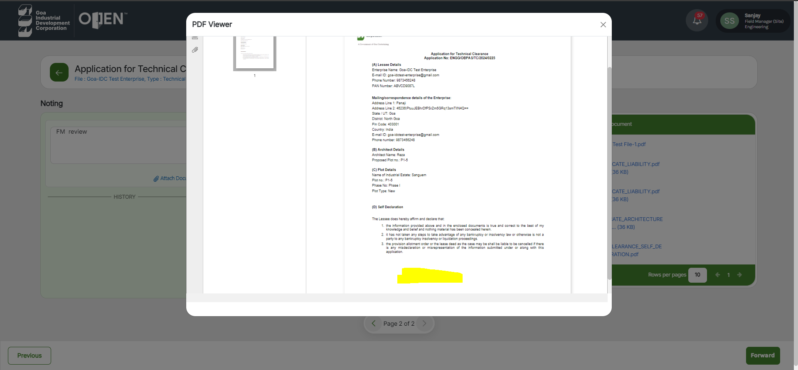

**#3.** Pdf copy of technical clearance is not showing under correspondence and name of consolidated document (mentioned above) is showing as Self Declaration which is wrong

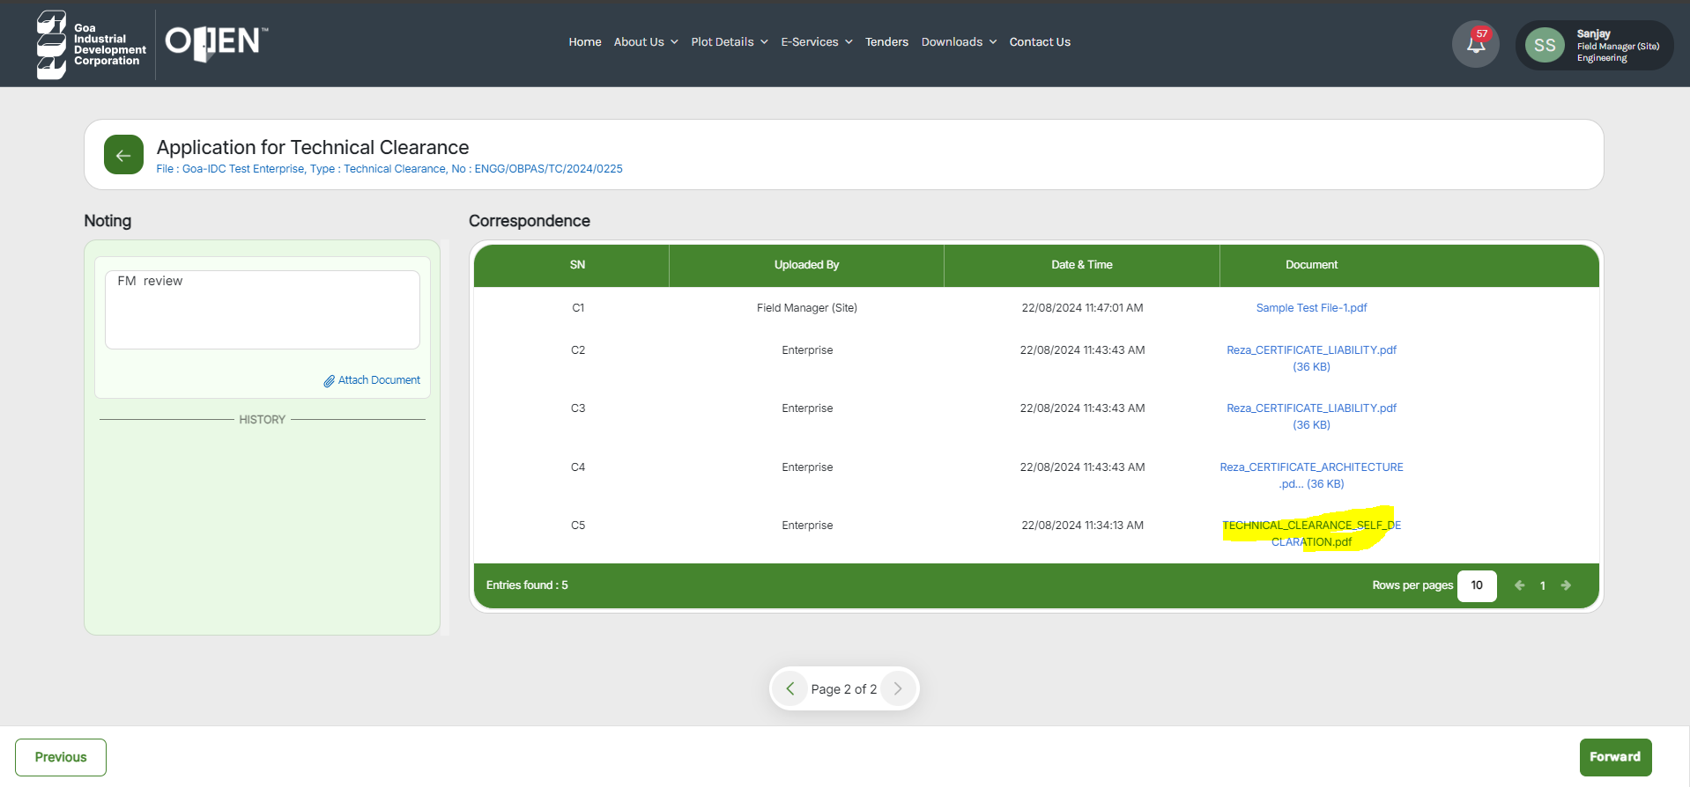

**#4.** The highlighted text should be Construction License pdf not Technical Clearance Template, please change accordingly

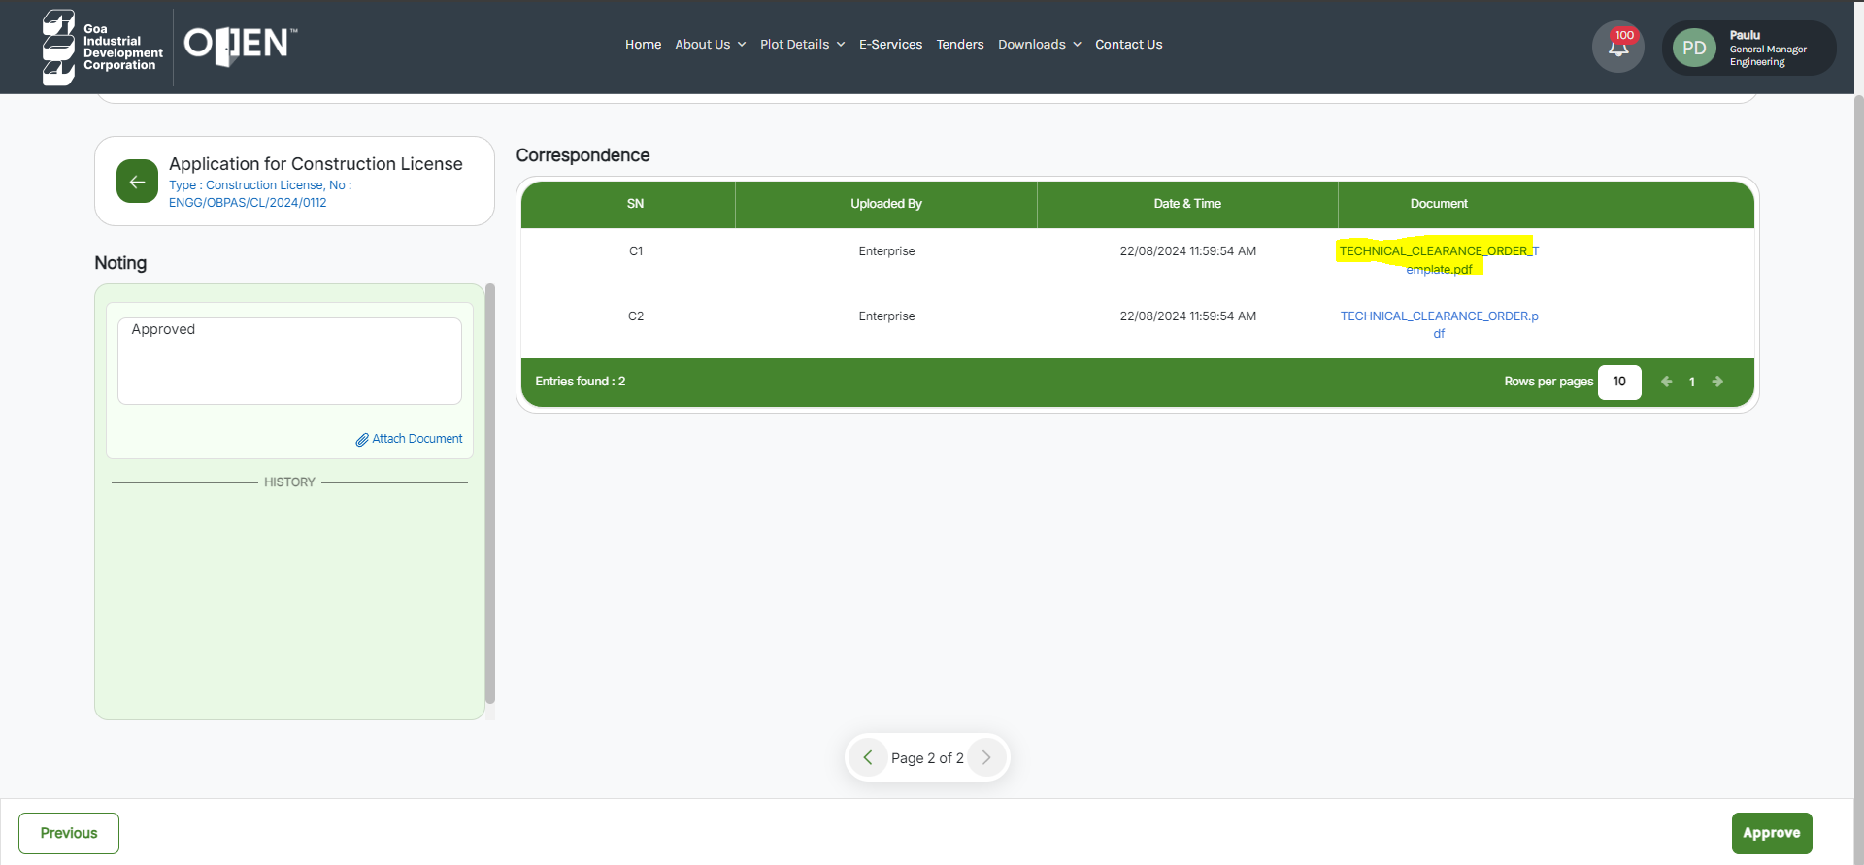

**#5.** GME (600066) is not able add any attachment from the attach document option mentioned below

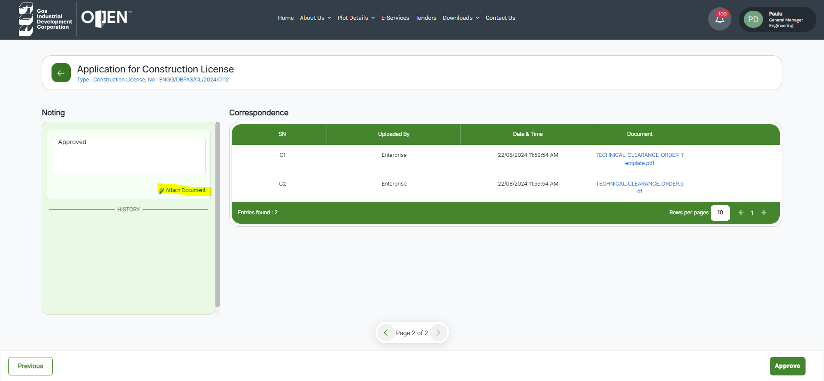

**#6.** Construction License is not showing properly to GME, information is not populating into the table.

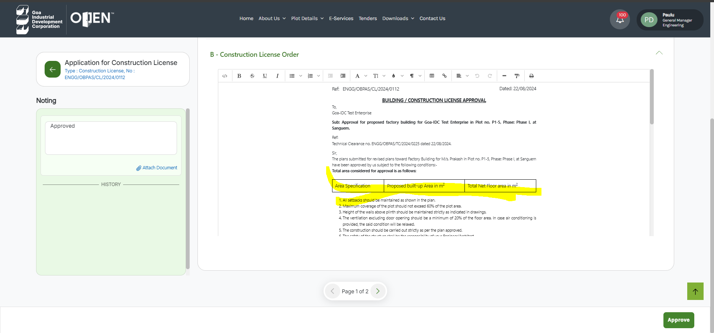

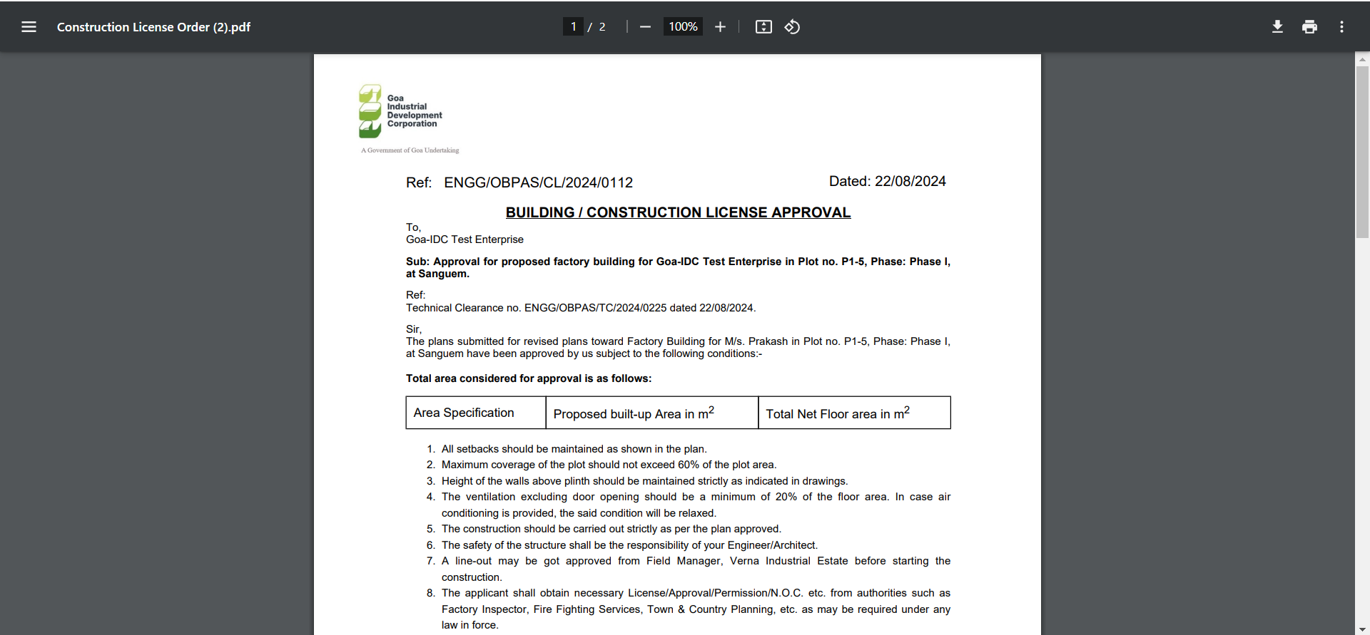

**#7.** Renewal of construction License should be a separate link under E-Services -> Engineering

**#8.** Clicking of E-Services -> Construction License should redirect the TC Application, currently it is redirecting to Renewal of Construction License.

**#9.** Expiration date should be auto populated after selecting construction license from the drop down

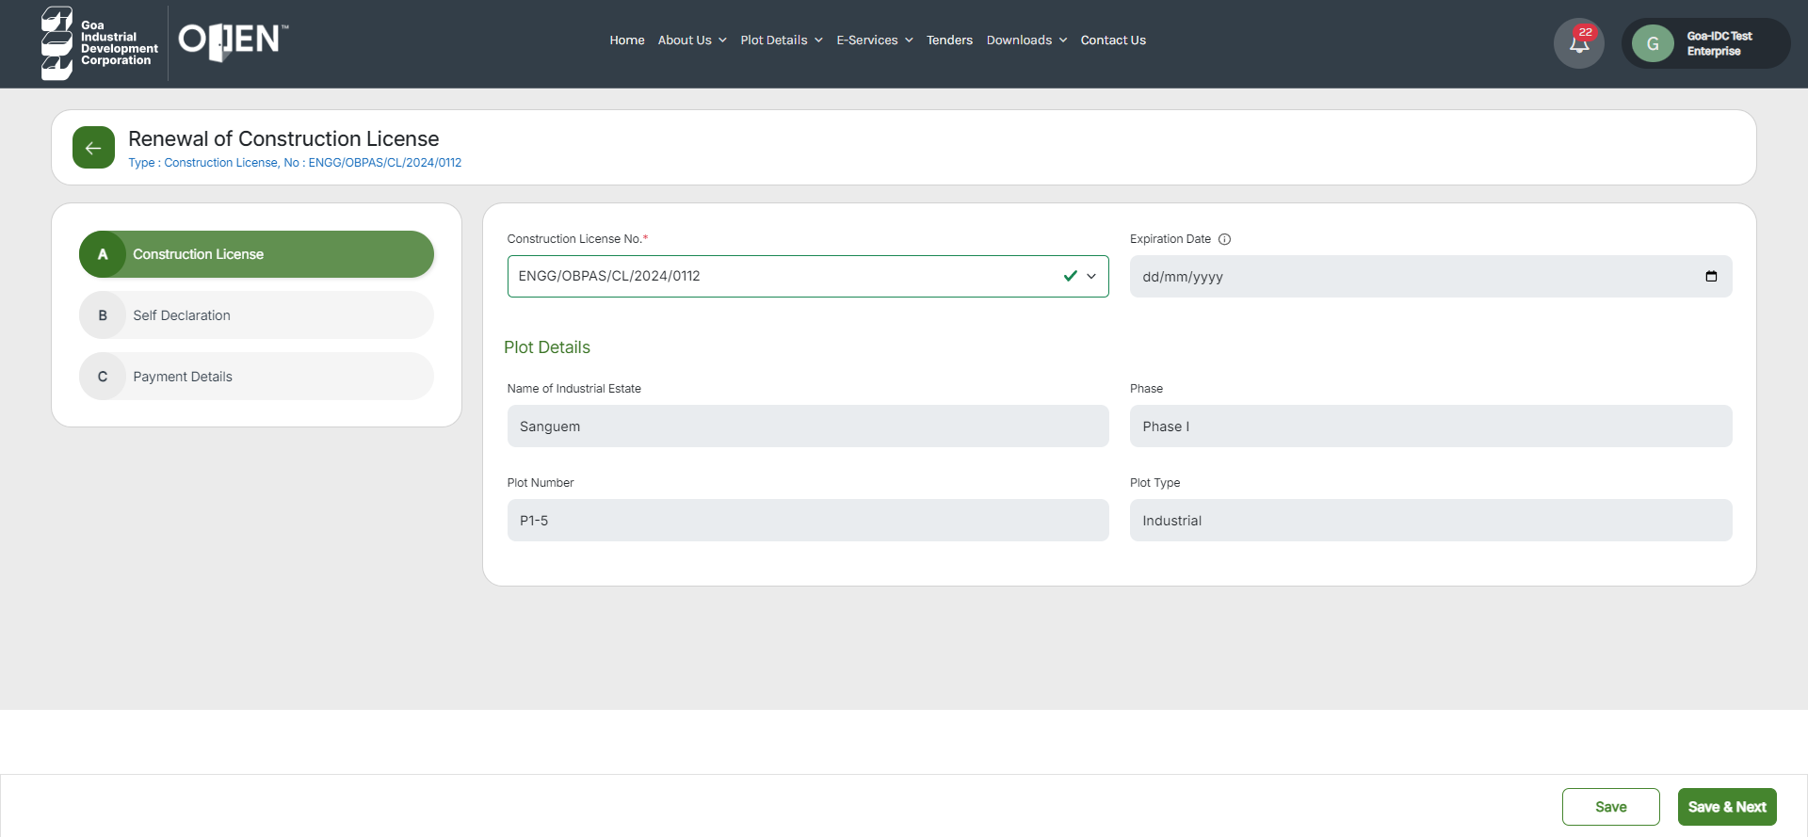

**#10.**  Renewal of Construction License should show as disable unless expiration CL in six months of time

**#11.**  Self-Declaration text to be changed in the Renewal of Construction as mentioned below,

(i) The information provided above and in the enclosed documents is true and correct to the best of my knowledge and belief and nothing material has been concealed herein.

(ii) It has not taken any steps to take advantage of any bankruptcy or insolvency law or otherwise is not a party to any bankruptcy, insolvency or liquidation proceedings.

(iii) The renewal of the aforementioned construction license shall be subject to all rules and regulations applicable to the original building plan. In the event of non-compliance with these requirements, the construction license shall be deemed null and void.