Day 10 - 18th June 2025

Employee ID: 201933938

Login ID: iamasif

Name: Shaik Asif

| Advance concepts | Collections Framework intro, Streams, File I/O, Multithreading overview |
| --- | --- |
| Trobuleshooting | Debugging Tools, Error Messages and Stack Traces, Breakpoints and Code Stepping, Logging for Debugging, Common Bug Patterns, Debugging Strategies, Hands-on Debugging Practice |

Multi Threading:

Task 1:

### **What is a Thread?**

A thread is the smallest unit of execution inside a process.

* It shares memory and resources with other threads in the same process.
* It runs a part of the code concurrently with other threads.

Example: In a music app:

* One thread plays music
* Another downloads lyrics
* Another responds to user touches

Task 2:

Understand the below code and run it to see the output.. Need to explain…

8 min 10.42 to 10.50

class RunnableDemo implements Runnable {

private Thread t;

private String threadName;

RunnableDemo( String name){

threadName = name;

System.out.println("Creating " + threadName );

}

public void run() {

System.out.println("Running " + threadName );

try {

for(int i = 4; i > 0; i--) {

System.out.println("Thread: " + threadName + ", " + i);

// Let the thread sleep for a while.

Thread.sleep(50);

}

} catch (InterruptedException e) {

System.out.println("Thread " + threadName + " interrupted.");

}

System.out.println("Thread " + threadName + " exiting.");

}

public void start ()

{

System.out.println("Starting " + threadName );

if (t == null)

{

t = new Thread (this, threadName);

t.start ();

}

}

}

public class TestThread {

public static void main(String args[]) {

RunnableDemo R1 = new RunnableDemo( "Thread-1");

R1.start();

RunnableDemo R2 = new RunnableDemo( "Thread-2");

R2.start();

}

}

**Understood**

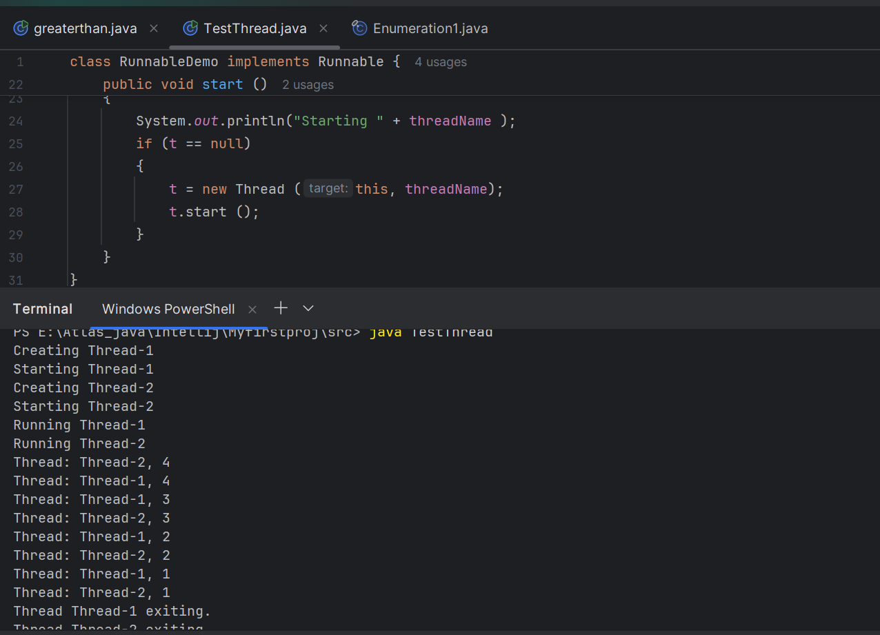

Task 3

👍

In the above code … try extending Thread class… and observe the output..

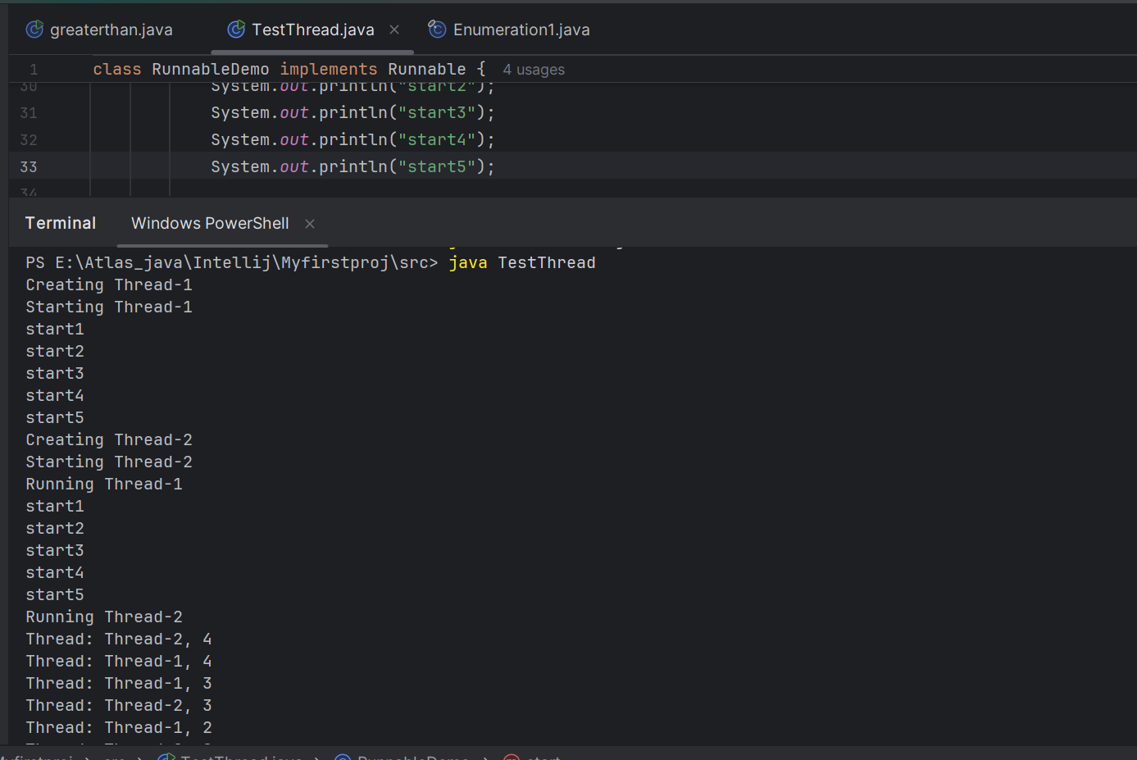

11.16 11.18

Understand:

ex:

Public Class1 extends Thread{ }

Or

4public Class1 extends Class2 implements Runnable ( )

Task 4:

class Counter {

private int count = 0;

public void increment() {

count++;

}

public int getCount() {

return count;

}

}

class ThreadDemo extends Thread {

Counter counter;

ThreadDemo(Counter counter) {

this.counter = counter;

}

public void run() {

for (int i = 0; i < 10; i++) {

counter.increment();

}

}

}

public class Main {

public static void main(String[] args) {

Counter counter = new Counter();

ThreadDemo t1 = new ThreadDemo(counter);

ThreadDemo t2 = new ThreadDemo(counter);

t1.start();

t2.start();

try {

t1.join();

t2.join();

} catch (InterruptedException e) {

e.printStackTrace();

}

System.out.println("Final count: " + counter.getCount());

}

}

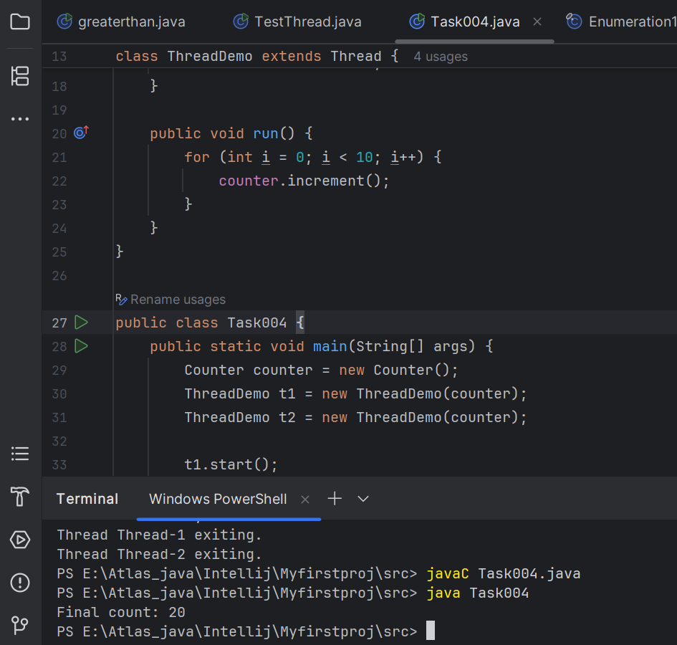

Task 5:

Use synchronized method:

11.54 to 11.59 5 min

Hint:

1. Synchronized Method:  
Synchronize the entire method to ensure only one thread can execute it at a time.

class Counter {  
 private int count = 0;  
  
 public synchronized void increment() {  
 count++;  
 }  
  
 public int getCount() {  
 return count;  
 }  
}

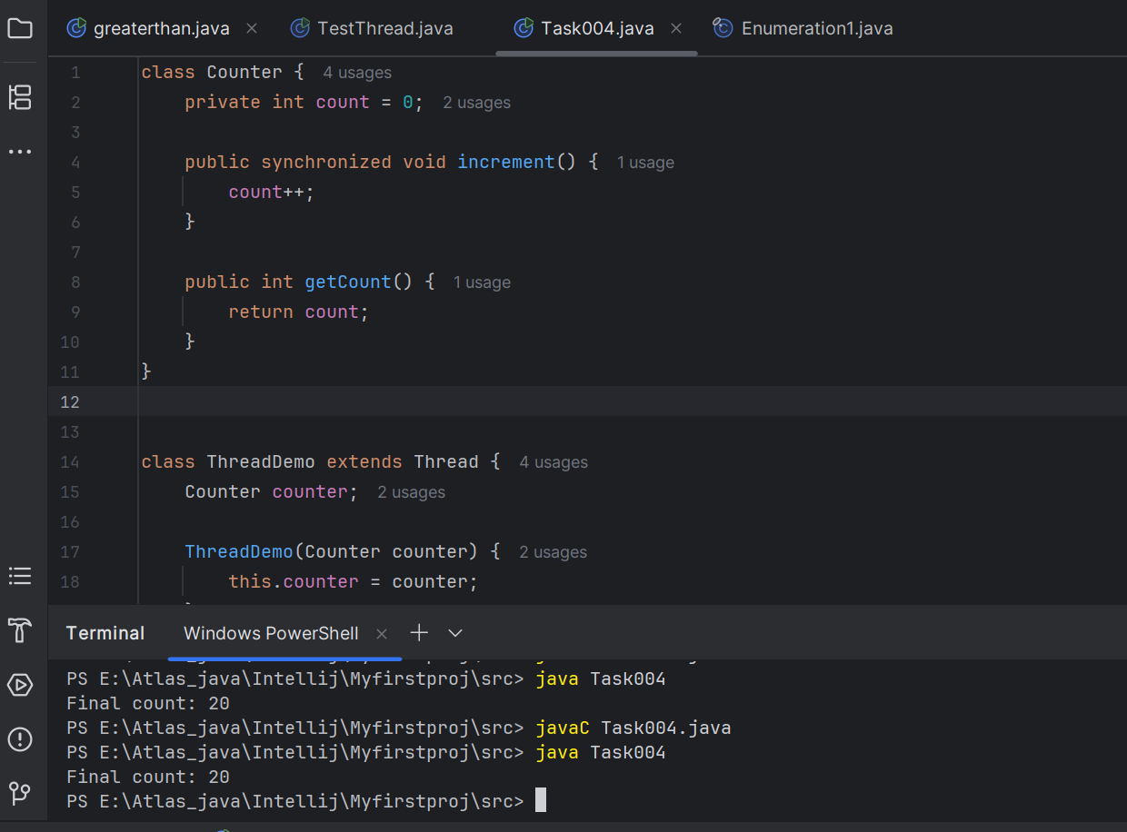

Task 6:

Using Sync Block

12.00 to 12.05

Hint:

2. Synchronized Block:  
Synchronize a block of code instead of the entire method, providing more control and efficiency.

class Counter {  
 private int count = 0;  
  
 public void increment() {  
 synchronized (this) {  
 count++;  
 }  
 }  
  
 public int getCount() {  
 return count;  
 }  
}

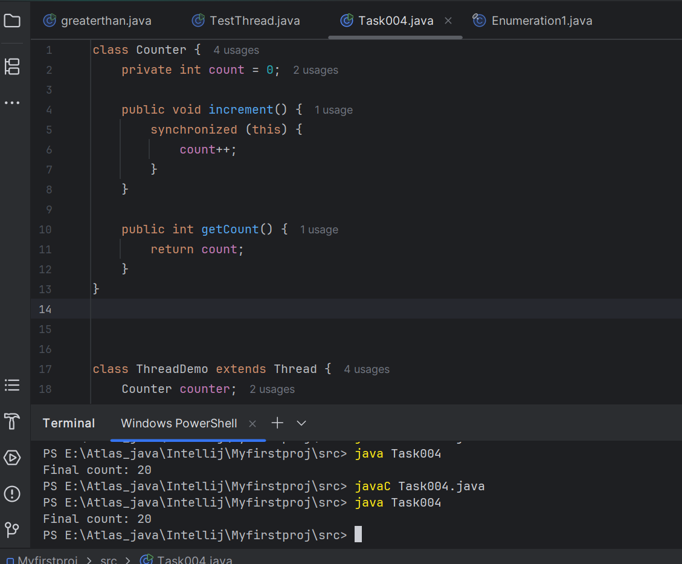

Task 7:

Using Static Sync

12.06 to 12.10

Hint:

3. Static Synchronization:  
Synchronize static methods to ensure only one thread can execute them for the class, not the instance.

class Counter {  
 private static int count = 0;  
  
 public static synchronized void increment() {  
 count++;  
 }  
  
 public static int getCount() {  
 return count;  
 }  
}

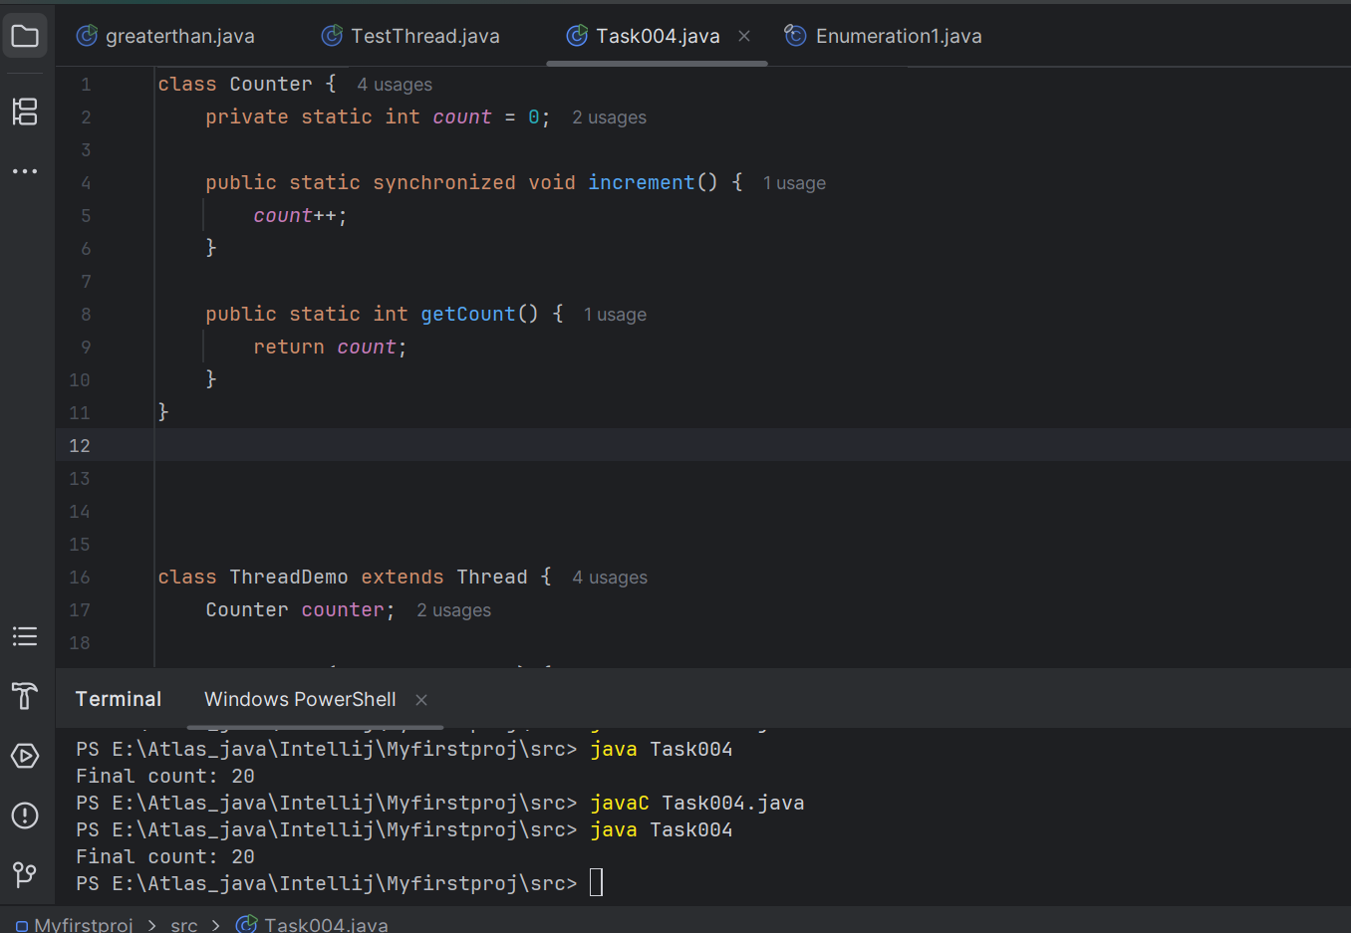

Task 8:

Using Locks

12.11 to 12.15

Hint:

4. Locks:  
Use `java.util.concurrent.locks.Lock` for more sophisticated thread synchronization.

import java.util.concurrent.locks.Lock;  
import java.util.concurrent.locks.ReentrantLock;  
  
class Counter {  
 private int count = 0;  
 private final Lock lock = new ReentrantLock();  
  
 public void increment() {  
 lock.lock();  
 try {  
 count++;  
 } finally {  
 lock.unlock();  
 }  
 }  
  
 public int getCount() {  
 return count;  
 }  
}

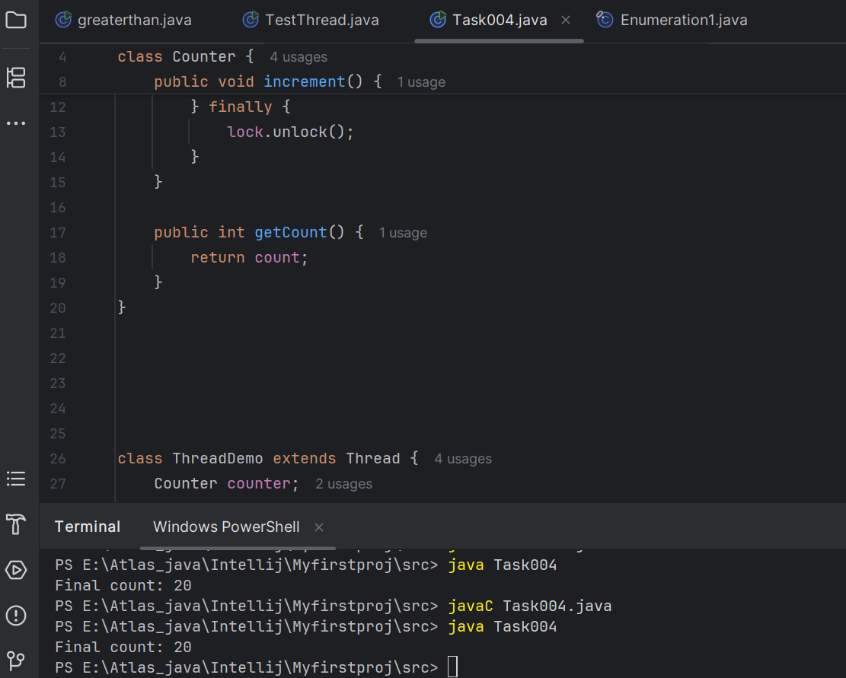

Task 9:

12.42 to 12.55 Sync Topic Rating will be done…

Task 10:

Dead Lock 👍

**Example of Deadlock**

class Resource {  
 synchronized void method1(Resource r) {  
 System.out.println(Thread.currentThread().getName() + " is executing method1");  
 try { Thread.sleep(100); } catch (InterruptedException e) {}  
 r.method2(this);  
 }  
  
 synchronized void method2(Resource r) {  
 System.out.println(Thread.currentThread().getName() + " is executing method2");  
 try { Thread.sleep(100); } catch (InterruptedException e) {}  
 r.method1(this);  
 }  
}  
public class DeadlockExample {  
 public static void main(String[] args) {  
 final Resource r1 = new Resource();  
 final Resource r2 = new Resource();  
  
 Thread t1 = new Thread(() -> r1.method1(r2), "Thread-1");  
 Thread t2 = new Thread(() -> r2.method1(r1), "Thread-2");  
  
 t1.start();  
 t2.start();  
 }  
}

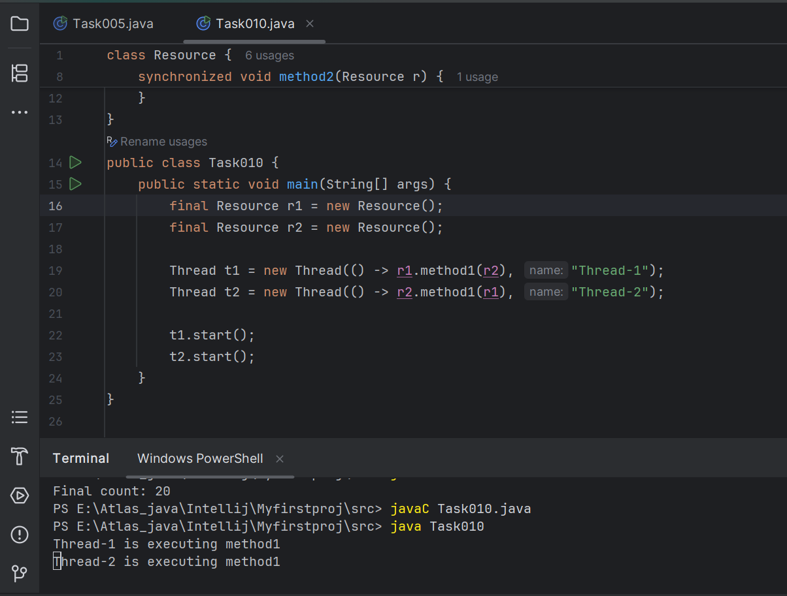

Task 11:

Inter- thread communication…

Example of Inter-thread Communication

class SharedResource {  
 private boolean ready = false;  
  
 synchronized void produce() {  
 try {  
 while (ready) {  
 wait();  
 }  
 System.out.println("Producing...");  
 ready = true;  
 notify();  
 } catch (InterruptedException e) {  
 e.printStackTrace();  
 }  
 }  
  
 synchronized void consume() {  
 try {  
 while (!ready) {  
 wait();  
 }  
 System.out.println("Consuming...");  
 ready = false;  
 notify();  
 } catch (InterruptedException e) {  
 e.printStackTrace();  
 }  
 }  
}  
  
public class InterThreadCommunicationExample {  
 public static void main(String[] args) {  
 SharedResource resource = new SharedResource();  
  
 Thread producer = new Thread(resource::produce);  
 Thread consumer = new Thread(resource::consume);  
  
 producer.start();  
 consumer.start();  
 }  
}

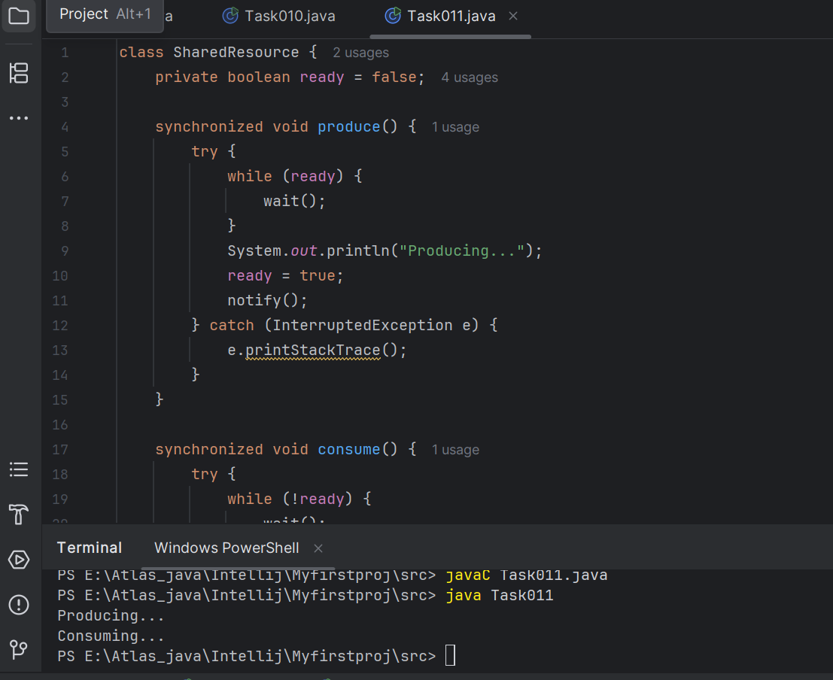

Task 12:

Interrupting a thread

**Example of Interrupting a Thread**

class InterruptibleThread extends Thread {  
 public void run() {  
 try {  
 while (!Thread.currentThread().isInterrupted()) {  
 System.out.println("Thread is running");  
 Thread.sleep(100);  
 }  
 } catch (InterruptedException e) {  
 System.out.println("Thread was interrupted");  
 }  
 }  
}  
  
public class InterruptExample {  
 public static void main(String[] args) {  
 InterruptibleThread thread = new InterruptibleThread();  
 thread.start();  
  
 try {  
 Thread.sleep(500);  
 thread.interrupt();  
 } catch (InterruptedException e) {  
 e.printStackTrace();  
 }  
 }  
}

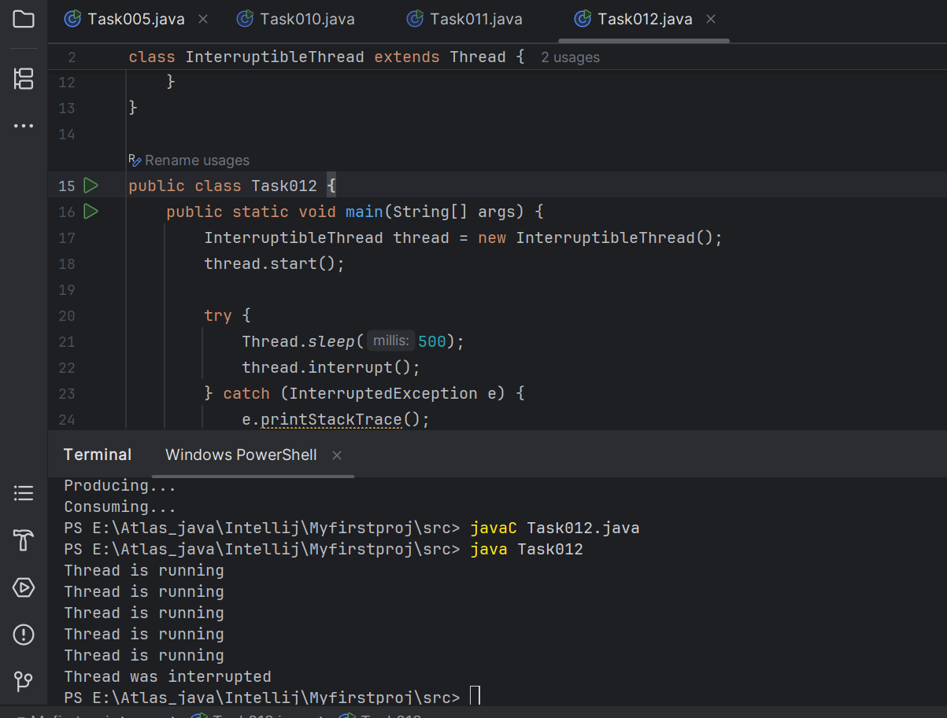

Task 13

Rating qn regarding Synchronisation…

2.31 to 3.05

Task 14::

What is Thread pool?..

A thread pool is like a group of worker threads that are already created and ready to do tasks.

Instead of creating a new thread every time you need to do something, you reuse threads from the pool.  
 This saves time and memory because creating and destroying threads repeatedly is slow and expensive.

- 5 min

Task 15:

Run the below code and see the file with the given name created or not..

Run it again with I like India instead of I love India.. And see the file …

public class WriteByte

{

public static void main(String args[])

{

File f1=new File(“FileName01.txt”); \\ to create new file FileOutputStream outfile = null;

byte Text[] = {'I',’ ‘,’'L','O','V','E',’ ‘,'I','N','D','I’,’A'};

try

{

outfile = new FileOutputStream(f1);

outfile.write(Text);

}

catch(IOException e)

{

System.out.println(e);

System.exit(-1);

}

System.out.println("Write Byte");

System.out.println("Thank You...!!!");

}

}

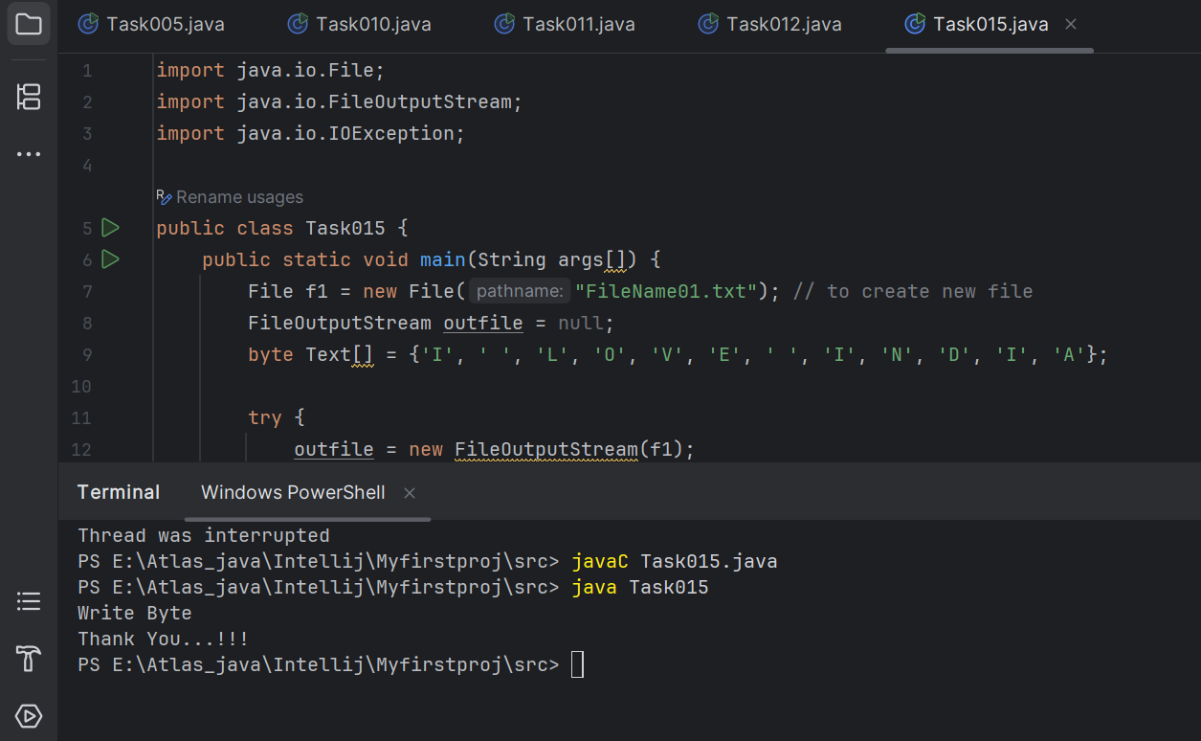

Task 16:

Try this code to see the output …

**Write a program which reads byte from file.**

import java.io.*;

public class ReadingByte

{

public static void main(String args[])

{

FileInputStream infile = null;

int b;

try

{

infile = new FileInputStream("FileName01.txt");

while((b = infile.read()) != -1)

{

System.out.println((char)b);

}

infile.close();

}

catch(IOException e)

{

System.out.println("Sorry..!! File Not Found...!!!");

}

}

}

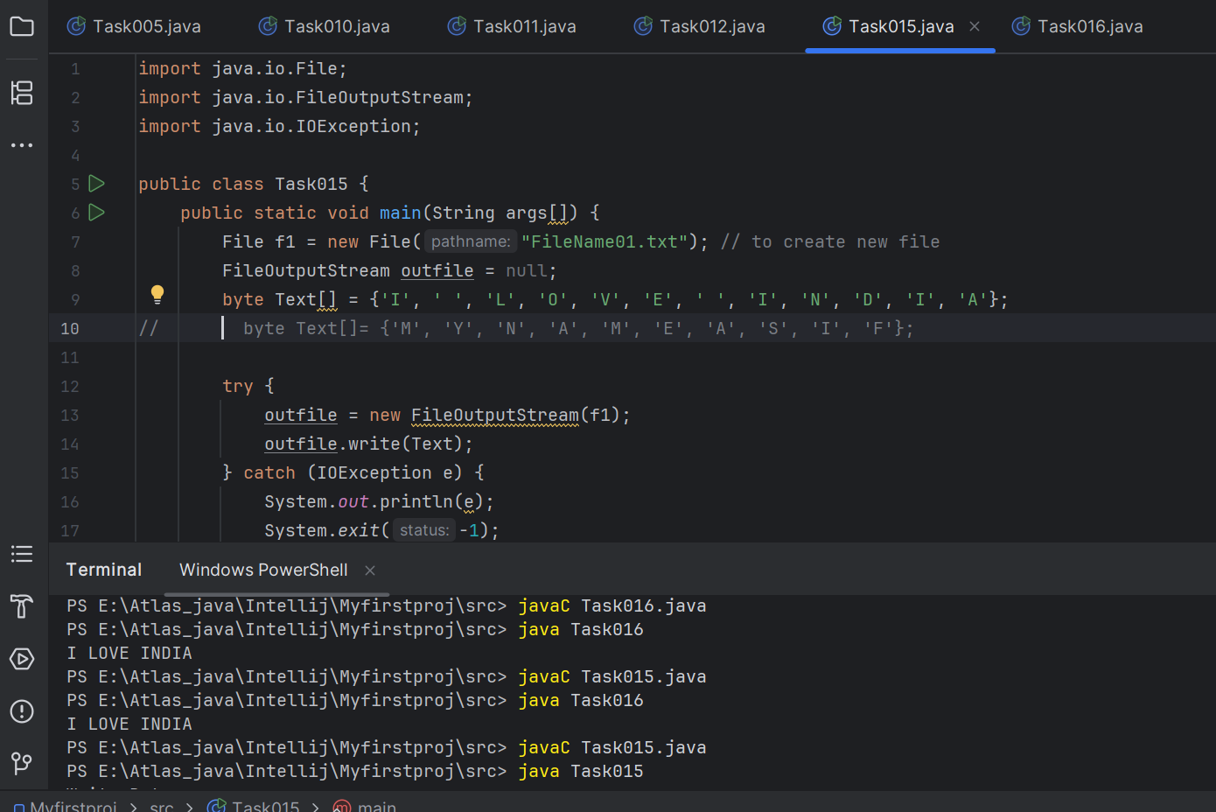

Task 17:

import java.io.*;

import java.util.*;

public class WriteByte_1

{

public static void main(String args[]) {

FileOutputStream outfile = null;

//String s=args[0]; // to input string from command line Scanner sc=new Scanner(System.in);

String s=sc.nextLine();

byte b1[] = s.getBytes();

try

{

outfile = new FileOutputStream("in.txt");

outfile.write(b1);

}

catch(IOException e)

{

System.out.println(e);

System.exit(-1);

}

System.out.println("Write Byte");

System.out.println("Thank You...!!!");

}

}

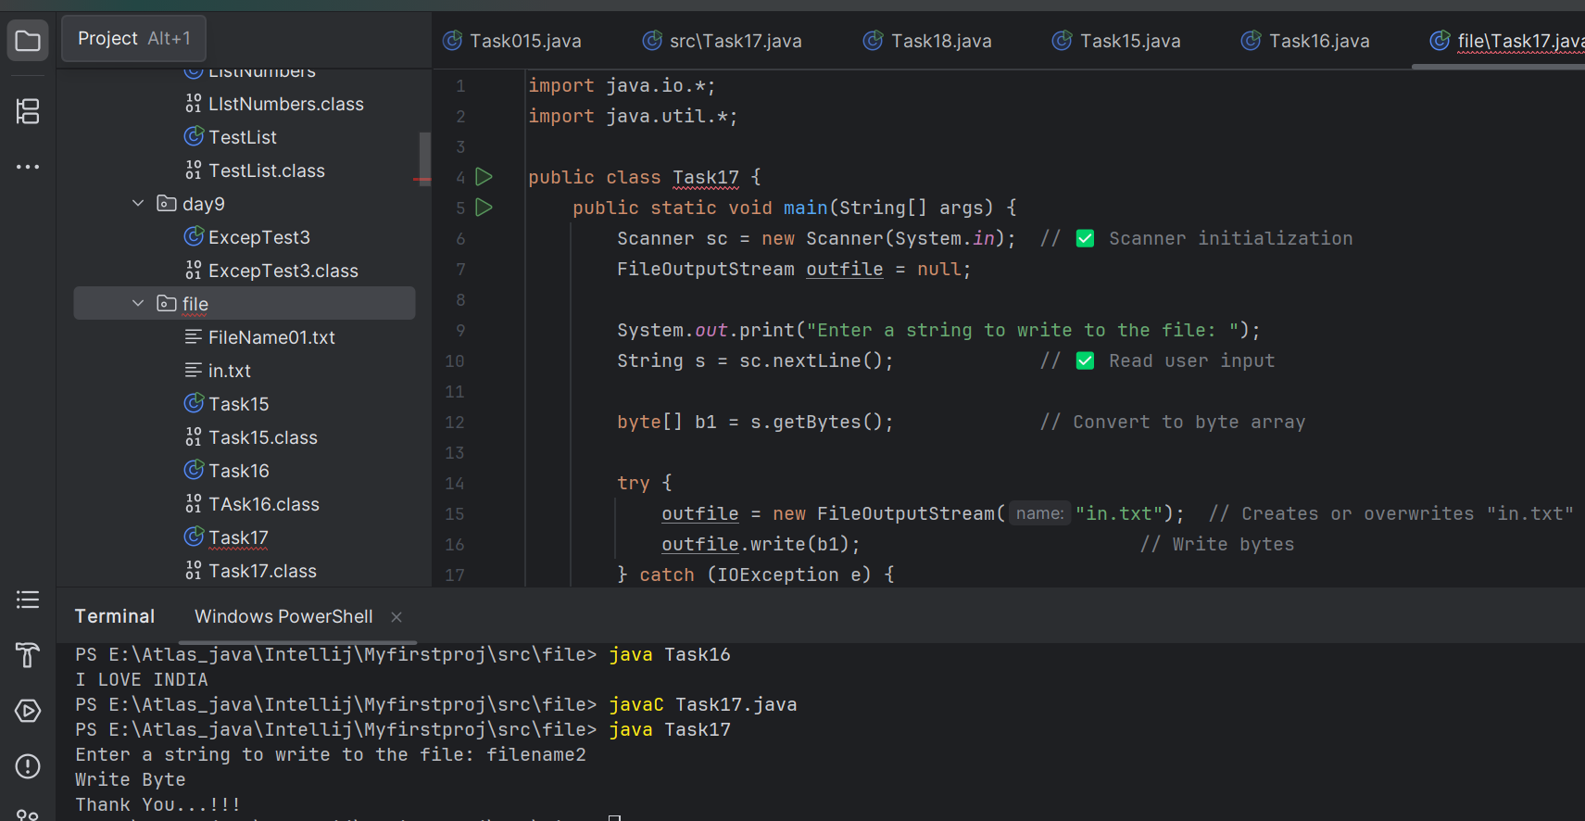

=========================================

**Reading/writing characters**

=========================================

**FileReader**and **FileWriter**

**Task 18:**

**Write a program which creates file and writes character into that file.**

import java.io.*;

Class CharacterWrite

{

public static void main(String args[])

{

File f1=new File("FileName03.txt");

FileWriterfw = null;

try

{

fw=new FileWriter(f1);

fw.write("ahmedabad \n");

fw.write(" baroda \n");

fw.close();

}

catch(FileNotFoundException e)

{

System.out.println("Sorry..!! File Not Found...!!!");

}

catch(IOException e)

{

System.out.println(e.getMessage());

}

System.out.println(“ write operation done!!”);

}

}

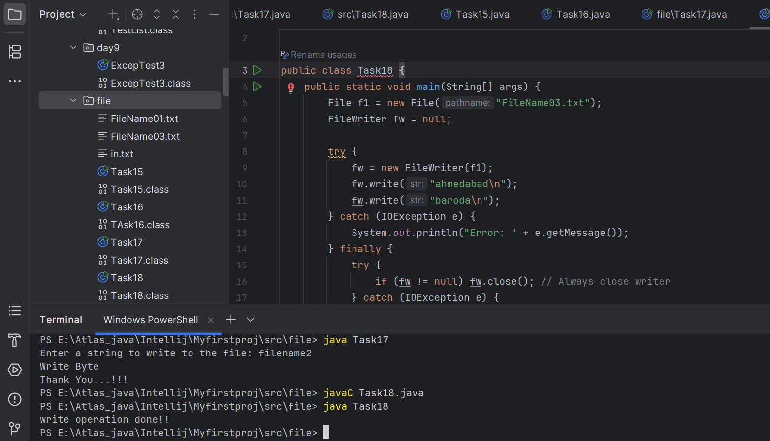

Task 19

**Write a program which reads character from file.**

import java.io.*;

Class Readchar

{

public static void main(String args[])

{

FileReader fr =null;

try

{

fr = new FileReader("FileName03.txt");

int ch;

while((ch = fr.read()) != -1)

{

System.out.print((char)ch);

}

System.out.println("Reading complete");

fr.close();

}

catch(FileNotFoundException e)

{

System.out.println("Sorry..!! File Not Found...!!!");

}

catch(IOException e)

{

System.out.println(e.getMessage());

}

}

}

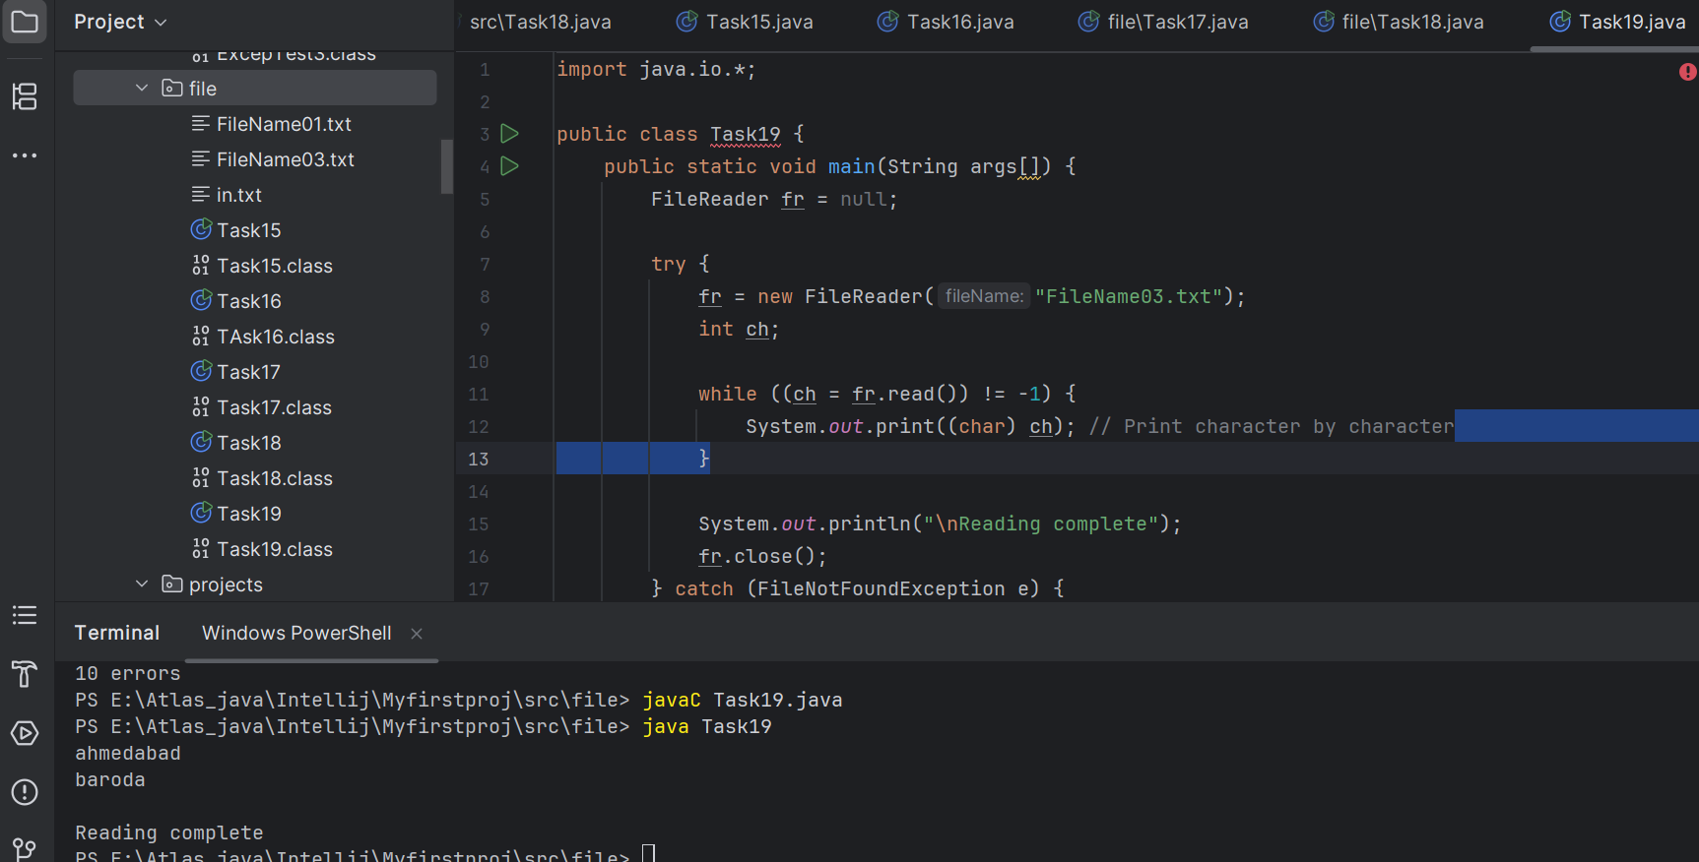

Task 20

**Write a program to read one byte at a time from a file and copy it into another file immediately**.

import java.io.*;

classCopyByte

{

public static void main(String args[])

{

try

{

byte b=0;

FileInputStream infile = new FileInputStream("NewFile01.txt");

FileOutputStreamoutfile = new FileOutputStream("NewFile05.txt");

while(byteread != -1)

{

b = (byte)infile.read();

outfile.write(b);

}

System.out.println("Byte Copied From in.txt to out.txt FIle ");

}

catch(FileNotFoundException e)

{

System.out.println("Sorry..!! File Not Found...!!!");

}

catch(IOException e)

{

System.out.println(e.getMessage());

}

}

}

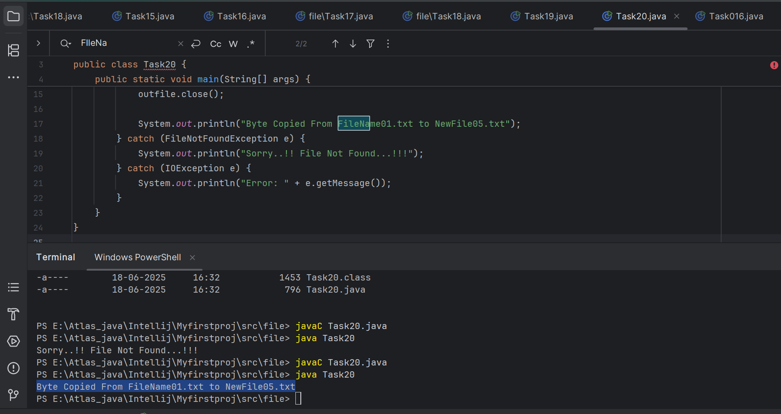

Task 21:

Merging two files to 3rd file..

**Write a program to merge two files in third file.**

import java.io.*;

classFileMergeDemo

{

public static void main(String args[])

{

try

{

FileInputStream file1 = new FileInputStream("File1.txt"); FileInputStream file2 = new FileInputStream("File2.txt"); SequenceInputStream file3 = new SequenceInputStream(file1, file2); BufferedInputStream br1 = new BufferedInputStream(file3); BufferedOutputStream br2 = new BufferedOutputStream(System.out); intch;

while((ch = br1.read())!=-1)

{

br2.write((char)ch);

}

br1.close();

br2.close();

file1.close();

file2.close();

System.out.println("Merge Two File Sucessfully ");

}

catch(IOException e)

{

System.out.println("Sorry..!! File Not Found...!!!");

}

}

}

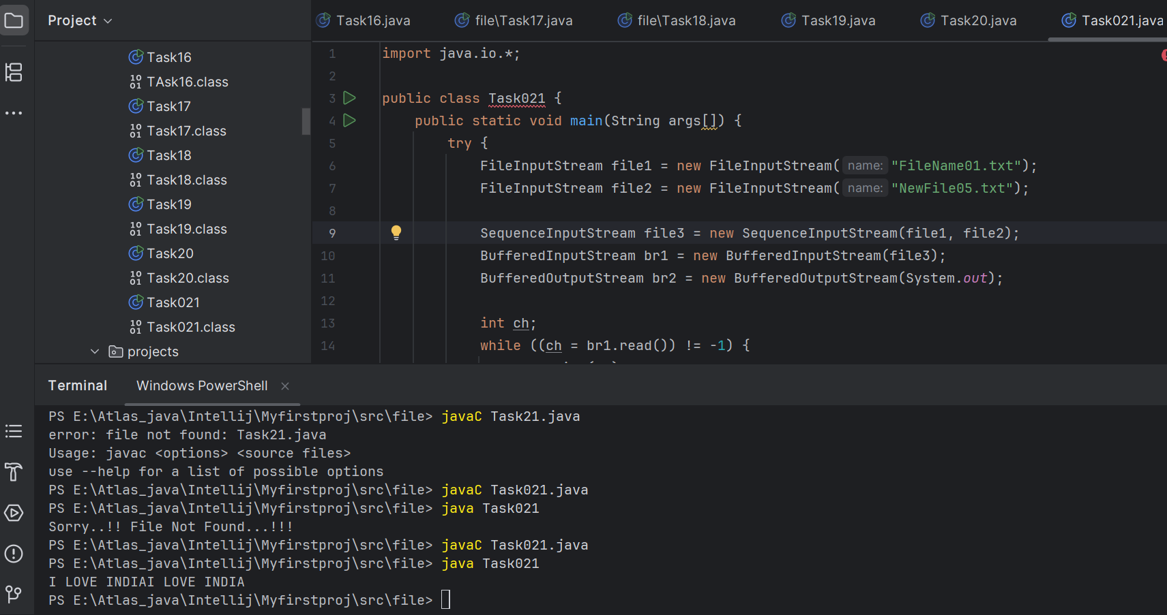

Task 22:

**Write an application to rename a file. Use the renameTo() method of File to accomplish**

/*this task. The first command line argument is the old filename and the second is the newfilename.

*/

import java.io.*;

classFileRenameDemo

{

public static void main(String args[])

{

File f1 = new File(args[0]);

File f2 = new File(args[1]);

f1.renameTo(f2);

System.out.println("Rename File " +f1+" To "+f2+" Sucessfully "); }

}

Output :

javacFileRenameDemo.java

javaFileRenameDemo input1.txt abc.txt

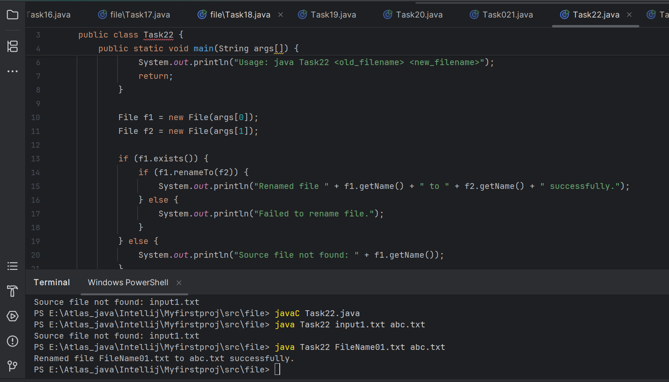

Task 23 👍

==================================================

Buffered reader and writer — for large files to be read.

==================================================

import java.io.BufferedReader;

import java.io.FileReader;

import java.io.IOException;

public class ReadFileExample {

public static void main(String[] args) {

try (BufferedReader br = new BufferedReader(new FileReader("largefile.txt"))) {

String line;

while ((line = br.readLine()) != null) {

System.out.println(line);

}

} catch (IOException e) {

e.printStackTrace();

}

}

}

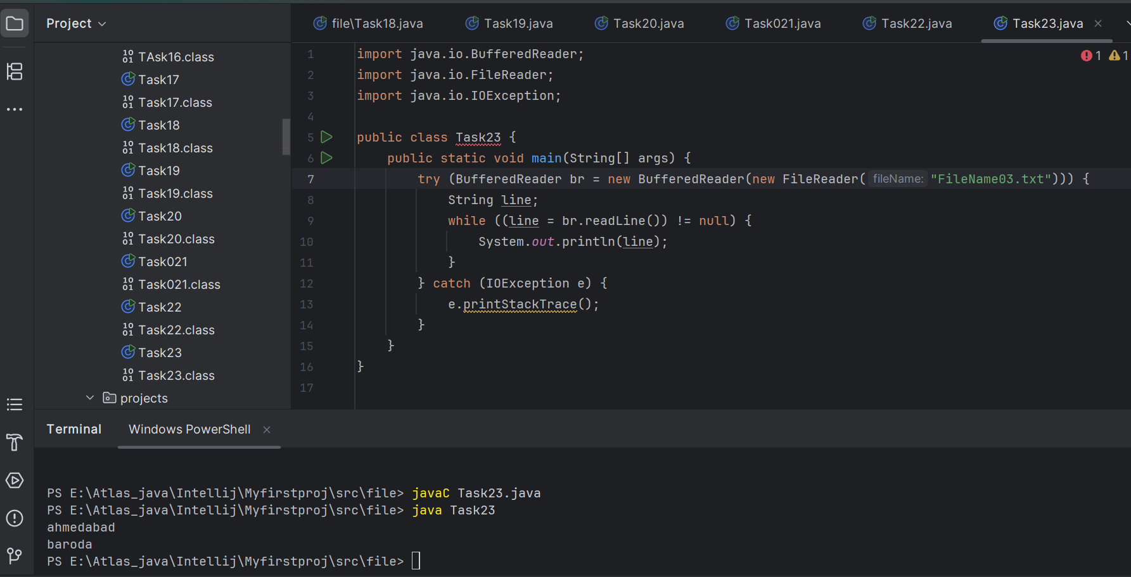

Task 24 non buffered

import java.io.FileReader;

import java.io.IOException;

public class NonBufferedReaderExample {

public static void main(String[] args) {

try (FileReader fr = new FileReader("largefile.txt")) {

int ch;

while ((ch = fr.read()) != -1) {

System.out.print((char) ch);

}

} catch (IOException e) {

e.printStackTrace();

}

}

}

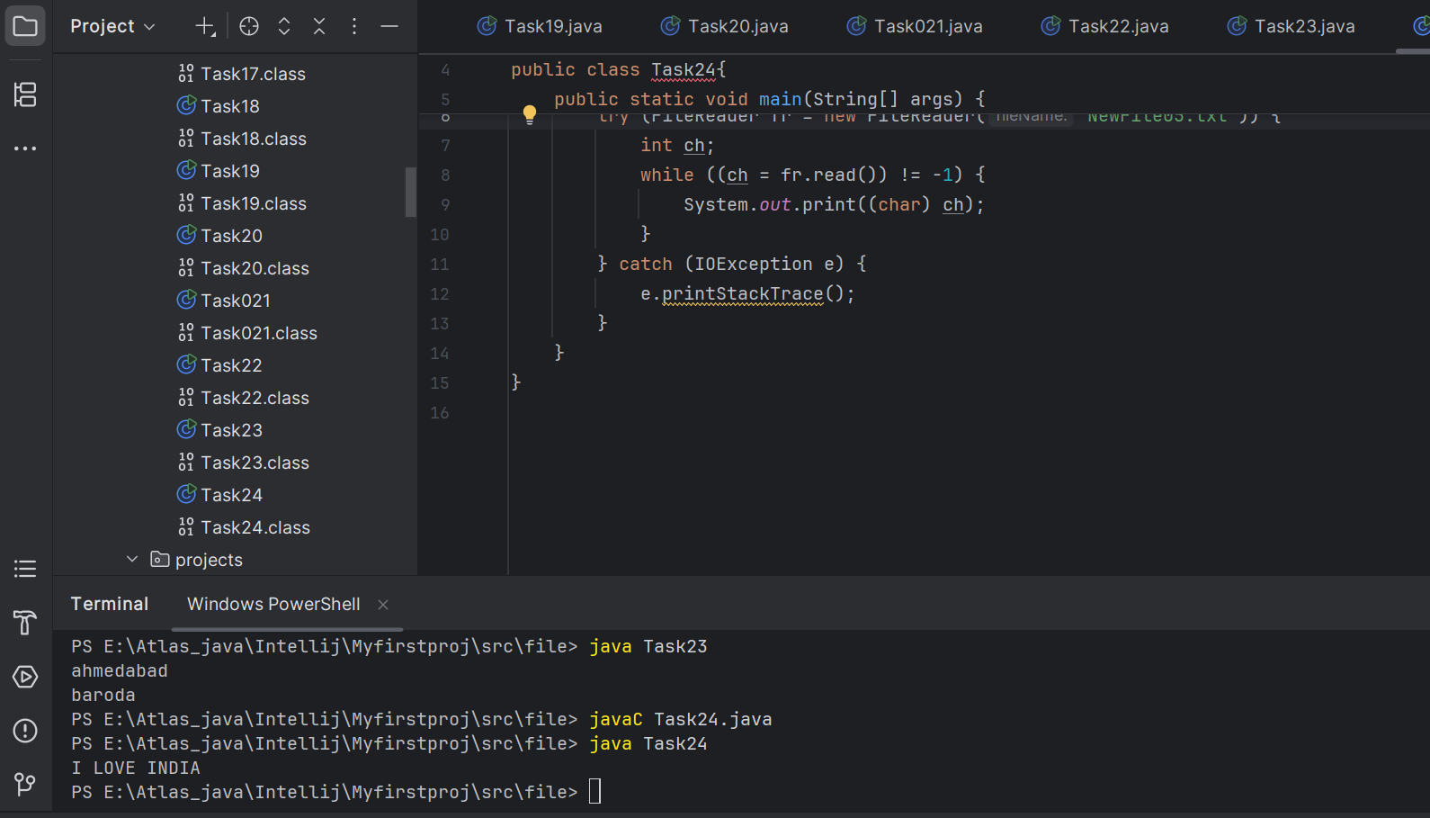

Task 25:

Buffered

import java.io.BufferedReader;

import java.io.FileReader;

import java.io.IOException;

public class BufferedReaderExample {

public static void main(String[] args) {

try (BufferedReader br = new BufferedReader(new FileReader("largefile.txt"))) {

String line;

while ((line = br.readLine()) != null) {

System.out.println(line);

}

} catch (IOException e) {

e.printStackTrace();

}

}

}

