Day 27

Employee ID: 201933938

Login ID: iamasif

Name: Shaik Asif

MVC Frame work

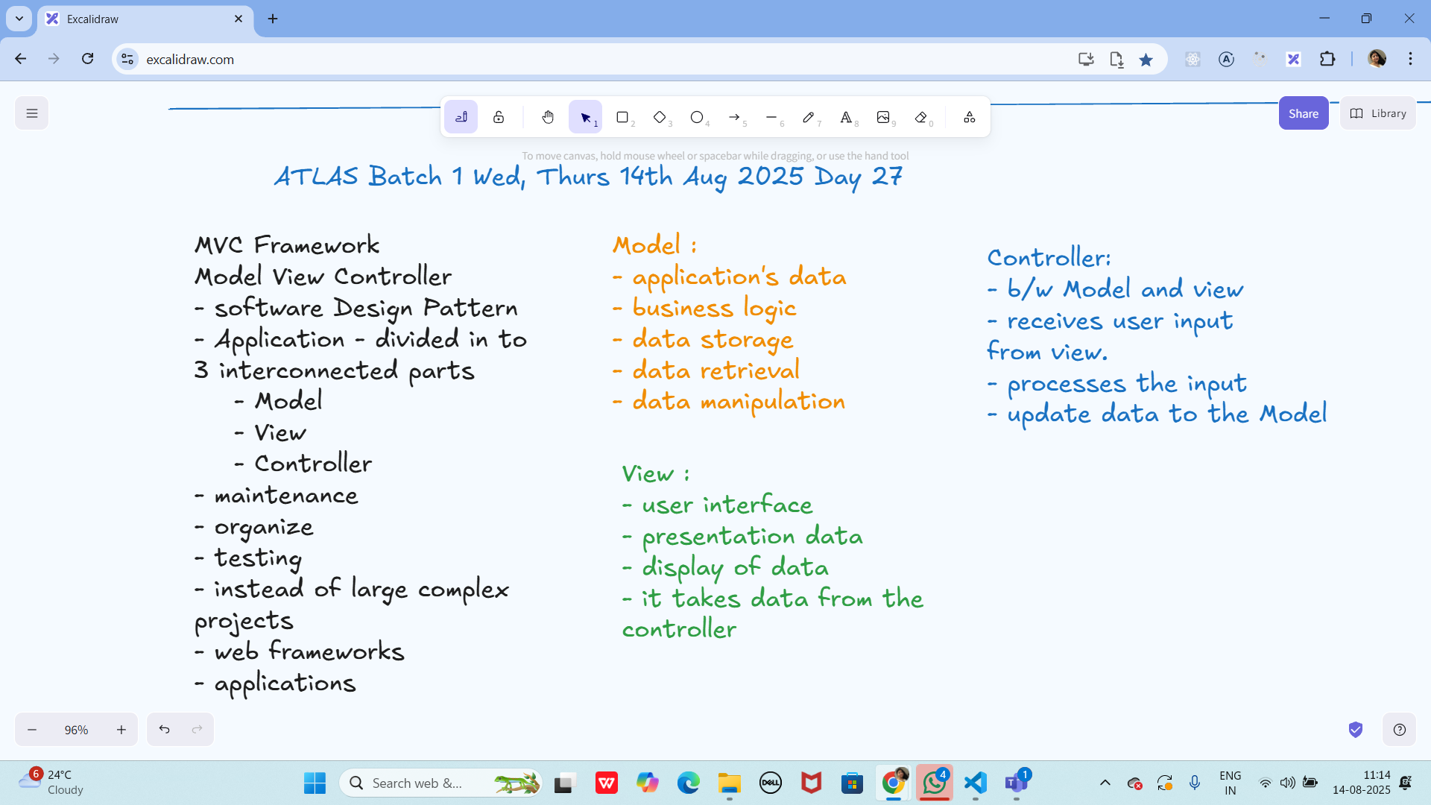

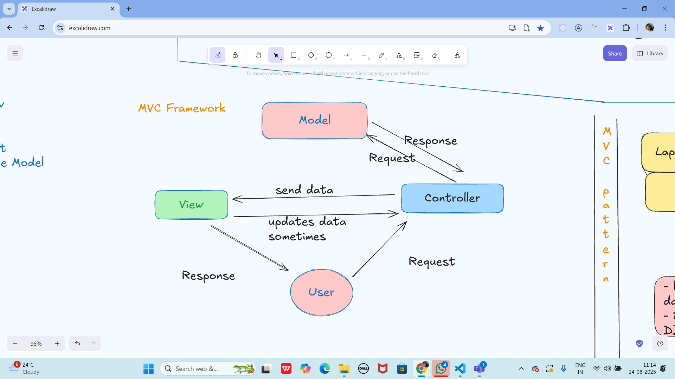

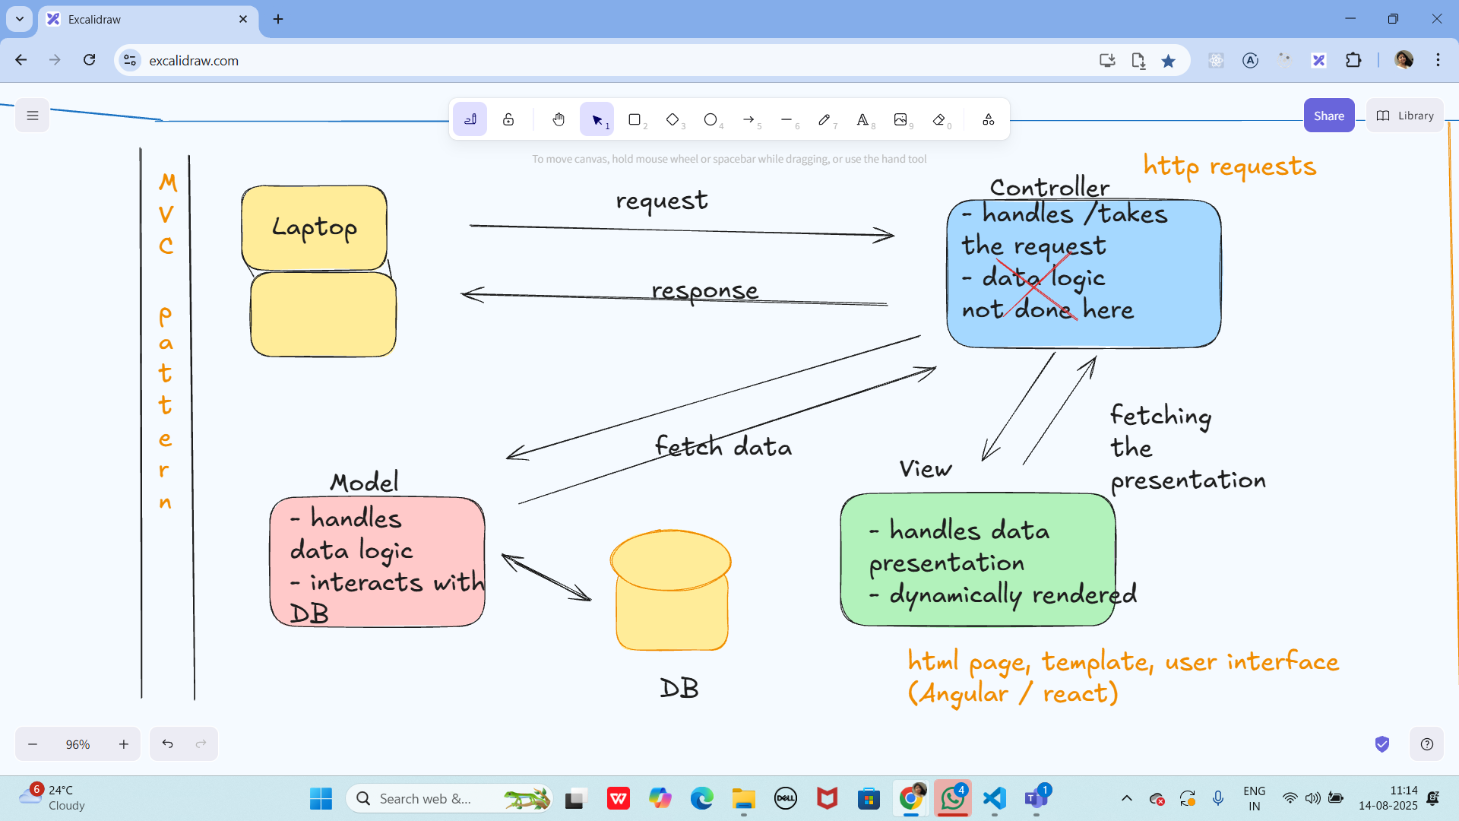

Large Scale Systems - architectural Patterns

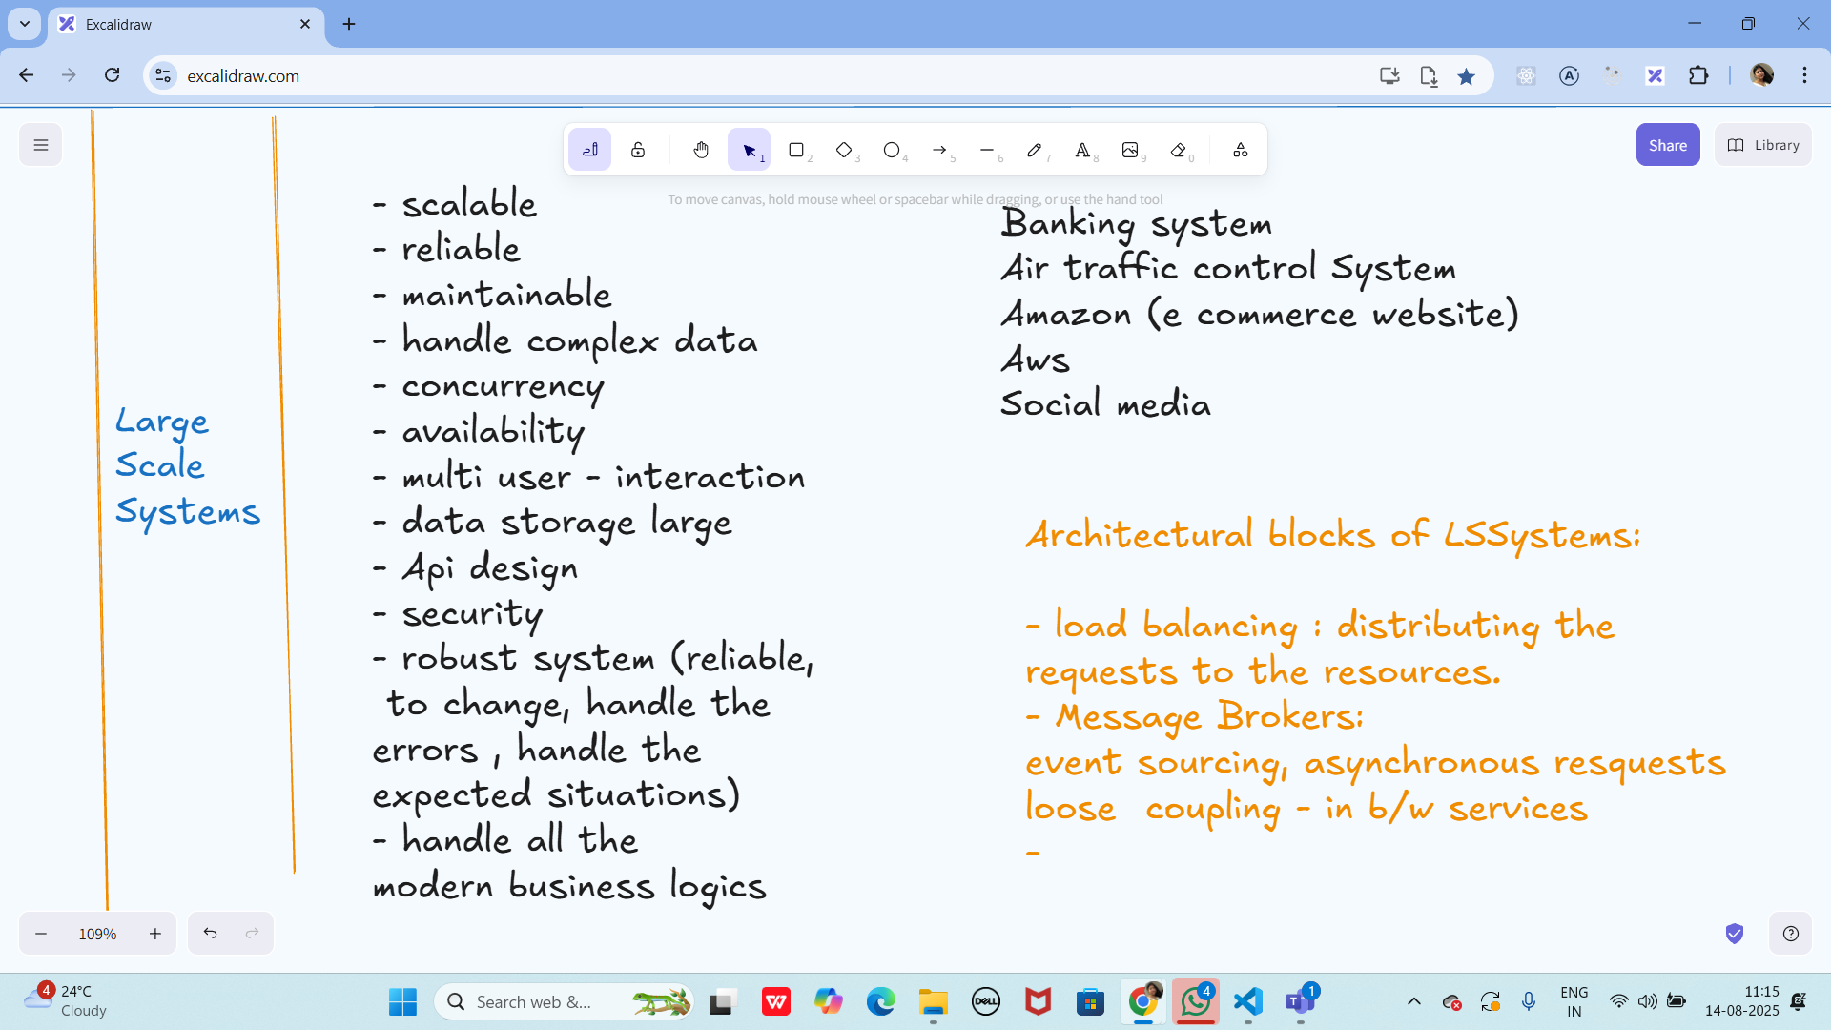

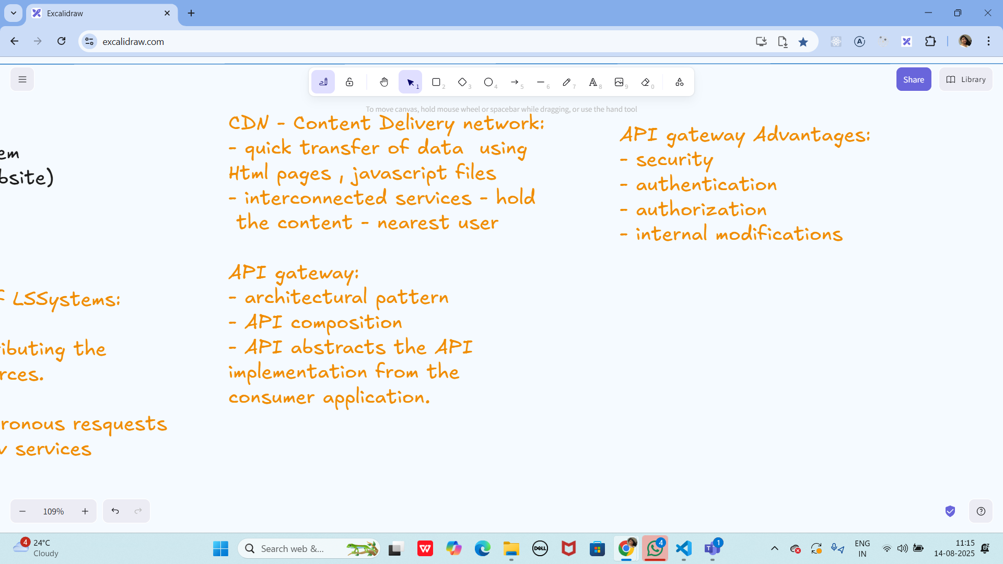

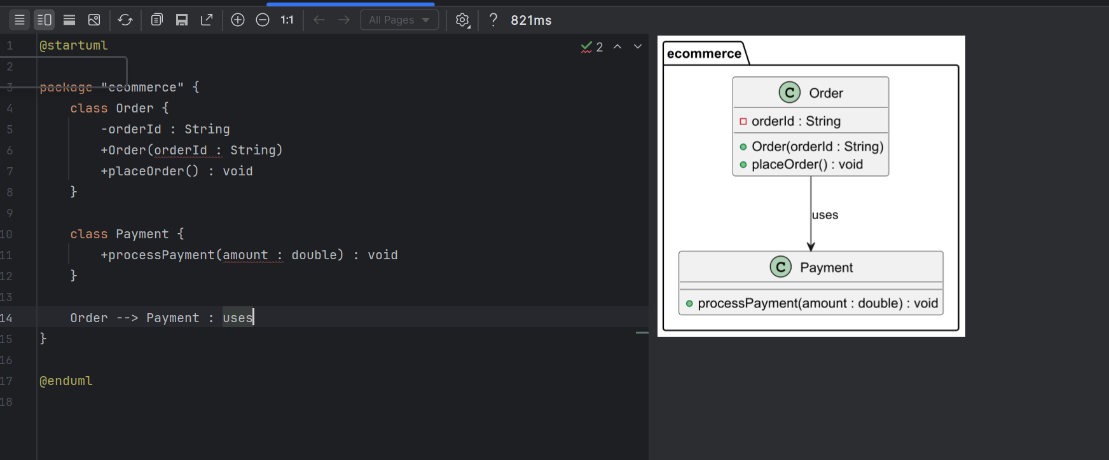

—-----------------------------------------------------------------------------------------------------------------------

Practice MCQ s

1. **In which of the following mechanisms, types of all variables and expressions are fixed at compilation time.**

a) Strong Typing

b) Weak Typing

c) Static Binding/ early binding

d) Dynamic Binding/ late binding

1. **In which of the following mechanisms, types of all variables and expressions are not known until runtime**
2. a) Strong Typing
3. b) Weak Typing
4. c) Static Binding/ early binding
5. d) Dynamic Binding/ late binding

3**. Which of the following statements about Persistence is correct?**

a) It is the enforcement of the class of an object, such that objects of different types may not be interchanged, or at the most they may be interchanged only in very restricted ways.

b) It is the property of an object through which its existence transcends time and/or space.

c) It is the property that distinguishes an active object from one that is not active.

d) All of the mentioned

4. What is that concept in type theory in which a single name may denote objects of many different classes that are related by some common super class referred to ______

a) Monomorphism

b) Type Checking

c) Polymorphism

d) Generalization

5. **Which of the following patterns is used to create a single instance of a class and provide a global point of access to it?**

a) Factory Pattern

b) Singleton Pattern

c) Builder Pattern

d) Prototype Pattern

6. **The Adapter pattern is a type of ______ pattern.**

a) Creational

b) Structural

c) Behavioral

d) Concurrency

1. W**hich design pattern defines a one-to-many dependency between objects so that when one object changes state, all its dependents are notified and updated automatically?**

a) Strategy Pattern

b) Command Pattern

c) Observer Pattern

d) Mediator Pattern

1. I**n which pattern does a class represent the functionality of another class, providing a simplified interface to a complex subsystem?**

a) Decorator Pattern

b) Facade Pattern

c) Proxy Pattern

d) Composite Pattern

1. **The Model-View-Controller (MVC) is an example of a ______ pattern.**

a) Creational

b) Structural

c) Behavioral

d) Architectural

**************************************************************************************************************************************************************************************************************************

Info Box:

Excalidraw updated -at 11.07

<https://excalidraw.com/#json=fqwLzw3QE7x9aLtxlzmvS,cEorQuehkSjH_5lL4douBw>

Excalidraw updated at 12:25

<https://excalidraw.com/#json=QjhoEmt3ur-5az9z1psth,yPhzeyA0EFh3fAnkWHtIjA>