Day 30

Employee ID: 201933938

Login ID: iamasif

Name: Shaik Asif

Architecture

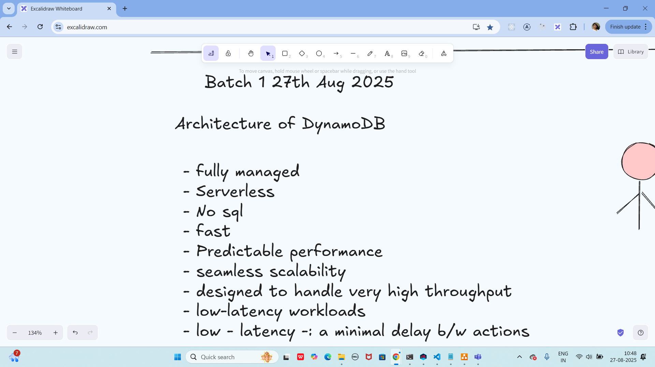

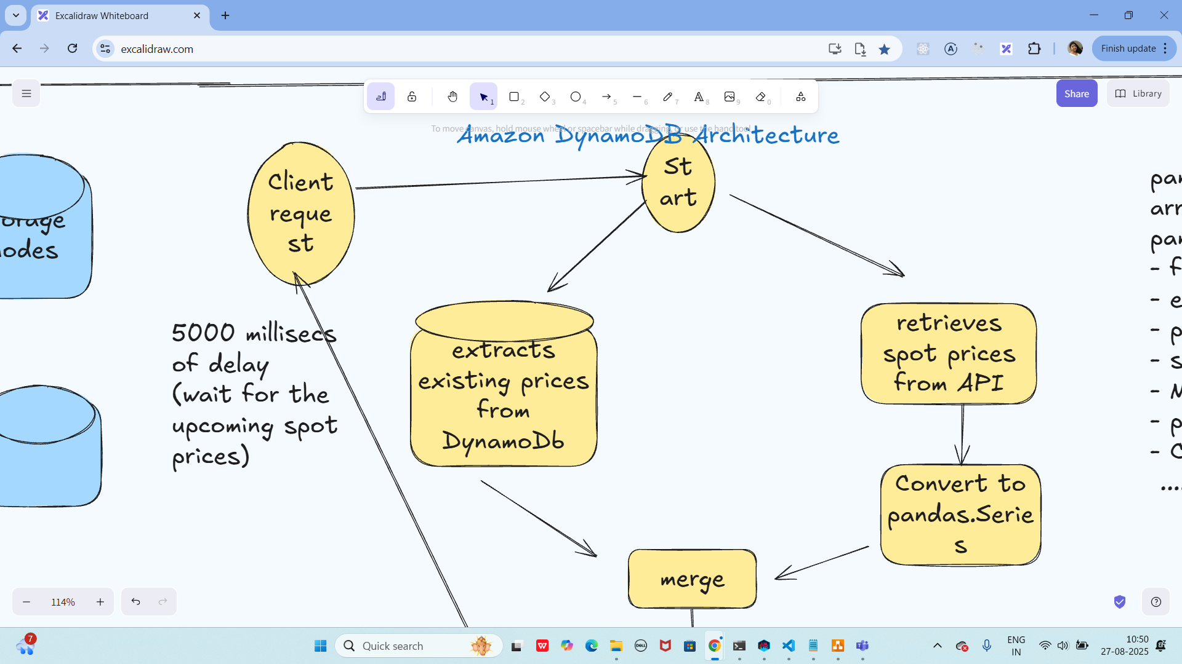

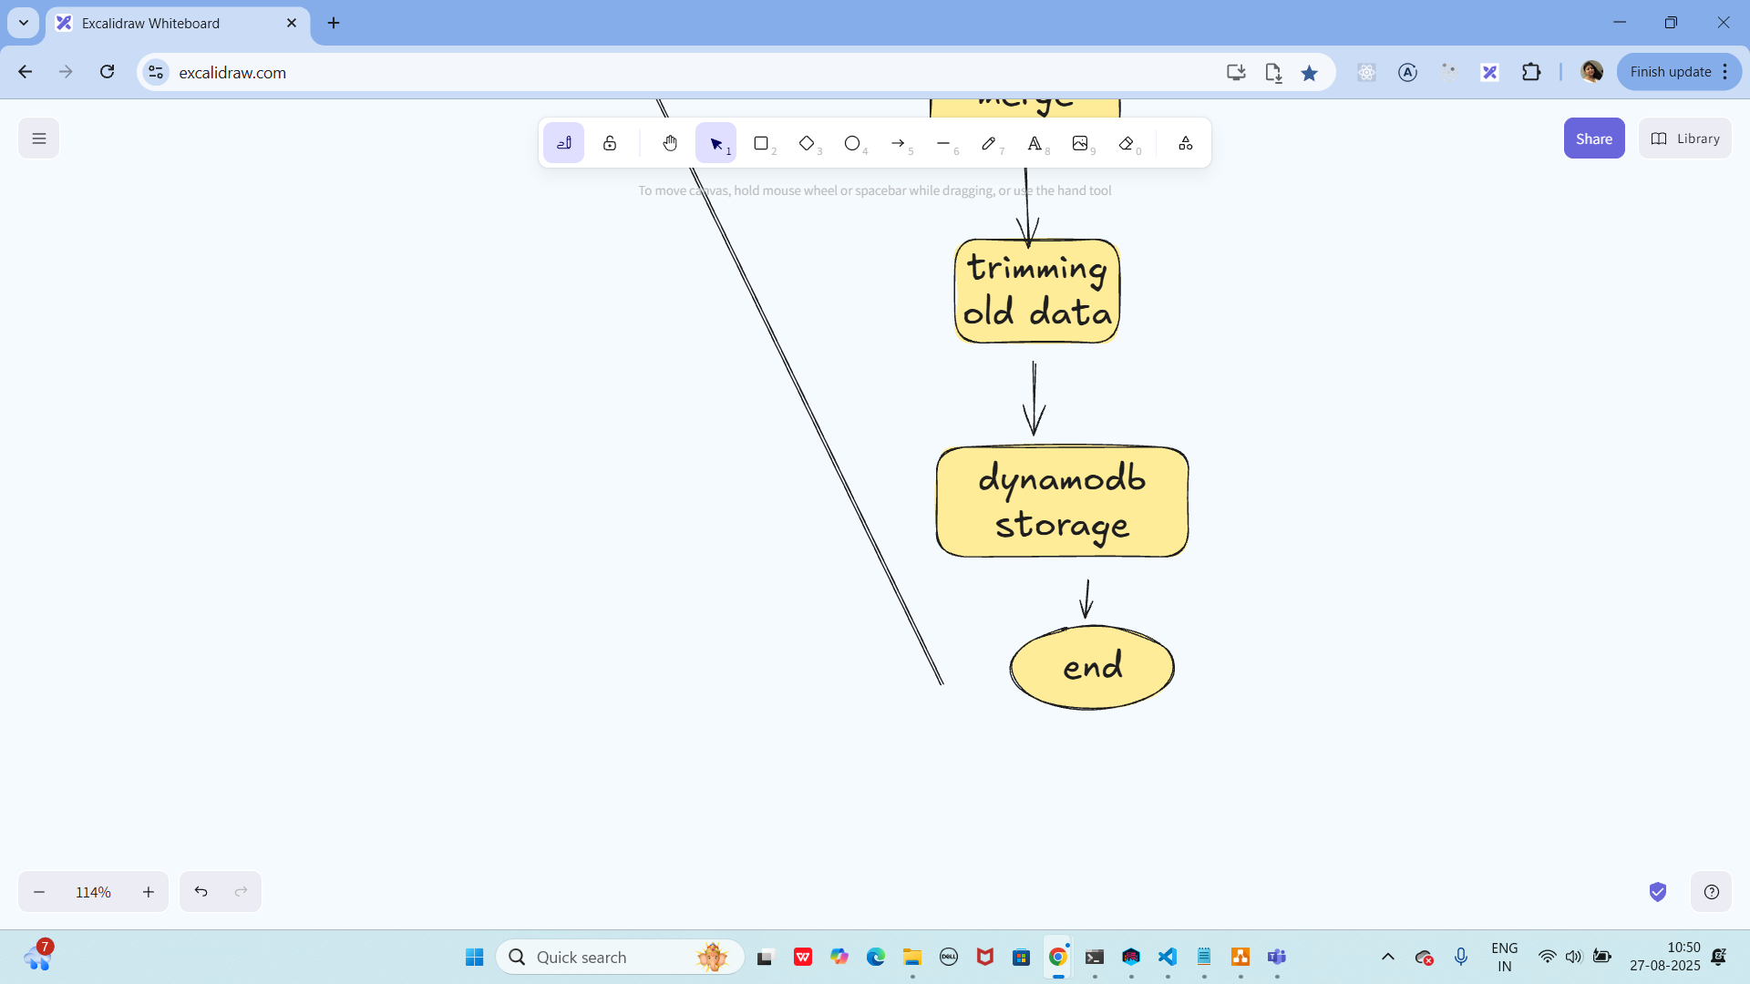

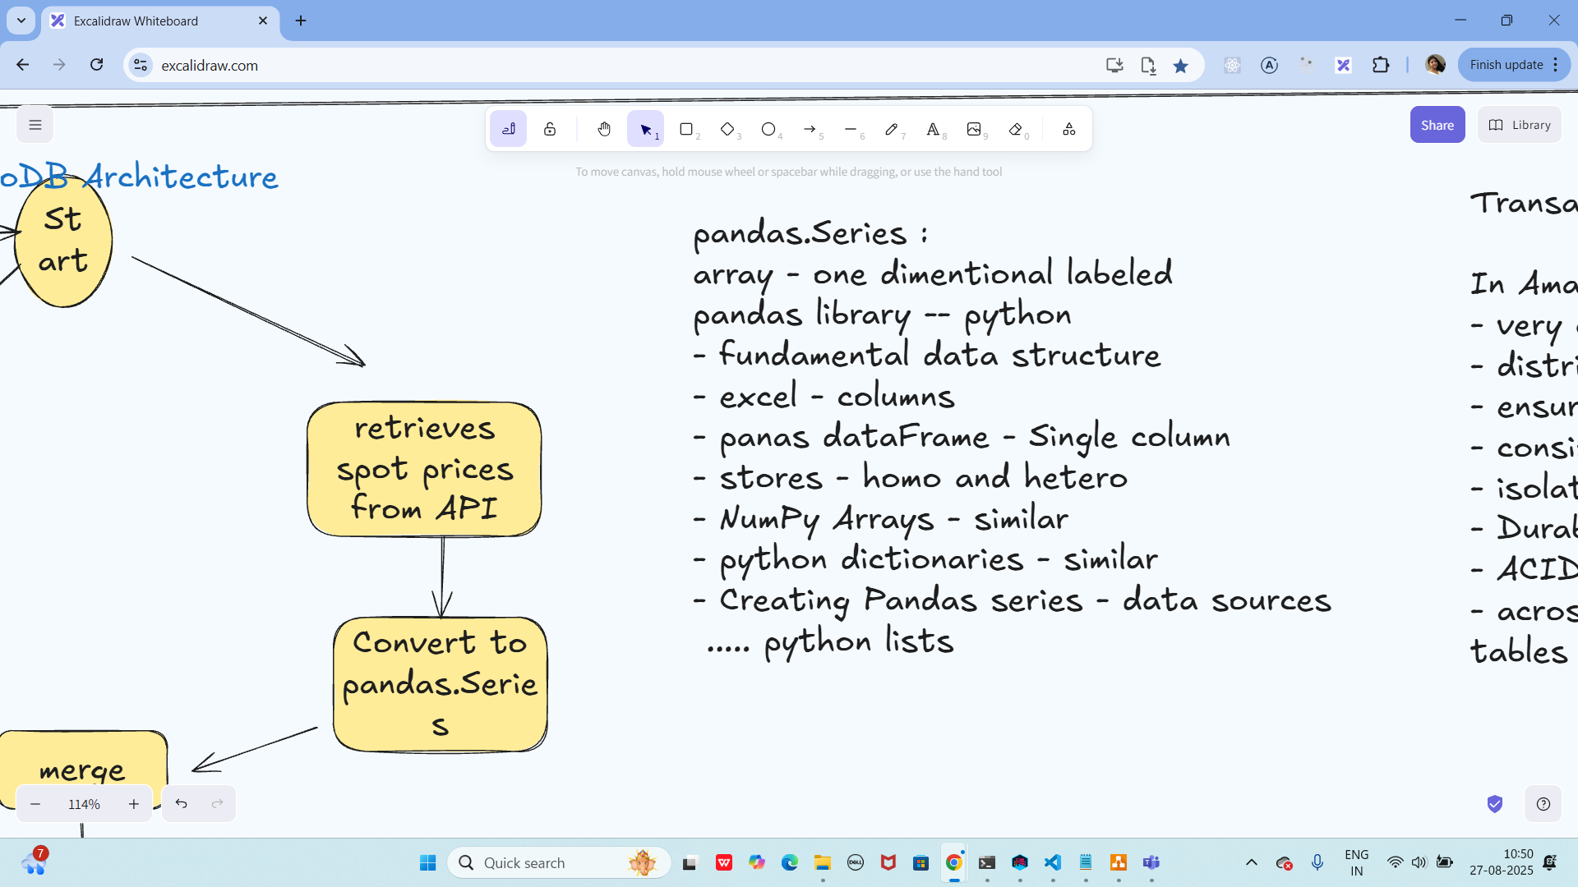

1.45 to 2.45 lunch:

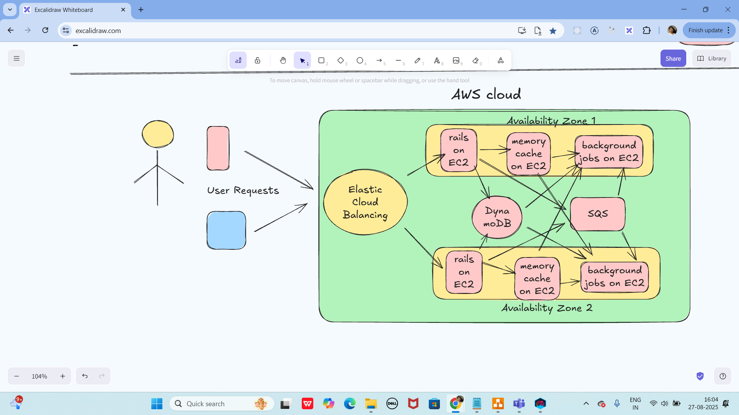

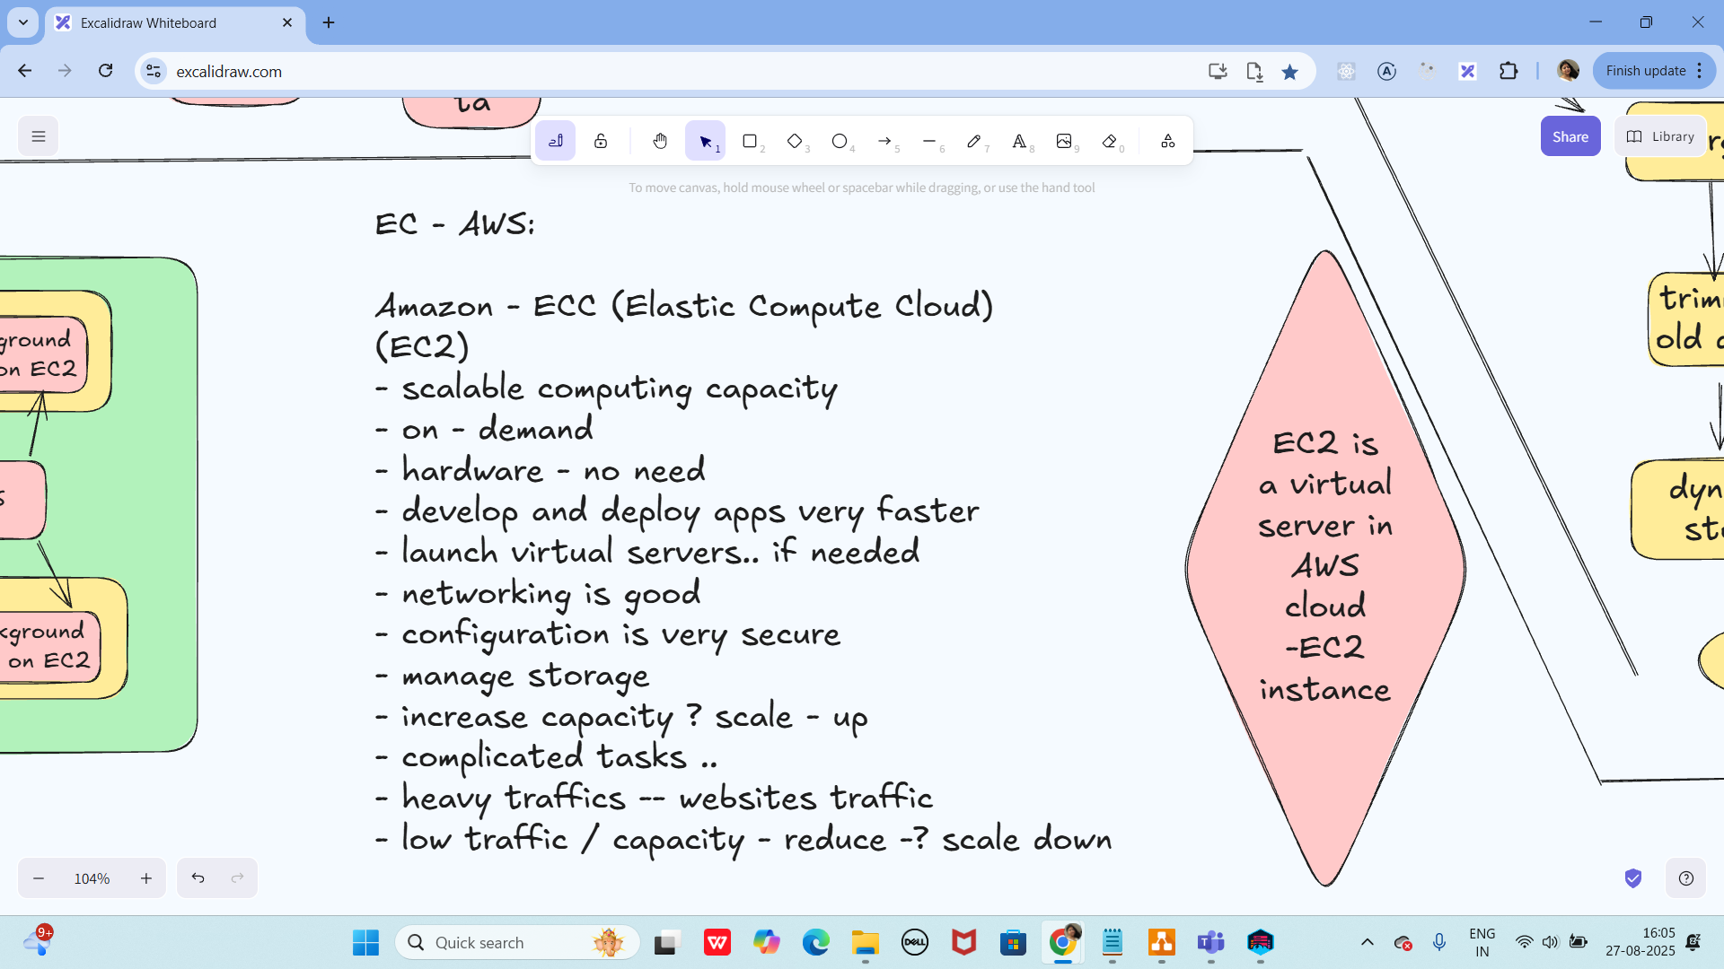

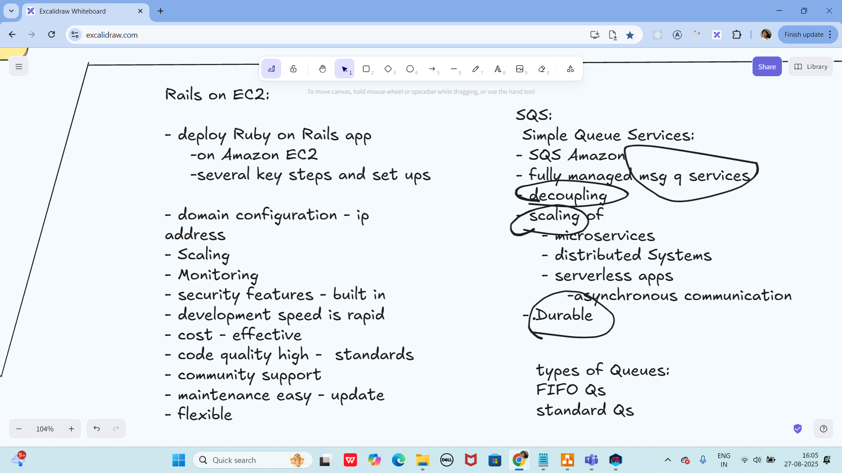

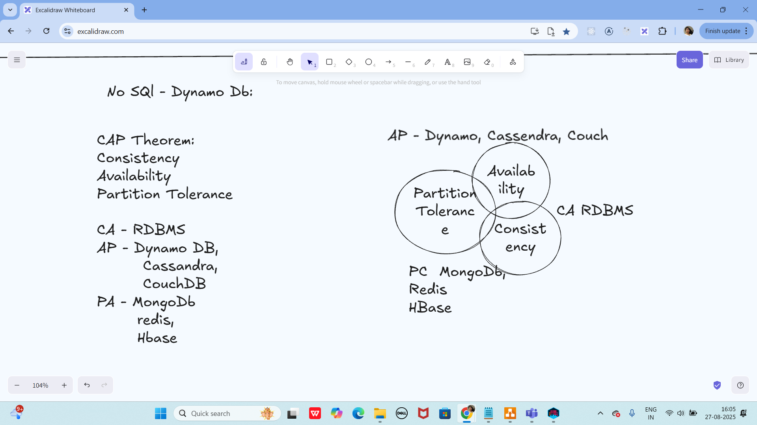

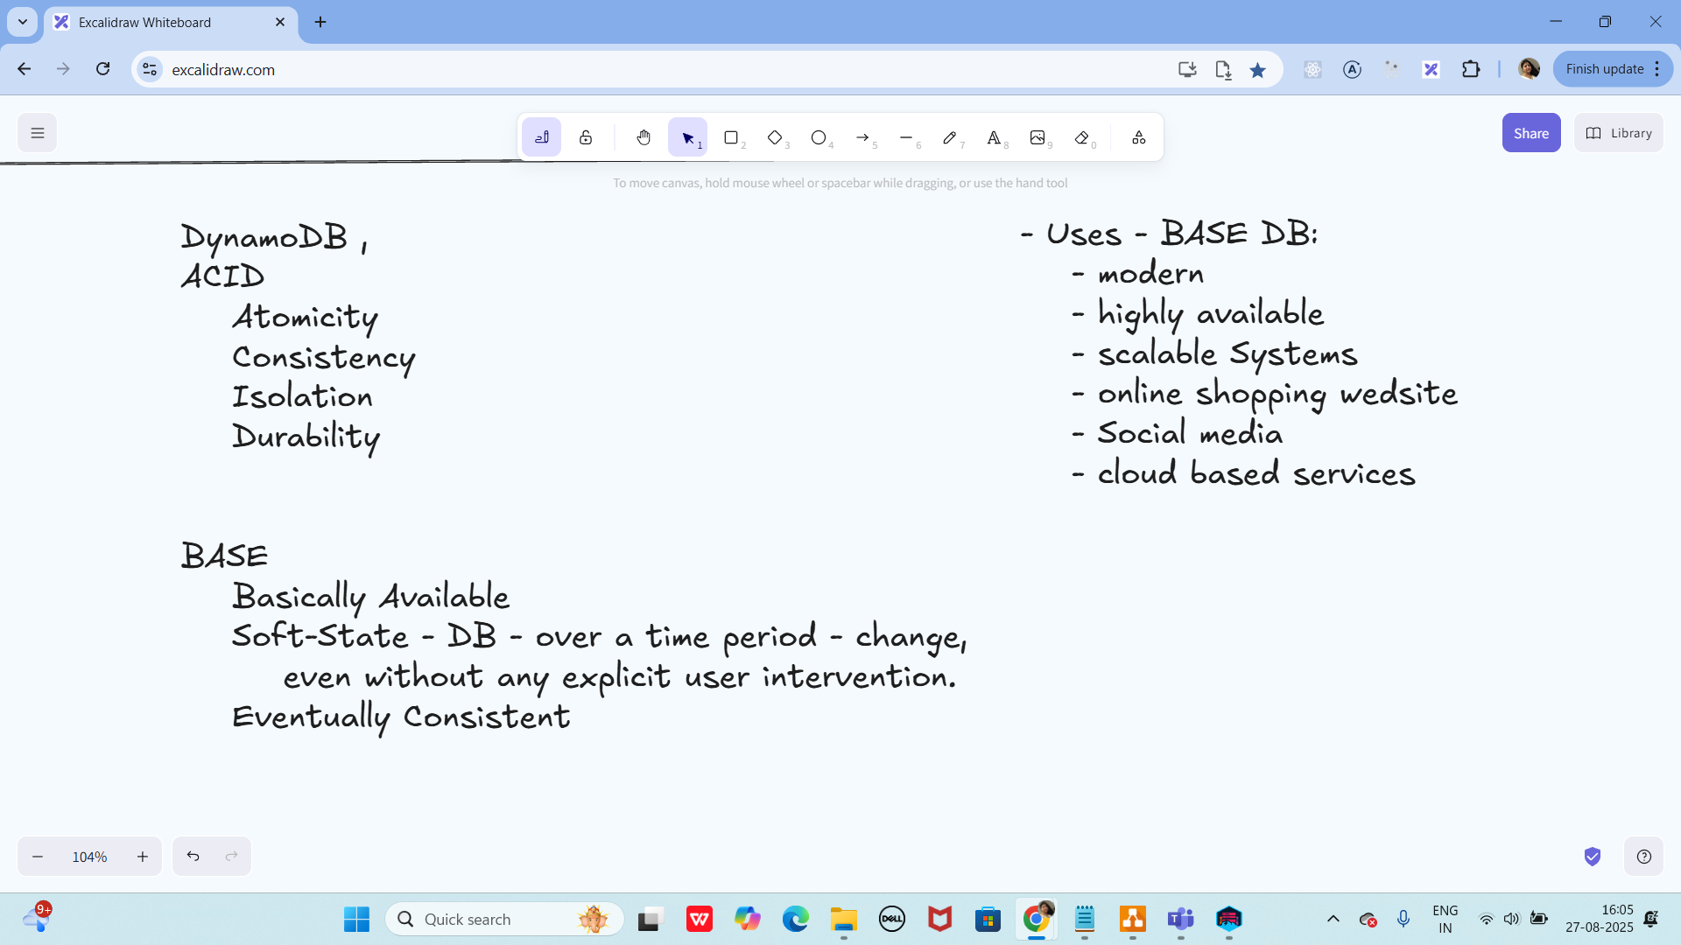

Info Box:

====================================================================================for Kinnera:

<dependencies>  
<!-- AWS SDK v2 for DynamoDB -->  
<dependency>  
<groupId>software.amazon.awssdk</groupId>  
<artifactId>dynamodb</artifactId>  
<version>2.25.61</version> <!-- use latest stable -->  
</dependency>

<!-- Jackson (for JSON) -->  
<dependency>  
<groupId>com.fasterxml.jackson.core</groupId>  
<artifactId>jackson-databind</artifactId>  
<version>2.17.2</version>  
</dependency>  
</dependencies>

By Vivek

<dependency>

<groupId>com.fasterxml.jackson.core</groupId>

<artifactId>jackson-databind</artifactId>

<version>2.20.0-rc1</version>

</dependency>

By Sudipto

AwsBasicCredentials awsCreds = AwsBasicCredentials.create("dummy", "dummy");

By Sudipto - aws access cred



By Yeshwanth

=====================================================================

Excalidraw updated at 10.47

<https://excalidraw.com/#json=0zlc-Blwv_3H-UmKoVCj1,oRBmqtN2dJ7dkzJ8UAhrXA>

Excalidraw updated at 16.03:

<https://excalidraw.com/#json=M2ML_ruh5B3w-47K7ALKc,NXXmmkpRfZb6y-0E9-uy6A>