Day 32

Employee ID: 201933938

Login ID: iamasif

Name: Shaik Asif

Hope you have received Credentials for accessing AWS cloud

Login to cloud environment

Change region to Asia - Mumbai

Search for DynamoDB

Task 1:

Create a table with few attributes..

Also add some records..

Take a ss of it and paste it

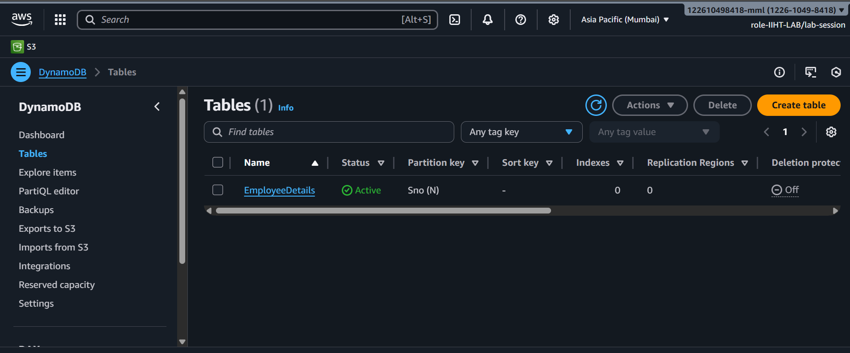

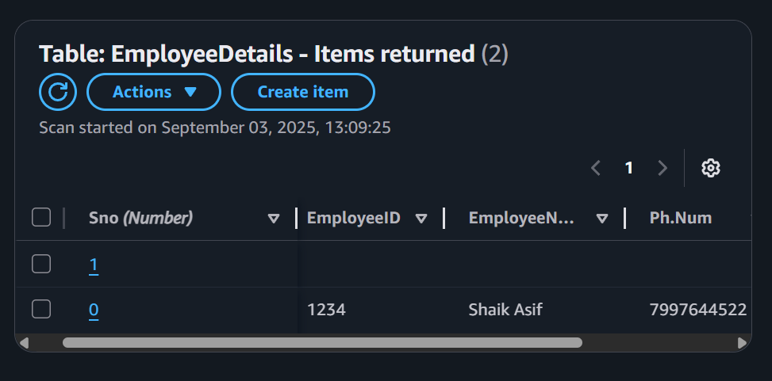

Task 2:

Create a table and do the crud operations on the table ..

CRUD

Created a table:

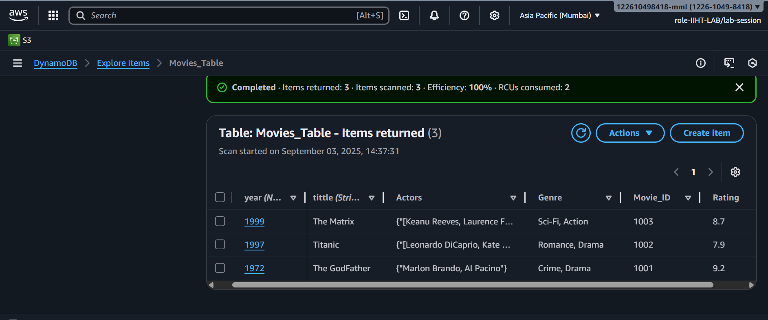

Read is done

Update: The matrix to the mansion

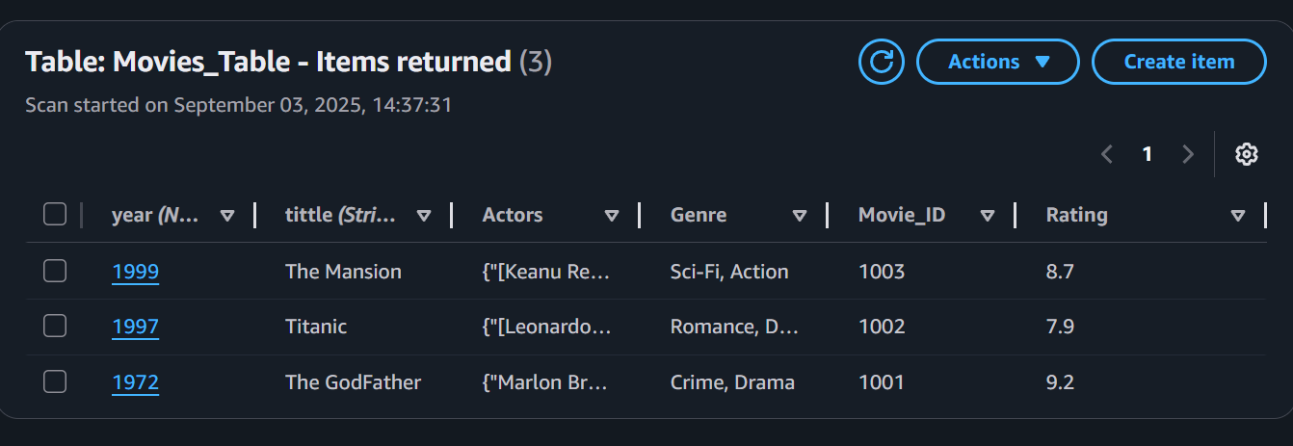

deleted :

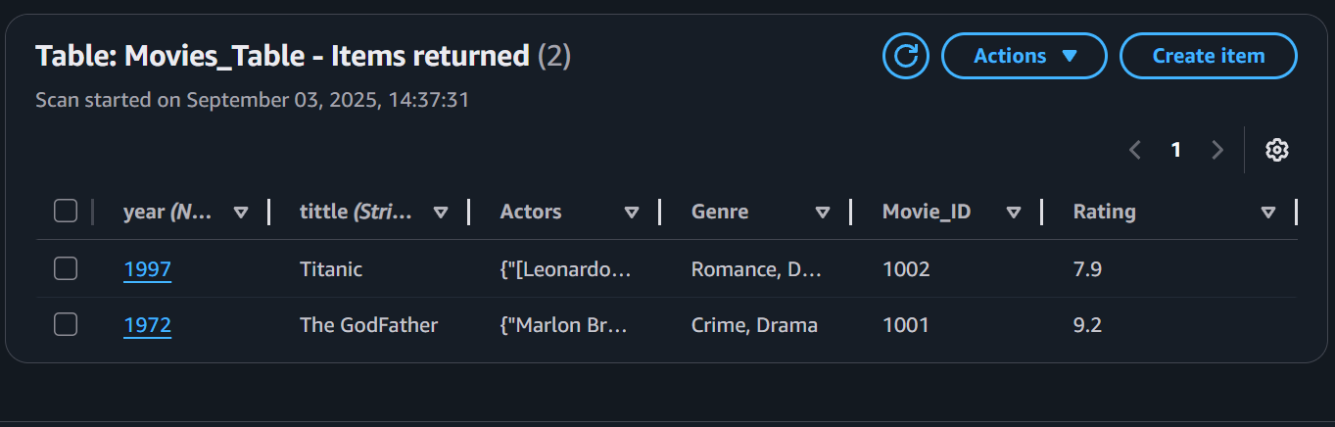

Added new attribute:

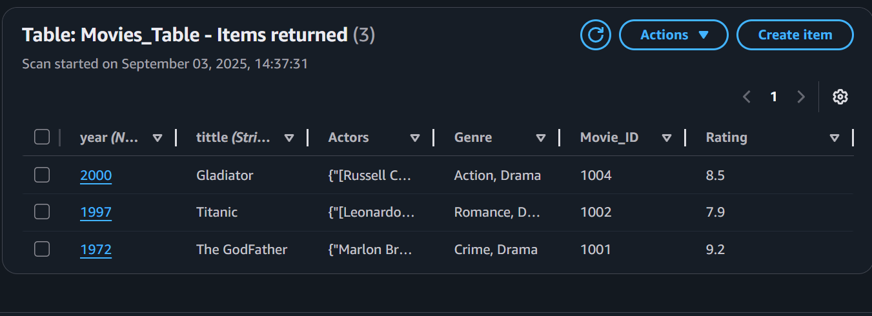

\

Creating a table

aws dynamodb create-table --table-name Employee --attribute-definitions AttributeName=ID,AttributeType=N AttributeName=EmpName,AttributeType=S --key-schema AttributeName=ID,KeyType=HASH AttributeName=EmpName,KeyType=RANGE --provisioned-throughput ReadCapacityUnits=5,WriteCapacityUnits=5

configuring AWS CLI

install aws cli - aws cli

configure aws cli

aws configure

aws access key

secret key

region and output format

IAM permissions:

IAM user or role

CreateTable

PutItems

Getitems

Query

UpdateItems

DeleteItems

DeleteTable

---------------------------------------------------------------

Add custom IAM policy

aws iam create policy \

--policy-name

DynamoDBManagementPolicy \

--policy-document '{"Version" : "2025-05-20",

"Statement" :

[ {"Effect": "Allow", "Action" :

["dynamodb: CreateTable",

"dynamodb: Query", .......],

"Resource": "*" } ] }'

the above policy lets give to a role/user

aws iam attach-user-policy --policy-arn arn:aws:iam:: DynamoDBManagementPolicy

--user-name emp(here give the username for whom your want to attach the above policy)

create table

insert data

crud operAtions

---- GUI , CLI, SDK...

insert into table

aws dynamodb put-item --table-name Employee --item '{"ID": {"N": "1001"},

"EmpName": {"S": "Prasunamba"} }'

aws dynamodb put-item --table-name Employee --item '{"ID": {"N": "1001"},

"EmpName": {"S": "Prasunamba"} }'

.....

Query:

aws dynamodb query --table-name Employee

--key-condition-expression "ID = :ID"

--expression-attribute-values '{":ID":{"N":"1001"}}'

Update:

aws dynamodb update-item --table-name Employee

--key '{"ID": {"N": "1001"} , "EmpName": {"S": "Prasunamba"} }'

--update-expression "set info = :info"

--expression-attribute-values '{":info": {"S": "MK"}}'

Delete :

aws dynamodb delete-item --table-name Employee

--key '{"ID": {"N": "1001"}, "EmpName":{"S": "Prasunamba"} }'

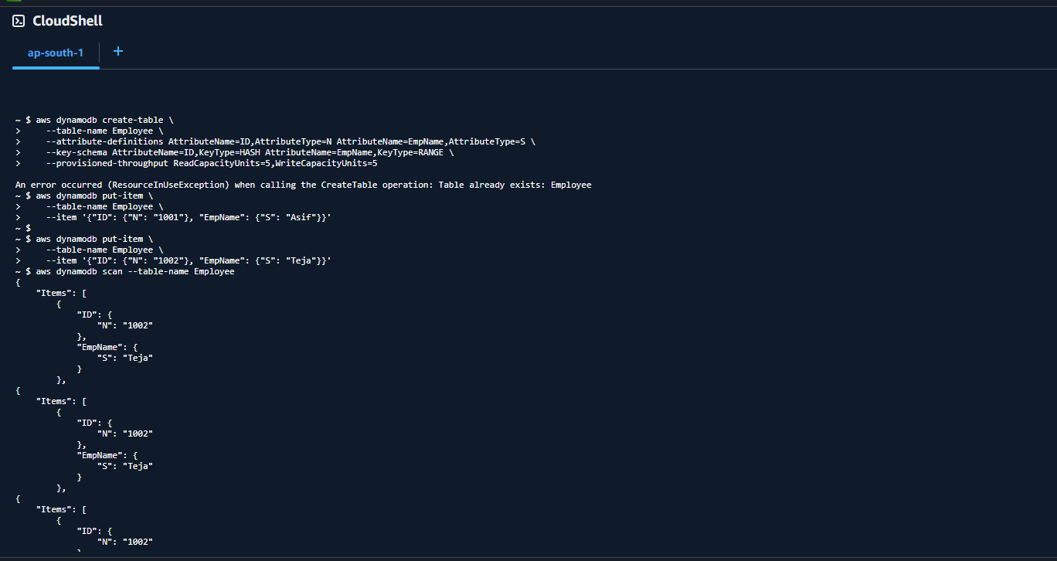

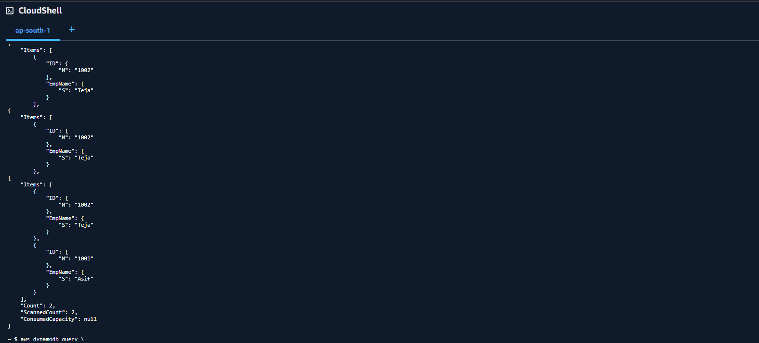

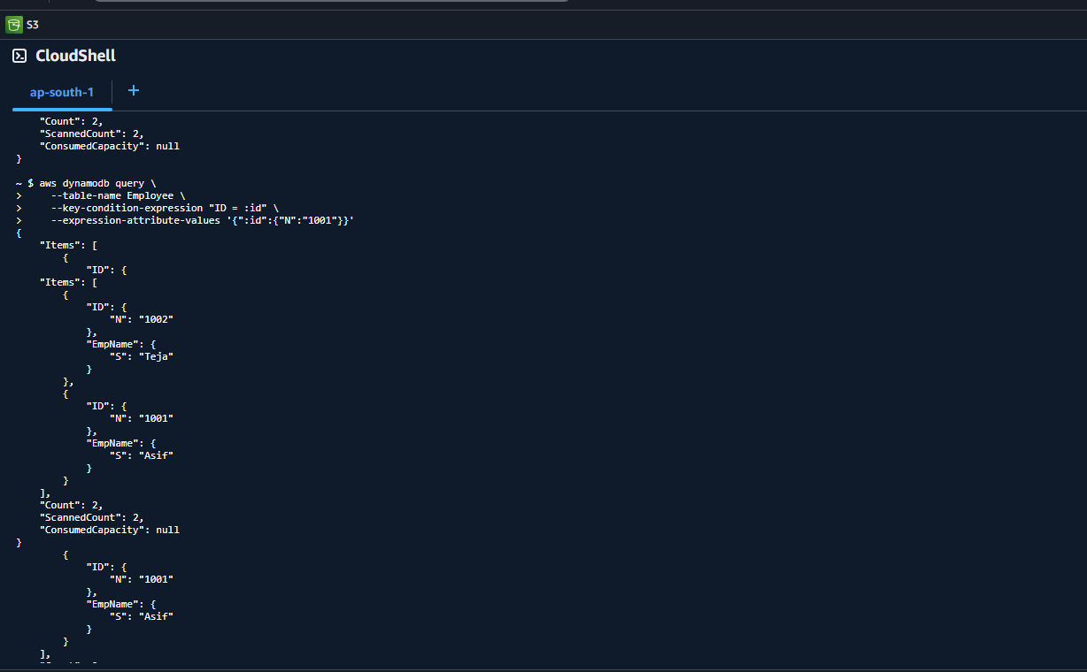

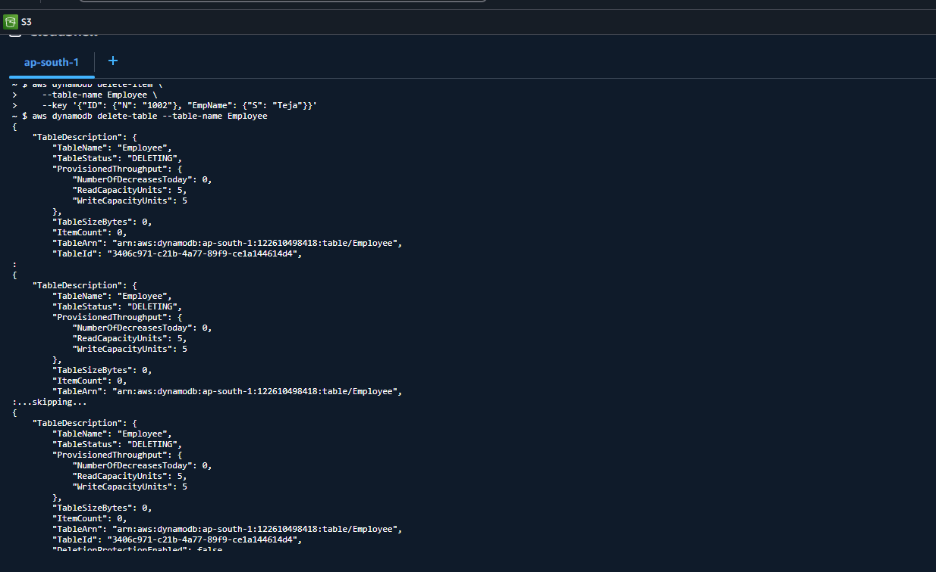

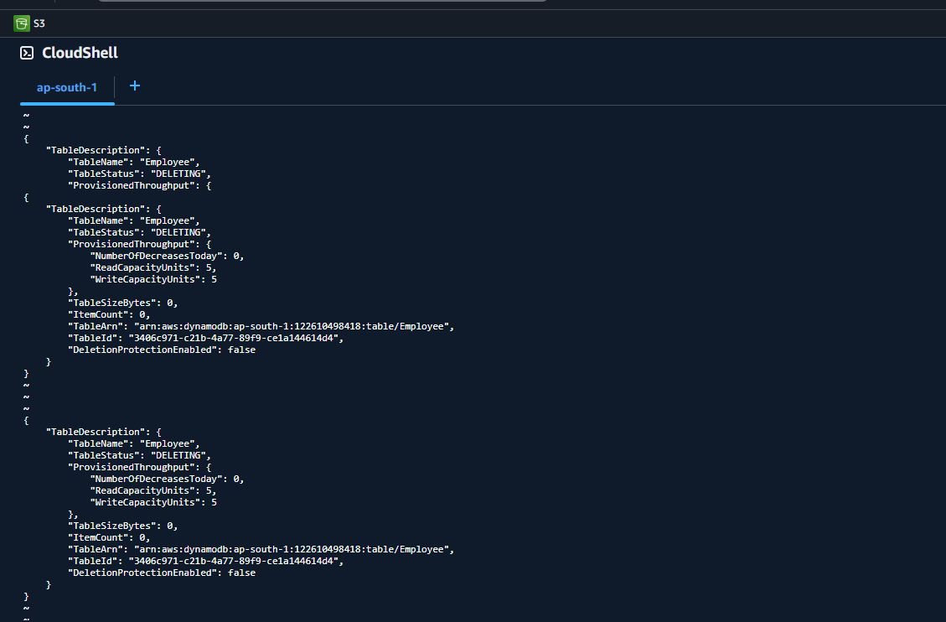

List the tables

Aws dynamodb list-tables

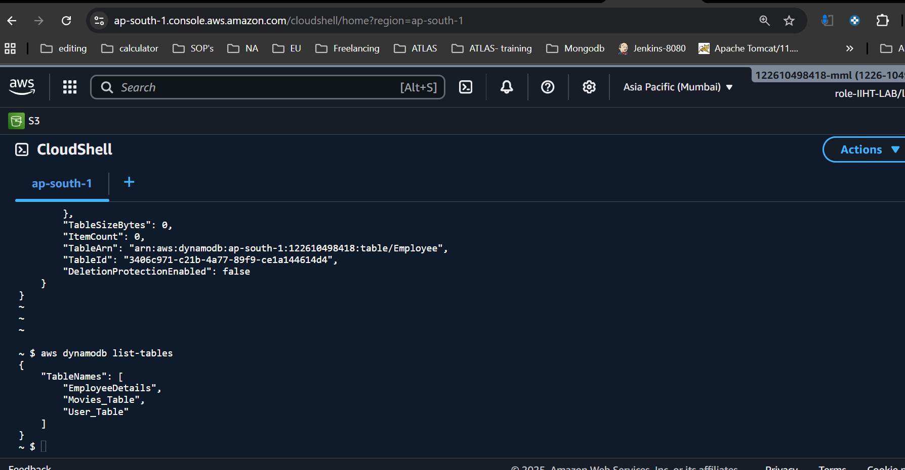

detailed info about our table

aws dynamodb describe-table --table-name Employee01

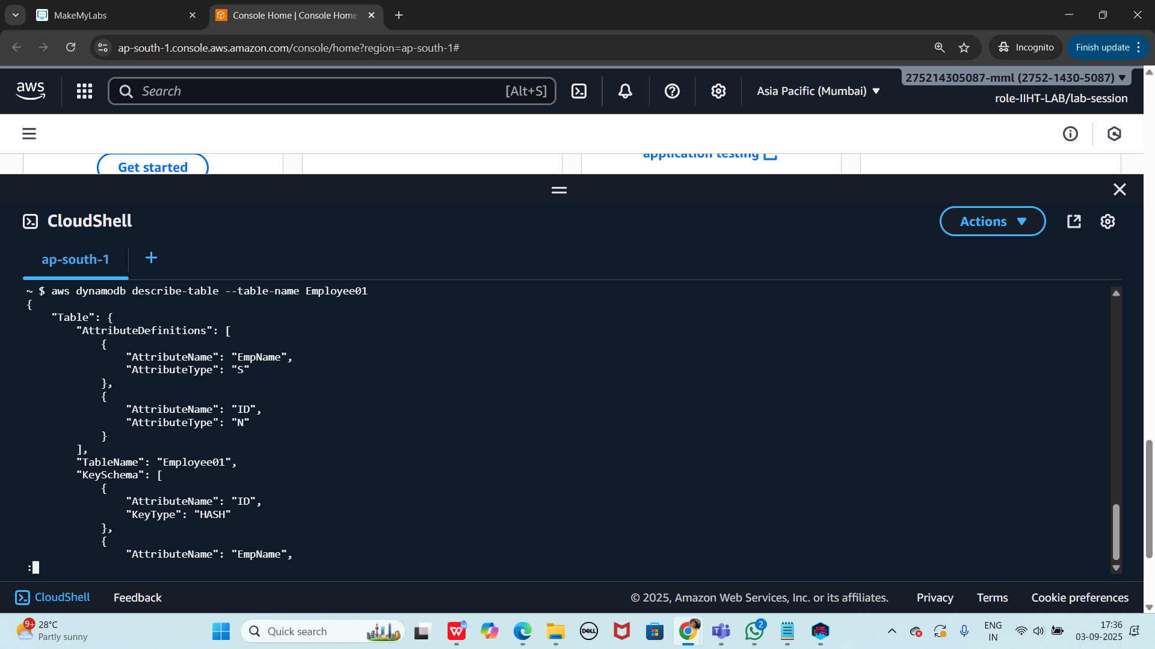

Scan the table

aws dynamodb scan --table-name Employee01

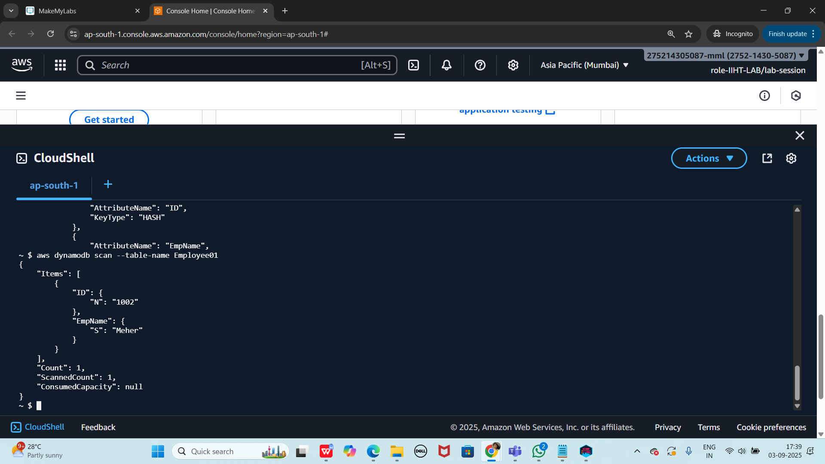

Aws - - version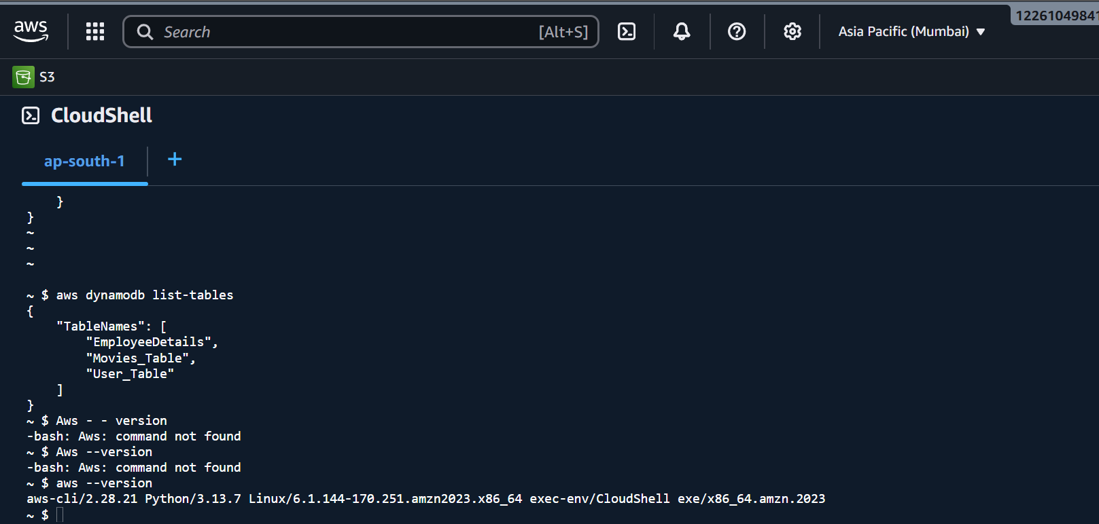

identity details of the user

aws sts get-caller-identity

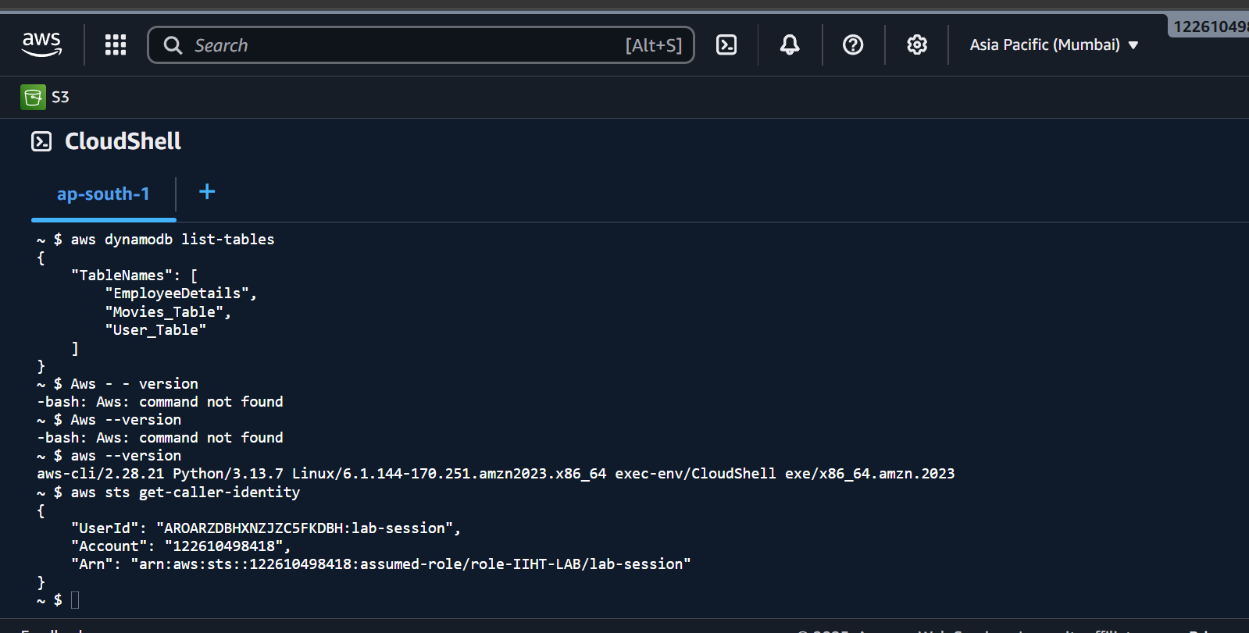

Creayting a table using wizard

Aws dynamodb wizard new-table

Fill the blanks

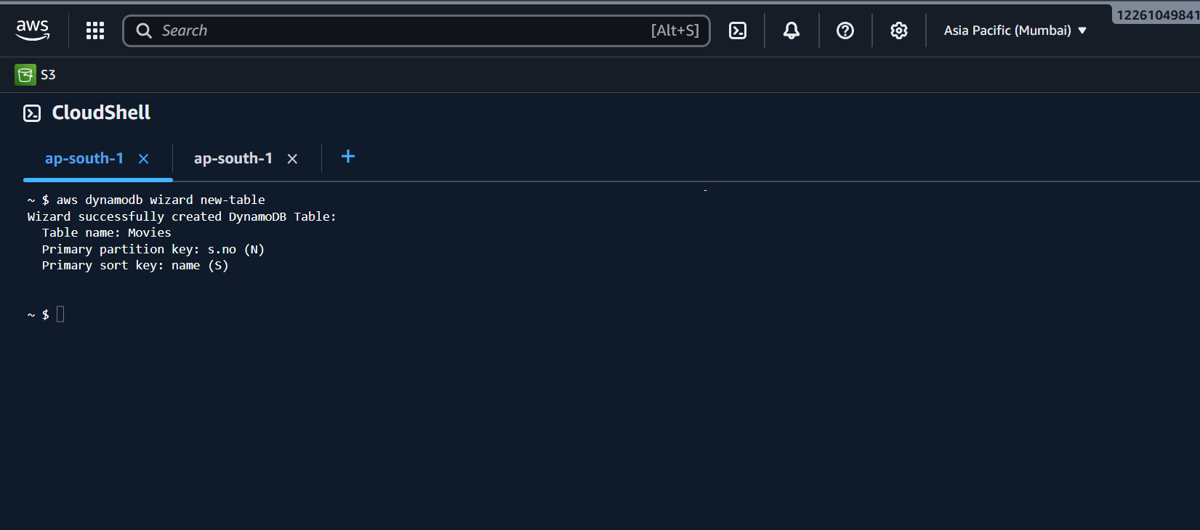

taking backup of a table

aws dynamodb create-backup --table-name Employee01 --backup-name MyEmployee01backup

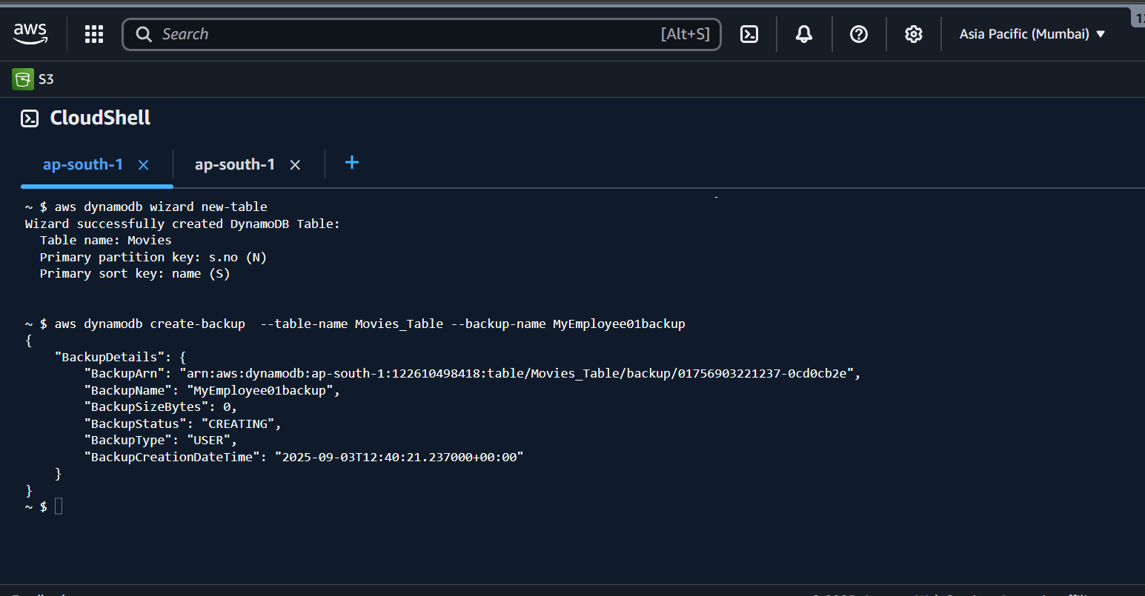

Aws dynamodb list-backups

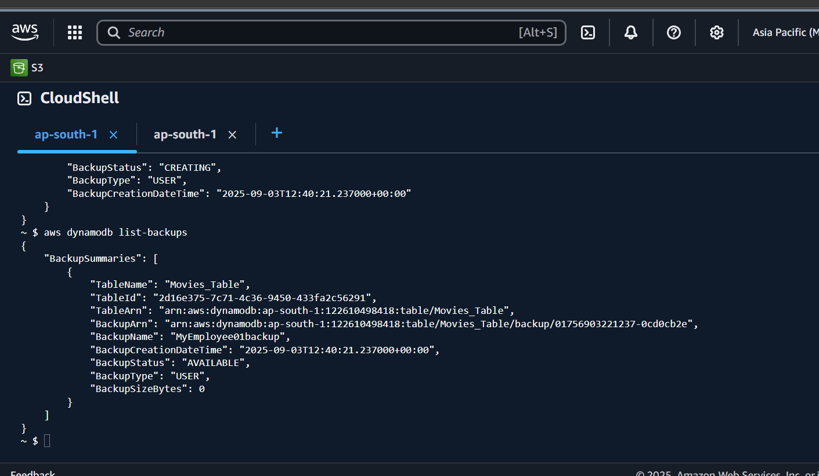

aws dynamodb describe-backup --backup-arn arn:aws:dynamodb:ap-south-1:275214305087:table/Employee01/backup/01756902583708-2e1a3b3e

aws dynamodb describe-backup --backup-arn arn:aws:dynamodb:ap-south-1:275214305087:table/Employee01/backup/01756902583708-2e1a3b3e

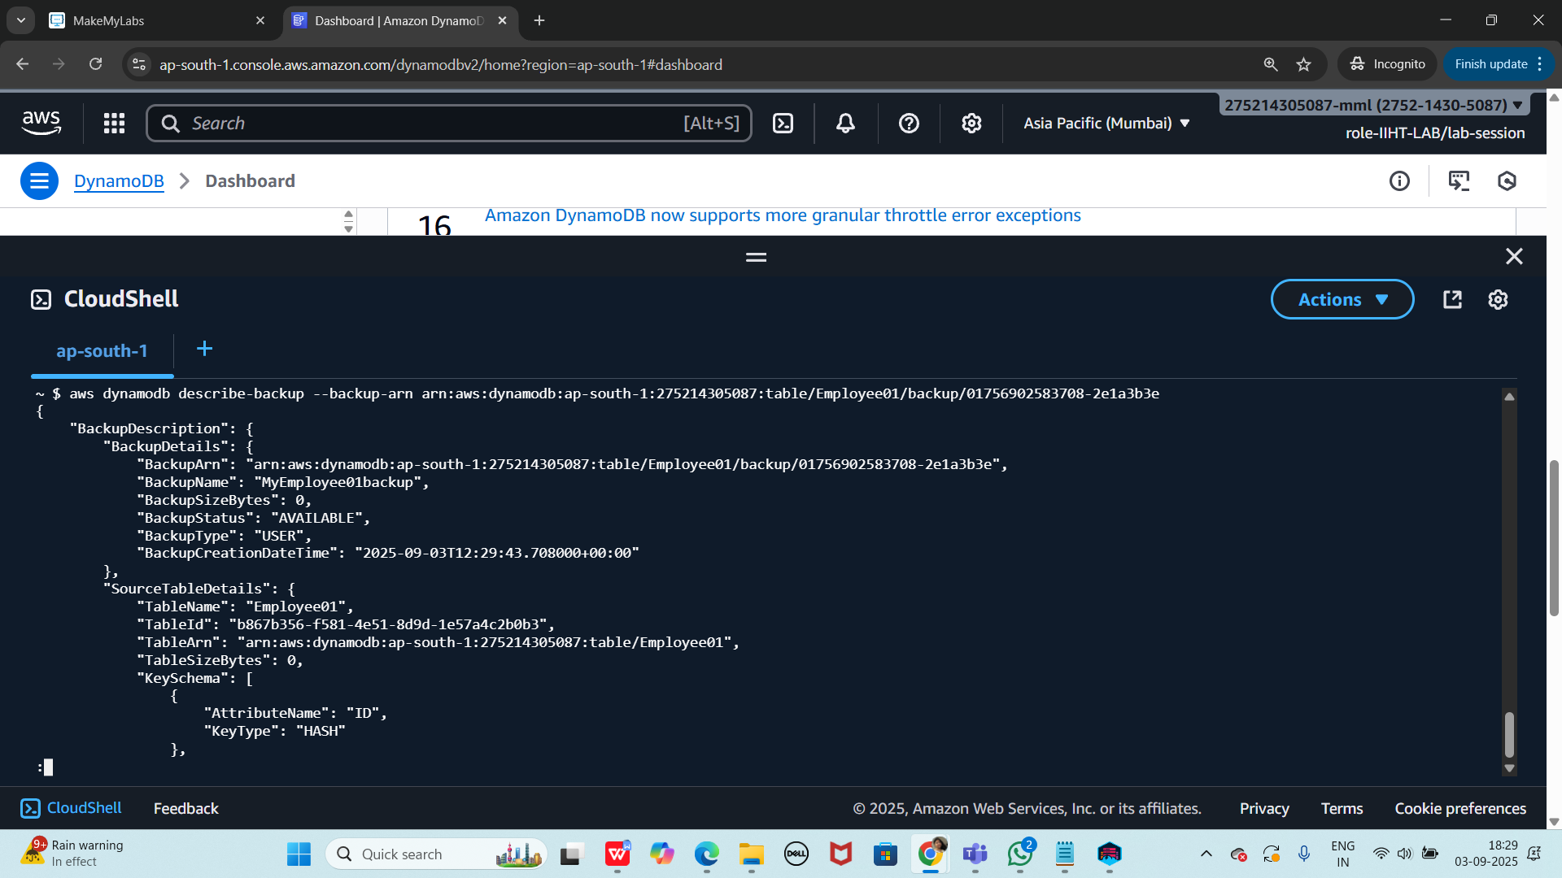

Restoring table from back up file

Using ARN

aws dynamodb restore-table-from-backup --target-table-name restoreEmpoloyee01 --backup-arn arn:aws:dynamodb:ap-south-1:275214305087:table/Employee01/backup/01756902583708-2e1a3b3e

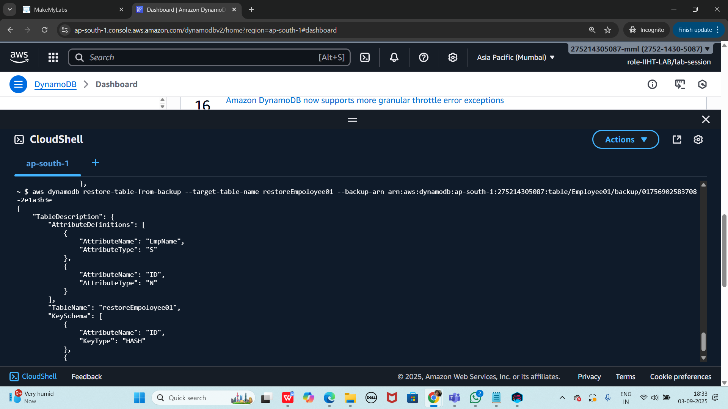

Check for the restore file… using list-tables command

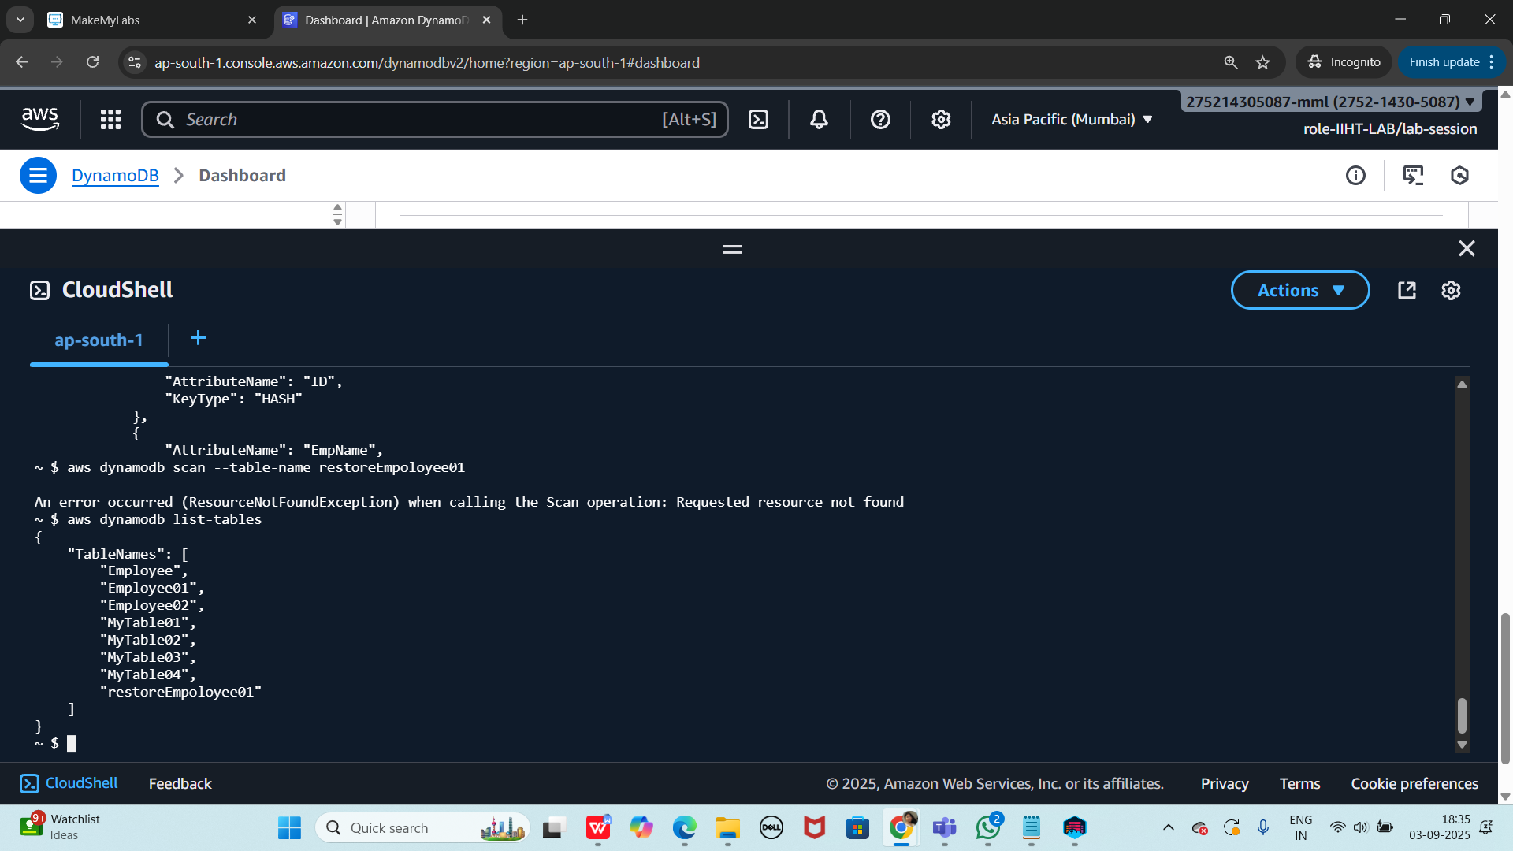

=============================================================

Home Task

Use the same crud operations to create a table of your choice with 4 columns and 5 records..

—--------------------------------------------------------------------------------------------------------------------

HINT:

Creating a table

aws dynamodb create-table --table-name Employee --attribute-definitions AttributeName=ID,AttributeType=N attributeName=EmpName,AttributeType=S --key-schema AttributeName=ID,KeyType=HASH AttributeName=EmpName,KeyType=RANGE --provisioned-throughput ReadCapacityUnits=5,WriteCapacityUnits=5

insert into table

aws dynamodb put-item --table-name Employee01 --item '{"ID": {"N": "1001"},"EmpName": {"S": "Prasunamba"}}'

aws dynamodb put-item --table-name Employee01 --item '{"ID": {"N": "1002"},"EmpName": {"S": "Meher"} }'

.....

Query:

aws dynamodb query --table-name Employee01 --key-condition-expression "ID = :ID" --expression-attribute-values '{":ID":{"N":"1001"}}'

Update:

aws dynamodb update-item --table-name Employee01 --key '{"ID": {"N": "1001"} , "EmpName": {"S": "Prasunamba"} }' --update-expression "set info = :info" --expression-attribute-values '{":info": {"S": "MK"}}'

Delete :

aws dynamodb delete-item --table-name Employee01 --key '{"ID": {"N": "1001"}, "EmpName":{"S": "Prasunamba"} }'

**Creating a table:**

~ $ aws dynamodb create-table \

> --table-name Students \

> --attribute-definitions AttributeName=StudentID,AttributeType=N AttributeName=Name,AttributeType=S \

},

{

:

{

"TableDescription": {

"AttributeDefinitions": [

{

"AttributeName": "Name",

"AttributeType": "S"

},

{

"AttributeName": "StudentID",

"AttributeType": "N"

}

],

"TableName": "Students",

"KeySchema": [

{

"AttributeName": "StudentID",

"KeyType": "HASH"

},

:...skipping...

{

"TableDescription": {

"AttributeDefinitions": [

{

"AttributeName": "Name",

"AttributeType": "S"

},

{

"AttributeName": "StudentID",

"AttributeType": "N"

}

],

"TableName": "Students",

"KeySchema": [

{

"AttributeName": "StudentID",

"KeyType": "HASH"

},

{

"AttributeName": "Name",

"KeyType": "RANGE"

:...skipping...

{

"TableDescription": {

"AttributeDefinitions": [

{

"AttributeName": "Name",

"AttributeType": "S"

},

{

"AttributeName": "StudentID",

"AttributeType": "N"

}

],

"TableName": "Students",

"KeySchema": [

{

"AttributeName": "StudentID",

"KeyType": "HASH"

},

{

"AttributeName": "Name",

"KeyType": "RANGE"

}

],

:...skipping...

{

"TableDescription": {

"AttributeDefinitions": [

{

"AttributeName": "Name",

"AttributeType": "S"

},

{

"AttributeName": "StudentID",

"AttributeType": "N"

}

],

"TableName": "Students",

"KeySchema": [

{

"AttributeName": "StudentID",

"KeyType": "HASH"

},

{

"AttributeName": "Name",

"KeyType": "RANGE"

}

],

"TableStatus": "CREATING",

"CreationDateTime": "2025-09-03T12:25:42.327000+00:00",

"ProvisionedThroughput": {

"NumberOfDecreasesToday": 0,

"ReadCapacityUnits": 5,

"WriteCapacityUnits": 5

},

"TableSizeBytes": 0,

"ItemCount": 0,

"TableArn": "arn:aws:dynamodb:ap-south-1:122610498418:table/Students",

"TableId": "238246e2-2df5-426a-8dbf-0169c274da72",

"DeletionProtectionEnabled": false

}

}

**Inserting data in a table:**

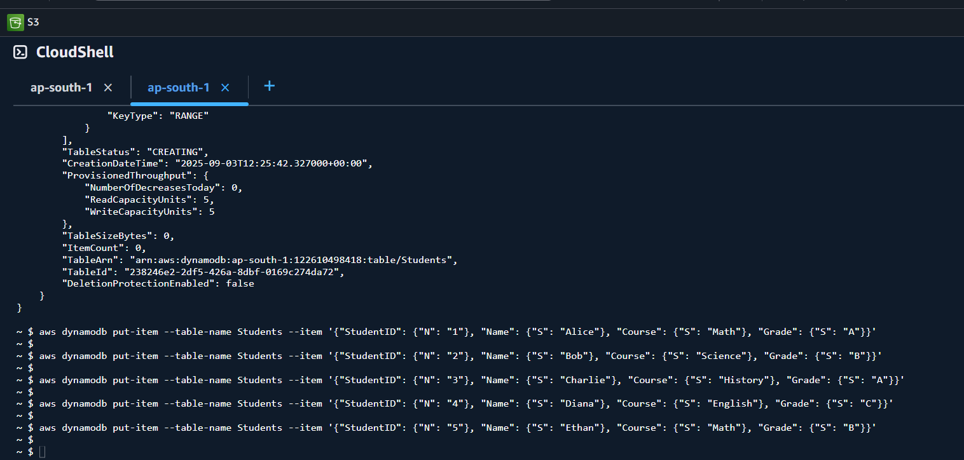

**Get all records for a particular StudentID (say 1):**

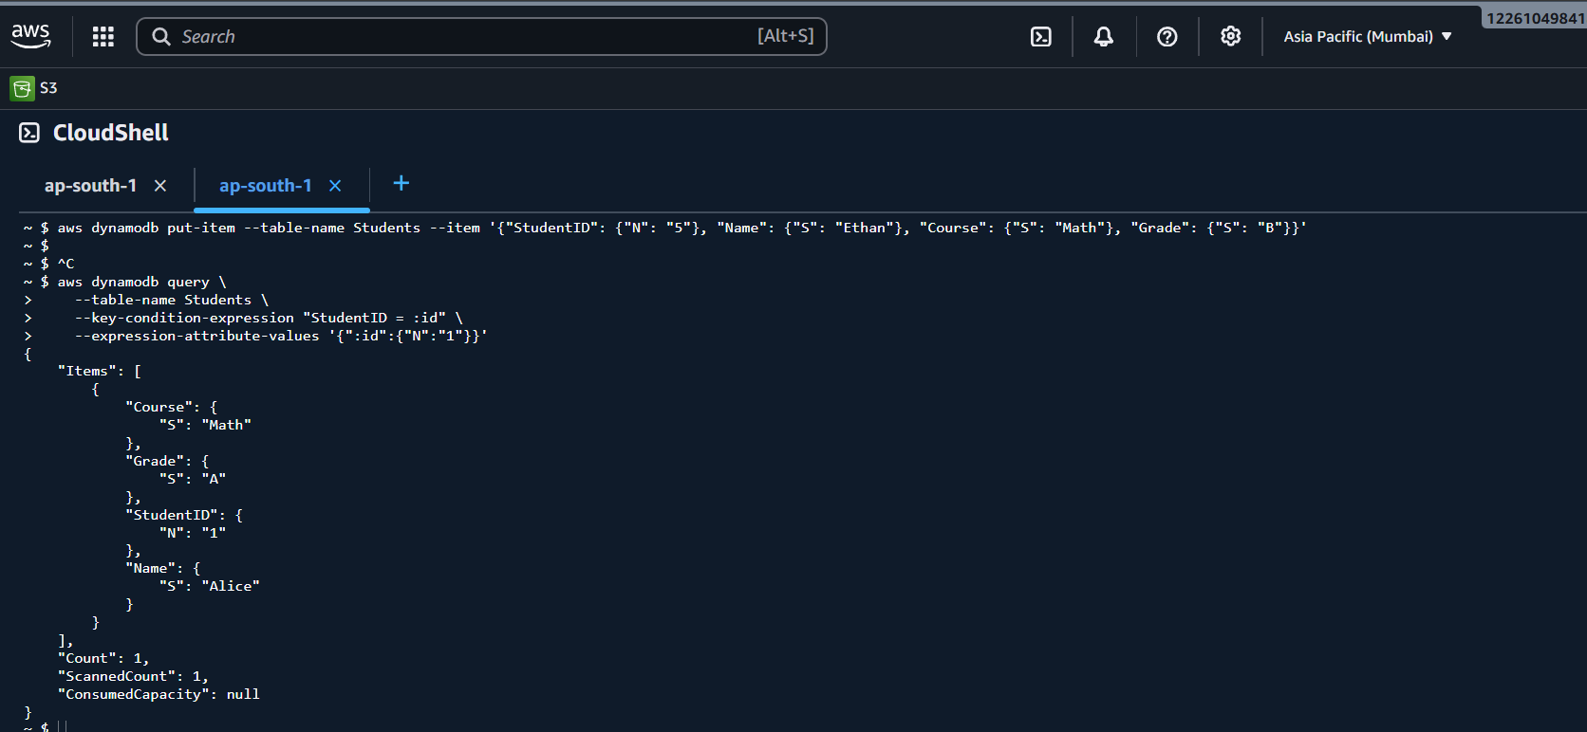

**Updating the data:**

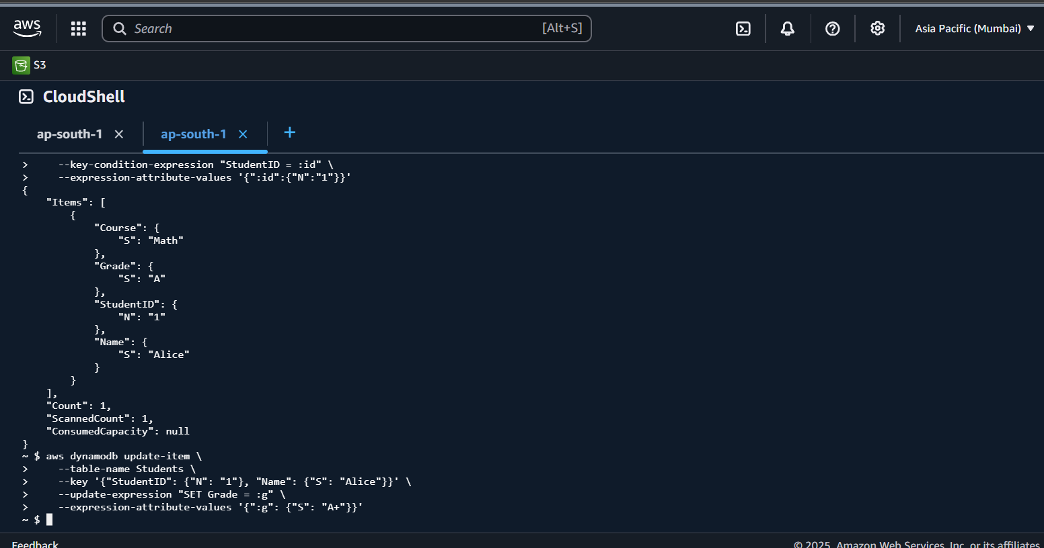

**Deleting the data:**

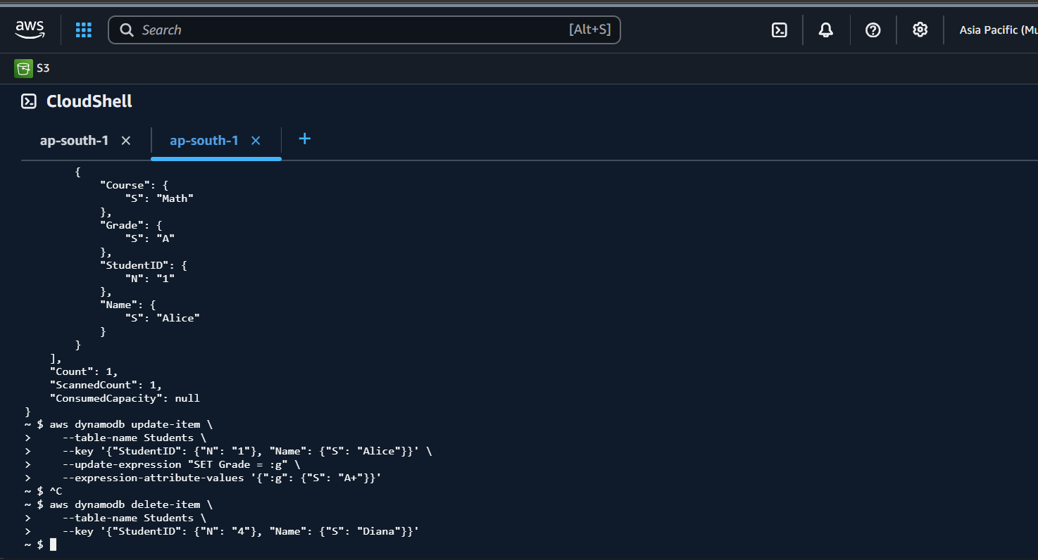

---------------------------------------------------------------------------------------------------------

Info Box:

Projects doc link.. ALL Projects 10 Day plan

<https://docs.google.com/document/d/1gOzEONAVHm-DifF-RhEy_PwsdjCnkLzi/edit?usp=sharing&ouid=103020917863623365252&rtpof=true&sd=true>

Batch 1 projects

<https://docs.google.com/spreadsheets/d/16Ia3jG_uJtTPvpDQTv-XW3-0OE1qagjD5pgB9TYcKDc/edit?usp=sharing>