Day 35

Employee ID: 201933938

Login ID: iamasif

Name: Shaik Asif

DAX (DynamoDB Accelerator)

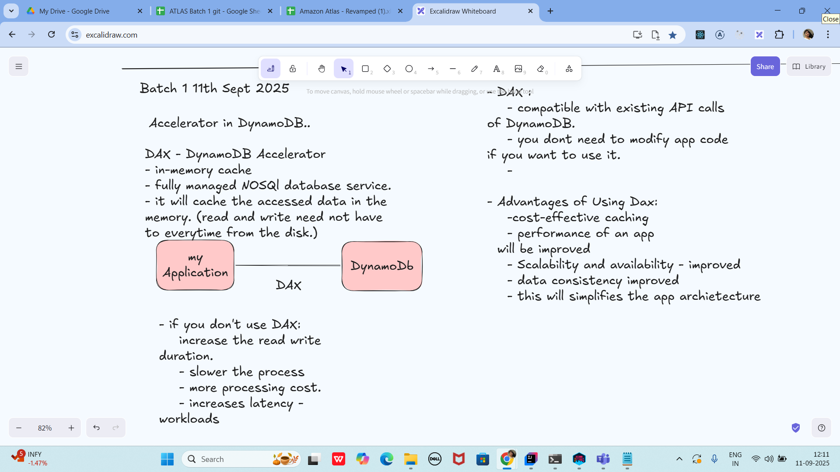

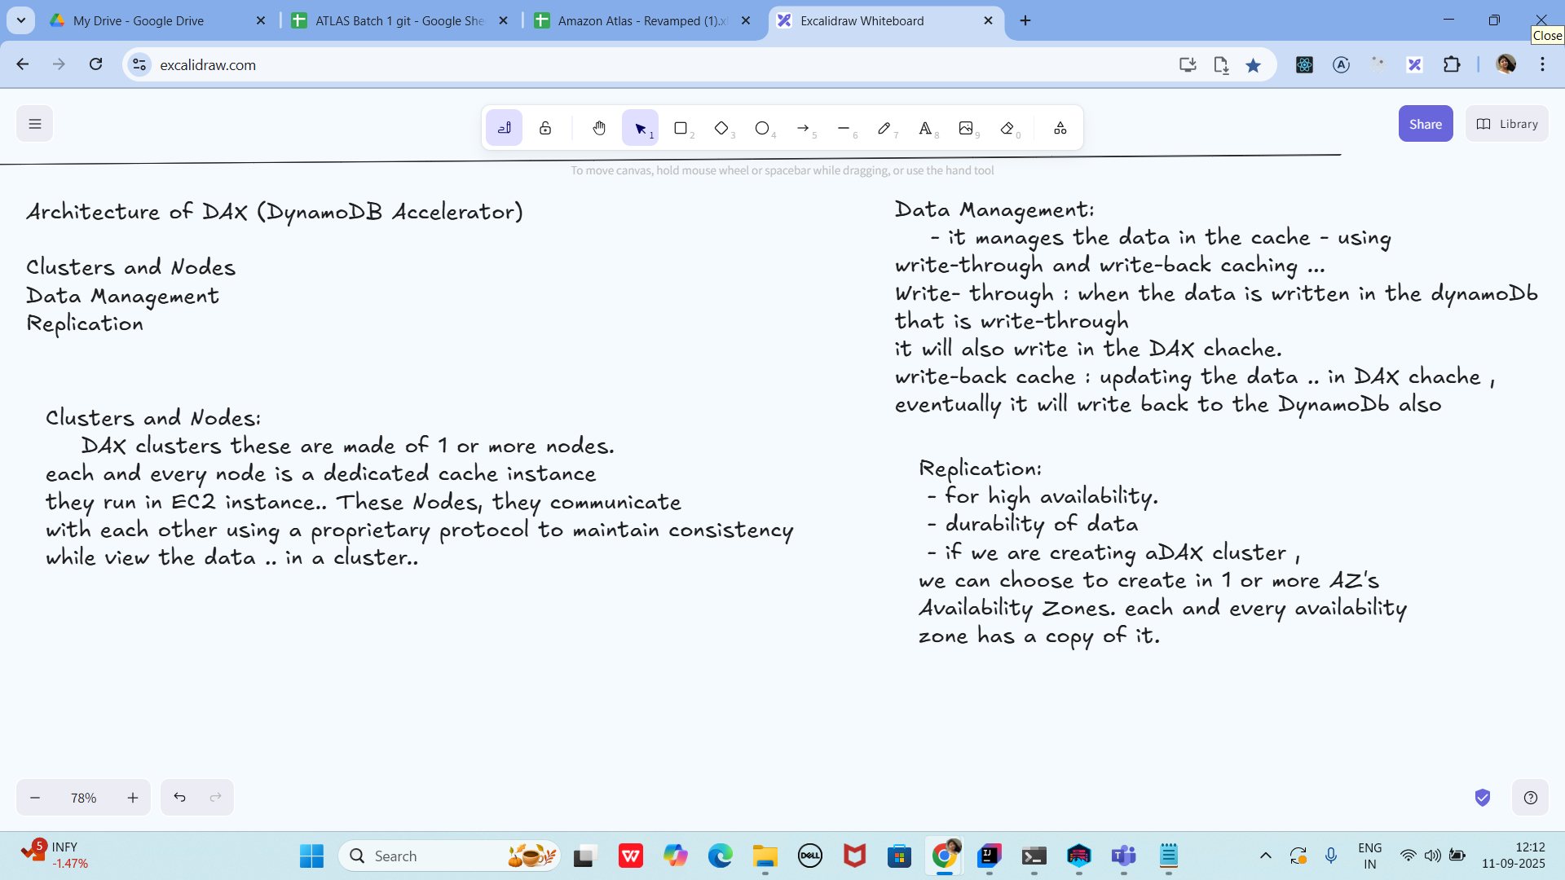

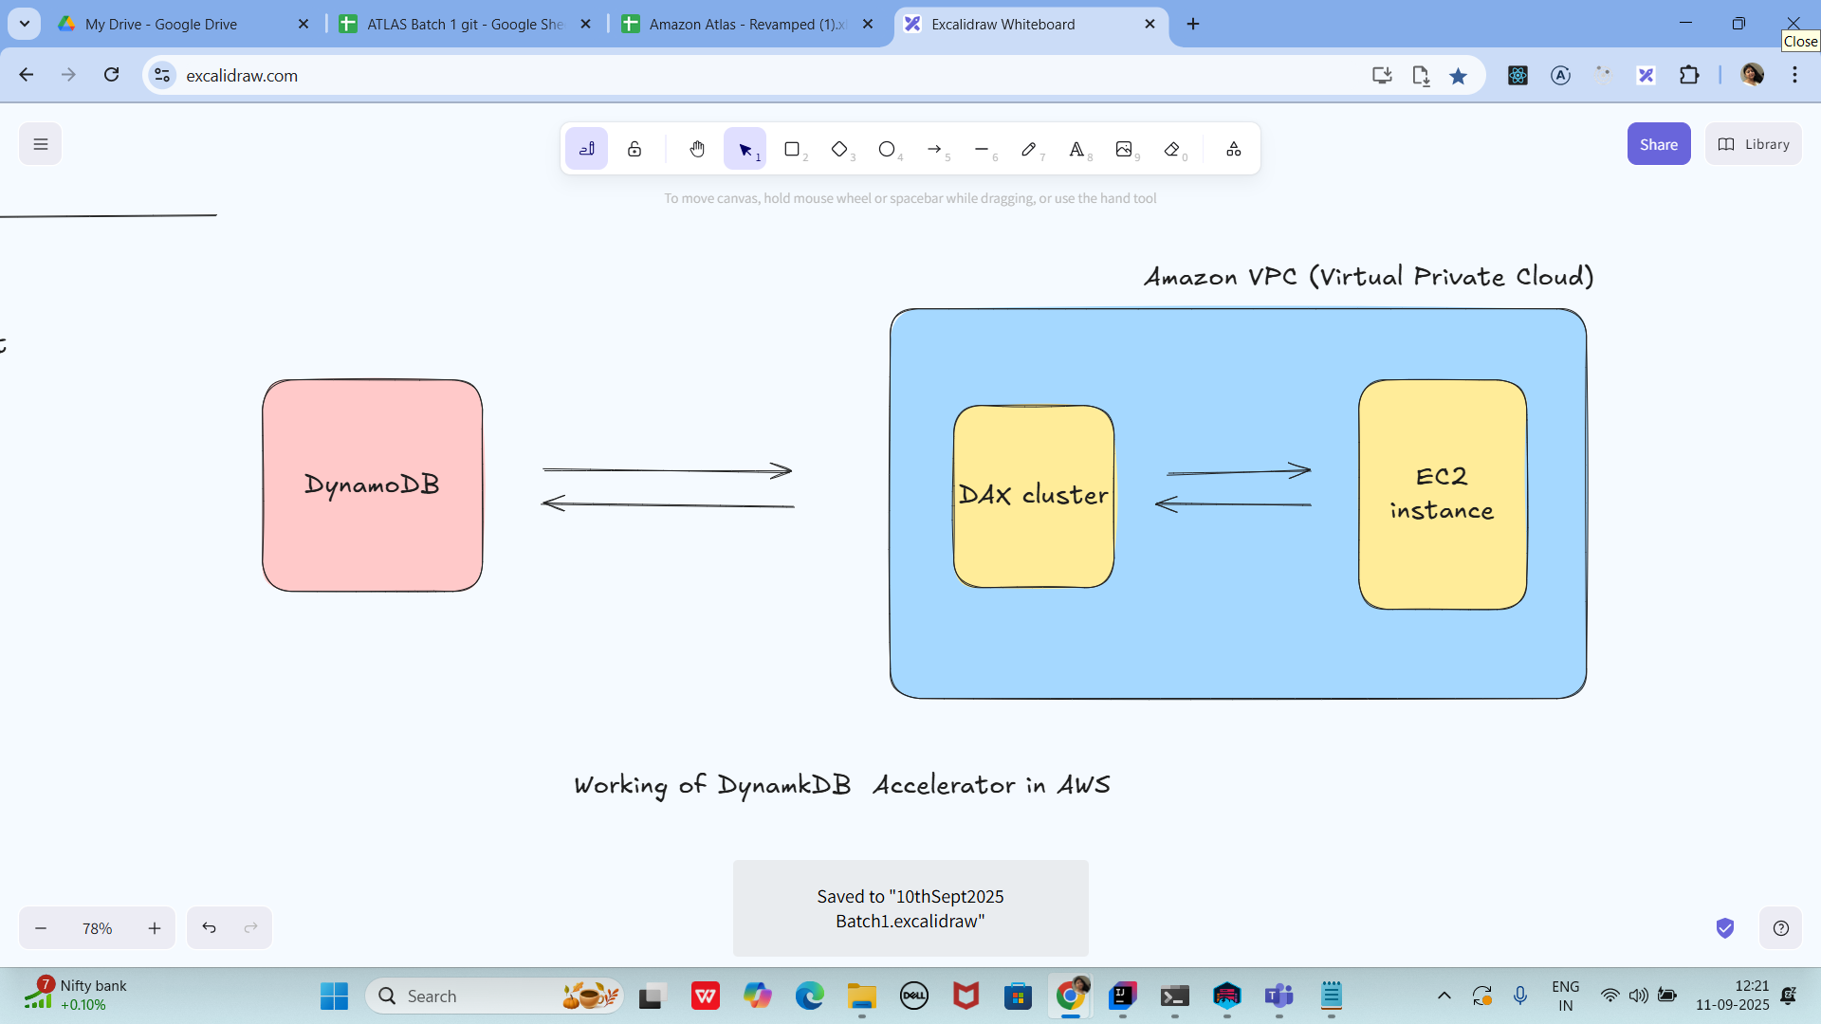

Creating a DAX cluster in AWS (using Console).

Requirements for resting cluster.

→ you need to have an AWs account … with permissions for DynamoDB and DAX.

—> create a table (old table also works

—> you need to create VPC and subnet

—> IAM Role will be used by DAX for Access to DynamoDB

Open DAX console

→ sign in to AWS management console

→ search for DynamoDB —> check for DAX cluster (left plane)

→ create cluster..

Configure Cluster settings:

→ Cluster name : give any name of your choice

→ Node type : dax.r5.large

→ cluster size : number of Nodes (1 to 3 for prod purpose)

→ IAM role:select the IAM role… (it has grants for AmazonDynamoDbFullAccess or create a custom role by giving the dynamoDb permissions..

Network settings:

VPC: plz select VPC the dynamoDB app is in

Subnets: you need to choose at least one subnet

Security groups : add security groups … which will allow the traffic from our app ECS

Or Lambda Functions.

Encryption and Security (this is not compulsory)

Encryption : we need to enable the encryption at rest ( not compulsory)

Parameter group : leave the default values as is..

TTL

Cachesing ….

Create it…. Try to review all the settings that you have given …

In the below screen shot you can see the status of my cluster as available

And also DAx endpoint copy from here and paste it in your code… instead of standard DynamoDB SDk

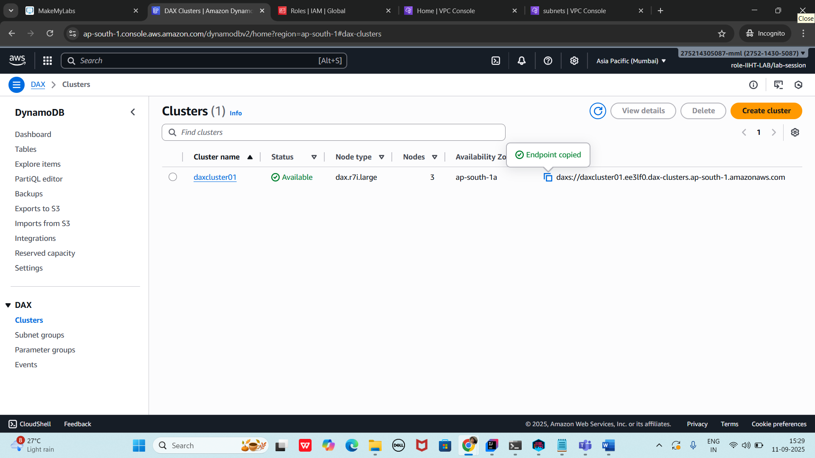

**Created**

