Day 8 - 28th May 2025

Employee ID: 201933938

Login ID: iamasif

Name: Shaik Asif

Enum , gettters and setters (encapsulation), Arrays, (pending from yesterday)

OOP's concepts Inheritance, Polymorphism, Encapsulation, Abstraction, Interfaces, Exception Handling,

Enums

//Attaching Multiple values

public enum Element {

H("Hydrogen", 1, 1.008f),

HE("Helium", 2, 4.0026f),

// ...

NE("Neon", 10, 20.180f);

private static final Map<String, Element> BY_LABEL = new HashMap<>();

private static final Map<Integer, Element> BY_ATOMIC_NUMBER = new HashMap<>();

private static final Map<Float, Element> BY_ATOMIC_WEIGHT = new HashMap<>();

static {

for (Element e : values()) { //for each loop

BY_LABEL.put(e.label, e);

BY_ATOMIC_NUMBER.put(e.atomicNumber, e);

BY_ATOMIC_WEIGHT.put(e.atomicWeight, e);

}

}

public final String label;

public final int atomicNumber;

public final float atomicWeight;

private Element(String label, int atomicNumber, float atomicWeight) {

this.label = label;

this.atomicNumber = atomicNumber;

this.atomicWeight = atomicWeight;

}

public static Element valueOfLabel(String label) {

return BY_LABEL.get(label);

}

public static Element valueOfAtomicNumber(int number) {

return BY_ATOMIC_NUMBER.get(number);

}

public static Element valueOfAtomicWeight(float weight) {

return BY_ATOMIC_WEIGHT.get(weight);

}

}

Task 19:

Wap to display the content of the above enum.. (main needs to be added)

10.06 to 10.10

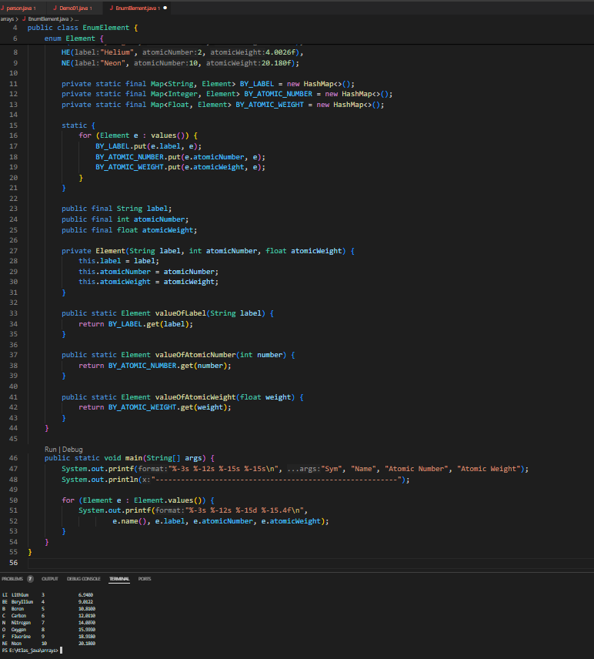

==================================================================

Code from yesterday

================================================================

Task 017:

Getter and setter

Create a program name Person.java

public class Person {

private String name;

// Getter

public String getName() {

return name;

}

// Setter

public void setName(String newName) {

this.name = newName;

}

}

Create another program named Task017.java

public class Task017{

public static void main(String[] args) {

Person myObj = new Person();

myObj.name = "John";

System.out.println(myObj.name);

}

}

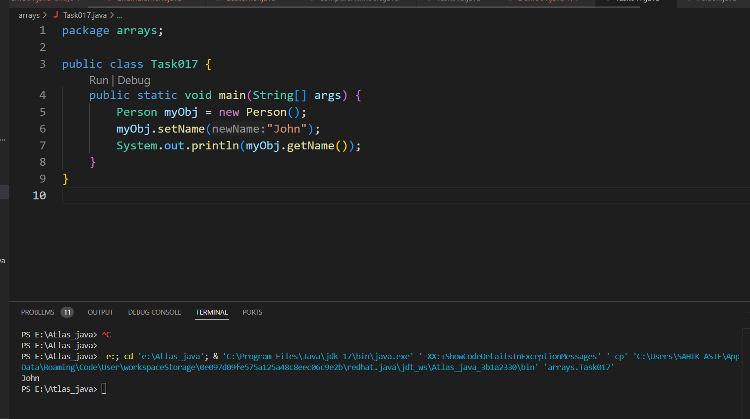

—----------------------------------what is the reason for the error —---------------explain

Task 018

Now create one more program named Task018.java

public class Main {

public static void main(String[] args) {

Person myObj = new Person();

myObj.setName("John");

System.out.println(myObj.getName());

}

}

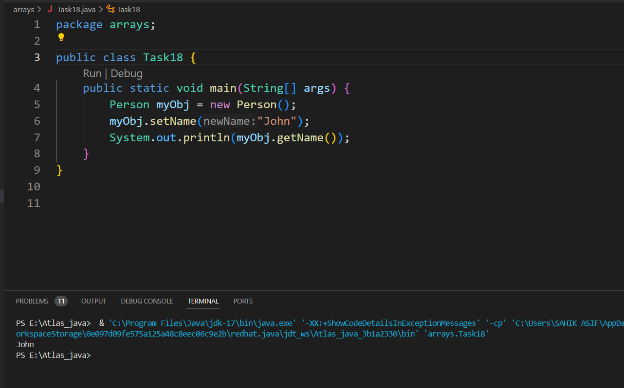

Now —--------------think what is the output of the above code—--------------

========================================================================

4444444444444444444444$$$$$$$$$$$$$$$$$$$$$$$$$$$$$$$$$444444444444444444444========================================================================

Arrays

Task 020:

Create an array of your name

Hint : use

Char[] Name = {‘P’, “r’, ….}; // initializing an array

sout(Name);

Int n = Name.length; // size of your name

sout(“there are “+ n +”letters in my name”);

Use for loop to display each letter..

HInt: use ghe below code snippet…

// traversing array

for (int i = 0; i < n; i++)

System.out.print(Name[i] + " ");

11.17 to 17.20

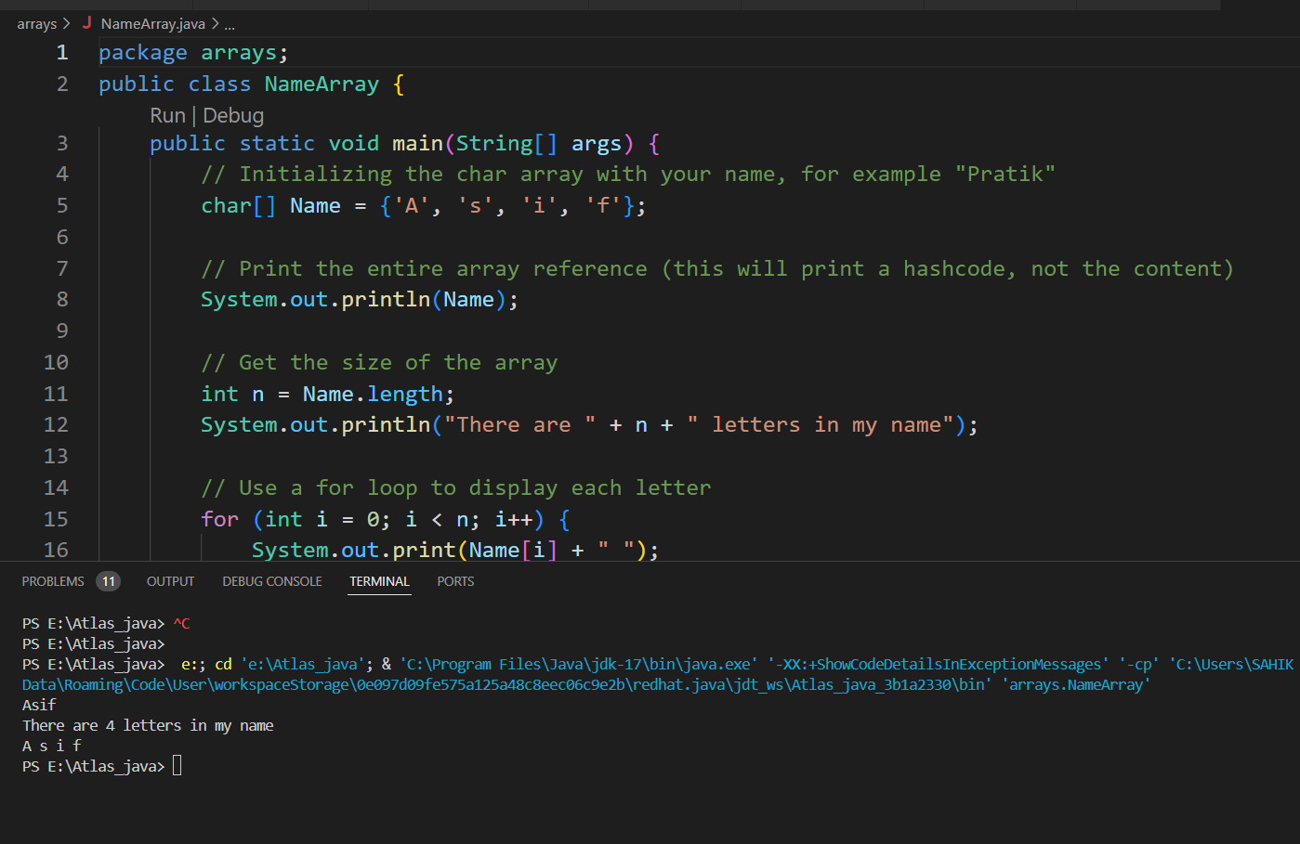

Coffee break : 11.20 to 11.35

Task 21: Home Task

**Example:** This example demonstrates how to initialize an array and traverse it using a for loop to print each element.

public class Main {

public static void main(String[] args)

{

​

// initializing array

int[] arr = { 1, 2, 3, 4, 5 };

​

// size of array

int n = arr.length;

​

// traversing array

for (int i = 0; i < n; i++)

System.out.print(arr[i] + " ");

}

}

**Output**

1 2 3 4 5

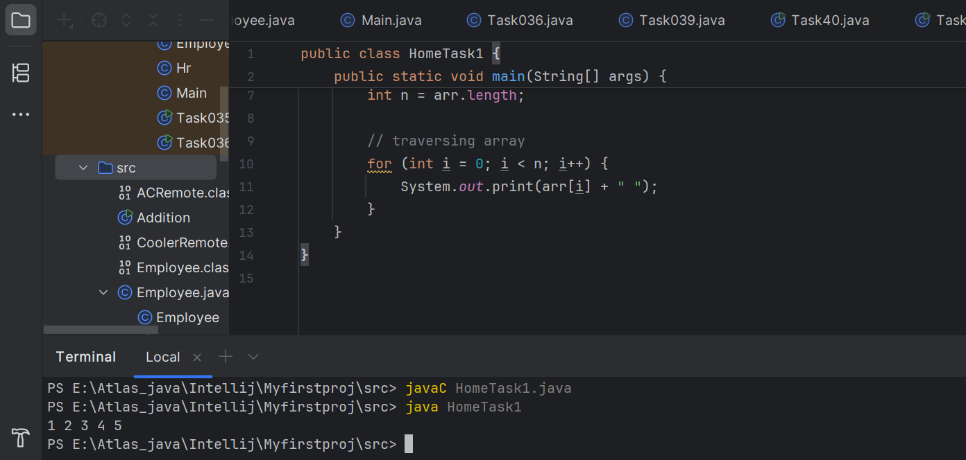

*Task 022 - home task*

#### **Implementation:**

// Java program to illustrate creating an array

// of integers, puts some values in the array,

// and prints each value to standard output.

​

class GFG {

public static void main(String[] args)

{

// declares an Array of integers.

int[] arr;

​

// allocating memory for 5 integers.

arr = new int[5];

​

// initialize the elements of the array

// first to last(fifth) element

arr[0] = 10;

arr[1] = 20;

arr[2] = 30;

arr[3] = 40;

arr[4] = 50;

​

// accessing the elements of the specified array

for (int i = 0; i < arr.length; i++)

System.out.println("Element at index "

+ i + " : " + arr[i]);

}

}

**Output**

Element at index 0 : 10

Element at index 1 : 20

Element at index 2 : 30

Element at index 3 : 40

Element at index 4 : 50

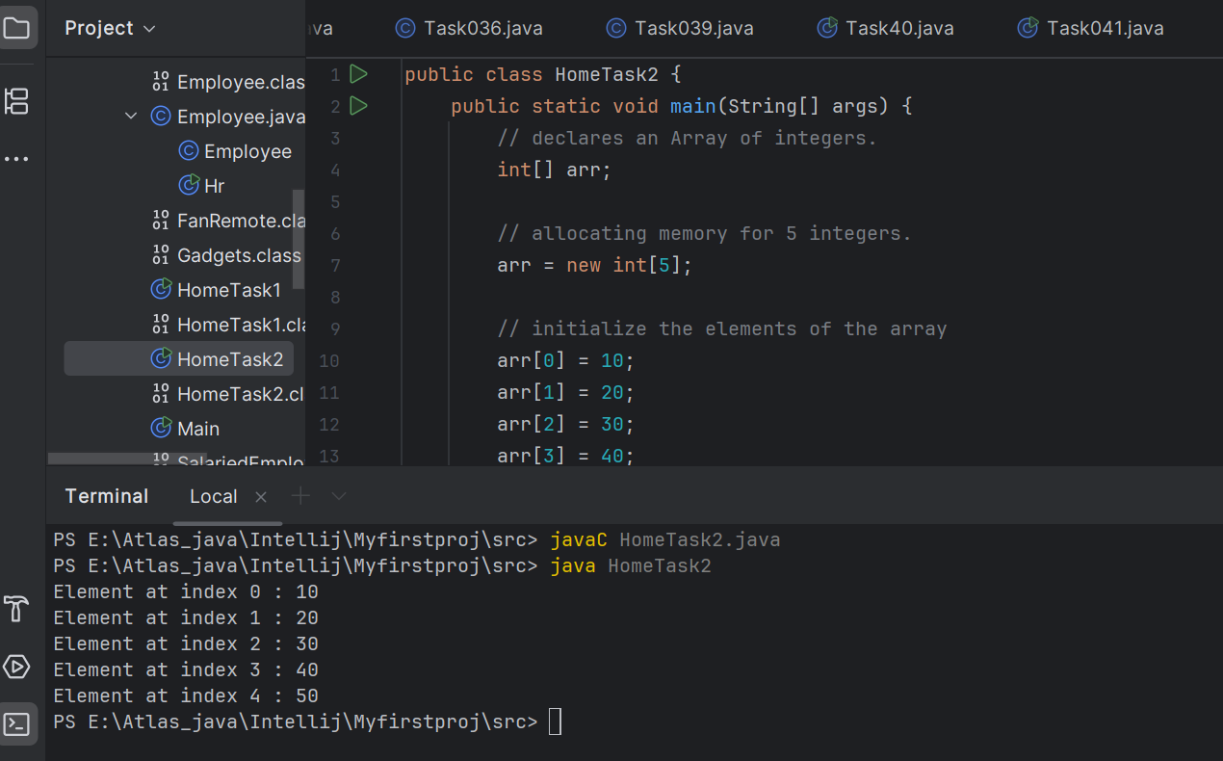

Task 023 - home task

**Example:** Here we are taking a student class and creating an array of Student with five Student objects stored in the array. The Student objects have to be instantiated using the constructor of the Student class, and their references should be assigned to the array elements.

// Java program to illustrate creating

// an array of objects

​

class Student {

public int roll_no;

public String name;

Student(int roll_no, String name){

this.roll_no = roll_no;

this.name = name;

}

}

​

public class Main {

public static void main(String[] args){

// declares an Array of Student

Student[] arr;

​

// allocating memory for 5 objects of type Student.

arr = new Student[5];

​

// initialize the elements of the array

arr[0] = new Student(1, "aman");

arr[1] = new Student(2, "vaibhav");

arr[2] = new Student(3, "shikar");

arr[3] = new Student(4, "dharmesh");

arr[4] = new Student(5, "mohit");

​

// accessing the elements of the specified array

for (int i = 0; i < arr.length; i++)

System.out.println("Element at " + i + " : { "

+ arr[i].roll_no + " "

+ arr[i].name+" }");

}

}

**Output**

Element at 0 : { 1 aman }

Element at 1 : { 2 vaibhav }

Element at 2 : { 3 shikar }

Element at 3 : { 4 dharmesh }

Element at 4 : { 5 mohit }

Task 024 Home task

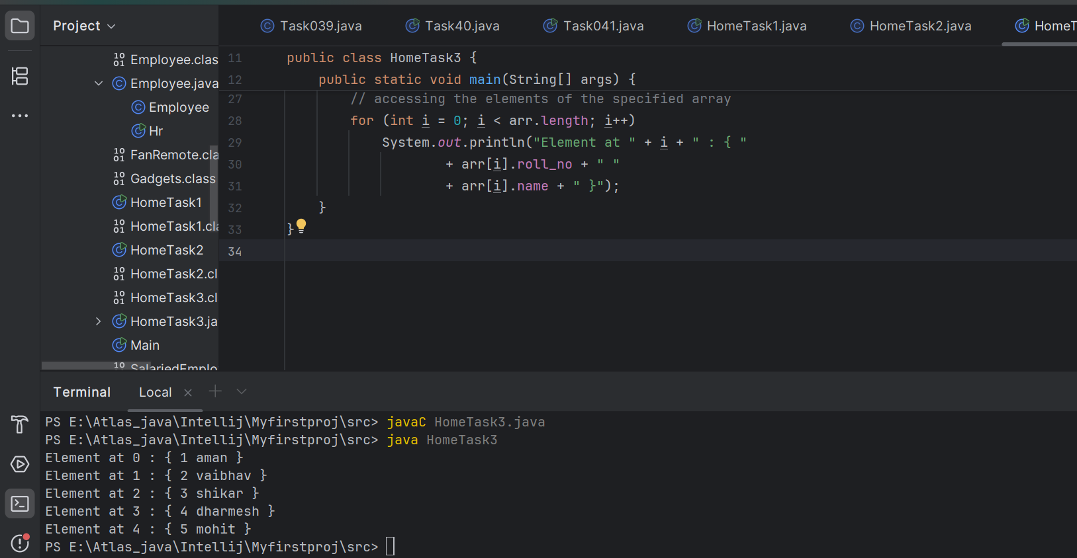

**Example:** An array of objects is also created like

// Java program to illustrate creating

// an array of objects

class Student{

public String name;

Student(String name){

this.name = name;

}

@Override

public String toString(){

return name;

}

}

​

public class Main{

public static void main (String[] args){

// declares an Array and initializing the

// elements of the array

Student[] myStudents = new Student[]{

new Student("Dharma"),new Student("sanvi"),

new Student("Rupa"),new Student("Ajay")

};

// accessing the elements of the specified array

for(Student m:myStudents){

System.out.println(m);

}

}

}

**Output**

Dharma

sanvi

Rupa

Ajay

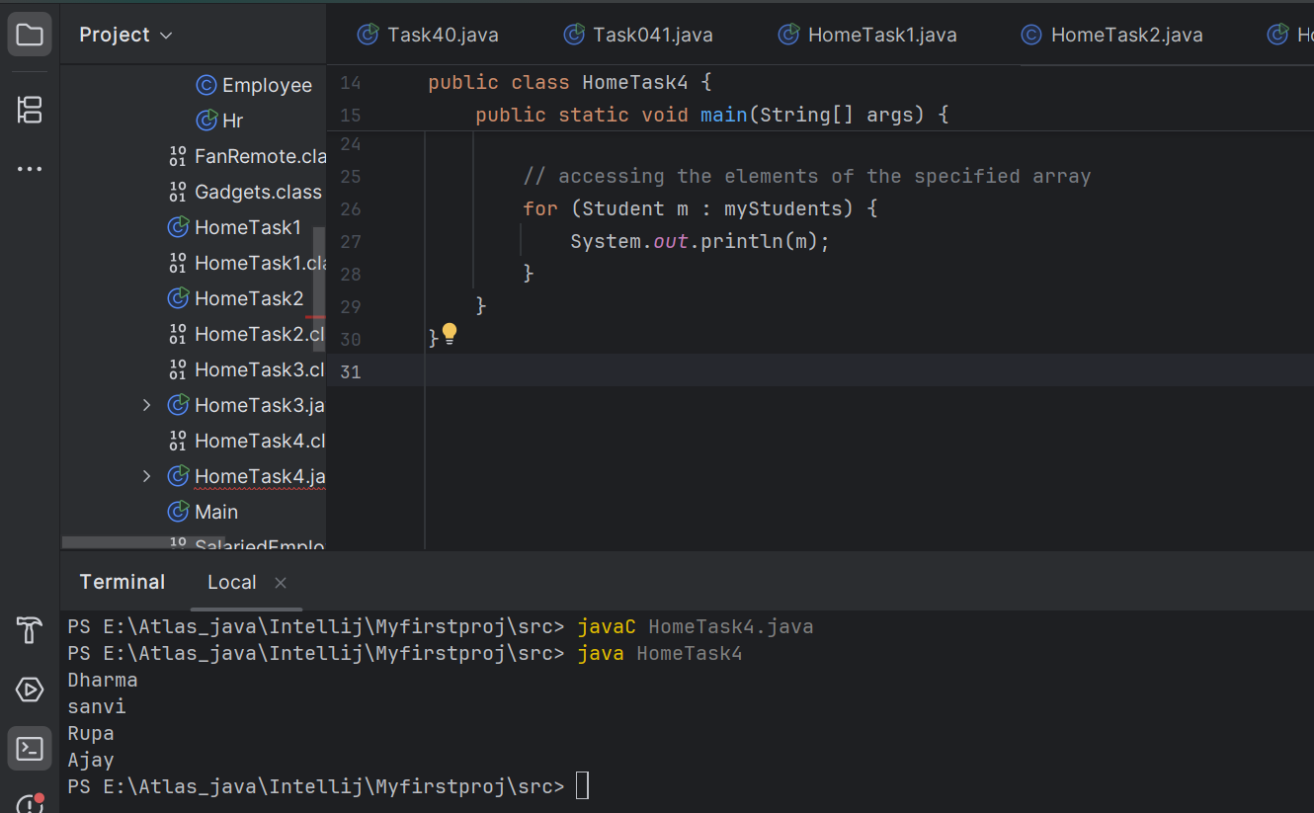

**Task 025 - home Task**

// Code for showing error "ArrayIndexOutOfBoundsException"

​

public class GFG {

public static void main(String[] args)

{

int[] arr = new int[4];

arr[0] = 10;

arr[1] = 20;

arr[2] = 30;

arr[3] = 40;

​

System.out.println(

"Trying to access element outside the size of array");

System.out.println(arr[5]);

}

}

**Output**

Trying to access element outside the size of array

Exception in thread "main" java.lang.ArrayIndexOutOfBoundsException: Index 5 out of bounds for length 4

at GFG.main(GFG.java:13)

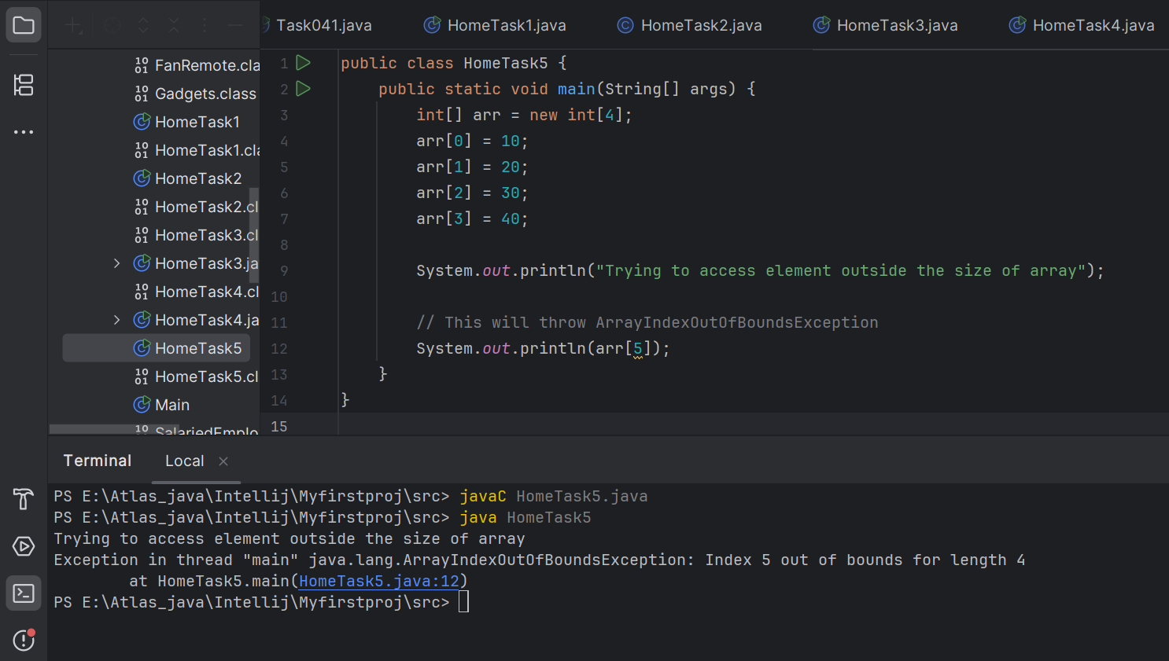

Task 026 - Home Task

**Example:** Now, after declaring and initializing the array we will check how to Traverse the Multidimensional Array using for loop.

// Java Program to Multidimensional Array

​

// Driver Class

public class multiDimensional {

// main function

public static void main(String args[])

{

// declaring and initializing 2D array

int arr[][] = { { 2, 7, 9 }, { 3, 6, 1 }, { 7, 4, 2 } };

​

// printing 2D array

for (int i = 0; i < 3; i++) {

for (int j = 0; j < 3; j++)

System.out.print(arr[i][j] + " ");

​

System.out.println();

}

}

}

**Output**

2 7 9

3 6 1

7 4 2

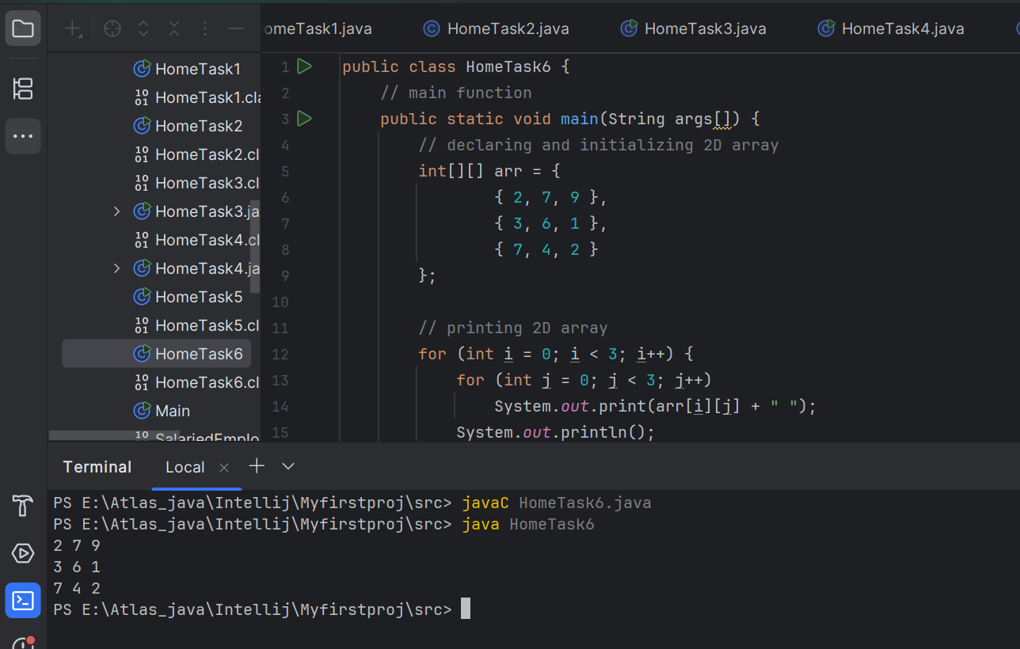

Task 27 - Home task

// Java program to demonstrate

// passing of array to method

​

public class Test {

// Driver method

public static void main(String args[])

{

int arr[] = { 3, 1, 2, 5, 4 };

​

// passing array to method m1

sum(arr);

}

​

public static void sum(int[] arr)

{

// getting sum of array values

int sum = 0;

​

for (int i = 0; i < arr.length; i++)

sum += arr[i];

​

System.out.println("sum of array values : " + sum);

}

}

**Output**

sum of array values : 15

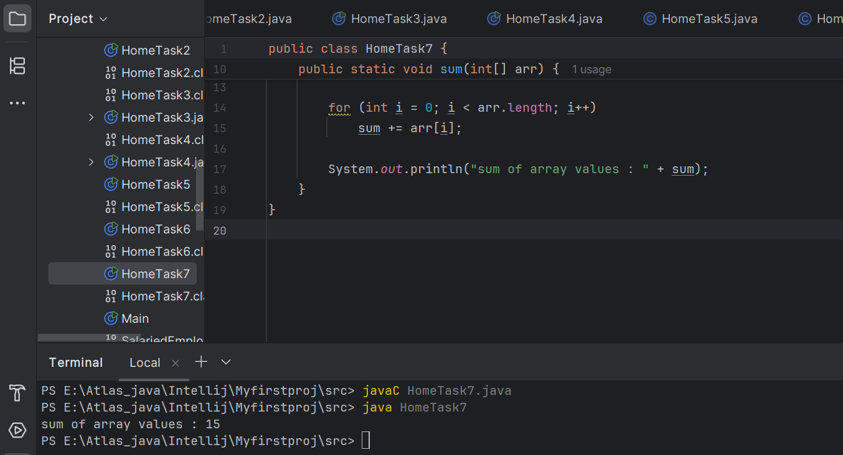

Task 28 - Home Task

// Java program to demonstrate

// return of array from method

​

class Test {

// Driver method

public static void main(String args[])

{

int arr[] = m1();

​

for (int i = 0; i < arr.length; i++)

System.out.print(arr[i] + " ");

}

​

public static int[] m1()

{

// returning array

return new int[] { 1, 2, 3 };

}

}

**Output**

1 2 3

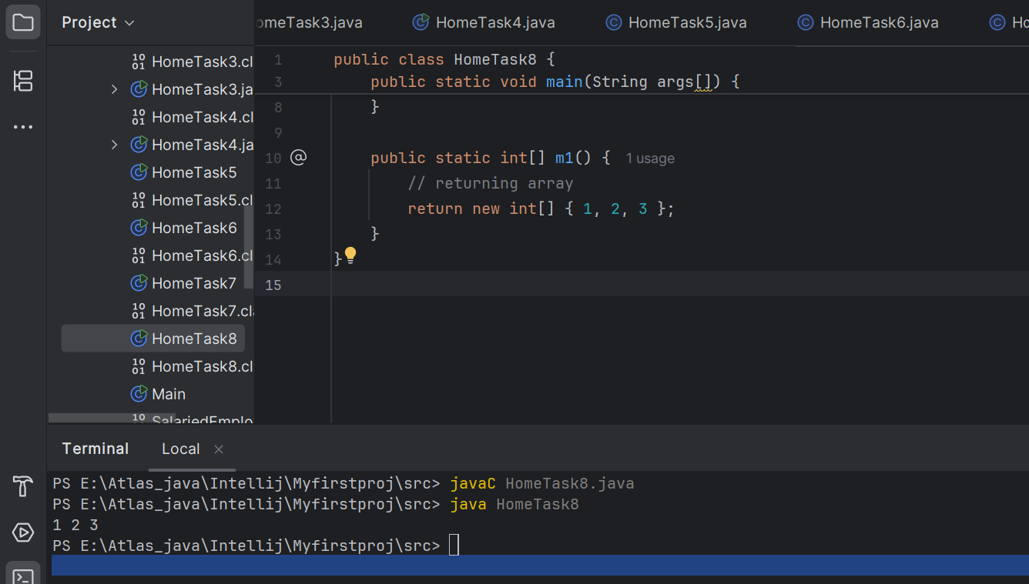

Task 29

class Test {

public static void main(String args[])

{

int intArray[] = { 1, 2, 3 };

int cloneArray[] = intArray.clone();

intArray[1]= 4;

// will print false as shallow copy is created

System.out.println(intArray == cloneArray);

for (int i = 0; i < cloneArray.length; i++) {

System.out.print(cloneArray[i] + " ");

}

System.out.println("Original Array");

for (int i = 0; i < cloneArray.length; i++) {

System.out.print(intArray[i] + " ");

}

}

}

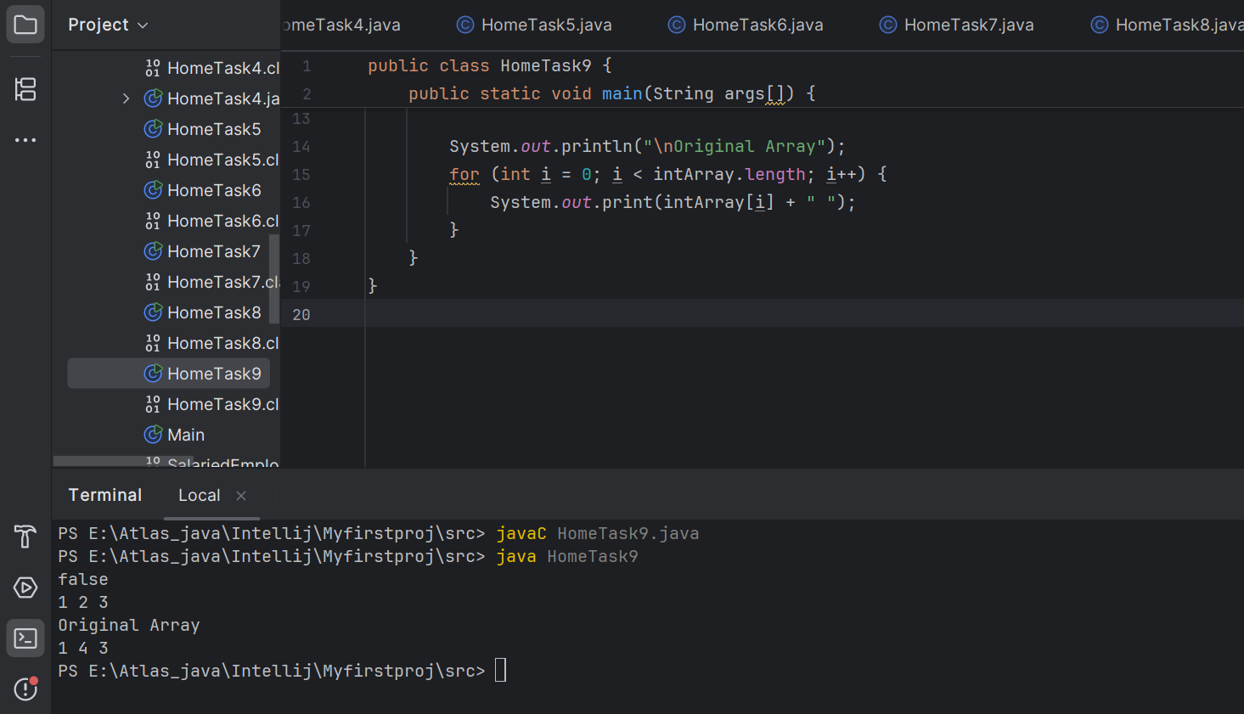

sHALLOW copy and Deep copy

| **Copy Type** | **Description** | **Example** |
| --- | --- | --- |
| **Shallow Copy** | Both arrays share references to the same objects | **Shallow Copied Array :** [[obj1, obj2] , [obj3], [obj4]] |
| **Deep Copy** | New instances of objects are created. | **Deep copied array :** [[newObj1, newObj2] , [newObj3], [newObj4]] |

+++++++++++++++++++++++++++++++++++++++++=============+++++++++++++++++

**Task 21 to Task 30 – home tasks — plz refer Doc 17 Arrays in java..**

++++++++++++++++++++++++++++++++++++++++++++++++++++++++++++++++++++++++

=========================================+++++++++++++++++++++++++++++++

**OOPS (Object Oriented Programming)** ++++++++++++++++++++++++++++++++++++++++++==============================

Inheritance, Polymorphism, Encapsulation, Abstraction, Interfaces, Exception Handling,

4 pillers of OOPS

Inheritance, Polymorphism, Encapsulation, Abstraction

Inheritance : getting parental characteristics

Inheritance —- > over riding

Types of inheritance

Single inheritance

Multi level inheritance

hYBRID IN

Hyrarical inhe

Multiple Inheritance — not supported in java

Due to diamond problem

Task 031

class Calculation {

int z;

public void addition(int x, int y) {

z = x + y;

System.out.println("The sum of the given numbers:"+z);

}

public void Subtraction(int x, int y) {

z = x - y;

System.out.println("The difference between the given numbers:"+z);

}

}

public class My_Calculation extends Calculation {

public void multiplication(int x, int y) {

z = x * y;

System.out.println("The product of the given numbers:"+z);

}

public static void main(String args[]) {

int a = 20, b = 10;

My_Calculation demo = new My_Calculation();

demo.addition(a, b);

demo.Subtraction(a, b);

demo.multiplication(a, b);

}

}

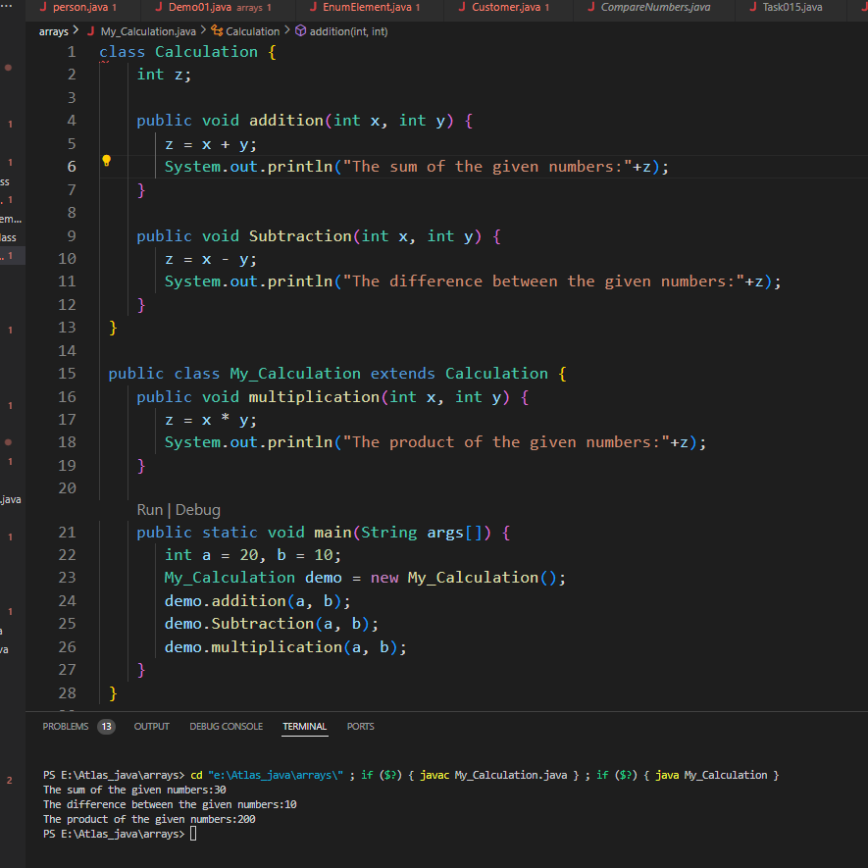

—--Task 032 ------------------------------------------------------------------------------

In the above code add a class clock — and try to extend calculation and clock in the my calculation class.. Is it possible ???? give reason.

class clock {

—--

—--

}

class my_calculation extends calculation , clock{ // multiple inheritance

// —---------------------------------- ???????????????????????

}

**No, it is not possible to extend both Calculation and Clock classes using multiple inheritance in Java. Java does not support multiple inheritance with classes.**

Task 033

—-----------------------------------------------------------------

class Customer {

Void purchage_list{

Int cos = 40t;

String items = “Tomatoes”;

}

}

public class Mart extends Customer {

Void billing(){

String items = “onions”;

Int cost = 30;

}

Psvm (String[] args) {

Super.items = “Potatoes”

Super.cost = 50;

Sout(items);

sout(cost);

sout”(%%%%%%%%%%%%%%”);

Sout(super.items);

sout(suer.cost);

}

}

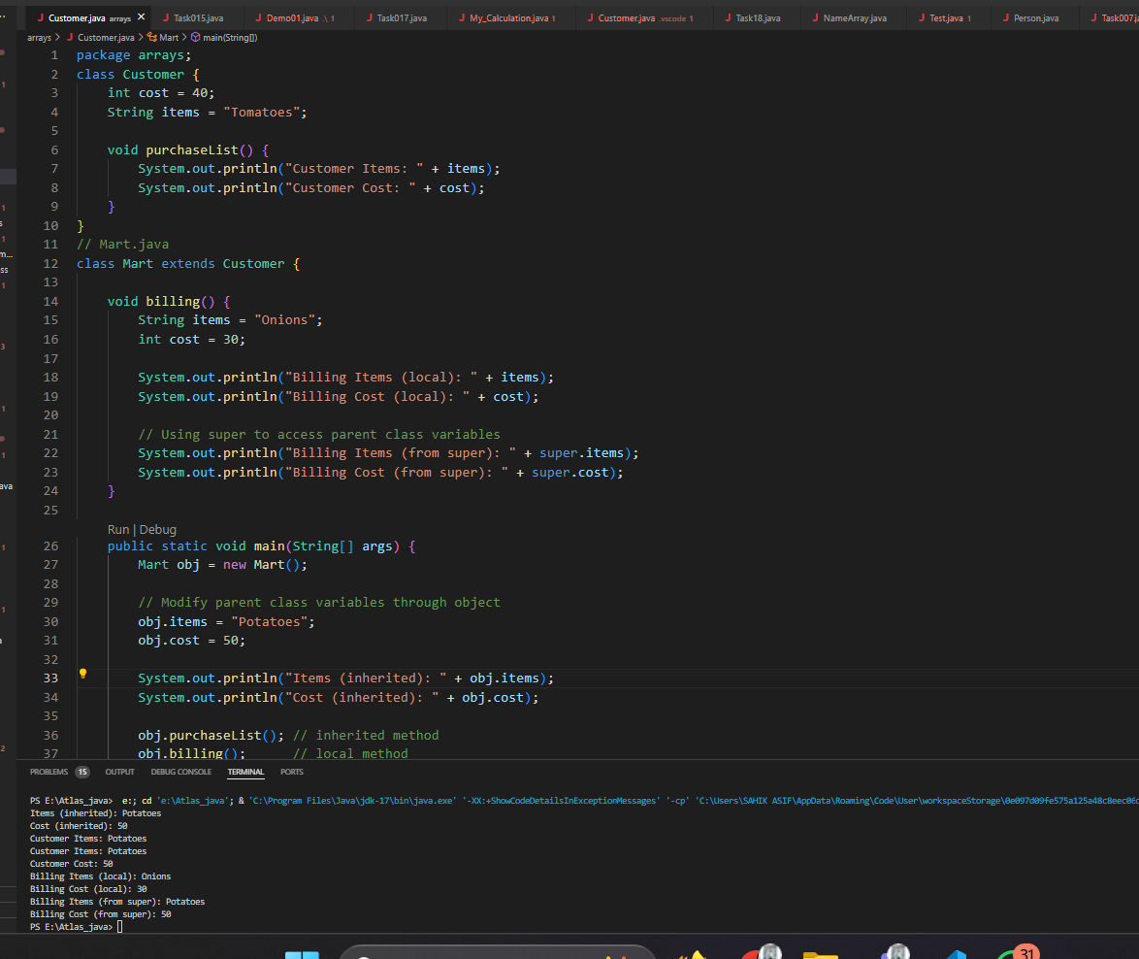

—----------------------------------------------------------------------------------------------------------------------------

Polymorphism – Method overloading

-------------------------------------------------------------------------------------------------------------------------------

Two or more methods having the same name but differ -

No of parameters

Type of parameters

Sequence of parameters

-------------------------------------------------------------------------------------------------------------------------------

**No of parameters:**

Task 034

Void add(int x, int y){

Sout —> x and y values

}

Void add(int x, int y, int z){

Sout —-> x, y, z values

}

psvm(){

add(10,20,30);

add(50,100);

}

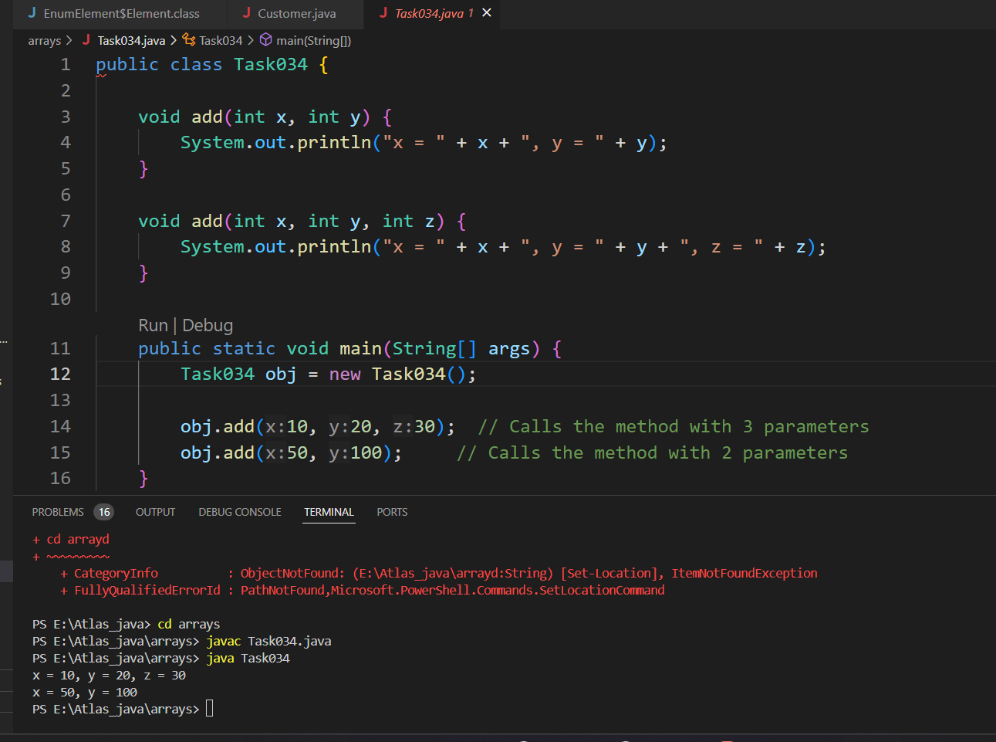

**Type of parameters**

Task 035

Void add(char x, char y){

Sout —-> x, y values

}

Void add(int x, int y) {

Sout —> x, y values

}

psvm(){

add(‘d’, ‘a’);

add(100, 100);

}

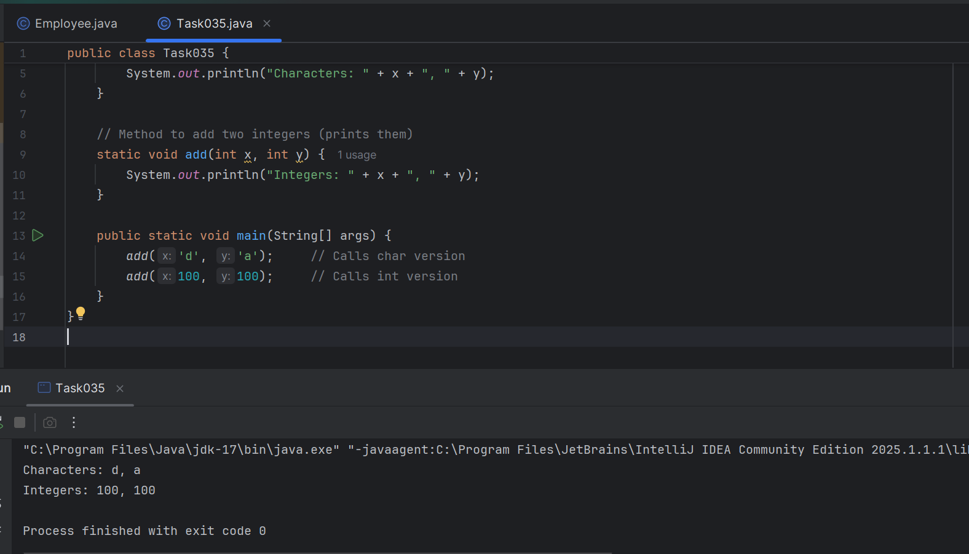

**Sequence of Parameters**

Task 036

Void add(int x, float y){

Sout → x, y values

}

Void add(float x, int y){

}

Void add(float x, int y){

Sout → x, y

}

psvm(){

add(10.50f, 60);

add(100, 80.80f)

}

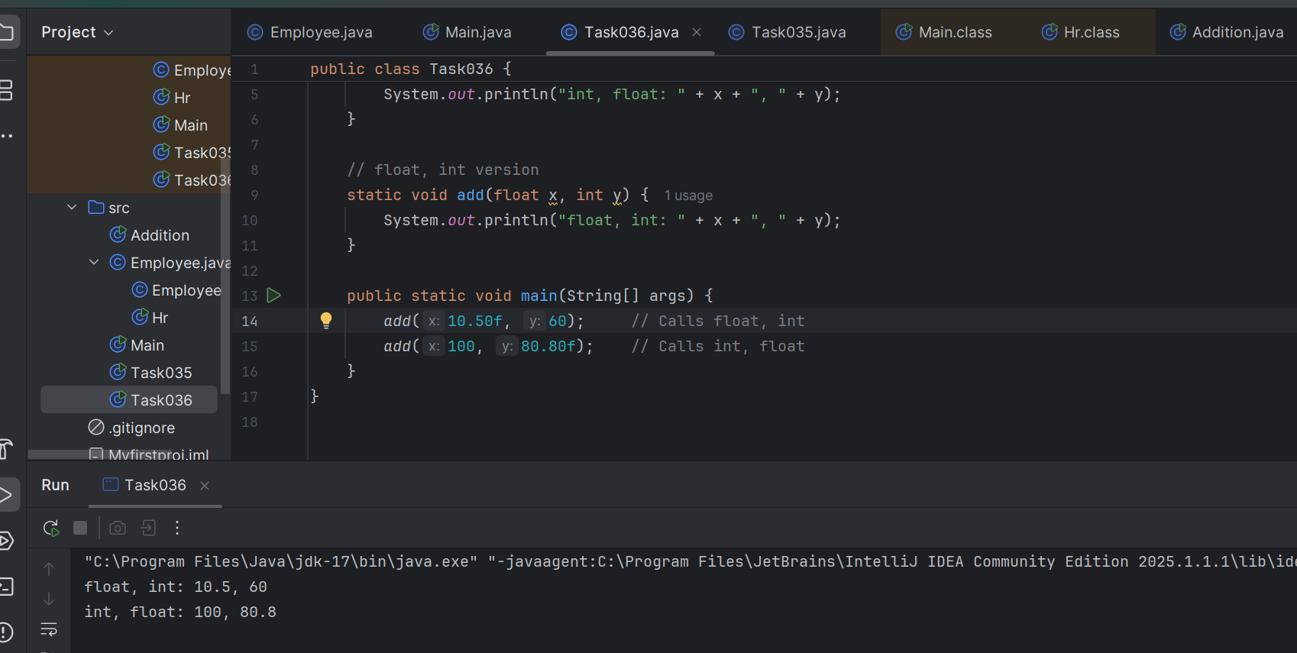

========================================================================

Encapsulation

========================================================================

Data hiding – secured data

Access modifiers 👍

private

Protected – inheritance

Public – anyone can access

Task 037:

Class employee{

Private int pwd;

Protected int Salary;

Public empid:

employee(){ // constructors are methods having same name as clas name (we have in c++)

}

~employee(){// destructors used in c++ but not in java

}

}

Class Hr extends Employee {

super.pwd = 1254; //===============> ??????

super.Salary = 50000; //==================> ?

Super.empid = 10001; // ======================>?

psvm(){

}

}

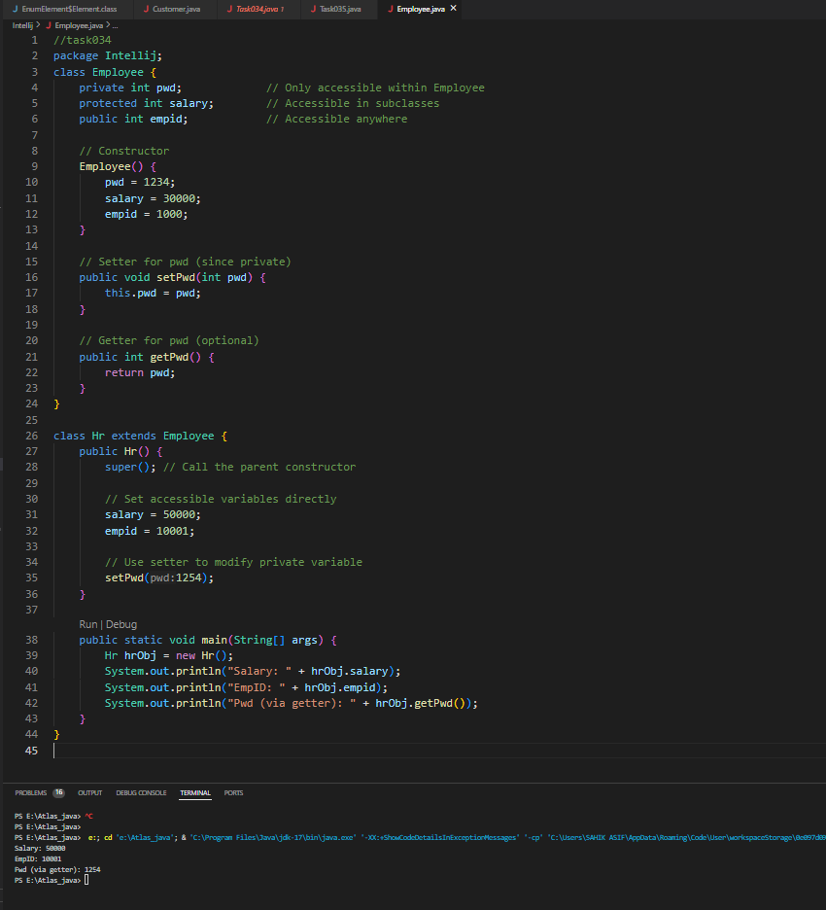

========================================================================

Abstraction ========================================================================

Java Abstract Classes

A Java class which contains the abstract keyword in its declaration is known as abstract class.

Java abstract classes may or may not contain abstract methods, i.e., methods without body ( public void get(); )

But, if a class has at least one abstract method, then the class must be declared abstract.

If a class is declared abstract, it cannot be instantiated.

To use an abstract class, you have to inherit it from another class, provide implementations to the abstract methods in it.

If you inherit an abstract class, you have to provide implementations to all the abstract methods in it.

Task 038 :

/* File name : AbstractDemo.java */

public class AbstractDemo {

public static void main(String [] args) {

/* Following is not allowed and would raise error */

Employee e = new Employee("George W.", "Houston, TX", 43);

System.out.println("\n Call mailCheck using Employee reference--");

e.mailCheck();

}

}

abstract class Employee {

private String name;

private String address;

private int number;

public Employee(String name, String address, int number) {

System.out.println("Constructing an Employee");

this.name = name;

this.address = address;

this.number = number;

}

public double computePay() {

System.out.println("Inside Employee computePay");

return 0.0;

}

public void mailCheck() {

System.out.println("Mailing a check to " + this.name + " " + this.address);

}

public String toString() {

return name + " " + address + " " + number;

}

public String getName() {

return name;

}

public String getAddress() {

return address;

}

public void setAddress(String newAddress) {

address = newAddress;

}

public int getNumber() {

return number;

}

}

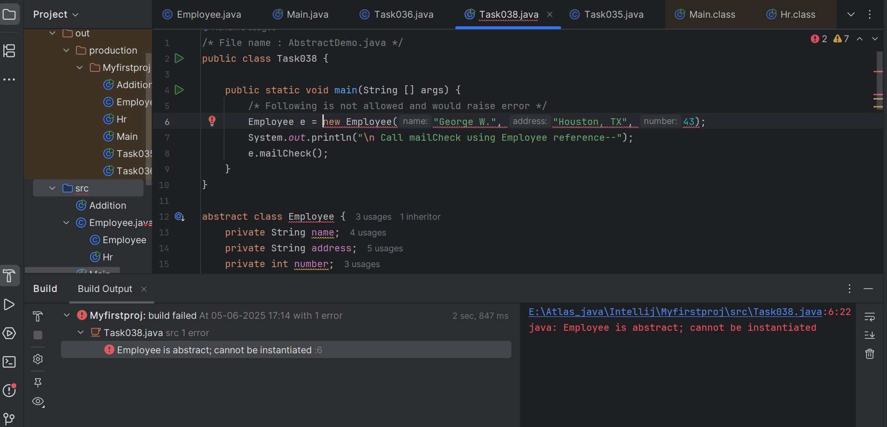

Task 039:

Rewrite the above code to give the output without errors..

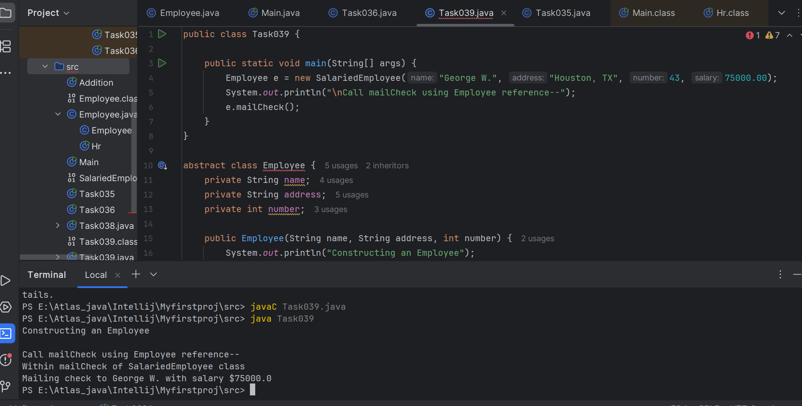

Task 040

// Working of Abstraction in Java

abstract class Gadgets {

abstract void turnOn();

abstract void turnOff();

}

// Concrete class implementing the abstract methods

class TVRemote extends Gadgets {

@Override

void turnOn() {

System.out.println("TV is turned ON.");

}

@Override

void turnOff() {

System.out.println("TV is turned OFF.");

}

}

// Main class to demonstrate abstraction

public class Main {

public static void main(String[] args) {

Gadgets remote = new TVRemote();

remote.turnOn();

remote.turnOff();

}

}

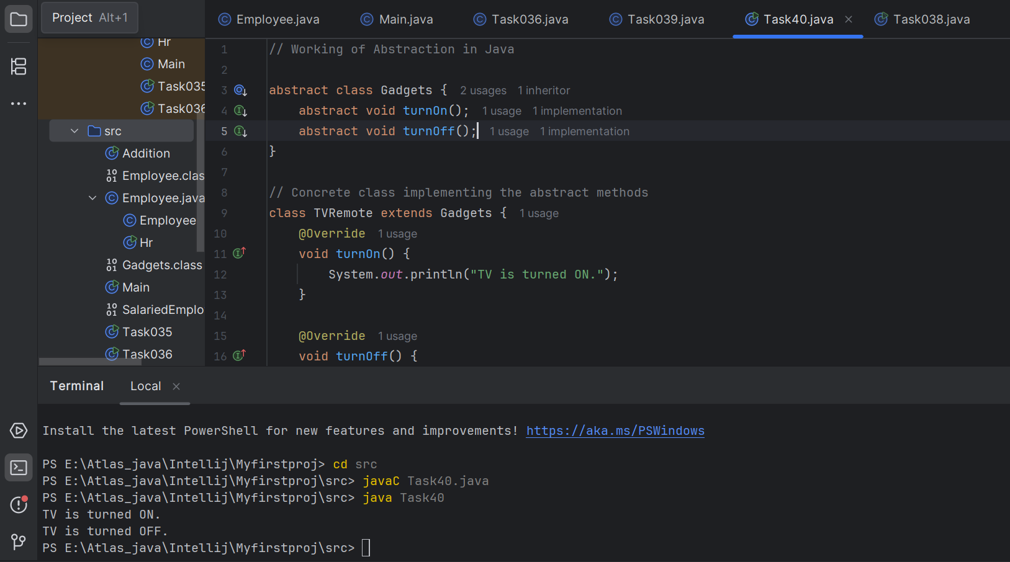

//Task 040

// Working of Abstraction in Java

abstract class Gadgets {

abstract void turnOn();

abstract void turnOff();

}

// Concrete class implementing the abstract methods

class TVRemote extends Gadgets {

@Override

void turnOn() {

System.out.println("TV is turned ON.");

}

@Override

void turnOff() {

System.out.println("TV is turned OFF.");

}

}

class ACRemote extends Gadgets {

@Override

void turnOn() {

System.out.println("AC is turned ON.");

}

@Override

void turnOff() {

System.out.println("AC is turned OFF.");

}

}

// Main class to demonstrate abstraction

public class Main {

public static void main(String[] args) {

Gadgets remote = new TVRemote();

Gadgets remote = new ACRemote();

remote.turnOn();

remote.turnOff();

Gadgets remote = new FanRemote();

Gadgets remote = new CoolerRemote();

remote.turnOn();

remote.turnOff();

}

}

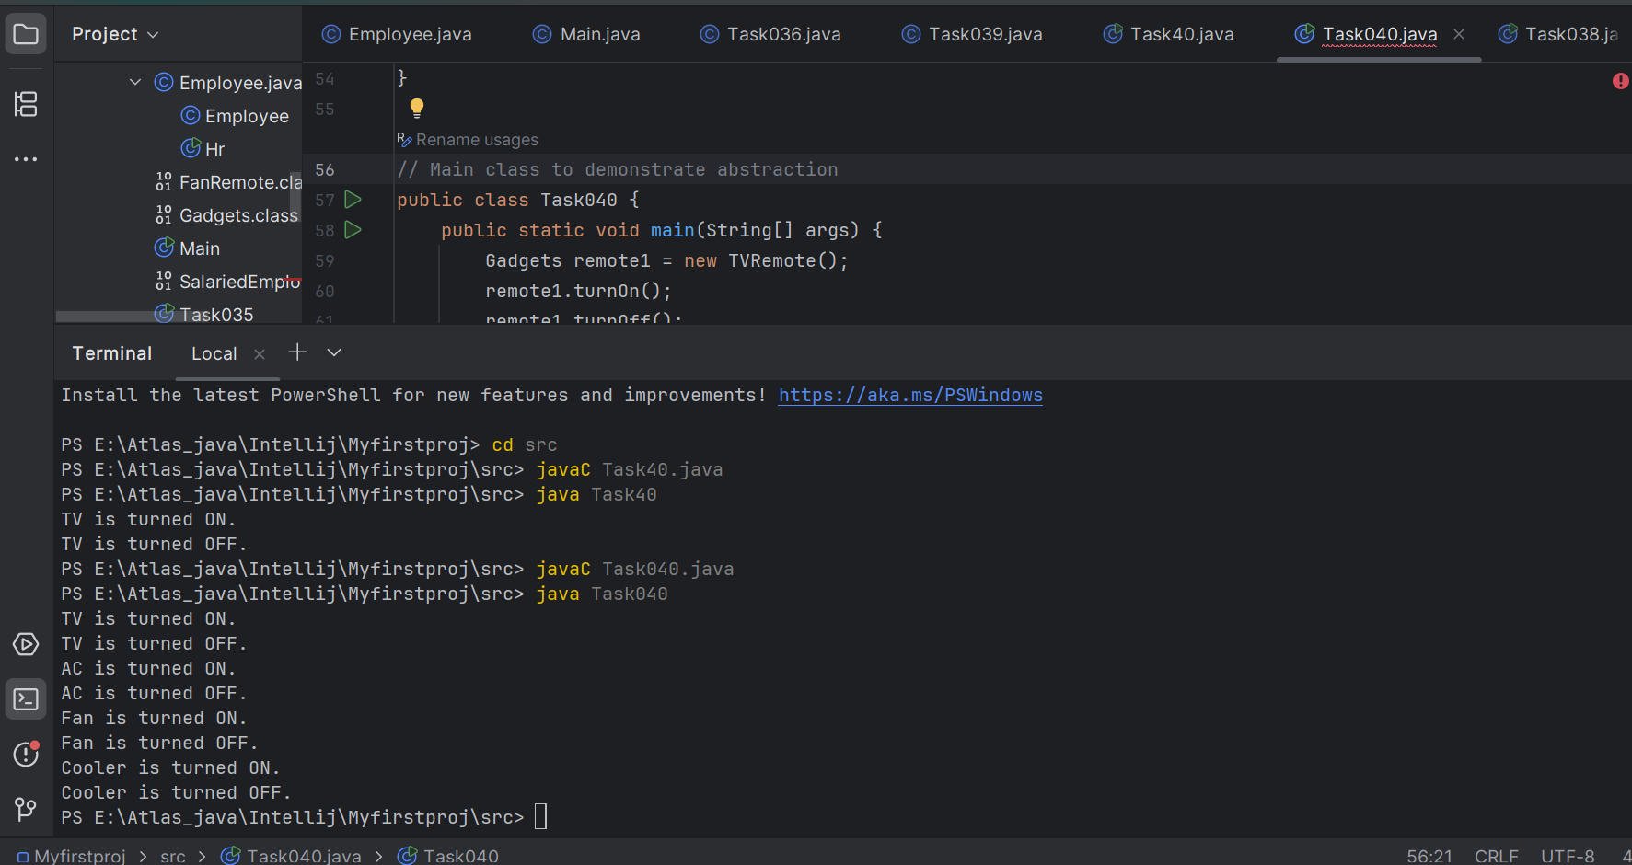

========================================================================

Interfaces in java

========================================================================

An **Interface in Java** programming language is defined as an abstract type used to specify the behaviour of a class. An interface in Java is a blueprint of a behaviour. A Java interface contains static constants and abstract methods.

**Key Properties of Interface:**

* The interface in Java is a mechanism to achieve [abstraction](https://www.geeksforgeeks.org/abstraction-in-java-2).
* By default, **variables in an interface are public, static, and final.**
* It is used to achieve abstraction and [multiple inheritance](https://www.geeksforgeeks.org/java-and-multiple-inheritance/) in Java.
* It **supports loose coupling** (classes depend on behavior, not implementation).
* In other words, i**nterfaces primarily define methods that other classes must implement.**
* An interface in Java defines a set of behaviours that a class can implement, usually representing an IS-A relationship, but not always in every scenario.

Task 041

import java.io.*;

// Interface Declared

//Driver Code Ends

interface testInterface {

// public, static and final

final int a = 10;

// public and abstract

void display();

}

// Class implementing interface

class TestClass implements testInterface {

// Implementing the capabilities of

// Interface

public void display(){

System.out.println("Myclass");

}

}

class Myclass

//Driver Code Starts

{

public static void main(String[] args)

{

TestClass t = new TestClass();

t.display();

System.out.println(t.a);

}

}

