Day 1

Employee ID: 201933938

Login ID: iamasif

Name: Shaik Asif

SDLC: Software development life cycle.

Task1:

**What is SDLC?**

It is a process used to developing software applications from starting like planning to execution

It involves several steps like planning, designing, developing, testing and deployment & maintenance.

Task2:

**Why is SDLC ?**

To give a smoother delivery to customers. We can develop the project with good quality, well planned and structural projects. Mainly delivering the results on time.

Task3:

**Stages in SDLC:**

1. Planning
2. Defining requirements
3. Design
4. Development
5. Testing
6. Deployment & maintenance

Task4:

1. **Waterfall Model**

* Simple to use
* Best suits for small, well defined projects
* Changes and difficult and costly once a phase is completed
* Minimal client interaction during development

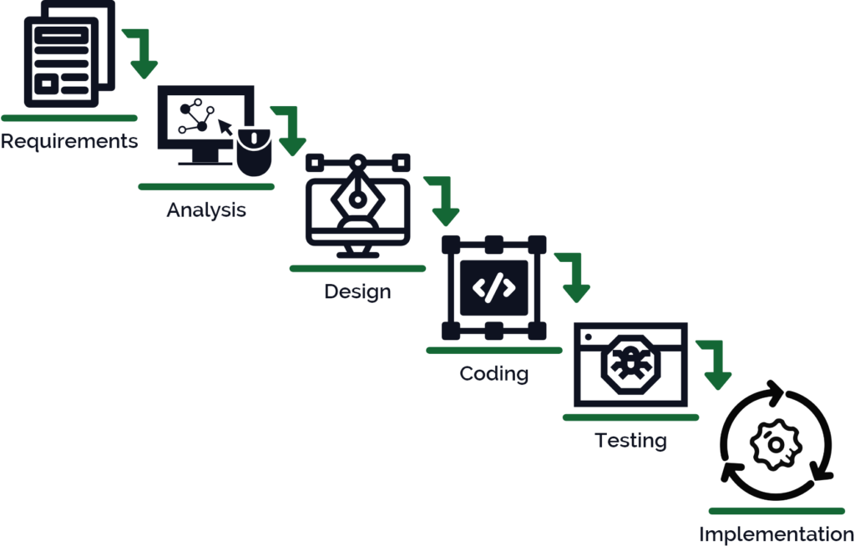

1. **Agile Model**

* Iterative & incremental development
* Customer collaboration over project negotiation
* Welcome changing requirements
* Face to face communication
* Sustainable development

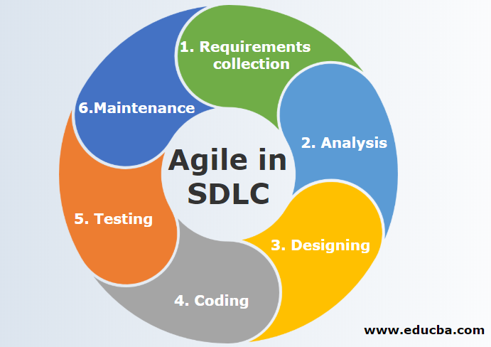

1. **V- Model**

* Sequential and structured
* Early test planning
* High reliability and quality focus
* Clear documentation
* Low risk for well understood requirements

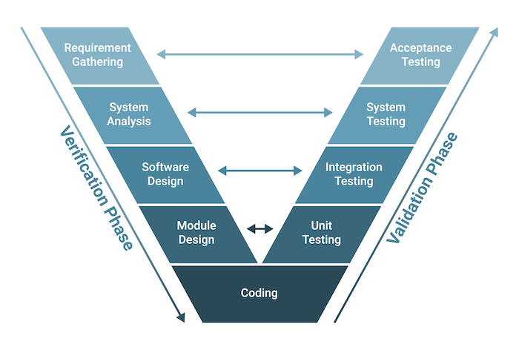

1. **Iterative model**

* Development in repeated cycles
* PARTIAL IMPLEMENTATION IN EACH ITERATION
* FLEXIBILITY REQUIREMENTS
* Risk management
* Testing in every iteration

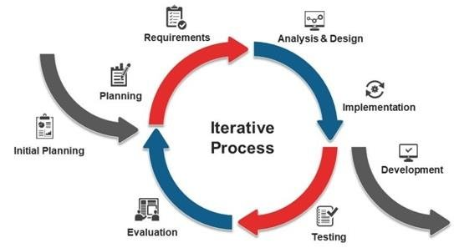

Task5:

**What are network types ?**

1. LAN ( Local area network )
2. WAN (wide area network )
3. WLAN(wireless local area network )
4. PAN (personal area network )

Task6:

**What are the types of servers ?**

1. **Web server:** Hosts websites and delivers web pages to users via HTTP/HTTPS.
2. **Database server:** stores, manages and processes data.
3. **DNS server (domain name system ):** translates domain names into IP addresses.
4. **FTP (file transfer protocol):** Facilitates the uploading and downloading of files over a network

**Task 8:**

**what is TCP and UDP? What is the difference?**

* TCP (Transmission Control Protocol)
* UDP (User Datagram Protocol)

both are core protocols of the Internet Protocol (IP) suite used for sending data over networks.

| **FEATURES** | **TCP** | **UDP** |
| --- | --- | --- |
| CONNECTIONS | YES (CONNECTION ORIENTED) | NO (CONNECTIONS) |
| SPEED | SLOWER | FASTER |
| ERROR CHECKING | YES | OPTIONAL OR MINIMAL |
| USE CASE EXAMPLES | HTTP, FTP, MAIL | DNS, STREAMING |

Task 9:

**What do you know about mac address ? What is the difference between Mac address and IP address.**

* MAC- Media Access Control address
* It is a unique identifier assigned to a **network interface card (NIC)** by the hardware manufacturer.
* It is used for communication within a local network like wifi.

**MAC addresses** are like your **device's fingerprint they** never change.

**IP addresses** are like your **home address** they tell the world how to reach you, but can change if you move networks.

Task 10:

**What is the OSI Model?**

* The **OSI model** (Open Systems Interconnection model)
* It is a **conceptual framework** used to understand and design how data moves through a network.

It divides the network communication process into **7 layers**, each with specific functions.

1. **Application Layer**: Closest to the user interfaces with software.
2. **Presentation Layer**: Formats or translates data
3. **Session Layer**: Manages sessions and connections between applications.
4. **Transport Layer**: Ensures reliable or unreliable delivery of data.
5. **Network Layer**: Handles routing and logical addressing.
6. **Data Link Layer**: Manages MAC addresses and frames within local networks.
7. **Physical Layer**: Deals with the actual physical connection

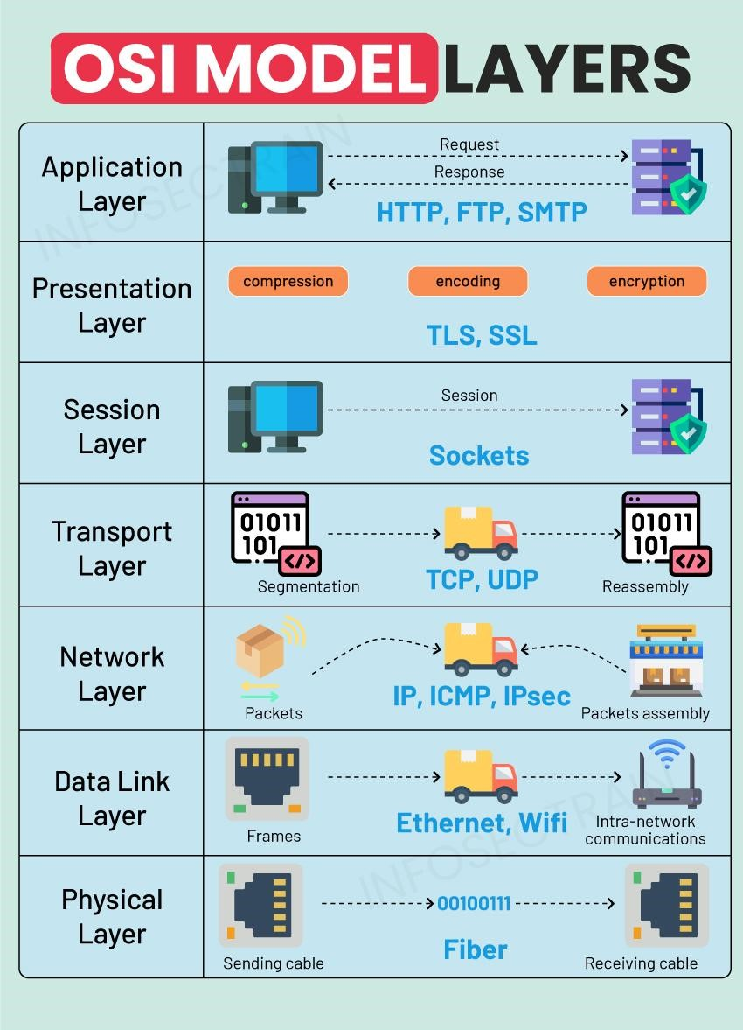

Task 11:

**What is an IPv4 address?**

IPv4 (Internet Protocol version 4) is the fourth version of the Internet Protocol, and it's the most widely used protocol to identify devices on a network using an addressing system.

IPv4 address format: 32-bit numeric address written as four decimal numbers, separated by dots.

Example: 192.168.0.1

| **Class** | **Starting Bits** | **Range** | **Default Subnet Mask** | |  | | --- |  | **Usage** | | --- | |
| --- | --- | --- | --- | --- | --- | --- |
| A | 0xxx | 1.0.0.0 – 126.255.255.255 | 255.0.0.0 | Very large networks |
| B | 10xx | 128.0.0.0 – 191.255.255.255 | 255.255.0.0 | Medium-sized networks |
| C | |  | | --- |  | 110x | | --- | | 192.0.0.0 – 223.255.255.255 | 255.255.255.0 | Small networks |
| D | 1110 | 224.0.0.0 – 239.255.255.255 | N/A | |  | | --- |  | Multicasting | | --- | |
| E | 1111 | 240.0.0.0 – 255.255.255.255 | N/A | |  | | --- |  | Reserved (experimental) | | --- | |

Task 12:

**What is a VPN?**

A VPN (Virtual Private Network) is a technology that creates a secure and encrypted connection over a public network (like the internet).

| **Advantage** | **Description** |
| --- | --- |
| Privacy & Anonymity | Hides your IP address and location from websites and ISPs. |
| Data Encryption | Encrypts your internet traffic, protecting it from hackers and surveillance. |
| Access Geo-Blocked Content | Lets you access services/content not available in your region (e.g., Netflix). |
| Bypass Censorship | Helps you access restricted or censored websites in certain countries. |
| Safe Public Wi-Fi Use | Secures your connection on open networks (cafes, airports, etc.). |
| Remote Access for Businesses | Allows employees to securely access company resources from anywhere. |

Task 13:

* **Access VPN**: Connects individual users remotely to a private network over the internet.
* **Site-to-Site VPN**: Connects entire networks (like branch offices) securely over the internet.
* **Intranet VPN**: Securely connects different internal departments or locations of the same organization.
* **Extranet VPN**: Provides secure access to a company’s network for external partners or clients.

Task 14:

### **What is a Node?**

A node in networking is any device that can send, receive, or forward data

### **What is a Link?**

A link is the communication path between two nodes.

Task 15:

**Topology means**: Topology in networking refers to the arrangement of devices (like computers, switches, routers) and how they are connected in a network. It defines the structure of a network both physical (actual layout) and logical (how data flows).

Task 16:

### **Bus Topology:**

* All devices share a single central cable (backbone).
* Simple and cost-effective but prone to collisions and failure if the main cable breaks.

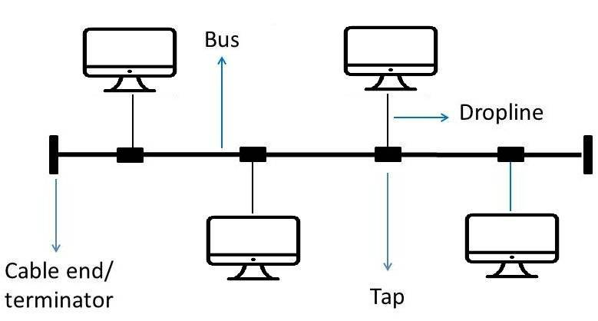

1. **Star Topology:**

* Devices are connected to a central hub or switch.
* Easy to manage and troubleshoot, but the whole network fails if the hub goes down.

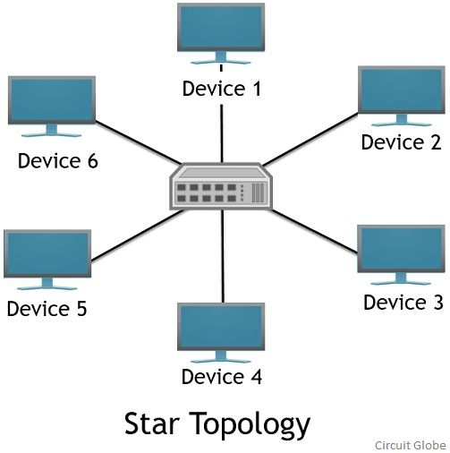

1. **Ring Topology:**

* Each device is connected to two others, forming a closed loop.
* Data travels in one direction (or two in dual-ring), but a single break can affect the network.

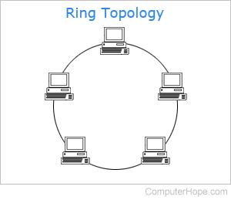

1. **Mesh Topology:**

* Devices are interconnected, either fully (every device to every other) or partially.
* Offers high redundancy and reliability, but is expensive and complex to install.

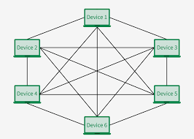

1. **Tree Topology:**

* A hierarchical combination of star and bus topologies.
* Scalable and structured, but failure in the backbone affects all connected branches.

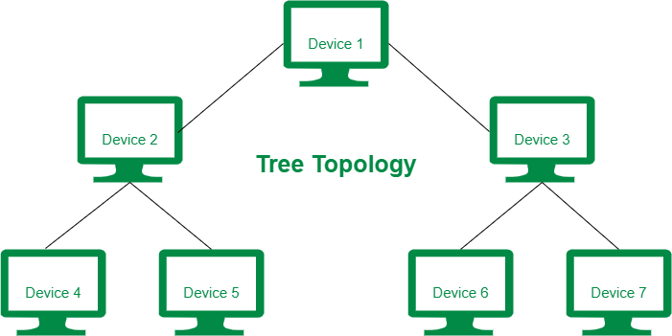

1. **Hybrid Topology:**

* A mix of two or more different topologies.
* Flexible and adaptable to various needs, though design and maintenance can be complex.

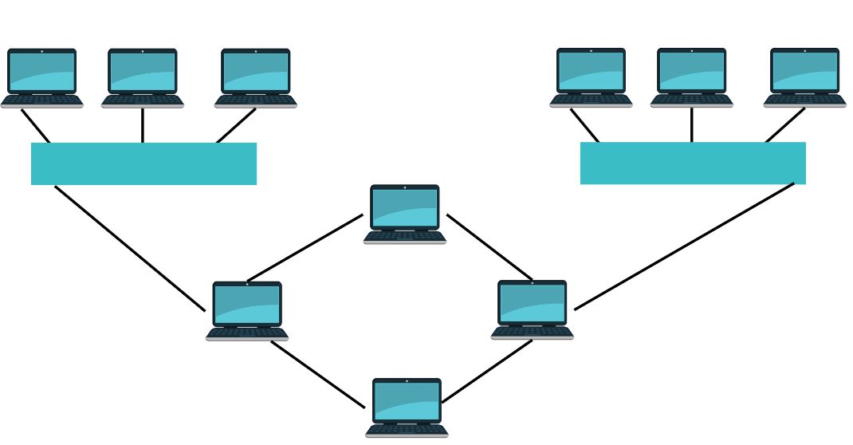

Task 17:

**What is extended bus topology ? its Tree Topology.**

Task 18:

### **What is the use of a router and how is it different from a gateway?**

### **Use of a Router**

A router is a network device that connects multiple networks, typically a local network (LAN) to a wide-area network (WAN) like the internet. Its primary purpose is to route data packets between these networks based on their IP addresses.

The difference is mainly

* Functionality
* Network Type
* Protocol Translation

A router connects networks and routes data between them, usually in an IP-based environment.

A gateway serves as a translator or bridge between different networks or protocols.

Task 19:

**Explain SMTP Protocol with a diagram.**

### **What is SMTP?**

SMTP (Simple Mail Transfer Protocol) is a protocol used for sending and routing emails between email servers on the internet. It is a text-based protocol used by mail servers to send and forward email messages. SMTP is a push protocol, meaning it is used to push emails from the sender to the receiver’s email server.

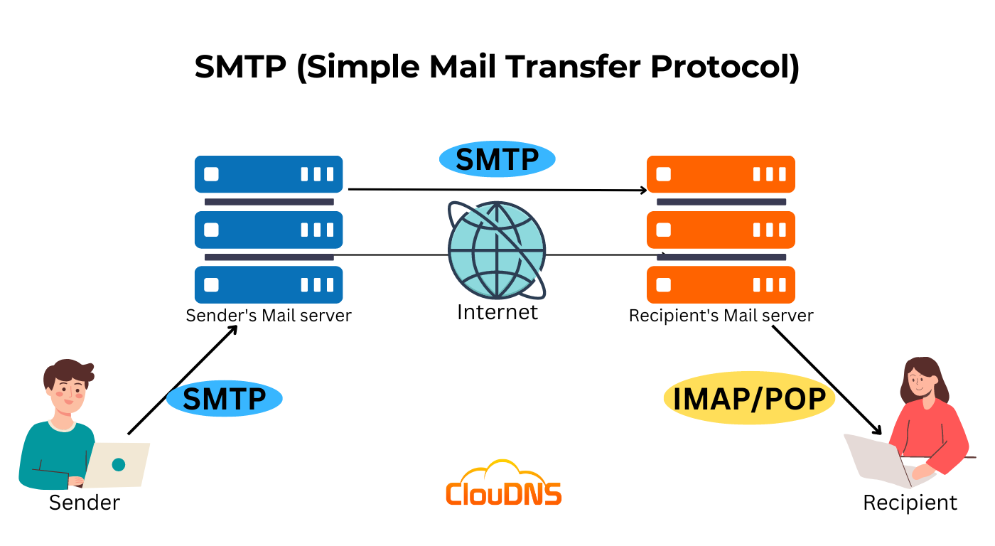

POP stands for Post Office Protocol

IMAP stands for Internet Message Access Protocol

Task 20:

**Differentiate between OSI and TCP/IP**

* **OSI:** Open Systems Interconnection Model
* **TCP/IP:** Transmission Control Protocol / Internet Protocol Model

**Model Type:**

* OSI: A conceptual/reference model used mainly for understanding and teaching networking concepts.
* TCP/IP: A practical model used for real-world data communication over the internet.

**Development:**

* OSI: Developed by ISO (International Organization for Standardization).
* TCP/IP: Developed by the U.S. Department of Defense.

**Number of Layers:**

* OSI: Consists of 7 layers.
* TCP/IP: Consists of 4 layers.

**Layer Structure:**

* OSI: Layers are more strictly separated with distinct functions.
* TCP/IP: Layers may have overlapping functions and are more flexible.

Protocol Dependency:

* OSI: Protocol-independent, does not specify actual protocols.
* TCP/IP: Protocol-specific, defines standard protocols like TCP, IP, HTTP, FTP, etc.

**Application Layer:**

* OSI: Has three layers dedicated to application: Application, Presentation, and Session.
* TCP/IP: Has one combined Application Layer that handles all three functions.

**Usage:**

* OSI: Used mainly as a reference model in academics.
* TCP/IP: Widely implemented in actual internet communication.

**Communication Style:**

* OSI: Follows vertical communication (top-down approach).
* TCP/IP: Follows horizontal communication (real-life interaction between layers).

Task 22:

**What is Low Level Design and High level Design.. Explain**

**High-Level Design (HLD):**

HLD provides a **broad overview** of the system. It outlines the system architecture, components, technologies, and how they interact.

* Focuses on what the system will do.
* Describes modules, components, and interactions.
* Covers architecture diagrams, data flow, tech stack.
* Used by architects and senior developers.

**Low-Level Design (LLD):**

LLD gives a **detailed view** of how each component or module will be implemented.

* Focuses on how the system will do it.
* Includes class diagrams, functions, database schema, API contracts, etc.08:07:31
* Used by developers during actual implementation.

Task 23:

**What is SRS (Software Requirement Specification). explain in 3 to 4 lines with a diagram.**

The Software Requirements Specification (SRS) is a comprehensive document that clearly defines the requirements of a software system. It is created before actual development begins and serves as a blueprint for both developers and stakeholders.

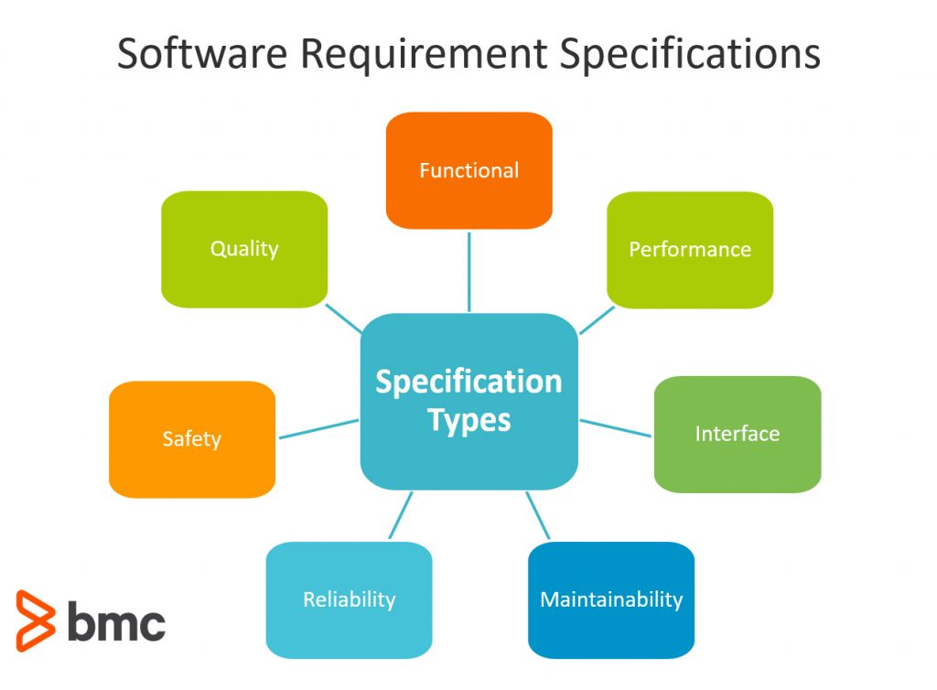

**QUESTIONS:**

### **7. What is Software Configuration Management, and how does it work?**

The process of tracking and regulating changes that occur during the software development lifecycle is known as software configuration management. Any modification made during the development of software must be tracked using a well-defined and controlled process. Any modifications performed during software development are regulated through a well-defined process, thanks to configuration management. Revision control and the establishment of baselines are two SCM procedures.

### **8. What do a Software Project Manager's responsibilities entail?**

The Software Project Manager is in charge of seeing the project through to completion. The Software Project Manager is responsible for ensuring that the entire team follows a methodical and well-defined approach to software development. They also handle project planning, tracking project status, resource management, and risk management.

### **9. What do you know about Scrum impediments?**

Obstacles or challenges that the scrum team faces slow down their work speed are referred to as impediments. An obstacle is anything that tries to prevent the scrum team from getting work "Done." Impediments can take many different forms. Some of the roadblocks include resource shortages or sick team members, technical, operational, and organisational issues, a lack of management support systems, and business issues.

### **10. Briefly explain Scrum methodology in the Agile model.**

Scrum is an agile development approach based on iterative and incremental procedures that are used in the creation of software. It's an agile structure that's adaptable, rapid, flexible, and excellent at delivering value to customers throughout the project's development. Companies of all sizes employ the Agile Scrum technique because of its ability to provide high-end cooperation and efficiency for project-based work. Scrum is a sort of agile approach that breaks projects down into manageable parts known as "sprints." The Agile Scrum methodology is ideal for companies who need to complete projects fast.

### **11. What are Capability Maturity Model(CMM) levels?**

Following are the five Capability Maturity Model Levels:

* Initial: The first step is to create an unstable process environment. The software development process is considered haphazard and even chaotic at times. There are few methods that have been specified, and success is based on individual effort and heroism.
* Repeatable: Work is planned and monitored, making it repeatable. To track cost, schedule, and functionality, basic project management techniques are implemented.
* Defined: This level encompasses written and defined standards that evolve over time and support consistent performance. The work is well defined at this point.
* Managed: Extensive data on the software development process and product quality are gathered. Both the software development process and the end products are quantified and managed.
* Optimized: Work is based on continuous improvement (optimization). The focus on continuously improving process performance is a significant feature of this level.

### **12. What is Capability Maturity Model?**

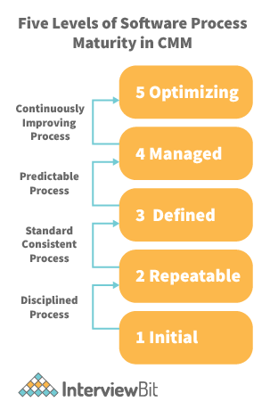

The Capability Maturity Model (CMM) is a cross-discipline and technical paradigm for facilitating and refining software development processes and system improvement. This methodology is at the heart of most management systems that aim to improve the quality of all product and service development and delivery.

### **13. What is Level-0 DFD?**

Context Diagram is another name for DFD Level 0. It's a high-level overview of the entire system or process that's being studied or modelled. It's meant to be a quick peek into the system, displaying it as a single high-level process with its connections to external entities. Stakeholders, business analysts, data analysts, and developers should all be able to understand it readily.

### **14. How can DDLC and SDLC work together?**

The DDLC (Documentation Development Life Cycle) is a software documentation development life cycle used by technical documenters to prepare software documentation. The life cycle is followed in tandem with the SDLC, as testers and developers work on the programme at the same time. Because the documentation requires input and feedback from the various phases of the SDLC, the DDLC has stages that are comparable to the SDLC.

### **15. What are different types of prototype model?**

There are four types of Prototyping models:

* Rapid Throwaway prototypes.
* Evolutionary prototype.
* Incremental prototype.
* Extreme prototype.

### **16. What is FRS document?**

This document captures the user's voice from the outside, or the end user's perspective. A Business System Analyst creates it (BSA). This paper demonstrates how a system will react when a user interacts with it in order to meet the BRD and SRD standards. The key area of interest for software experts is the Functional Requirement Specification (FRS). An FRS is useful for software testers to learn the situations in which the product is intended to be tested, just as it is for developers to understand what product they are planning to produce. An FRS's ultimate purpose is to meet all of the requirements outlined in the SRS and BRS regulations.

### **17. What is the Software release process?**

The Software Development Life Cycle (SDLC) release phase is historically connected with production, deployment, and post-production operations, which generally include software maintenance and support. So, release management is the process of managing, planning, scheduling, and controlling a full software development at every stage and environment, including testing and releasing software releases.

### **18. What is the use of JAD session?**

JAD is a strategy for defining business system requirements that are commonly utilised in the early phases of a systems development project. JAD's goal is to bring MIS and end-users together in a structured workshop setting in order to extract outcome system needs. It allows clients and developers to swiftly agree on a project's fundamental scope, objectives, and specifications

## **SDLC MCQ**

1.

A feasibility study using the SDLC model is conducted to

determine whether or not the project is technically possible

determine whether the proposal is financially viable

**Both a and b**

None of the above

2.

A well-documented life cycle model aids in the detection of what during the development phase?

Inconsistencies

Redundancies

Omission

**All of the above**

3.

How many lines of code does the Build & Fix Model suit for programming exercises?

**100-200**

300-400

600-700

Above 800+

4.

In which life cycle does regression testing play a significant role?

Waterfall model

V model

Iterative model

**All of the above**

5.

What determines if the project should go forward?

**feasibility assessment**

opportunity identification

system evaluation

program specification

6.

What is the most significant disadvantage of employing the RAD Model?

**Developers/designers that are highly specialized and skilled are required.**

Component reusability is improved.

Encourages client/customer input.

Increases component reusability.

7.

Which of the following developmental models is incremental?

Prototyping, V model, Agile

**Prototyping, RAD, Agile, RUP**

Prototyping, V model, RAD, Agile, RUP

All of the above

8.

Which of the following is an Agile development characteristic?

Shared code ownership

Test-Driven Development

Implement the simplest solution to meet today's problem

Continual feedback from customer

**All of the above**

9.

Which of the following steps in the SDLC framework are valid?

Requirement Gathering

Software Design

System Analysis

**All of the above**

10.

Who is in charge of system development, staffing, budgeting, and reporting, as well as ensuring that deadlines are met?

**Project managers**

Network engineers

Graphic designers

Systems analysts