Day 2

Employee ID: 201933938

Login ID: iamasif

Name: Shaik Asif

Day 2 - 15th May 2025

DevOps / Cloud Fundamentals

Devops Basics

"Introduction to Git, Git- Tracking your changes, Git understanding index area and local repositories, Git branches, Merging branches in Git.

Introduction to cloud, Introduction to Jenkins, Introduction to Chef, Introduction to Containers, Introduction to DevOps — CI/CD, Meaning, Principles & Examples, DevOps Lifecycle — Different Phases Explained with Examples, Introduction to Docker, Purpose of using Docker."

—---------------------------------------------------------------------------------

Git

Repo

Public or private

Push -

Pull

Commit -

.gitignore

.md

—--------------

Git status

Git add .

Git add file name

Git commit -m “msg here”

11.47 to 11.52

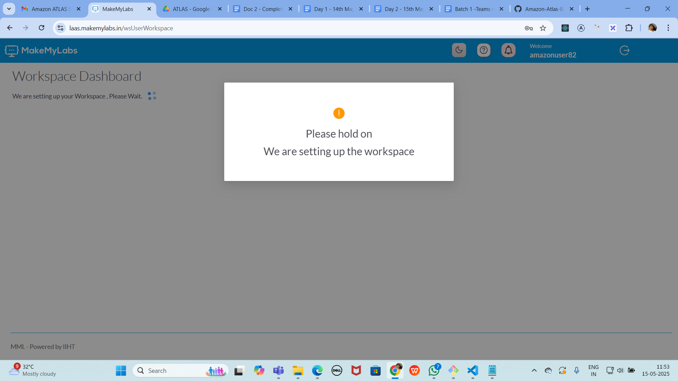

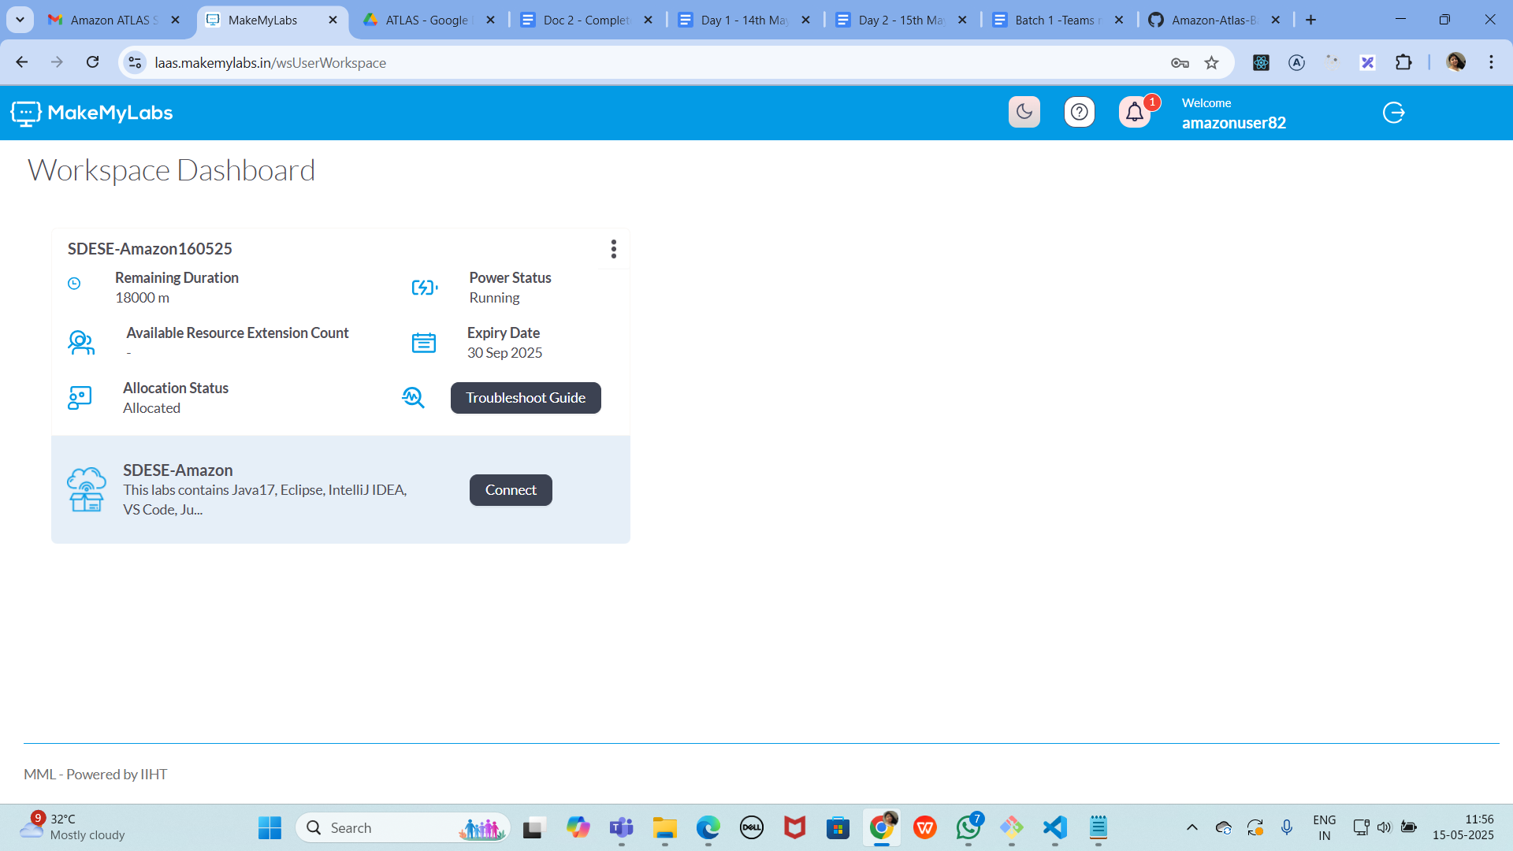

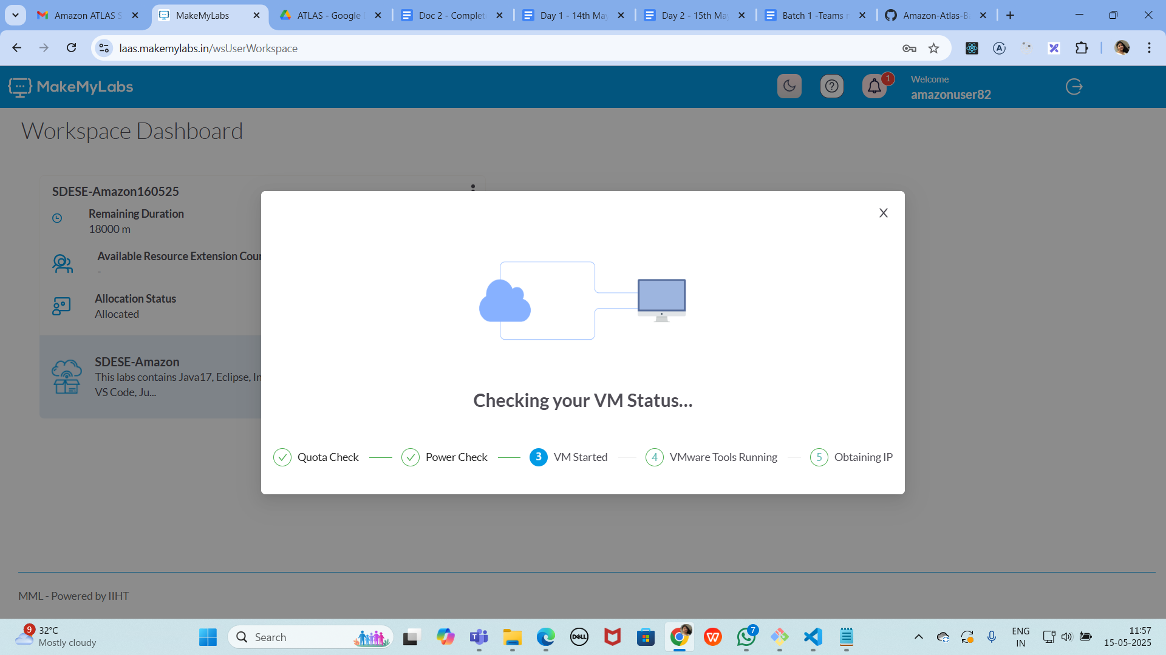

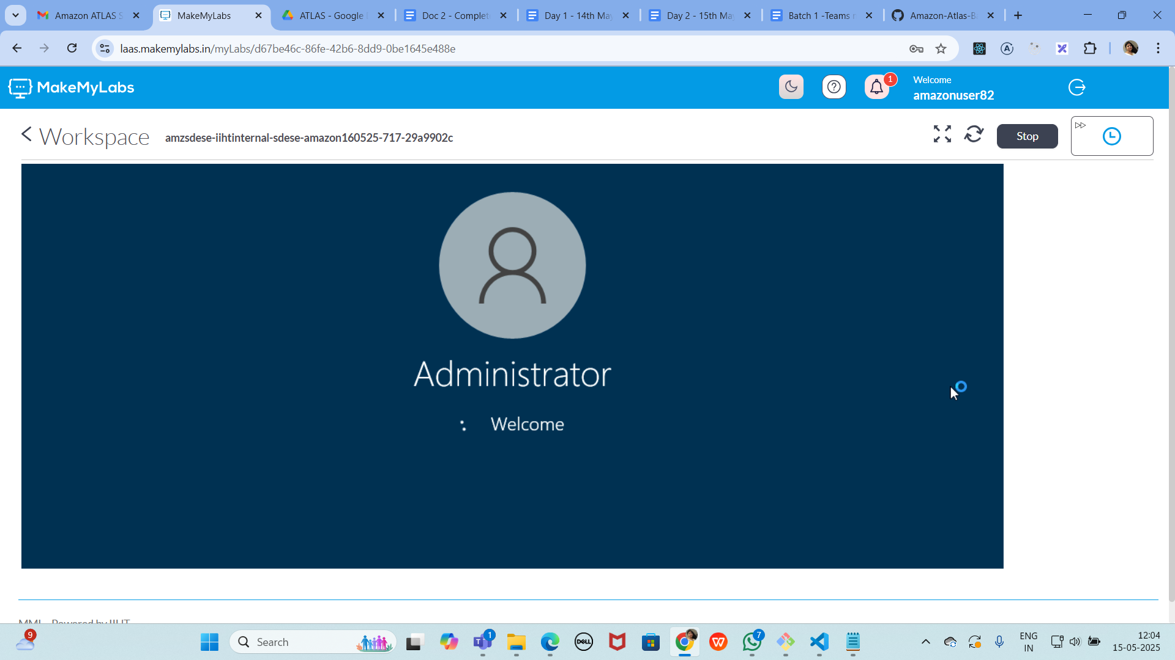

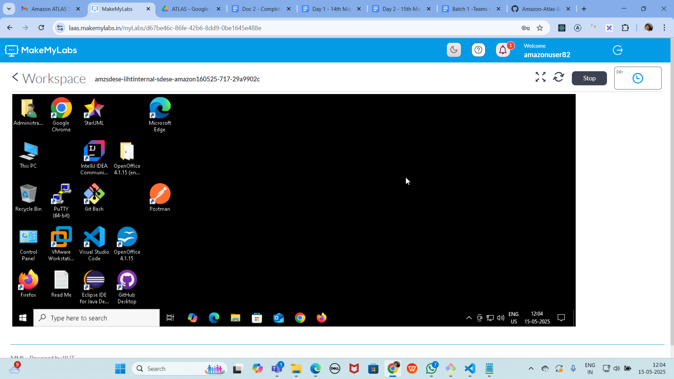

GIt commands:

Git status

Git init

Git add “filename”

Git commit -m “type msg”

Git clone url

Git remote add origin url

Git push origin main

Git config –global user.email “email id”

Git config –global user.name “name here”

Git status

Git log

GIT Clone should give you something like this..

PRASUNA@DESKTOP-0SHFTUP MINGW64 ~/OneDrive/Documents/Prasunamba/Trainings/Amazon Atlas Batch 1 (master)

$ git clone https://github.com/PrasunambaMK-ACooklet/Amazon-Atlas-Batch-1.git

Cloning into 'Amazon-Atlas-Batch-1'...

remote: Enumerating objects: 3, done.

remote: Counting objects: 100% (3/3), done.

remote: Total 3 (delta 0), reused 0 (delta 0), pack-reused 0 (from 0)

Receiving objects: 100% (3/3), done.

**All tasks are done**

