Day 5 - 28th May 2025

Employee ID: 201933938

Login ID: iamasif

Name: Shaik Asif

Operating System Fundamentals

Linux

Linux Fundamentals

Linux Basics , Introduction to System Access and File System, Linux Command Syntax, Files and Directory Permissions (chmod), File Permissions Using Numeric Mode, File Ownership Commands (chown, chgrp), Access Control List (ACL), Help Commands, TAB Completion and Up Arrow Keys, Adding Text to Files, Input and Output Redirects (>, >>, <, stdin, stdout and stderr), Standard Output to a File (tee command), Pipes ( | ), File Maintenance Commands (cp, rm, mv, mkdir, rmdir), File Display Commands (cat, less, more, head, tail), Filters / Text Processing Commands, cut - Text Processors Commands, awk - Text Processors Commands, grep/egrep - Text Processors Commands, sort/uniq - Text Processors Commands, wc - Text Processors Commands, Compare Files (diff and cmp), Compress and uncompress (tar, gzip, gunzip), Truncate File Size (truncate), Combining and Splitting Files, Basics of System Administration & Networking

To check if linux is installed in your windows 👍

Go to cmd and type wsl –version

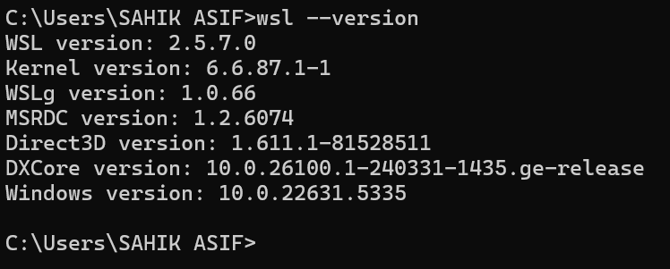

Plz check power shell type

Wsl –version

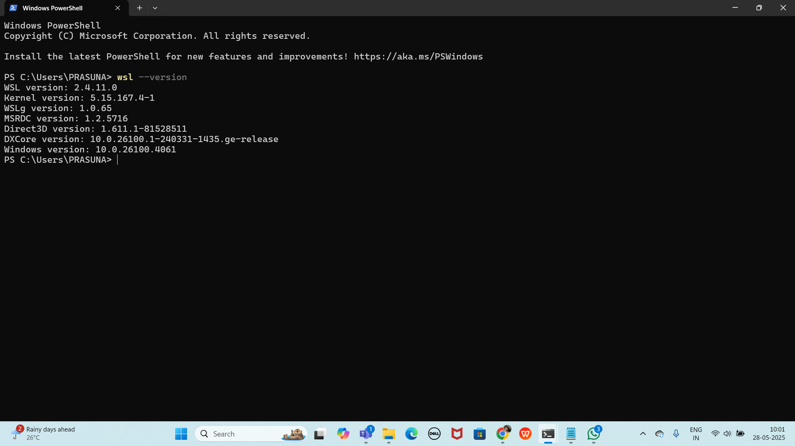

If not installed try to use below linux..

In cmd:

wsl

Install linux

<https://learn.microsoft.com/en-us/linux/install>

Task 1:

Create a Directory with the Name Linux Practice.

3 min

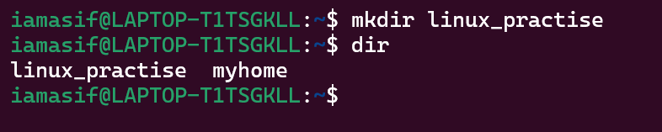

Task2:

Change to the directory

2 min



Task 3:

Create a file names TestFile1.txt and add the content to it.

5 min

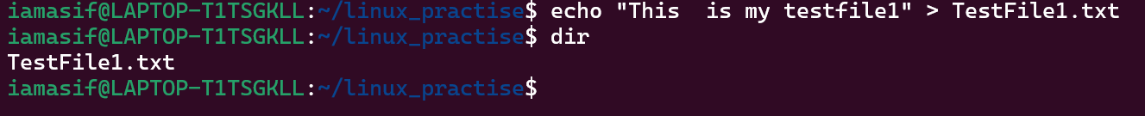

Task 4:

Create a Folder named Dummy and try to delete it.

5 min.

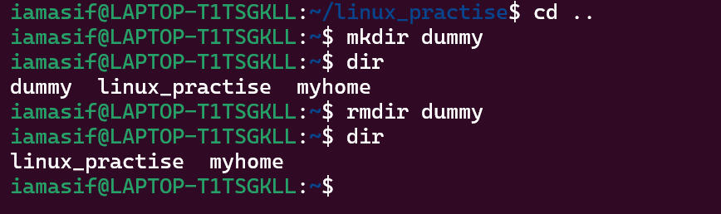

Task 5:

Plz check the working directory (Hint : pwd)

2 min

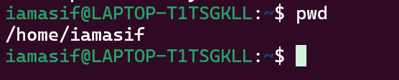

Task 6:

How do you check all the files and directories in the directory you are in?

By ls or ls -la for all files, including hidden and system files

3 min

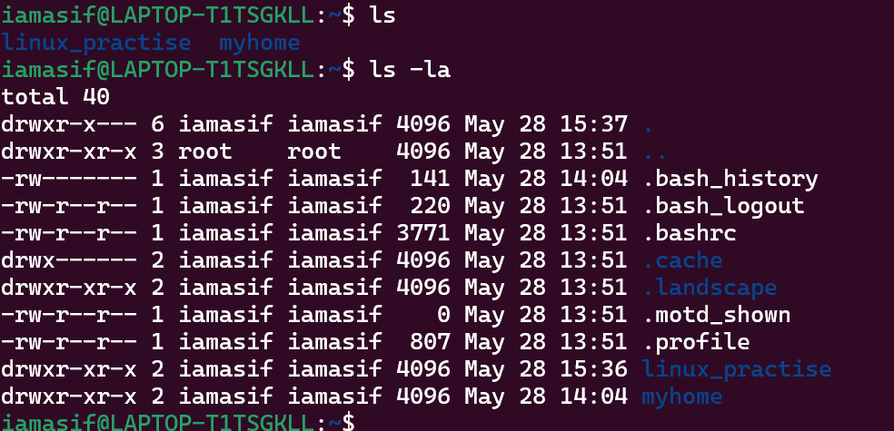

Task 7:

Create five files named TestFile2.txt.. TestFile3.txt… and so on till TestFile6.txt

5min

11.50 to 11.55

Plz raise ur hand once done

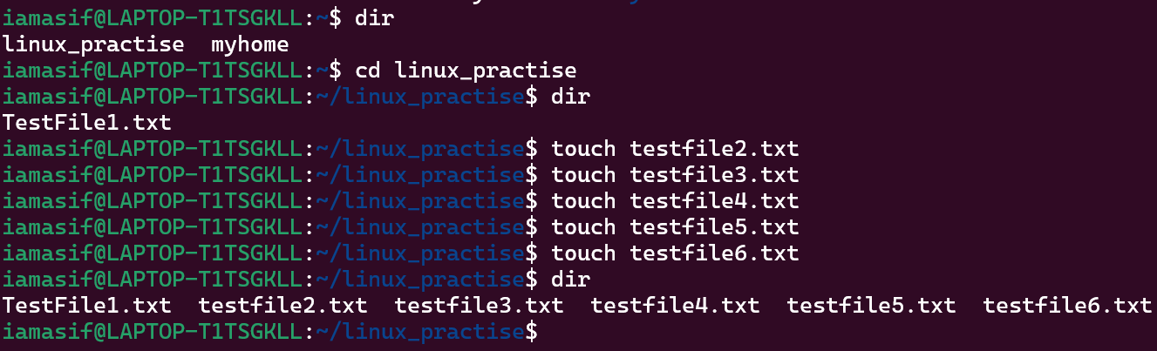

Task 8:

Copy all files from Dir 1 ti Dir 2

2 min 11.55 to 11.57

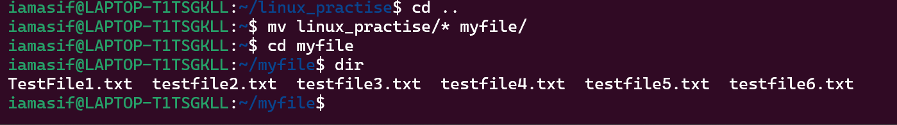

Task 9:

Move all files from Dir 2 to Dir 3 (finally ur Dir 2 should be empty)

3 min 11.58 to 12.00



Task 10:

Can you plz show me the diff between **rm** and **rmdir** commands with screen shots ?

12.01 to 12.05

Rm removes the files

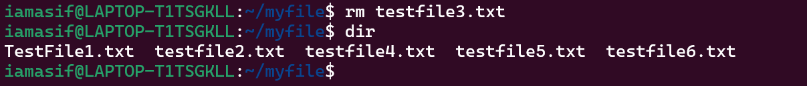

Rmdir removes the directory

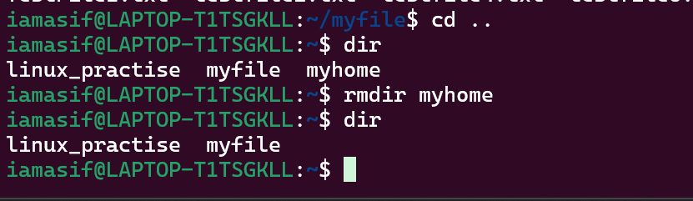

Ok now open Lorem Ipsum in your browser

<https://www.lipsum.com/> u can use this link for random text..

Task 11:

Now use specifically use cat command to create a file

And add the dummy text of 2 to 3 paragraphs from the above link Lorem Ipsum.

5 min 12.08 to 12.13

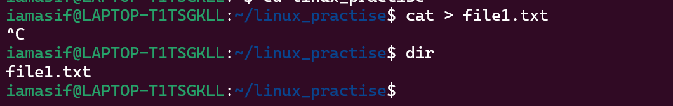

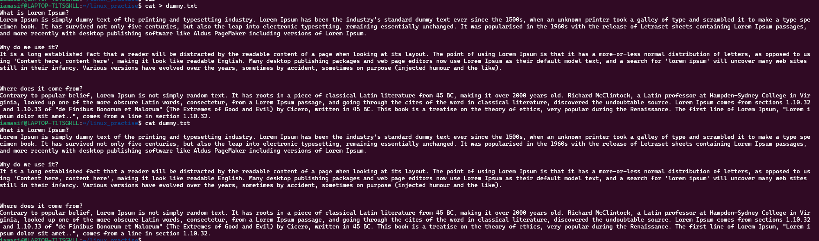

Task 12:

How to get only the top part of your file..

Hint: use head

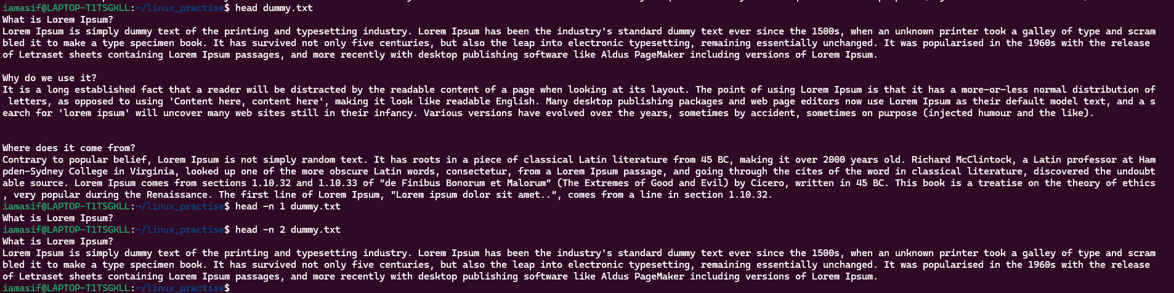

5 min 12.14 to 12.18

Task 13:

How to get only the last part of your file

Hint: use tail

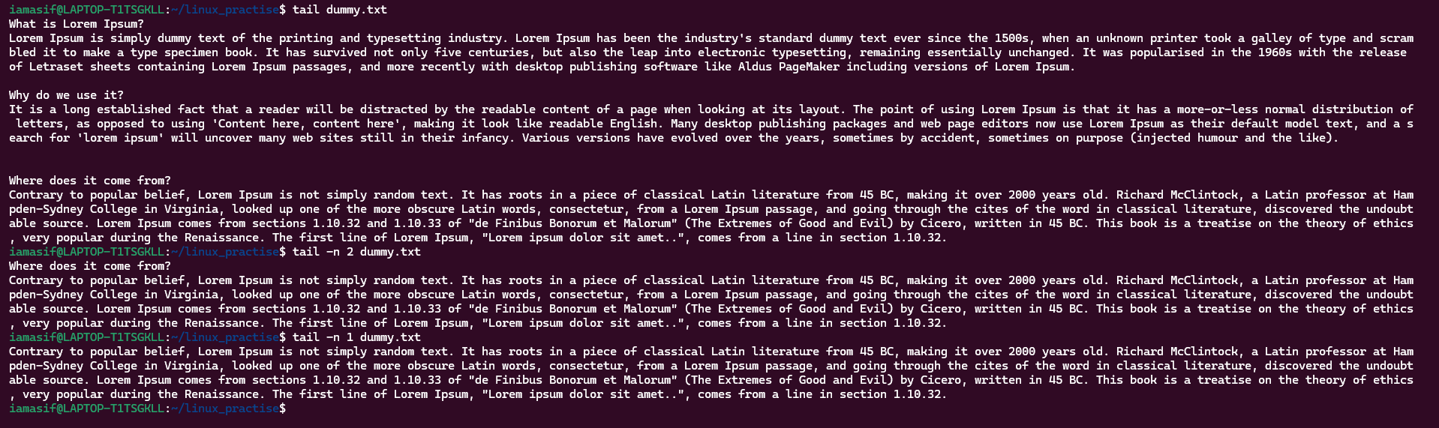

12.19 to 12.24

Task 14:

Plz add dummy text of 5 to 6 pages in to the same file

And

Now show the file in page by page

Hint : use less command

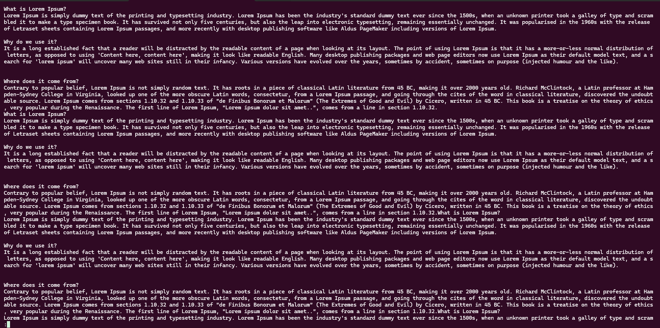

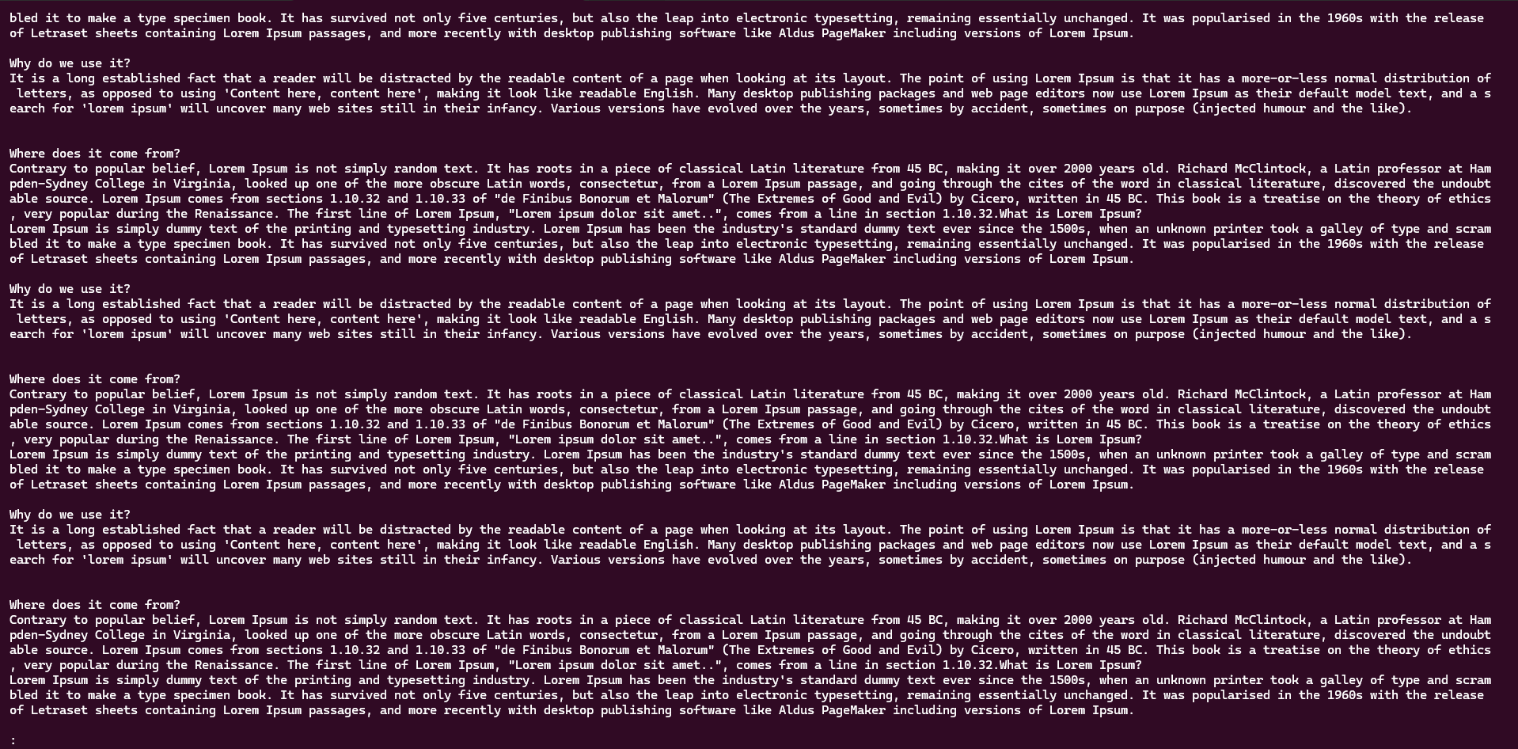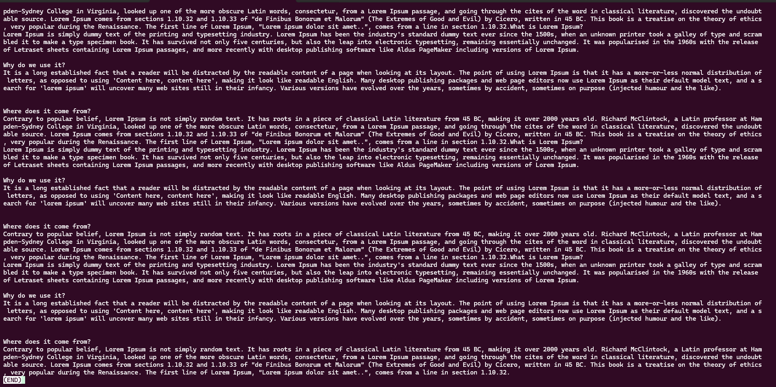

12.25 to 12.35 10 min

Task 15:

Use more command on the above file and find out the diff between less command and more command.

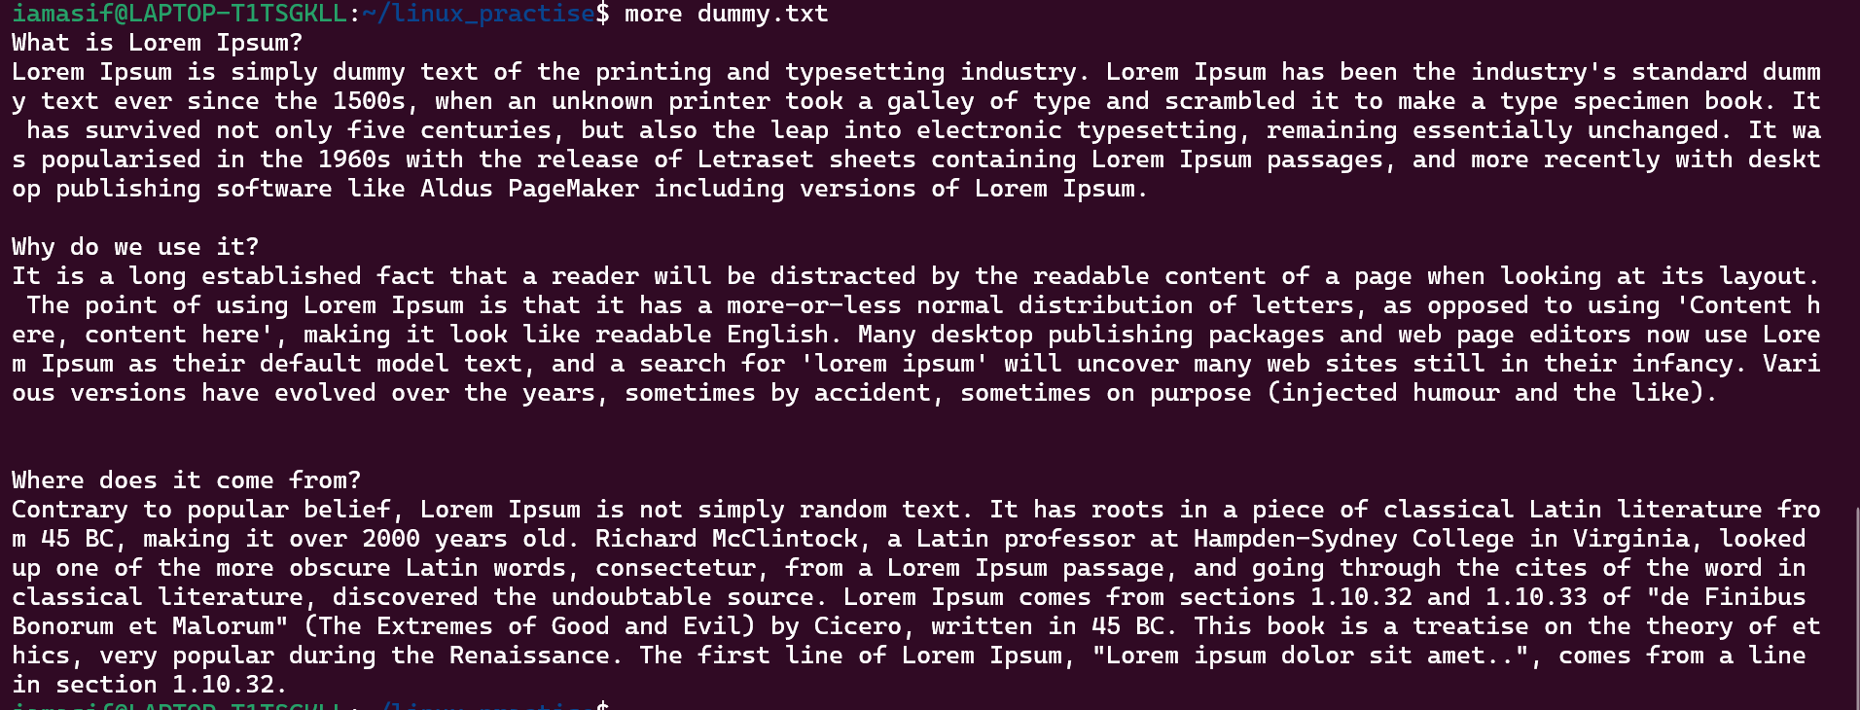

12.36 to 12.40 5 min

What is e in echo command..?

The e in the echo command is an option that enables the interpretation of backslash escape sequences. These sequences allow you to insert special characters and formatting into the output.

Task 16:

Can you use echo command with -e and see the diff.. Also take a ss and paste .

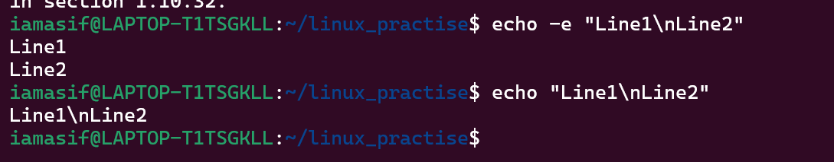

12.44 to 12.48 4 min

Task 17:

What is diff between ls and ls -l command .. ss plz

## 

## **ls command**

* Lists the files and folders in the current directory.
* Output is brief, showing only names.

## ls -l command (Long listing)

* The -l flag means long format

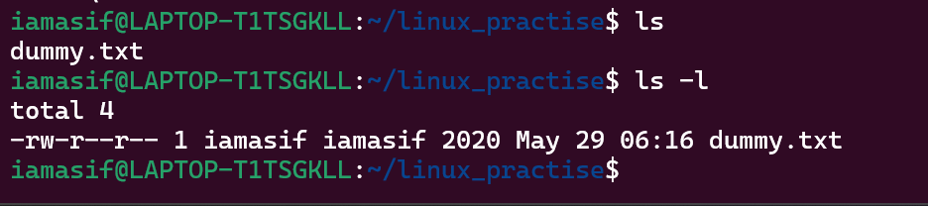

12.49 to 12.55.

Task 18:

Create a file using **touch** command , **cat** command and **echo** command and take ss (screen shot)..

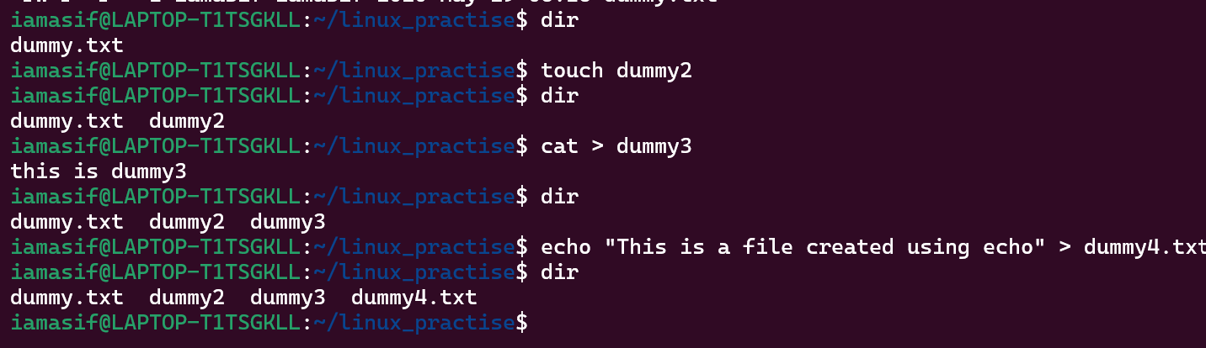

Also write the difference between touch , cat and echo commands.

## 

## **touch Command**

* Purpose: Creates an empty file or updates the timestamp of an existing file.
* Does not add content to the file.

## **echo Command**

* Purpose: Used to display a line of text or write text into a file.
* It’s also commonly used in scripting.

## **cat Command**

* Purpose: Used to create, view, or combine files.
* When used with > it can create a file and let you type content directly into it.

12.55 to 1pm

Task 19:

Can you guys try to display the calendar by using a command..

Hint: use cal

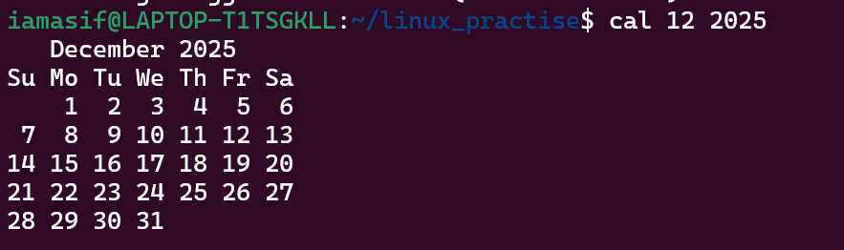

2 min 14.45 to 14.47

Task 20:

Can you go back to 1 directory .. at a time whats the command

**Cd ..**

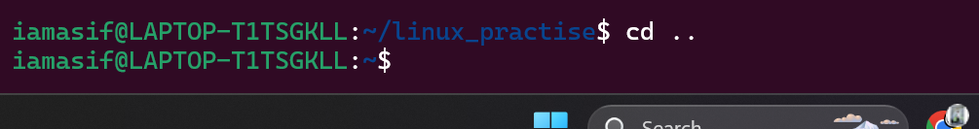

2 min 14.48 to 14.49

Task 21:

How to know whose user u are working on ?

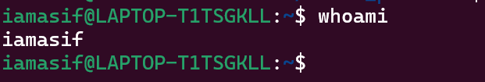

Hint: use whoami command

2 min 14.50 to 14.52

Task 22:

Try to find out who is peeping into your system..

Use users, who and w commands with ss

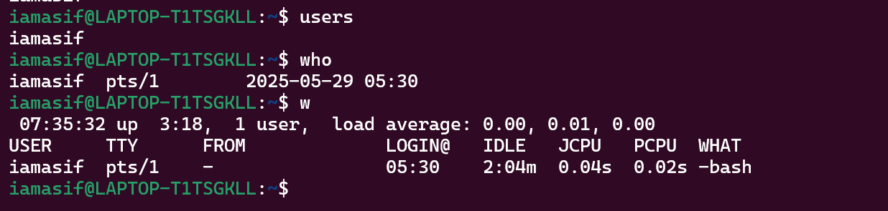

15.06 to 15.16

Task 23:

Can you guys try to check how much disk space is consumed..

Hint : use df -h

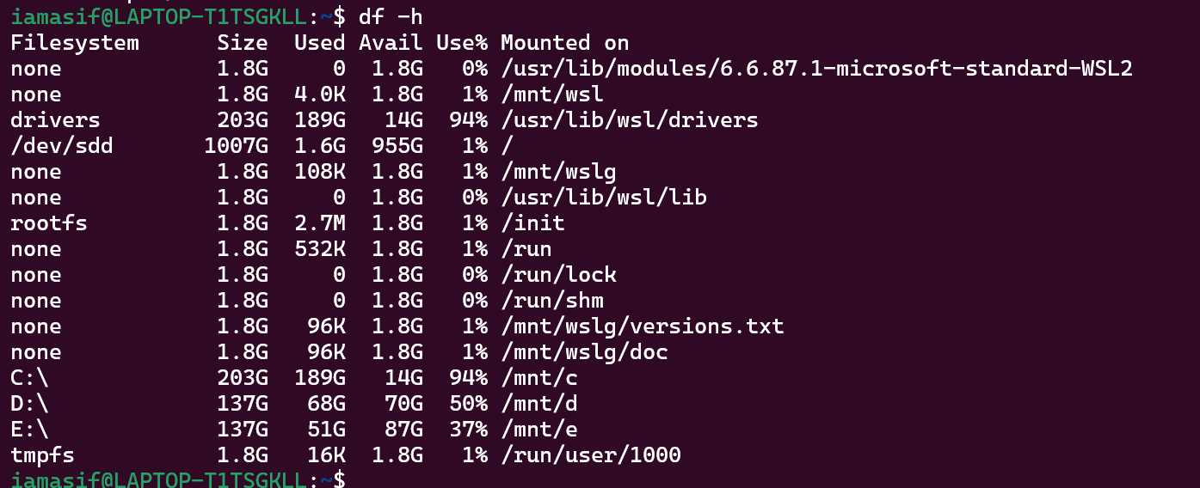

15.17 to 15.20

Task 24:

Can you plz try using the below commands

| **Prefix** | **Description** |
| --- | --- |
| **-** | **Regular file**, such as an ASCII text file, binary executable, or hard link. |
| **b** | **Block special file**. Block input/output device file such as a physical hard drive. |
| **c** | **Character special file**. Raw input/output device file such as a physical hard drive. |
| **d** | **Directory** which contains a listing of other files and directories. |
| **l** | **Symbolic link file**. Links on any regular file. |
| **p** | **Named pipe**. A mechanism for interprocess communications. |
| **s** | **Socket** which is used for interprocess communication. |

Task 25:

Find the list pf all files ending with .txt

Hint : use * in ls

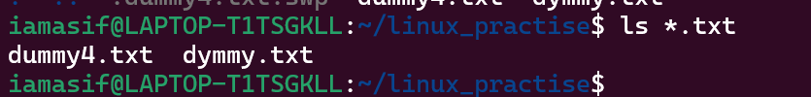

2 min 15.32 to 15.34

Task 26:

In Linux all the hidden files starts with . (period)

How to check all the hidden files in Linux..

Hint : use ls -a

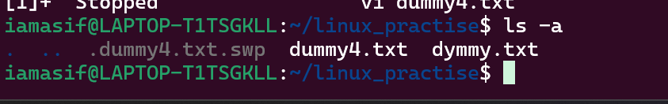

15.35 to 15.37

Task 27:

What is the difference between . and .. in linux

Line 1 line for each

* . refers to the current directory.
* .. refers to the parent directory (one level up).

2 min 15.38 to 15.40

Task 28:

Can you create a file using vi editor and show the details in ss

Hint:

Esc is for come out of the edit mode

Press two keys Shift &plus; ZZ together to come out of the file completely

* I - to insert

To move inside the file

* **l** key to move to the right side.
* **h** key to move to the left side.
* **k** key to move upside in the file.
* **j** key to move downside in the file.
* 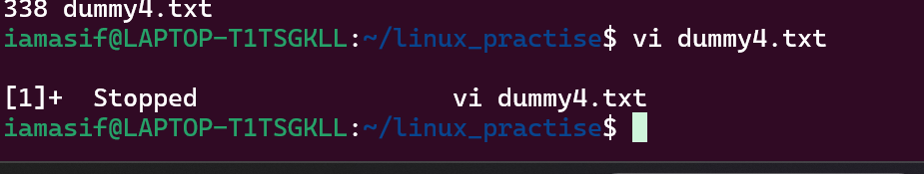

Task 29:

How to find the no of words in the file

Hint: use wc

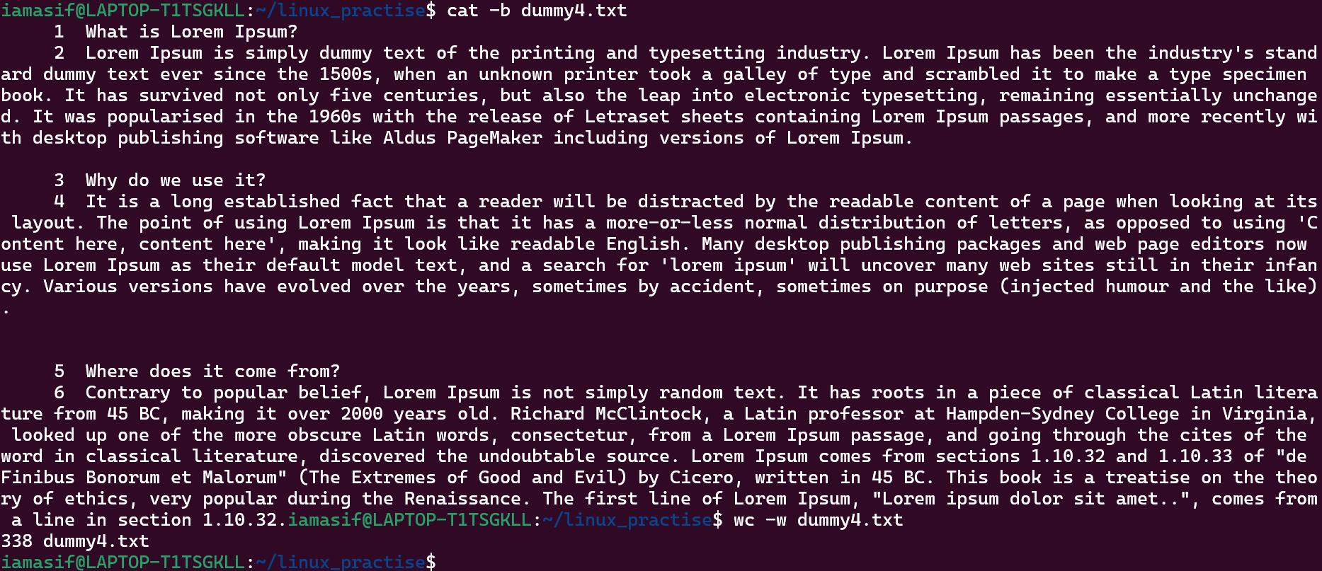

15.44 to 15.48

Here is the detail of all the four columns of wc command −

* **First Column** − Represents the total number of lines in the file.
* **Second Column** − Represents the total number of words in the file.
* **Third Column** − Represents the total number of bytes in the file. This is the actual size of the file.
* **Fourth Column** − Represents the file name.

Task 30:

What is the use of cat -b myfilename.txt command?

It display the contents of myfilename.txt with line numbers, but only for non-blank lines.

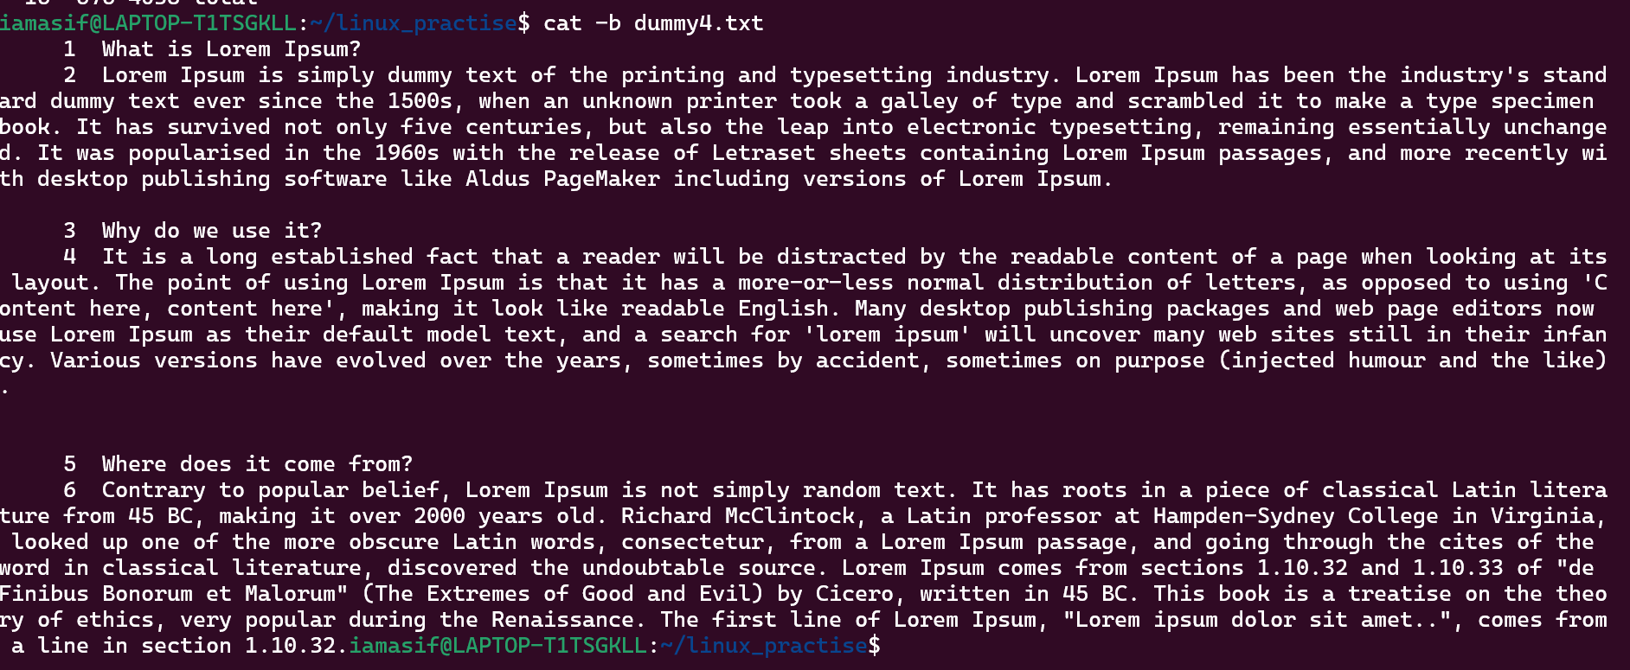

15.49 tpo 15.52

Task 31:

Can I use the wc with 2 or more files?

Yes

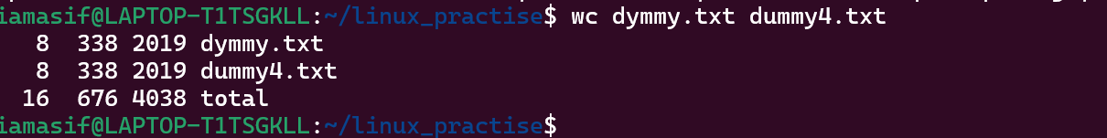

Wc file1 file2 file3

15.53 to 15.58

Task 32:

How to copy content of one file to another file

Hint: use cp:

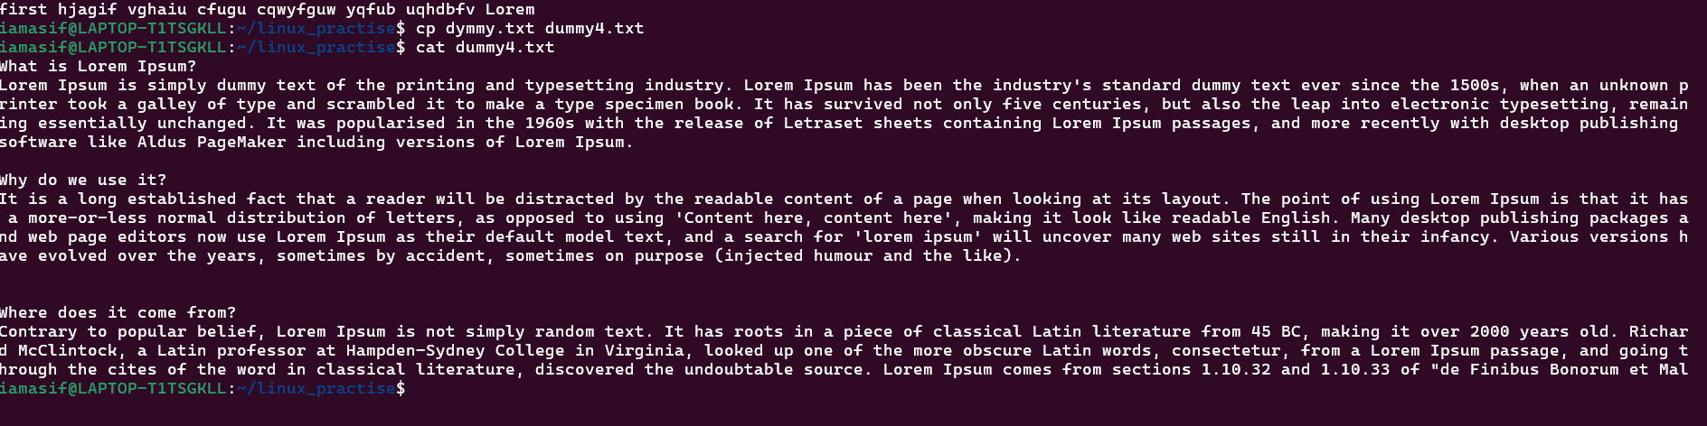

15.59 to 16.05

Task 33:

Now I want to rename my file with MYFILENEW can i do that if so how ?

Hint use : mv

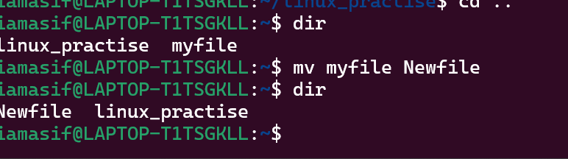

Task 34:

Can i remove or delete multiple files in linux..? How?

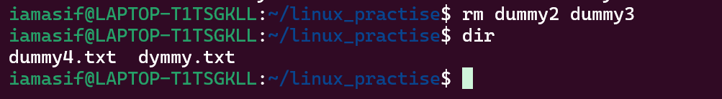

16.06 to 16.08

Task 35:

In directory / slash is root … can you try cd / what is it doing?

Ss plz

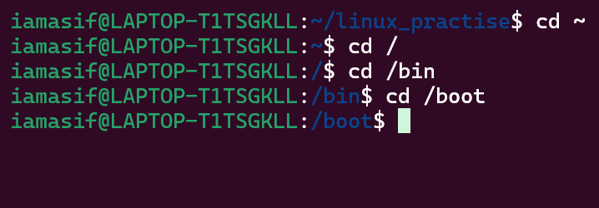

16.09 to 16.11

Linux directory structure: plz have a reading and try to remember..

| **Directory** | **Description** |
| --- | --- |
| **/bin** | important binary applications |
| **/boot** | boot configuration files, kernels, and other files needed at boot time. |
| **/dev** | System device files. |
| **/etc** | configuration files, startup scripts, etc. |
| **/home** | List of home directories for different users |
| **/lib** | system libraries, shared libraries |
| **/lost+found** | a lost+found system for files that exist under the root (/) directory |
| **/media** | automatically mounted (loaded) partitions on your hard drive and removable media such as CDs, digital cameras, etc. |
| **/mnt** | manually mounted filesystems on your hard drive |
| **/opt** | 3rd part applications to be installed |
| **/proc** | Maintains information about the state of the system, including currently running processes. |
| **/root** | root user's home directory. |
| **/sbin** | important system binaries |
| **/srv** | contain files that are served to other systems |
| **/sys** | system files |
| **/tmp** | temporary files |
| **/usr** | applications and files that are mostly available for all users to access |
| **/var** | variable files such as logs and databases |

Task 36:

What is the way go go to home directory ?

Hint : use cd ~

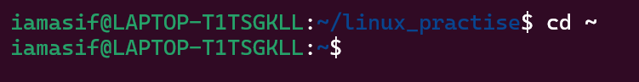

16.12 to 16.15

16.15 to 16.30 Tea Break

Task 37:

If i want to move to different users home directory

Hint : use ~username

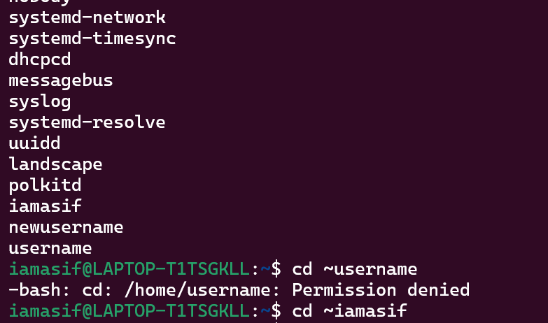

16.30 to 16.35

Task 38:

Chmods: What is chmod?

chmod = change mode

It sets read (r), write (w), and execute (x) permissions for:

* u → user (owner)
* g → group
* o → others
* a → all (user + group + others)

Doc 11 Linux intro.pdf shared in docs to study folder in the shared drive..for your ref..

—------------------------------------------commands to work in linux —----------------------------------------

Basic Navigation & File Operations:

* cd: Change directory.
* pwd: Print working directory.
* ls: List directory contents.
* mkdir: Create a new directory.
* rmdir: Remove an empty directory.
* rm: Remove files or directories.
* cp: Copy files or directories.
* mv: Move or rename files or directories.
* touch: Create an empty file.

File Content Management:

* cat: Concatenate and display the contents of a file.
* head: Display the first part of a file.
* tail: Display the last part of a file.
* less: Display file contents, page by page.
* more: Display file contents, page by page.

System Information & Utility:

* uname: Print system information.
* whoami: Display the current user's name.
* date: Display the current date and time.
* cal: Display the calendar for a specified month or year.
* df: Display disk space usage.
* du: Display disk space usage for a specific directory.
* top: Display real-time processor activity.
* man: Access the command manual.
* grep: Search for patterns within files.
* echo: Print text to the terminal.

Other Useful Commands:

* sudo: Execute a command with superuser privileges.
* chmod: Change file permissions.
* chown: Change file ownership.
* tar: Create archives.
* gzip: Compress or decompress files.
* unzip: Unzip archives.
* zip: Create zip archives.