# **E-Learning Platform with Auto Evaluation**

# **Day 1 – Requirements**

Project Title: E-Learning Platform with Auto Evaluation

The main goal of this project is to create an intelligent E-Learning platform where students can upload their assignment files, and the system automatically evaluates and stores their results. The project focuses on automation, cloud integration, and structured data handling using DynamoDB.

## **Objectives**

- Allow students to upload assignment files (.java or .txt, depending on assignment type).  
- Automatically extract and store student details from the file.  
- Store and manage assignment results in DynamoDB.  
- Provide APIs for CRUD operations (Create, Read, Update, Delete).  
- Enable educators or admins to fetch or update student records easily.

## **Problem Definition**

Traditional evaluation systems often require manual data entry and result updates. This project aims to automate the process from assignment submission to result storage. By integrating DynamoDB as the backend, the system ensures scalability and real-time access to student results.

## 

## **Key Functionalities**

1. Students upload assignment result files via a REST API.  
2. The backend parses the uploaded text file to extract student details such as name, ID, score, and status.  
3. The parsed data is stored in DynamoDB as structured records.  
4. APIs allow users to read, update, or delete data.  
5. The system supports scalability and cloud integration for future AWS deployment.

## **System Overview (Use Case Diagram)**

**day1.uml**@startuml  
actor Student  
actor Admin  
  
rectangle "E-Learning Platform" {  
 Student --> (Upload Assignment File)  
 Admin --> (View Student Results)  
 Admin --> (Update/Delete Student Data)  
 (Upload Assignment File) --> (Parse & Store Data in DynamoDB)  
}  
@enduml

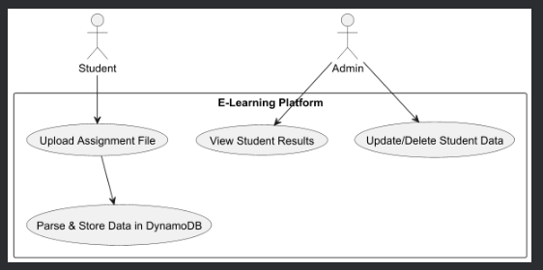

## **Outcome of Day 1**

On Day 1, the project's core requirements and scope were finalized. The objective is to automate the assignment evaluation process, enabling digital transformation in the learning and grading workflow. The foundation for further design and development was clearly defined.

## **Conclusion**

Day 1 successfully laid the groundwork for the E-Learning Platform with Auto Evaluation project. By clearly defining the requirements and objectives, the team established a solid understanding of the problem and the desired outcome. With this foundation, the project is now ready to move into the design phase, where system components and data flow will be structured in detail.