# **Day 3 – Implementation of Core Components**

## **Objective**

The objective of Day 3 was to start implementing the core components of the Auto Evaluation system, including the creation of essential models, repositories, and services that form the foundation of the application.

## **Tasks Completed**

1. Created model classes to represent core entities such as Student, Assignment, and EvaluationResult.  
2. Implemented repository classes to interact with DynamoDB using AWS SDK v2.  
3. Designed service interfaces and corresponding implementations to handle the business logic of evaluation and data persistence.  
4. Ensured that each service follows the principles of clean code, modularity, and dependency injection.

## **System Architecture**

The architecture followed a layered pattern — Controller, Service, and Repository. Each layer was clearly separated to ensure scalability and maintainability.

## **day3.uml**

@startuml  
rectangle Controller {  
 (EvaluationController)  
}  
  
rectangle Service {  
 (EvaluationServiceImpl)  
}  
  
rectangle Repository {  
 (EvaluationResultRepository)  
}  
  
(EvaluationController) --> (EvaluationServiceImpl)  
(EvaluationServiceImpl) --> (EvaluationResultRepository)  
@enduml

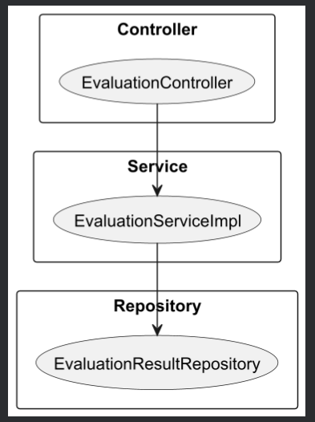

## **Key Components**

- **Model Classes**: Represented entities like Student, Assignment, and EvaluationResult.  
- **Repository Layer:** Interacted with DynamoDB using the Enhanced Client API.  
- **Service Layer:** Contained the core logic to evaluate and save student data.  
- **Controller Layer:** Exposed REST endpoints for file upload and result retrieval.

## **Outcome of Day 3**

By the end of Day 3, the system had a working foundation that allowed data flow from API requests to persistence in DynamoDB. The backend structure was modular, reusable, and ready for integration with the evaluation engine.

## 

## 

## **Conclusion**

Day 3 focused on building the backbone of the project the model, repository, and service layers. With a clear and maintainable structure in place, the project was well-prepared for the next step implementing the actual evaluation logic and handling student submissions.