# **Day 4 – Integration of File Upload and DynamoDB Storage**

On Day 4, the primary focus was integrating the file upload functionality with DynamoDB storage.  
This step connected the system’s frontend interaction (uploading assignment files) with backend persistence (storing data in DynamoDB).  
The upload and parsing flow was established with proper validation and exception handling.

## **Objectives**

1. Enable students to upload assignment files in .txt format.  
2. Parse and extract student data such as name, ID, score, and status from the file.  
3. Store parsed data into the DynamoDB 'EvaluationResult' table.  
4. Handle invalid or malformed file uploads gracefully using exception handling.

## **Implementation Summary**

A REST endpoint was created for file uploads, handled through a dedicated controller.  
The uploaded file was passed to a service class responsible for parsing its contents and saving the extracted data into DynamoDB.  
  
To achieve this, the following key components were implemented:  
- FileUploadController.java — Handles HTTP POST requests for uploading files.  
- FileUploadServiceImpl.java — Parses the uploaded file and interacts with the repository to save data.  
- EvaluationResultRepository.java — Manages DynamoDB operations for storing EvaluationResult entities.

## **System Design (Activity Diagram)**

**day4.uml**@startuml  
start  
:User uploads assignment file (.txt);  
:Validate file format;  
if (File is valid?) then (Yes)  
 :Parse file contents;  
 :Extract student details;  
 :Save details in DynamoDB;  
 :Return success response;  
else (No)  
 :Return error message;  
endif  
stop  
@enduml

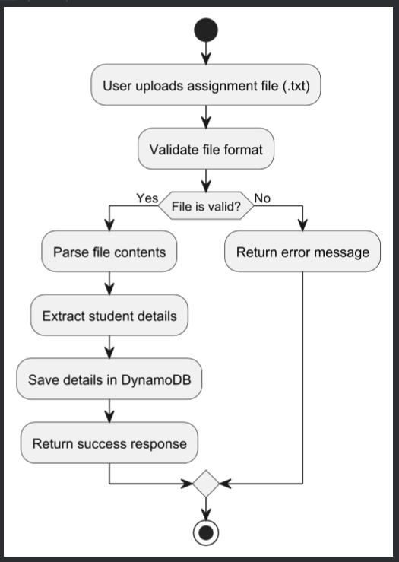

**Outcome of Day 4**

By the end of Day 4, the system could successfully process and store student assignment data uploaded as text files.  
Data integrity and validation mechanisms ensured that only correctly formatted inputs were stored in DynamoDB.  
This day established a critical backend foundation for the automated evaluation process.

## **Conclusion**

Day 4 completed the data ingestion and persistence layer of the project.  
The integration between the file upload API and DynamoDB ensured smooth data flow and reliability.  
This milestone marked the readiness for the next phase implementing the evaluation logic and result analysis.