# **Day 6 – Evaluation Flow Verification and Error Logging**

## **Objective**

The objective of Day 6 was to verify the complete flow of the auto-evaluation system — from file upload to evaluation result storage. Additionally, error handling and logging were implemented to ensure that failed evaluations or exceptions are properly tracked.

## **Tasks Completed**

1. Verified the evaluation process for different types of submissions:  
 - Successful evaluation (valid Java code).  
 - Partial pass (logic issues but compilation success).  
 - Failed evaluation (compilation error).  
  
2. Introduced the EvaluationLog table in DynamoDB to capture and track all submission attempts with timestamps.  
  
3. Added the EvaluationErrorLogs table to log detailed error information for submissions that failed during evaluation.  
  
4. Tested the workflow to ensure that:  
 - EvaluationResult is updated correctly in DynamoDB.  
 - EvaluationLog records every submission attempt.  
 - EvaluationErrorLogs stores stack traces or error messages when failures occur.

## **System Flow**

The evaluation flow was verified step by step, ensuring each component interacts correctly with others. Below is the conceptual workflow:

**day6.uml**  
@startuml  
actor Student  
participant "EvaluationController" as EC  
participant "EvaluationServiceImpl" as ES  
participant "EvaluationEngineImpl" as EE  
database "DynamoDB" as DB  
  
Student -> EC : Upload submission  
EC -> ES : Validate and process submission  
ES -> EE : Run evaluation  
EE -> DB : Store results in EvaluationResult  
ES -> DB : Log success or failure in EvaluationLog / EvaluationErrorLogs  
EC -> Student : Return evaluation result  
@enduml  
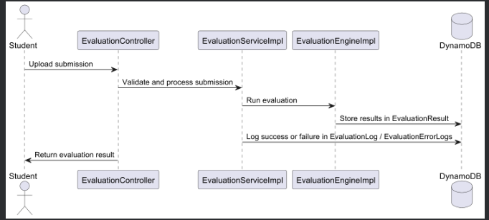

## **Testing Scenarios**

- Uploaded three types of submissions:  
 1. Valid file (PASS) → Stored in EvaluationResult + EvaluationLog.  
 2. Partially correct file (PARTIAL_PASS) → Logged in EvaluationLog.  
 3. File with compile error → Logged in EvaluationErrorLogs.  
  
- Verified that all logs were successfully stored in DynamoDB tables.  
- Ensured no data corruption occurred during evaluation retries.

## **Outcome of Day 6**

- The end-to-end evaluation process was verified successfully.  
- Logging for both successful and failed submissions was implemented.  
- The system became more stable, reliable, and traceable.

## **Conclusion**

Day 6 was crucial for system validation. The introduction of detailed error and evaluation logs ensured transparency and traceability of the auto-evaluation workflow. With this, debugging and analysis became easier, and the foundation for the next phase Leaderboard and Reporting was established.