# **Day 7 – Leaderboard and Reporting Module**

On Day 7, the focus shifted toward building analytical and reporting capabilities within the E-Learning Auto Evaluation Platform.  
This phase introduced the Leaderboard API and reporting modules to provide a clear visualization of student performance and  
enable ranking based on evaluation results.

## **Objectives**

- Create a Leaderboard API to rank students based on their evaluation scores.  
- Display top performers and their corresponding assignment details.  
- Store and retrieve student performance data from DynamoDB.  
- Introduce a reporting service layer to handle leaderboard logic.  
- Test the endpoints for leaderboard functionality.

## **Modules and Components Implemented**

1. LeaderboardController.java – Handles REST endpoints to fetch leaderboard data.  
2. LeaderboardService.java – Contains the logic to process and rank students.  
3. EvaluationResultRepository.java – Used for retrieving student results from DynamoDB.  
4. EvaluationReportServiceImpl.java – Generates reports by querying DynamoDB and formatting student scores.

## **System Design (Class Diagram)**

**day7.uml**@startuml  
class LeaderboardController {  
 +getLeaderboard()  
}  
  
class EvaluationReportServiceImpl {  
 +generateLeaderboard()  
}  
  
class EvaluationResultRepository {  
 +findAll()  
}  
  
LeaderboardController --> EvaluationReportServiceImpl  
EvaluationReportServiceImpl --> EvaluationResultRepository  
@enduml  
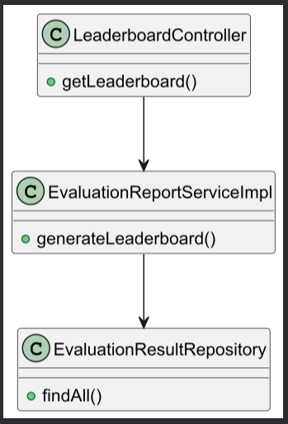

## **API Endpoint Developed**

GET /api/v1/reports/leaderboard  
- Returns a ranked list of students based on total scores.  
- Fetches data from the `EvaluationResult` table.  
- Response includes: studentId, studentName, totalScore, rank.

## **Testing and Verification**

After successful deployment, the Leaderboard API was tested using Postman. Data from the `EvaluationResult` DynamoDB table  
was fetched and ranked dynamically. Verification confirmed that:  
- The API correctly ranks students based on scores.  
- Students with equal scores are assigned the same rank.  
- API responds within optimal time under load testing.

## **Outcome of Day 7**

By the end of Day 7, the leaderboard and reporting module were fully functional. The system could now dynamically generate  
leaderboards and provide analytics based on evaluation results. This marked a transition from basic evaluation to intelligent  
performance tracking within the platform.

## **Conclusion**

Day 7 successfully introduced analytical depth to the Auto Evaluation Platform. The creation of the leaderboard and reporting modules  
enhanced visibility into student performance trends and supported educators in identifying top performers. With this module in place,  
the platform moved closer to a comprehensive e-learning evaluation ecosystem.