# **Day 9 – Leaderboard and Analytics APIs**

Day 9 of the E-Learning Auto Evaluation Platform focused on implementing Leaderboard and Analytics features.  
 The goal was to create APIs that allow the admin or students to view performance insights such as rankings,  
 average scores, and student progress across assignments.  
 This phase also involved ensuring that the platform can fetch summarized data from DynamoDB efficiently.

## **Objectives**

- Develop REST APIs to fetch and display leaderboard data.  
- Calculate rankings based on student scores.  
- Fetch reports by student, assignment, and performance category.  
- Integrate the report generation logic with EvaluationResultRepository.  
- Ensure that APIs are optimized for fast read operations from DynamoDB.

## **Tasks Completed**

1. Created the EvaluationReportServiceImpl.java class to handle all reporting logic.  
2. Implemented methods to:  
 - Fetch reports for a specific student (getReportByStudentId).  
 - Fetch reports for a specific assignment (getReportByAssignmentId).  
 - Fetch all evaluation results for analytics.  
 - Generate a leaderboard sorted by score in descending order.  
3. Added EvaluationReportController.java to expose the leaderboard and report APIs.  
4. Fixed and enhanced EvaluationResultRepository.java** to include query methods such as:  
 - findByStudentId()  
 - findByAssignmentId()  
 - findAll()  
5. Tested all endpoints in Postman to ensure accurate results from DynamoDB.

## **System Overview (Class Diagram)**

**day9.uml**@startuml  
class EvaluationReportController {  
 +getLeaderboard()  
 +getReportByStudentId(studentId)  
 +getReportByAssignmentId(assignmentId)  
}  
  
class EvaluationReportServiceImpl {  
 +getLeaderboard()  
 +getReportByStudentId()  
 +getReportByAssignmentId()  
 +getAllReports()  
}  
  
class EvaluationResultRepository {  
 +findByStudentId()  
 +findByAssignmentId()  
 +findAll()  
}  
  
EvaluationReportController --> EvaluationReportServiceImpl  
EvaluationReportServiceImpl --> EvaluationResultRepository  
@enduml  
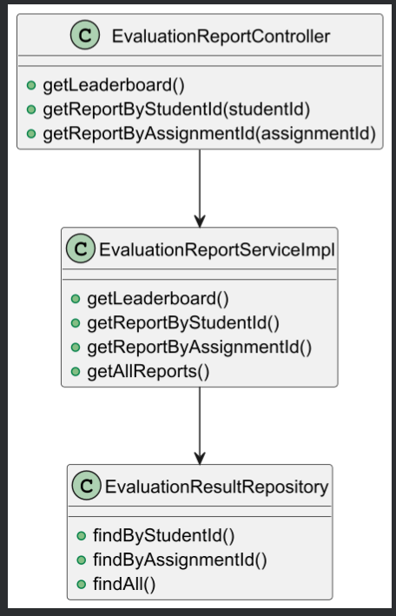

## **Outcome of Day 9**

By the end of Day 9, the system was successfully enhanced with advanced analytics and leaderboard functionality.  
 This allowed both students and admins to easily visualize performance trends and identify top performers.  
 All API endpoints were tested and verified to pull accurate data from DynamoDB.  
 The project was now fully capable of handling automated evaluations, storing results, and providing insights through APIs.

## **Conclusion**

Day 9 successfully introduced leaderboard and analytics capabilities into the Auto Evaluation Platform.  
 The system can now fetch and analyze performance data efficiently, enabling transparent and data-driven insights.  
 With these enhancements, the platform evolved into a comprehensive E-Learning evaluation ecosystem combining automation, analytics, and cloud integration.