Day9: DevOps CI/CD with test execution.

**Exposing REST APIs** using Spring Boot so external clients (like frontend apps, Postman, or other services) can interact with your evaluation system.

Specifically:

1. Expose a REST API for submitting solutions → triggers evaluation.
2. Expose APIs to fetch scores and logs for a student.
3. Return JSON responses from the APIs.
4. Wire everything together with Spring Boot controllers.

**Project Structure (new files)**

* src/main/java/org/example/controller/
* EvaluationController.java

**Step 1: Fix AtlasApplication with**

package org.example;

import org.springframework.boot.SpringApplication;

import org.springframework.boot.autoconfigure.SpringBootApplication;

@SpringBootApplication

public class AtlasApplication {

public static void main(String[] args) {

SpringApplication.run(AtlasApplication.class, args);

}

}

**Step 2: Create EvaluationController**

**Step 3: Run & Test**

* mvn spring-boot:run

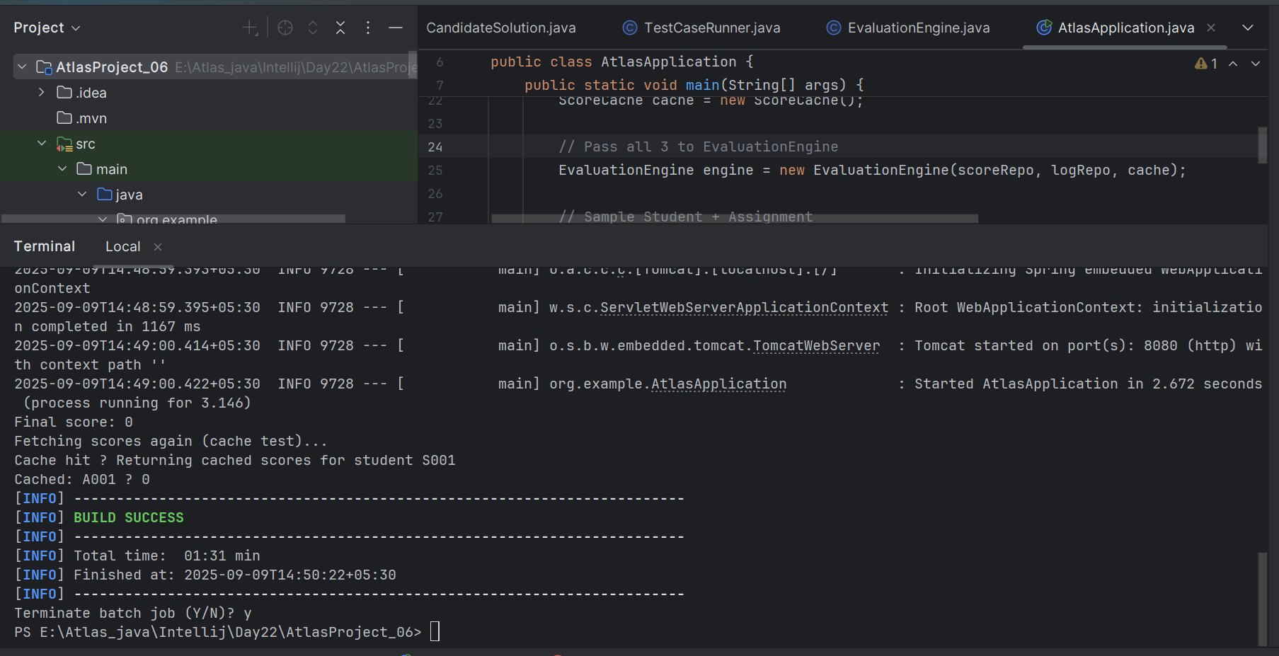

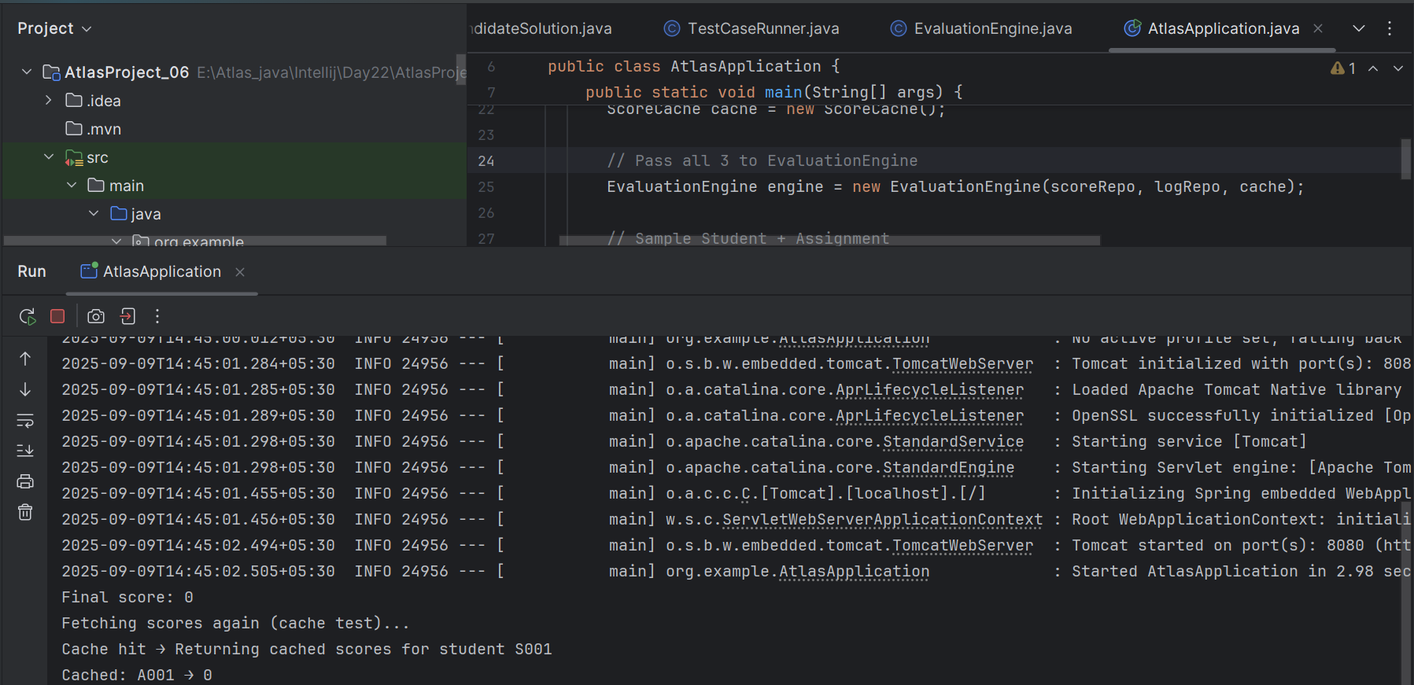

**Dont close it and open new terminal**

Invoke-RestMethod -Uri 'http://127.0.0.1:8080/api/evaluation/submit?studentId=S001&name=Alice&assignmentId=A001' -Method POST

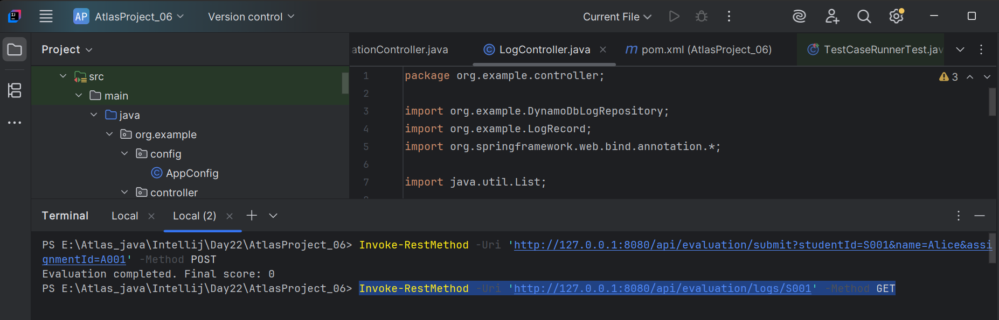

Invoke-RestMethod -Uri 'http://127.0.0.1:8080/api/evaluation/logs/S001' -Method GET

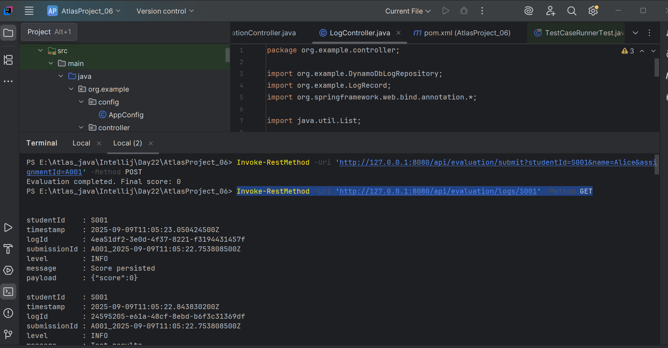

### 

### **Day 9 – Conclusion**

* Exposed the evaluation engine via Spring Boot REST API endpoints.
* Added three endpoints:  
  1. POST /api/evaluation/submit → triggers evaluation, persists score, updates cache, logs events.
  2. GET /api/evaluation/scores/{studentId} → retrieves scores, preferring cache with DynamoDB fallback.
  3. GET /api/evaluation/logs/{studentId} → fetches log history for auditing/debugging.
* Verified functionality using Postman / PowerShell:  
  1. Submitting an evaluation produced a Final score and persisted data.
  2. Fetching scores returned ScoreRecord JSON objects.
  3. Logs endpoint provided detailed evaluation steps.
* The system is now a network-accessible service, not just a local console runner.
* This completes the transition from prototype pipeline → production-ready REST API that other services or frontends can consume.