Day 31

Employee ID: 201933938

Login ID: iamasif

Name: Shaik Asif

CRUD Operations

**CREATED TABLE:**

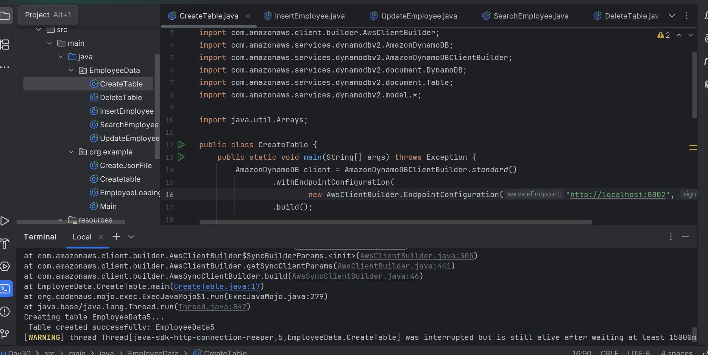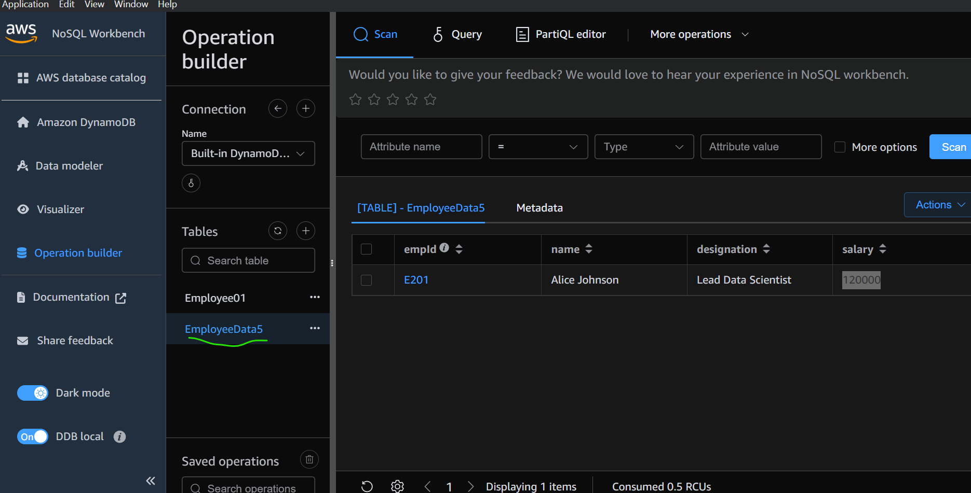

INSERTED:

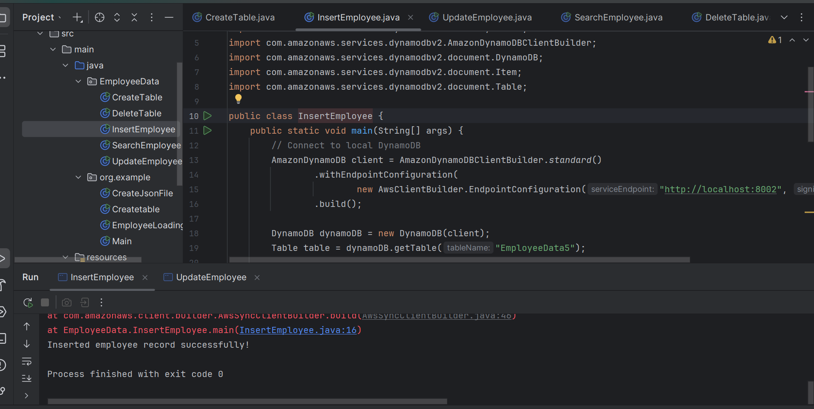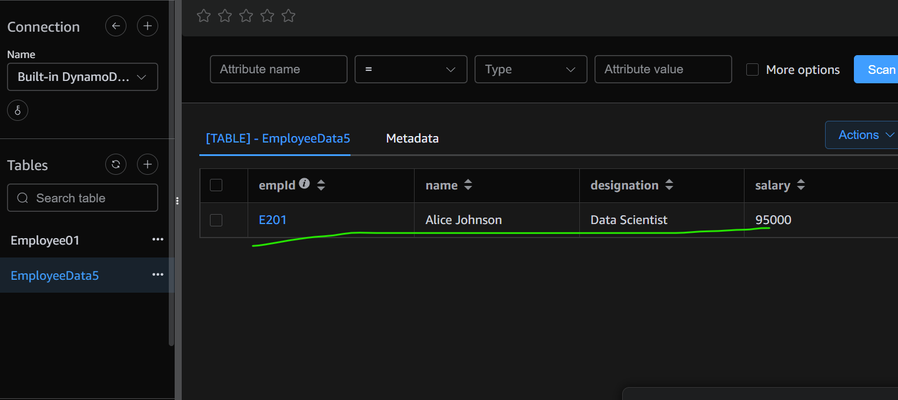

UPDATE:

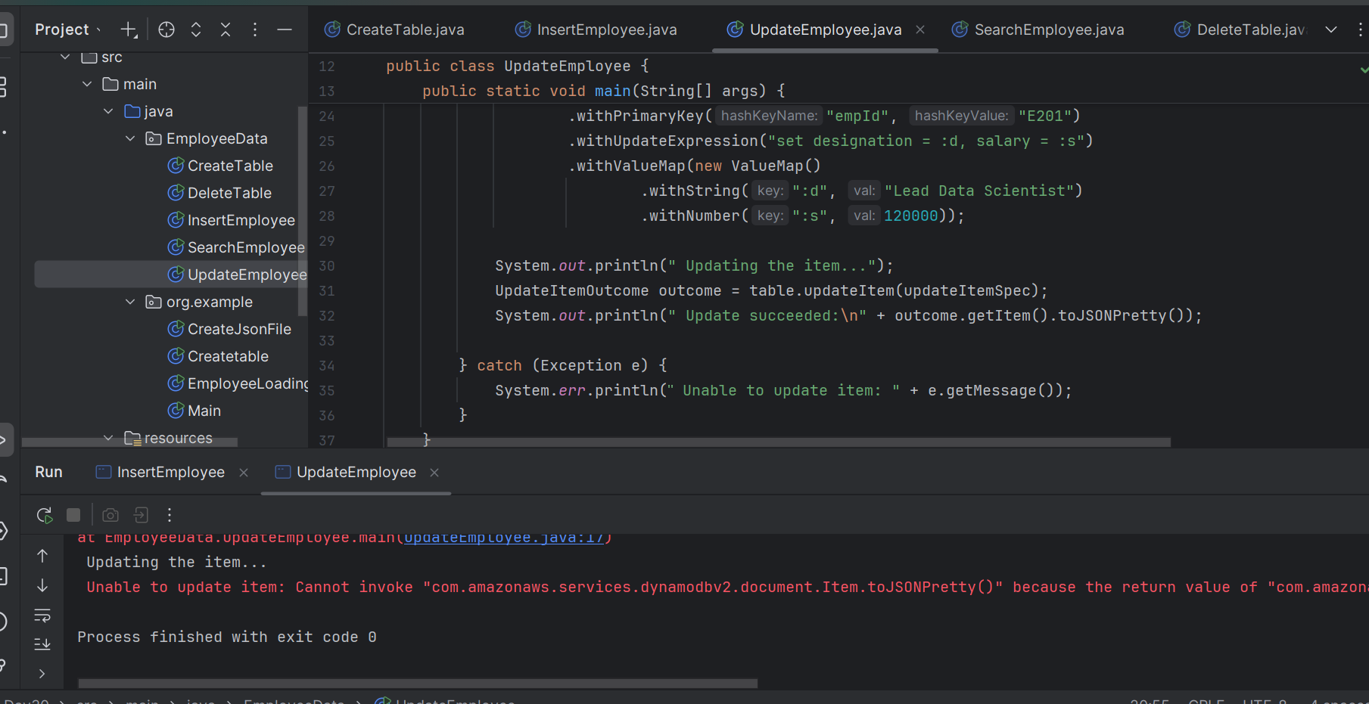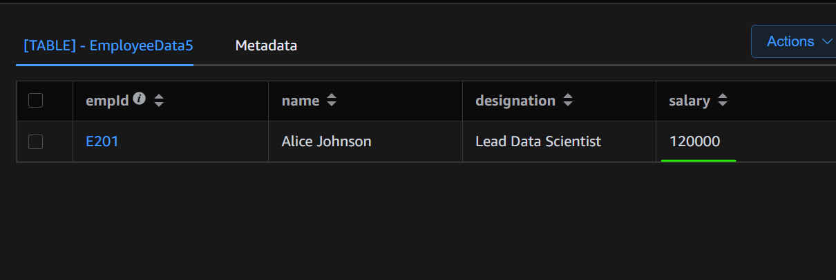:

SEARCHING:

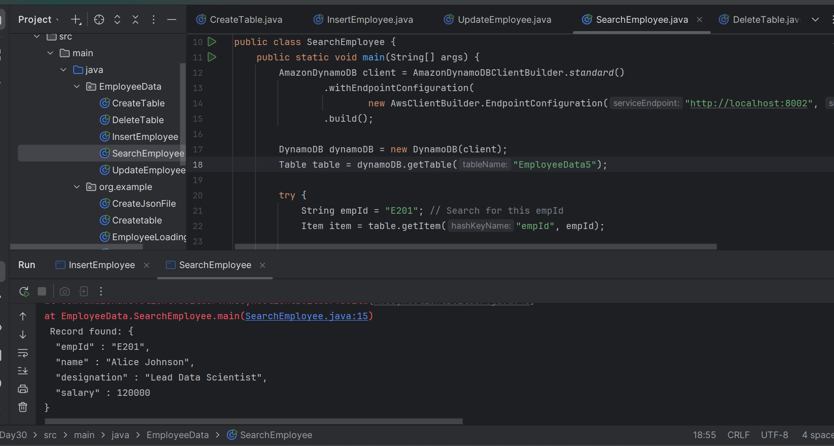

DELETION:

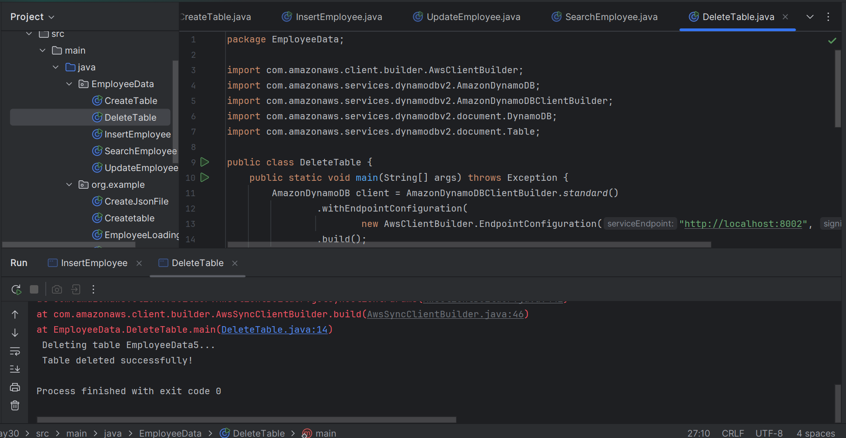

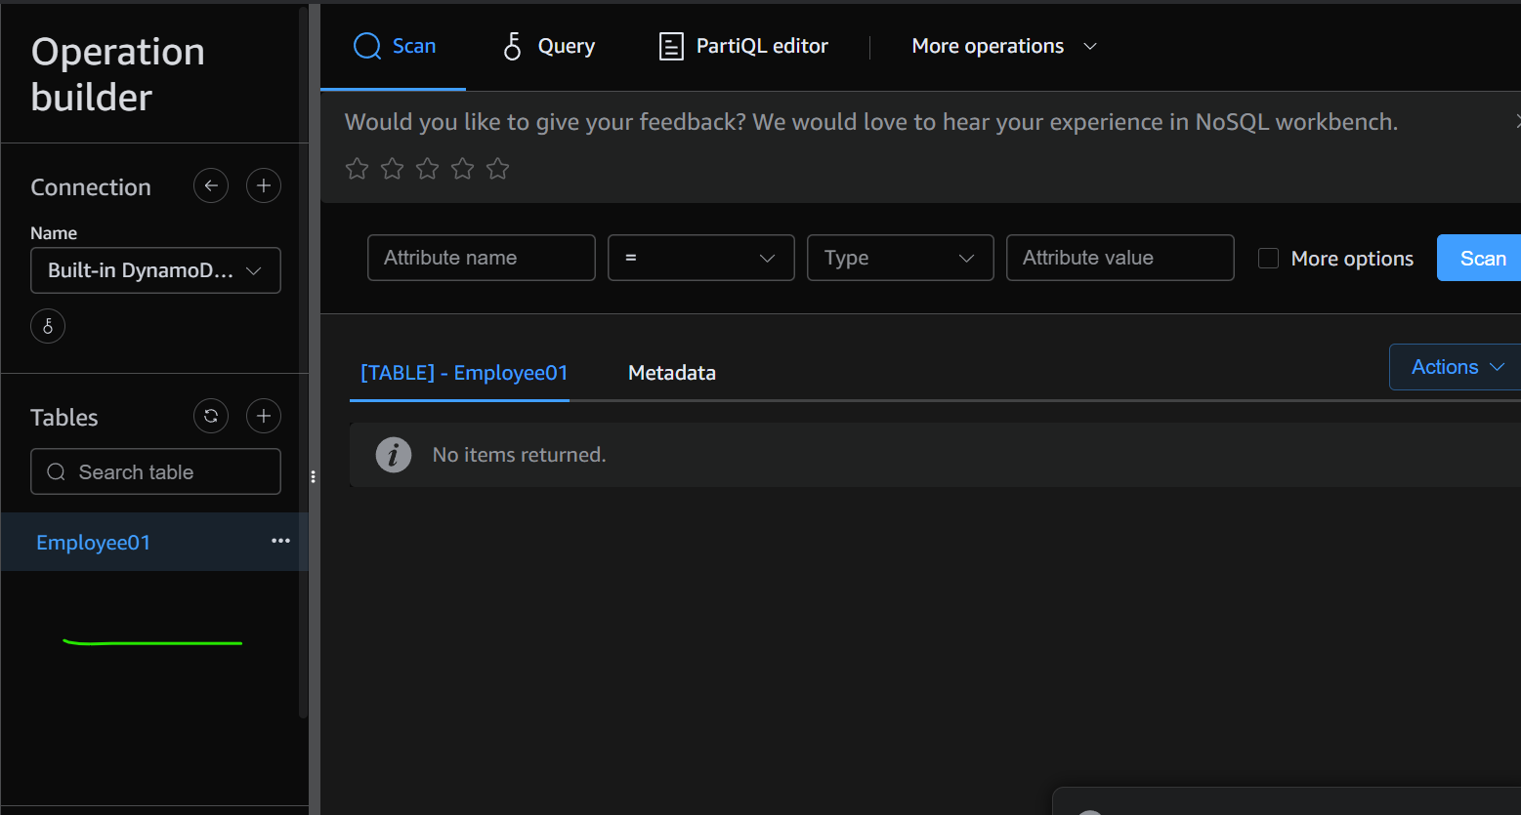

Juz FYI

Day 29 - Tasks

Create a Table

Load a table with data (Insert operation)

Day 30 - Tasks:

Query a record from the table

Delete a record from the table

Day 31st - tasks:

Task 01:

Update a record in the table

Info Box:

table.putItem(new Item()

.withPrimaryKey("ID", ID, "Nomenclature", Nomenclature)

.withJSON("Stat", currentNode.path("Stat").toString()));

System.out.println("Successful load: " + ID + " " + Nomenclature);

For kinnera

Codes for reference link

<https://drive.google.com/drive/folders/1LwhNov1s1-vHzF9GPAObLSnP9kAvipmw?usp=sharing>

In the above link check for Codesforreference → DynamoDB → update.java