Foundations of Agile and Agile Frameworks

**EXERCISE WORKBOOK**

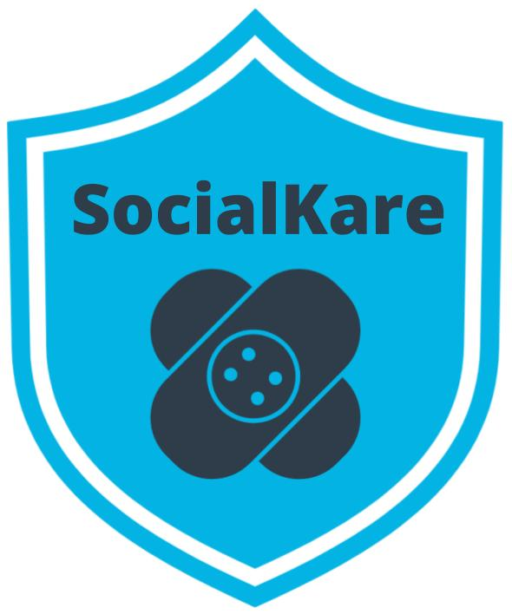



**Table of Contents**

1. SocialKare.gov Case Study

2. Why Agile Exercises

* Agile Mindset Anti-patterns
* Agile Manifesto
* Waterfall vs. Agile
* Setting an Agile Mindset

3. Agile Teams Exercises

* Three Core Roles
* High Performing Teams
* Non-Core Roles
* Agile Decision Making

 4. Agile Frameworks Exercises

* Set Up The Scrum Framework
* Kanban vs. XP
* Recommend a Framework

**Case Study: SocialKare.gov**

SocialKare.gov was launched to allow citizens of Nunamerica to enroll in Social Services provided by the government as a result of a devastating pandemic. Unfortunately, the launch of SocialKare.gov was seen as a disaster from all project management metrics, as well as by its key stakeholders’ low satisfaction ratings.

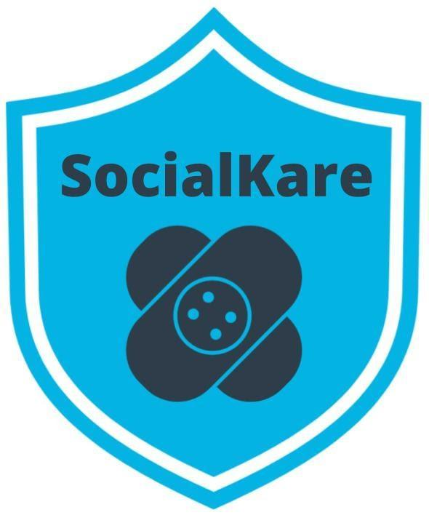

***We will be using this scenario for all of the exercises in this course***

**Independent Investigation**

An independent post-mortem investigation was launched into this project.

The investigation found a pattern of

* poor practices
* lack of clearly identified technical standards
* poor methods to identify software and coding errors.

This led to poor functionality on the website.

During the post-mortem, for virtually every error or gap, the project team claimed it had insufficient time to complete the website by the imposed deadline.

The project was a fixed fee contract with a clearly defined scope of work that was identified up front. As it eventually turned out, this was a complex website with a lot of unrealistic expectations. The multiple government agencies and stakeholders involved handed over a detailed set of inconsistent and difficult to decipher requirements up front. The expectations set for the project team was that they must deliver this content per the defined requirements and contract terms.

An anonymous survey of the team also indicated low morale, stress and employee fatigue.

**8 Key Findings from Independent Investigation**

1. The website launched across all States on the same day. With zero prior experience for citizens who had never used such a website for their important Social Services needs, there was tremendous confusion during the first few days. The system got overwhelmed with users and a multitude of performance issues were reported immediately.
2. Despite following strict government processes, the project developed the website without effective planning or oversight. The government agencies incurred significant cost increases, schedule mistakes and delayed system functionality because of changing requirements at the tail end of the project for functionality that had to go through a stringent change control review. This resulted in significant delays. More agencies were supposed to have input on the development of the website, but the project team did not have a structured approach to obtaining their input.
3. Major coding errors and insufficient capacity for scaling. An investigation identified excessive serious coding flaws in the structure of the website. The project team did not take enough steps to correct the issue until much later in the project life cycle. Some were resolved after going to production. The website was launched with insufficient visitor capacity, leading to further end user frustration. This was captured in the lessons learned session conducted after going to production. There were no Retrospectives and interim lessons learned sessions while the project was underway.
4. Majority of the eligibility requirements were never approved by SocialKare project sponsors and supporting systems integration testing was patchy. The project team claimed they were trying to develop the system in an expedited fashion to meet the deadline so steps ‘had to be missed’. Two months before the scheduled launch, integration tests on the website had not been completed. End-to-end testing, left as the last phase, was never completed before the website launched.
5. Despite thorough documentation and paper trails, oversight was inadequate. Theoretically, a number of governing committees were supposed to oversee the project through quarterly meetings with status updates. The project team spent a significant amount of time keeping up with the required project documents. However, no one raised issues of SocialKare.gov's functionality at the quarterly meetings since neither business representatives nor end user representatives had any hands-on demonstration of functionality that was being built.
6. The project team did not actively engage those business users who best understood the needs of the end users. The project team did not have a formal structure in place to ensure that everyone involved had a shared understanding of all the requirements.
7. While the project team was incentivized to deliver the requirements as specified, due to the time crunch, there was little in the way of ensuring these requirements made business sense throughout the project life cycle. The project team was overwhelmed with an excessive amount of requirements, all flagged as mandatory. What was given as detailed requirements upfront is what the project team worked diligently to deliver. The details were fuzzy in many instances, but the team did not have reliable business representatives readily available to clarify in a timely manner. So, the project team proceeded based on assumptions. It was later realized that several of these requirements were of little value to end users. Further, several key requirements were never uncovered until going to production.
8. Work was assigned by the Project Manager and her boss to the team members as the beginning of the project. Monthly status meetings were conducted by the Project Manager to check on progress based on the defined milestones upfront. Each team member worked on their own list of tasks in silos. The Project Manager monitored everyone’s technical progress individually and stepped in to troubleshoot technical problems. The developers started to depend on the Project Manager’s technical assistance.

**SocialKare.gov Employees**

*This information will be helpful for the Three Core Roles Exercise*

* **John Details**:   
  John is a detail oriented individual who likes to plan everything out in tremendous detail. He has several years of experience as a Technical Project Manager. Prior to stepping into the role of Project Manager, John was a Developer. He is known to have good communication skills.
* **Sarah Tenure**:   
  Sarah has been with the Agency responsible for launching SocialKare.gov for over 2 decades. Sarah has a lot of business knowledge and carries a certain amount of credibility due to this tenure. Sarah is strong headed and likes to make decisions based on how she sees things because she believes she has better insight than others who may have been with the organization for as long as she has.
* **Tim Devs**:   
  Tim has excellent technical skills. He prefers working as an individual contributor where he can spend time diving into the technical challenges on his own. He is well respected for his technical expertise. Tim maintains a strong focus on technical delivery and prefers the business users to stay out of his way while he is working through the development work. Tim leads a team of 5 developers with specialized vertical skills who are also on this project team
* **Jane Dollars**:   
  Jane has sponsored this project. She is a senior executive and likes to stay involved with the day to day activities of projects that she sponsors.

**Why Agile Exercises**

**Agile Mindset Anti-Patterns**

**Instructions:** Read the SocialKare.gov  case study and identify at least three anti-patterns that prevented the Agile mindset from being present. Explain why each anti-pattern is problematic.

|  |  |
| --- | --- |
| **Anti-Pattern** | **Evidence and Results** |
| The Project Team did not engage business users who best understood the needs of the project | The project team was not involving the business people in the SDLC since they were not in constant communication with the business people and this led to incorrect prioritization of the project needs and the development of low-value features. |
| Each Team Member worked in silos | There was no sufficient communication between the team and this led to the team not being able to build a product that was of a nature that required changing needs. Since the team was not communicating well they were not able to catch the faults in the product in the early stages and were lagging and stared missing out on essential features and time of testing |
| There was thorough documentation but inadequate oversight | The agile manifesto suggests as a core principle of working software over comprehensive documentation. However comprehensive documentation was given a higher priority that led to the team being focused on the documentation more than the final product itself leading to less time and effort allocation on the product and not understanding the nature and the fluid requirements of the product and necessary steps. |
|  |  |

**Agile Manifesto**

**Instructions:** Review the SocialKare.gov case study and review the Agile Manifesto Paired Core Values and Agile Principles.  Of the four Paired Core Values, which stand out as being absent at SocialKare.gov? Which Agile Principles are missing? Identify at least two of each and explain why.

|  |  |
| --- | --- |
| **Missing Paired Core Value** | **Evidence and Results** |
| Individuals and Interactions over Processes and Tools | The team was supposed to be working in collaboration and create an environment where every member of the team could be heard, instead of the team rather focused on working in silos where the project manager was working to resolve only the technical issues with the members. This led to unnecessary tools and processes being used while not focusing on the team itself |
| Working software over comprehensive documentation | The team focused on making thorough documentation and did not focus on providing a product with built-in quality.  This led to a product with multiple errors and bugs that were not fixed before launch. |
|  |  |

|  |  |
| --- | --- |
| **Missing Agile Principle** | **Evidence and Results** |
| Welcome changing requirements, even late in development. Agile processes harness change for the customer’s competitive advantage. | The team was given a fixed set of requirements at the very beginning of the SDLC. The requirements needed to be changed however no changes were made to the requirements leading to the delivery of unnecessary features and waste of resources. |
| Business people and developers must work together daily throughout the project. | The business people who knew the business needs of the product were not communicated throughout the development of the product, The developers were working individually and did not communicate with the business people regularly. The resulted in the team not being able to understand all the requirements and leaving the business people in confusion. |
|  |  |

**Agile vs. Waterfall**

**Instructions:** Review the SocialKare.gov case study. Where do you see weaknesses in the Waterfall approach to the SocialKare.gov project being applicable? Identify at least two weaknesses and explain why you see them as weaknesses when compared to the Agile approach for SocialKare.gov.

|  |  |
| --- | --- |
| **Weakness** | **Evidence and Results** |
| The waterfall model is rigid in terms of the scope of the product being developed | I see them as a weakness because the product being built is of some complexity here and this requires fluidity and flexibility in developing the project. If a waterfall approach is taken the building the product then the requirements will not match and unnecessary features will be developed |
| The waterfall model focuses on the work to be done and the delivery of the product rather than keeping the customer or the user mindset in mind | I see this as a weakness because not focusing on the consumer of the product will lead to an ineffective product. There is evidence that the product was confusing for the end users to use and this led to a lot of errors and bugs which was very costly for the organization. |
|  |  |

**Setting An Agile Mindset**

**Instructions:** Review the SocialKare.gov case study. Outline three recommendations to set an Agile Mindset at SocialKare.gov. Consider the Agile Manifesto in your recommendation and avoid the negative pitfalls of Waterfall. Explain why your recommendation will help.

|  |  |
| --- | --- |
| **Recommendation** | **How It Will Help The Team** |
| Focus on Working Software over comprehensive documentation | According to the Agile manifesto, working software is more crucial as compared to just creating comprehensive documentation and a badly developed final product. So focusing more on the working software part will allow the team to meet the requirements of the customer and help in better delivering the product.  Furthermore, the time saved in documentation can also be used to allow for better feature analysis and development as more man work will be available. |
| Focus in developing individual and interactions over process and tools | There was no shared understanding of the requirements due to low priority being given to the individual who understood the requirements of the end users best. Shared understanding of the requirements will allow to best analyze the situation and bring out products that actually are valuable to the end user. |
| Include retrospective and interim sessions to allow for learning and development while the project is being developed. | No team is perfect, and there is always scope of improvement especially when teams work together over a complex project. Having retrospective session will allow for team growth, mutual understanding and empathy, and better optimization for the upcoming feature being developed. |
|  |  |

**Agile Team Exercises**

**Three Core Roles**

**Instructions:** Review the SocialKare.gov case and focus on the employees. Identify the three Agile Core roles and their responsibilities and assign a SocialKare.gov employee to each role. Explain your assignments.

|  |  |  |  |
| --- | --- | --- | --- |
| **Role** | **Responsibilities** | **Employee** | **Justification** |
| The Product Owner | The product is crucial as the PO has the knowledge about the requirements for the business and understands best what is needed on the user side, ensures that the backlog actually meets all the requirements and also ensures that the product is delivered as required | Sarah Tenure, Jane Dollars | Sarah and Jan would be the best for the role of the due to having high business insights and being assigned at higher level position will higher authority to allow for ensuring that the requirements actually meet the user needs. |
| The Facilitator | The Facilitator should be a servant leader who is ready to | John Details | John has high technical skills while at the same time having high communication skills as well .So he would be a good servant leader who would be able to understand diverse people and be able to cut out biases and motivate teams. |
| Team member | The team member is someone who will actually be building the product and be able to contribute to make the final shippable product. | Tim Devs | Tim will be perfect choice for the team member as he works best in shipping technical products and works best while building product and better to manage him rather than outing him on a management intensive role. |
| Team member |  |  |  |

**High Performing Agile Teams**

**Instructions:** Review the SocialKare.gov case and focus on the employees. Choose three team members and identify areas where they are not following Agile best practices. Share suggestions for improvement as coaching opportunities and explain why the coaching is needed.

|  |  |  |
| --- | --- | --- |
| **Role/Team Member** | **Coaching Opportunity** | **Justification** |
| John Details | John needs to be coached on how to encourage innovation and free thinking, alongside the inclusion of uncommitted goals to allow for exceptional work delivery. He also needs to appreciate the team. He should focus on facilitation. | This is because John plans out tasks with extreme details. It is highly unlikely that the project and development specifics will stay constant throughout the development process and hence planning will be an overkill |
| Sarah Tenure | Sarah needs to be coached to how to pass on the insights she has to the rest of the team in order to allow for a better understanding of the product and she also need to recognize and appreciate the team as she can be the PO | Sarah tends to make decisions based on how she sees things, which is not good for an agile team.She needs to allow for decentralized, self-directed teams that can make their own decisions and encourage team thinking. |
| Tim Devs | Tim needs to be trained on how to work in a cross-functional team in a more collaborative manner | This is because he currently prefers to work alone and does not want the business people to interfere with his work. However to build a good agile team the technical and the business people need to work together, |

**Non-Core Roles**

**Instructions:** Review the SocialKare.gov case. Identify at least three non-core roles for the Agile Team. Explain why that role is important to the team’s success.

|  |  |
| --- | --- |
| **Non-Core Role** | **Justification** |
| Center for Excellence | They ensure that a specific feature is built with high quality and can serve value to the end customer or user. |
| Enterprise Architect | The EA will ensure that the solution being developed is feasible under the technical standards by ensuring proper scrutiny in reviewing the solution |
| Domain Subject Matter Expert | The SME can be helpful especially in this case as the expert could be a health regulatory expert who could better help the analysts understand the scenario with better expertise and help in carving out a more suited solution. |
|  |  |

**Agile Decision Making**

**Instructions:** Review the SocialKare.gov case study. identify three types of decisions that should be centralized and three that should be decentralized at SocialKare.gov. Explain your recommendations.

|  |  |
| --- | --- |
| **Centralized Decisions** | **Justification** |
| Long Business Profit Decisions | These decision are more suited if taken by the high level executives who have more knowledge and experience and insights into understanding what is the best route to bring in the most business value to the company |
| Business Model Decisions | The business model depends on several market actor that th agile team might not be well suited to understand and hence it is best to leave on the executives |
| Decision on allocating employees for a certain position | Allocating and reallocating the team members should be a management design supported by the HR members as doing such acts in the team will cause unnecessary tension and conflicts and stop useful workings. |
| **Decentralized Decisions** | **Justification** |
| Setting the duration for regular agile meetups | The team meeting timings should be upto the team as seen well suited to the free timing slots and availability of the team members. |
| Choosing the tools and libraries for development of the project | The use of tools are to be made according to the competency and the comfort of the team members using the tools and solution alignment from the technical viewpoints. Hence it is best suited to leave it to the team members |
| Choosing frameworks and events for encouraging learnings in the team | Since the team is the one is supposed to learn, hence it is best to rely on the team to self-coordinate themselves and find out what works best for them in order to best help them in their learning journey. |

**Agile Framework Exercises**

**The Benefits of Using Agile Frameworks**

**Instructions:** Review the SocialKare.gov case study. List at least 3 specific benefits of using an Agile Framework and explain how those benefits will help SocialKare.gov achieve its goals.

|  |  |
| --- | --- |
| **Benefit from Using an Agile Framework** | **How The Benefit will Help SocialKare.gov** |
| Focuses on individuals over processes | A focus on individuals over process means that the company will be able to retain and recruit the best members for propelling the agile team to deliver the best quality product that serves the customers the most. |
| Agile focuses on working software over a comprehensive documentation | Since working software is the primary form of measurement of team progress, it is really easy and efficient to understand th velocity of the team, and additional time is saved up for development and testing works rather than churning up documentation. |
| Agile Teams respond to change better over time | Since in a fast-paced world, the requirements and the market conditions keep on changing, the user always tends to want a different solution that solves an additional problem. Agile teams are a well fit for this situation as they can solve dynamic problems in an ever changing manner. |
|  |  |

**Set Up the Scrum Framework**

**Instructions:** Review the SocialKare.gov case study. Set up Scrum for the SocialKare.gov team by recommending the core roles to fill and the ceremonies to be conducted. Include the schedule, duration and agenda for each recommended ceremony.

|  |  |
| --- | --- |
| **Role** | **Responsibilities** |
| Product Owner | The product owner should create the product vision and then priorities the backlog and set a clear vision for the development of the product. The product owner also is the voice of the customer and needs to ensure that the right features are chosen form the sprint backlog to be developed |
| Scrum Master | The scrum master should be facilitating the scrum session and looking over to implement scrum effectively. |
| Agile Team Members | The agile team members should bring in T shaped skills and work together to implement the sprint backlog set in the scrum session and put best efforts to meet the backlog for the sprints. |

|  |  |  |  |
| --- | --- | --- | --- |
| **Scrum Ceremony** | **Purpose** | **Agenda** | **Schedule and Frequency** |
| Project Vision |  |  |  |
| Daily Standups |  |  |  |
| Sprint Planning |  |  |  |

|  |  |  |  |
| --- | --- | --- | --- |
| **Scrum Ceremony** | **Purpose** | **Agenda** | **Schedule and Frequency** |
| Sprint Review |  |  |  |
| Sprint Retrospectives |  |  |  |
| Release Plans |  |  |  |

**Kanban vs. XP**

**Instructions:** Review the Kanban and XP Frameworks. Identify key differences between the two frameworks in terms of roles, ceremonies and practices.  
  
**Core Roles in Kanban**

|  |  |
| --- | --- |
| **Role** | **Responsibilities** |
|  |  |
|  |  |
|  |  |

**Core Roles in XP**

|  |  |
| --- | --- |
| **Role** | **Responsibilities** |
|  |  |
|  |  |
|  |  |
|  |  |

**Kanban Ceremonies**

|  |  |  |  |
| --- | --- | --- | --- |
| **Ceremony** | **Purpose** | **Agenda** | **Schedule and Frequency** |
|  |  |  |  |
|  |  |  |  |
|  |  |  |  |
|  |  |  |  |

**XP Ceremonies**

|  |  |  |  |
| --- | --- | --- | --- |
| **Ceremony** | **Purpose** | **Agenda** | **Schedule and Frequency** |
|  |  |  |  |
|  |  |  |  |
|  |  |  |  |
|  |  |  |  |
|  |  |  |  |
|  |  |  |  |

|  |
| --- |
| **Key Differences Between Kanban and XP** |
|  |

**Recommend a Framework**

**Instructions:** Review the SocialKare.gov case study and the Scrum, Kanban and XP frameworks. Recommend a framework or combinations of frameworks for SocialKare.gov. Justify your recommendation by listing the specific characteristics of the framework that will bring value to SocialKare.gov.

|  |
| --- |
| **Recommended Framework** |
| The recommended framework for SocialKare.gov is the Scrum Framework. |

|  |  |
| --- | --- |
| **Characteristic** | **Justification** |
|  |  |
|  |  |
|  |  |