Intake Assignment:

1. **Used library or framework:** abp.io from volosoft (<https://abp.io/>)
2. **Development Platform:** .Net Core
3. **Development Architecture:** Microservice
4. **Client UI Theme:** Metronic Theme from KeenTheme.com
5. **Client Web UI framework/platform:** Angular 23 framework
6. **Database connectivity:** Entity framework Core (Code First)
7. **Database:** SQL Server

To Run/Execute the assignment Intake Solution, please follow the instructions.

1. Keep both folders (**aspnet-core** and **Intake-client**) into same location
2. Run the command prompt from the **aspnet-core** folder and execute the following command
   1. dotnet tool install -g Volo.Abp.Cli
3. Open the solution **Intake.Sln** from **aspnet-core** folder using Visual Studio 2022
4. Find and Open **appsettings.json** from projects **Intake.DbMigrator** and **Intake.HttpApi.Host**
5. Set the default database server (sql server) from the both **appsettings.json** files
6. Right click to the **Intake.DbMigrator** project and select **Set as StartUp Project**
7. Build the solution to ensure the solution is error free.
8. Run/Execute the solution. You will get the following result

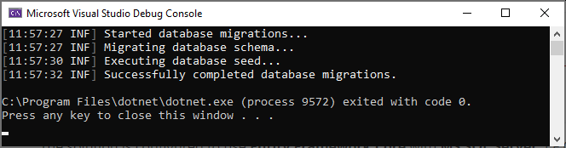

1. Check the Database, the database **Intake** is created.
2. Execute the **Intake_seed.sql** in the Intake database from sql server.
3. Right click to the **Intake.HttpApi.Host** project and select **Set as StartUp Project**
4. Run/Execute the solution. You will get the following result from the web browser.

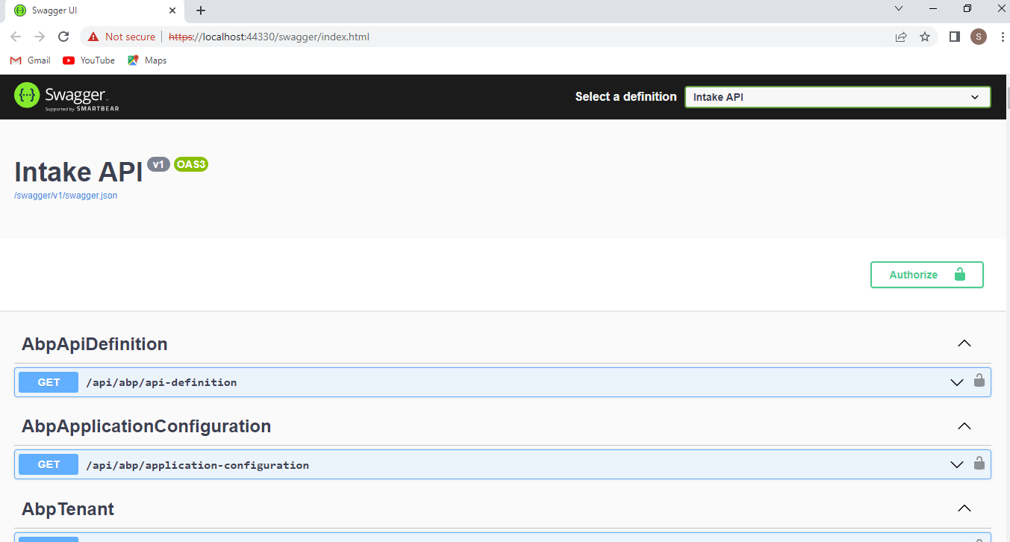

1. The API is running. (you can see and check the customer, machine, sensor and process apis)
2. Open the 2nd folder (Intake-client) in the visual studio or visual studio code.
3. open **cmd** from the folder enter into the **src** directory then run the **npm install** command

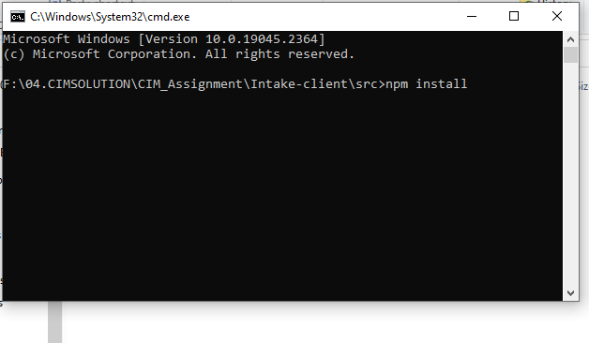

1. If installation done, then execute the following command **npm start.**  Compilation will be start.
2. After successful compile the login page will be appeared.

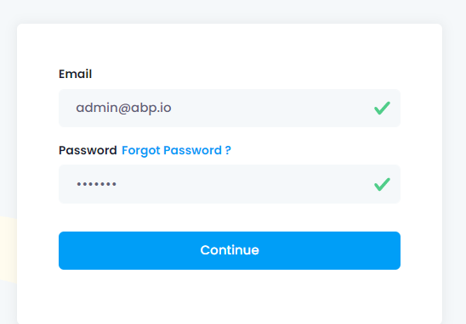

**Login Credentials :**

**User email:** [admin@abp.io](mailto:admin@abp.io)

**Password:** 1q2w3E*

The question answers for the assignment

1. The process overview page:

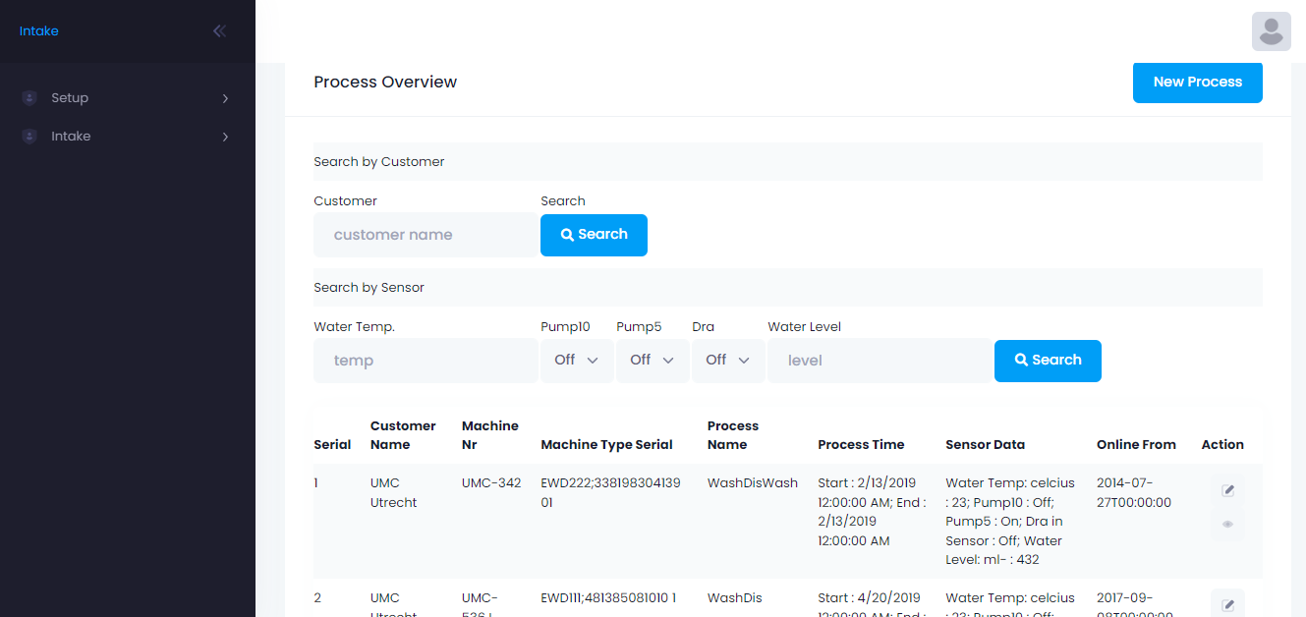

1. To See details for a single process, click to the view button from action column
2. Search a process by the customer name
3. Search a process by the Sensor data.

The additional pages from setup menu

1. Customer list and Entry page

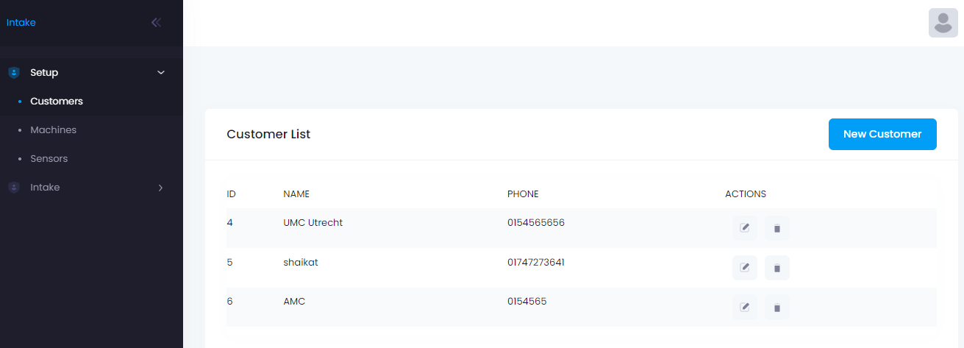

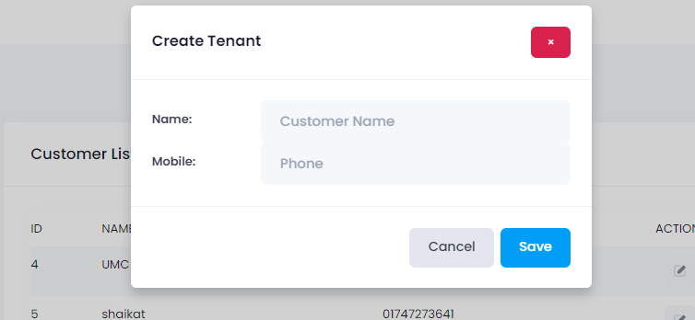

1. Machine list and Entry page

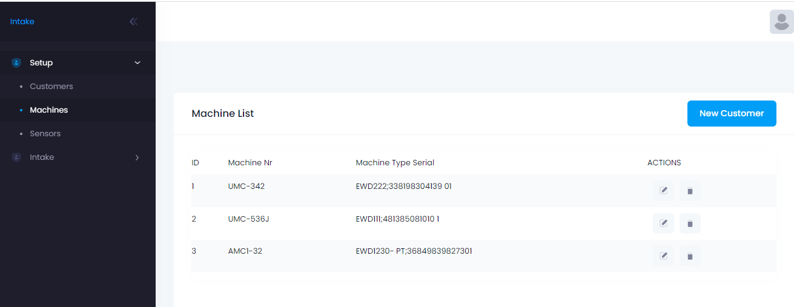

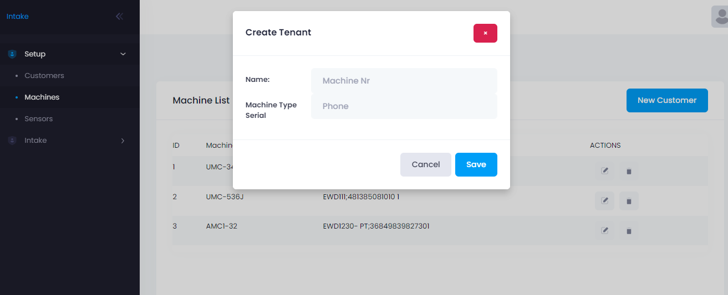

1. Sensor list and entry page

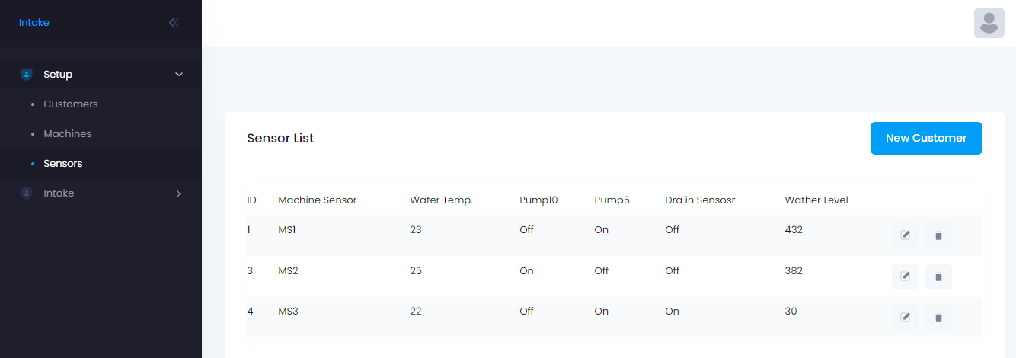

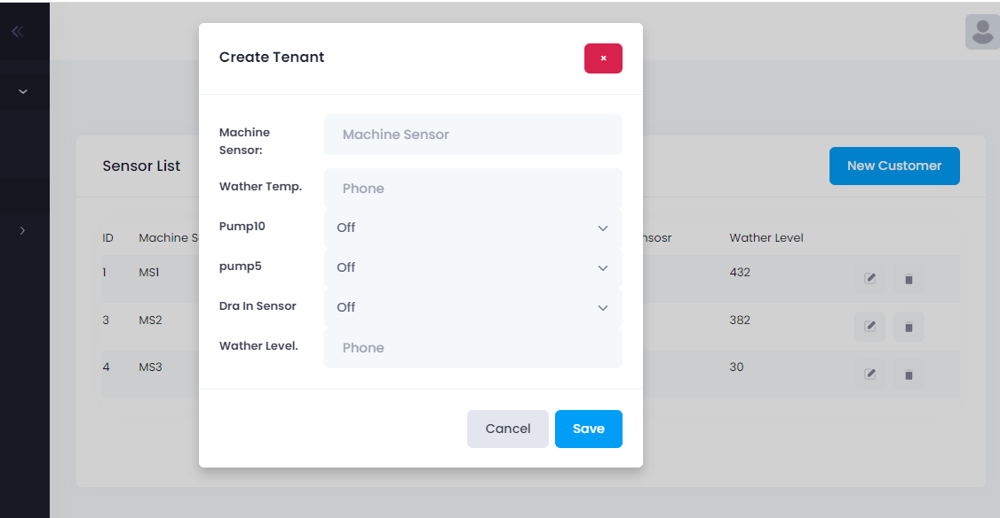

1. Process entry page.

