**SOFTWARE REQUIREMENT SPECIFICATION**

**FOR**

**SoowGood**

**(Digital HealthCare Solution)**

Document Version No.: 0.1

Template Version No.: 0.1

Coppanet limited, Bangladesh

**Template Revision History**

| Version  No. | Version Date | Changes/Description | Prepared By | Reviewed/  Approved By |
| --- | --- | --- | --- | --- |
| 0.1 |  | First version |  |  |
| 0.2 |  | Updated |  |  |
| 1.0 |  | Baselined |  |  |
| 1.1 |  | Updated |  |  |

*Users should not delete the content

**Document Revision History**

| Version  No. | Version Date | Changes/Description | Prepared By | Reviewed/  Approved By |
| --- | --- | --- | --- | --- |
| 0.1 |  | Initial Draft | Shiakat Barua |  |
|  |  |  |  |  |
|  |  |  |  |  |

**CONTENTS**

1 Introduction 1

1.1 Overview 1

1.2 Purpose 1

1.3 References 1

1.4 Definitions 1

2 SCOPE 1

2.1 System Overview 1

2.2 PROPOSED System Overview 1

2.3 Document Overview 1

2.4 REFERENCED DOCUMENTS 2

3 REQUIREMENTS 3

3.1 Functional Requirements 3

3.1.1 DATA Input 3

3.1.2 DATA OUTPUT 3

3.1.3 Source Definition-Data mapping 4

3.1.4 Approval process of data 7

3.1.5 Report Generation 7

3.1.6 The data flow diagram: 8

3.2 External Interface Requirements 9

3.3 Data Requirements 9

3.4 Look and Feel Requirements 9

3.4.1 Data Fatching for 42 File (Maker): 9

3.4.2 Data Fatching for 42 File (Maker): 10

3.4.3 UPload Data to Schedule EFCP1 (Maker): 10

3.4.4 See the EFCP1 Schedule (Maker): 11

3.4.5 Data Fatching EFCR1 File (Maker): 12

Figure 6: EFCR1 Data Saving 13

3.4.6 Data Fatching for EFCP2 File (Maker): 13

Figure 7: EFCP2 Data Saving 14

3.4.7 Data Correction for CERQ (Maker): 14

Figure 8: CERQ Data Correction Page 15

3.4.8 Data Approval CERQ (Checker): 15

Figure 9: CERQ Data Approval Page 16

3.4.9 Rejected Data CERQ (Maker): 16

Figure 10: CERQ Rejected Data 17

3.4.10 Report Generation: 17

3.5 Security Requirements 18

3.6 Environment Requirements 18

3.6.1 Hardware Requirements 18

3.6.2 Software Requirements 18

3.7 Performance Requirements 18

3.7.1 Response Time 18

3.7.2 Recovery Time 19

3.8 Generic Constraints 19

3.9 Statutory & Regulatory Requirements 19

3.10 Other Requirements 19

4 RISKS, ASSUMPTIONS AND DEPENDENCIES 19

5 USER DOCUMENTATION AND TRAINING 20

6 ABBREVIATIONS AND ACRONYMS 21

7 APPENDIX (ADDITIONAL DATA) 21

8 Sign off 21

**List of Figures**

Figure 1: Data Flow Diagram 6

Figure 2: Data Upload Page 8

Figure 4: Data Correction Page 9

Figure 5: Rejected Data Page 10

Figure 6: Approved Data Page 11

Figure 7: Report Generation Page 12

# Introduction

## Overview

## Purpose

## References

|  |  |
| --- | --- |
| Sr. No. | Reference Name |
| 1 |  |

## Definitions

As per public requirements, doctor’s guidelines, market analysis and business idea.

# SCOPE

## System Overview

**SoowGood** digital healthcare application is a game-changer, empowering doctors with efficient appointment management, access to comprehensive patient histories, and diversified income opportunities. Join us in revolutionizing the healthcare landscape in Bangladesh, enabling doctors to provide the best care possible while enhancing their professional journey. Together, let's shape the future of healthcare.

## PROPOSED System Overview

The propose system designed by the following questions-answers procedures.

**Patients**

Introducing our revolutionary digital healthcare application designed to address the key challenges faced by patients in Bangladesh. We understand the frustration of waiting for hours or even an entire day at the doctor's clinic for just a few minutes of consultation. With our application, we offer a seamless solution.

**Problem 1:** Patients endure the hassle of calling receptionists to book appointments and receive approximate time slots. Alternatively, they waste valuable time waiting endlessly at the clinic.

Solution: Our application allows patients to schedule appointments easily with doctors at different branches and locations, including online audio or video consultations. Say goodbye to long waits and hello to convenient and efficient healthcare management. Track your appointments effortlessly within the application.

**Problem 2:** Patients struggle to find the right specialist doctors, resorting to unreliable word-of-mouth referrals or costly trial-and-error experiences.

Solution: Our platform offers a comprehensive list of specialist doctors accompanied by verified patient reviews and experiences. Make informed decisions regarding your healthcare provider, ensuring the quality and appropriateness of your treatment.

**Problem 3:** Following consultations, patients face the arduous task of physically visiting recommended pharmacies, waiting for prescriptions, and collecting medicines. This process is particularly burdensome for individuals with severe health issues.

Solution: We have digitized the entire medical experience. Through our application, patients can consult with doctors online from the comfort of their homes and receive electronic prescriptions. These prescriptions are seamlessly transmitted to partnered pharmacies, enabling medicine delivery directly to their doorstep. Experience the convenience of a complete, hassle-free medical journey without ever leaving your home.

**Doctors:**

Introducing our innovative digital healthcare application designed to address the pressing challenges faced by doctors in Bangladesh. We recognize the struggles doctors encounter with manual appointment scheduling, limited time for reviewing patient histories, and insufficient income opportunities. Our application is here to provide the ideal solutions.

**Problem 1:** Doctors often need to hire receptionists or rely on hospitals for appointment scheduling, resulting in additional costs and potential scheduling conflicts.

Solution: Our application empowers doctors to take control of their schedules and appointments directly from their smartphones. By eliminating the need for receptionists, doctors can efficiently manage their appointments, reducing waiting times for patients and streamlining their practice operations.

**Problem 2:** Doctors struggle to thoroughly review patients' medical histories during appointment times, leading to rushed consultations and potential oversight of critical details.

Solution: With our application, doctors gain access to patients' medical history prior to appointments. This comprehensive information allows doctors to review and analyze patient histories at their own pace, ensuring informed decisions and personalized care during consultations. Time constraints will no longer compromise the quality of patient interactions.

**Problem 3:** Young and junior doctors face financial challenges as they are not adequately compensated by hospitals and organizations, limiting their professional growth opportunities.

Solution: Our platform offers an additional income channel for junior doctors and medical students. By providing opportunities to offer additional services such as nursing or physiotherapy outside of their primary organization, they can enhance their income and gain valuable experience, fostering their professional development.

## Document Overview

The document covers process flow of the existing ideas and the proposed system, user interface, data flow diagram, risk and Securities Services reporting system. This document can also help to prepare test case design.

## REFERENCED DOCUMENTS

|  |  |  |  |
| --- | --- | --- | --- |
| S/N | Document Title | Version | Sample Document |
|  |  |  |  |
|  |  |  |  |

# REQUIREMENTS

## Functional Requirements

### DATA Flow Process

**Application Registration/Login**

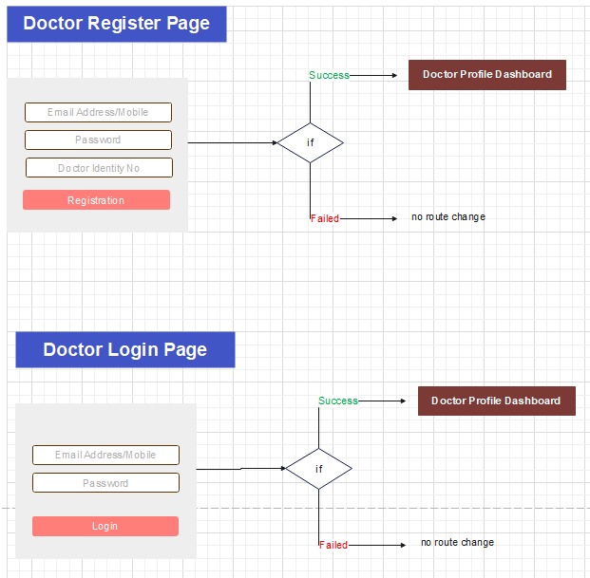

|  |  |
| --- | --- |
| **Sign-in for Provider and Beneficiary** | |
| noWhitespaceValidator | Check for entered email or mobile no is in validate format or not |
| logIn | Check enter email or password is valid or not  **User open direct login page from navigation**      If email and password is valid it will     navigate to **/provider/profile** if login user is provider and **/users** if it is beneficiary  If email and password not valid it show the message to user  **While Booking Appointment**  If email and password is valid it will     navigate to appointment booking page |
| goingToRegister | Navigate to /registration page |
| forgetPass | Navigate to /forget-password page |
| socialsigin | Check login through social plugins like facebook or google. |
| getSocialMediaUserData | Call back function for social plugin to check user is valid or not |
| subscribeToLogin | Check login through linkedin |
| **Function Name** | **API** |
| logIn | Users/login |
| getSocialMediaUserData | Users/verifyuserusingsociallogin |
| **New registration for Doctor** | |
| linkedInCredentials | Declare variable to initiate linkedin credentials |
| noWhitespaceValidator | Check for entered email or mobile no is in validate format or not |
| signUpProvider | Check provided email is available for registration or not and if it is available it get OTP and redirect to OTP verification screen /code-verification |
| socialsigin | Get email or mobile no. through social plugins like facebook or google. |
| getSocialMediaUserDataFaceBook | Call back function after facebook account selection for login |
| getSocialMediaUserDataGoogle | Call back function after google account selection for login |
| getSocialMediaUserData | Check email or mobile no get from social plugin if it exists in the database or not. |
| subscribeToLogin | Get email or mobile no. through linkedin |
| **Function Name** | **API** |
| signUpProvider | Users/verifyuser  If the email or mobile no is exists it will send email or sms to respective email or mobile no |
|  |
| **New registration for beneficiary** | |
| linkedInCredentials | Declare variable to initiate linkedin credentials |
| noWhitespaceValidator | Check for entered email or mobile no is in validate format or not |
| signUpBeneficial | Check provided email is available for registration or not and if it is available it get OTP and redirect to OTP verification screen /code-verification |
| socialsigin | Get email or mobile no. through social plugins like facebook or google. |
| getSocialMediaUserDataFaceBook | Call back function after facebook account selection for login |
| getSocialMediaUserDataGoogle | Call back function after google account selection for login |
| getSocialMediaUserData | Check email or mobile no get from social plugin if it exists in the database or not. |
| subscribeToLogin | Get email or mobile no. through linkedin |
| **Function Name** | **API** |
| signUpBeneficial | Users/verifyuser  If the email or mobile no is exists it will send email or sms to respective email or mobile no |
|  |
| **Verify OTP for Sign-Up and Forget Password** | |
| onDoneClick | Check enter otp with generated otp. |
| resendotp | Resend OTP to email or mobile no from user want to sign up or request  forget password. |
| forgetPassword | It will check if the requested email or mobile no. is registered or not. If it is register it will send the OTP to register email or mobile no |
| verifyuser | It will check if the requested email is registered or not. It is not register it will sent OTP to requested email |
| **Function Name** | **API** |
| onDoneClick | Users/confirmverification  Check generated OTP with enter if OTP matches it will redirect to  **/provider/profile/** if you sign up as provider  **/users/setting/** if user sign up as Beneficiary  **/update-password/** if user sign up while booking(Quick SignUp) |
| forgetPassword | Users/forgotPassword |
| verifyuser | Users/verifyuser |
| Forgot Password | |
| noWhitespaceValidator | Check for entered email or mobile no is in validate format or not |
| forgetPassword | It will check if the requested email or mobile no. is registered or not. If it is register it will send the OTP to register email or mobile no |
| onBackButton | Navigate to **/sign-in** |
| **Function Name** | **API** |
| forgetPassword | Users/forgotPassword |

**Landing Page:**

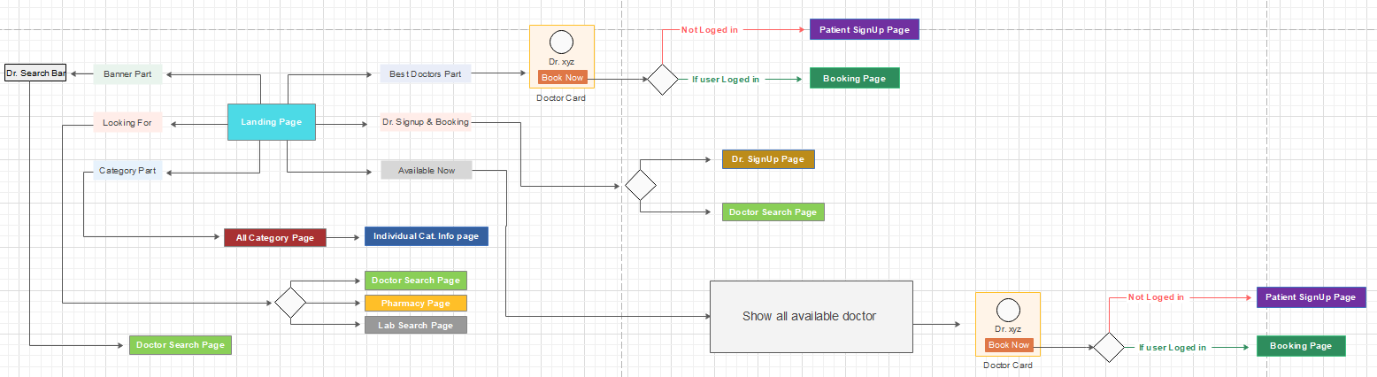

|  |  |
| --- | --- |
| **Use to show application header** | |
| checkStatus | Check user is login or not |
| onLogClick | Redirect to first page of application |
| onLoginClick | Redirect to signin page |
| onBeneficialSignUp | Redirect to sign up page for Beneficiary |
| onProviderSignUp | Redirect to sign up page for provider |
| **Show the home page data** | | | |
| getAllProvider | | Get list of 5 provider according to rating | |
| getAllClinicAndSpecialities | | Load the data below the Clinic and Specialities heading | |
| printrating | | Display rating for each provider display under our provider | |
| onLogoClick | | Click event of soowgood logo present at header and footer | |
| onSearchLocaltionBtnClick | | it will redirect to search page and show provider for location | |
| onSearchBtnClick | | it will redirect to search page and show provider for name and location | |
| onClinicAndSpecialitiesClick | | It will swap the data for Cancer Specialist and Eye Specialist | |
| onViewMore | | It will redirect to provider/user show profile and schedule for selected provider | |
| bookNow | | It will redirect to provider/user show profile and schedule for selected provider | |
| GetCurrentLocation | | Get current location for user | |
| openreviewandrating | | Open previous review and rating for provider | |
| **Function Name** | | **API** | |
| getAllProvider | | Searches/Provider | |
| getAllClinicAndSpecialities | | ProviderCategoryInfoes/AllServices | |

**Patients Profile Dashboad:**

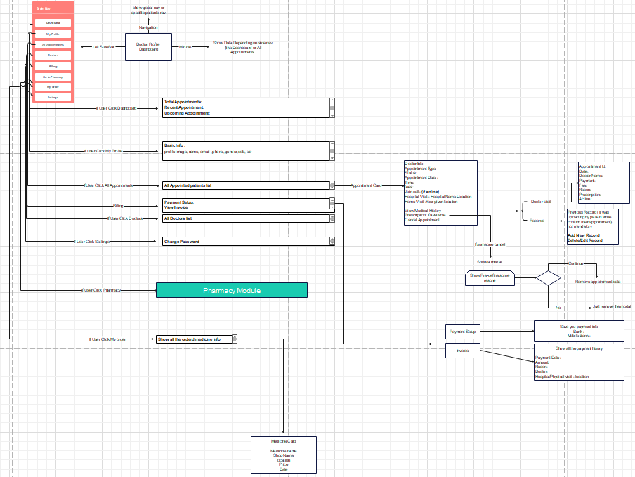

|  |  |
| --- | --- |
| getProfilePicture | Show profile picture for login user |
| onSelect | Select main menu |
| onSelectChildren | Select child menu from menu drawer |
| opensupporthelp | Open help page |
| getCardAppointments | Show count of today applint with provider |
| getCardDoctors | Show the count of provider for which beneficiary book the appointment |
| getAllBookingData | Get list of appointment according to tab (Recent and Upcoming) |
| onJoinCallClick | beneficiary  can join the call by click on that |
| onRejectDetailsClick | beneficiary can cancel appointment  System not allow to cancel appoint 6 hour of appointment time |
| updateAppointmentCancel | Cancel appoint |
| upcomingAppointment | Show upcoming appointment |
| recentAppointment | Show recent appointment |
| onCreatePrescriptionClick | Navigate to **/patient-prescription/** |
| **Function Name** | **API** |
| getCardAppointments | Dashboard/AllAppointment |
| getCardDoctors | Dashboard/VisitedDoctor |
| getReceiverPoints | Dashboard/ReceiverPoint |
| getAllBookingData | Bookings/patientAppointmentHistory |
| onJoinCallClick | Bookings/checkAppointmentForVideoCall |
| onRejectDetailsClick | Bookings/checkAppointmentCancellation |
| updateAppointmentCancel | Bookings/cancelBookingByPatient |

Maker will fetch data for 42 file type data, RQ closing data, Schedule EFCP2 and Schedule EFCP1. 42 file type data will have fetched from GLTRN archive and also RQ closing data will have fetched from BDDB2 of the corresponding month. Both data will show into the maker end as above mentioned sample data. The source of EFCR1 and EFCP2 data are the generated schedule data of EFCP1 and EFCP2 into the FRS. After fetching all the data maker will save the data as input data to prepare the return. Maker also upload source input excel for EFCP1 schedule data to generate the EFCP1 schedule. After fetching getting all data maker will generate the actual report data for data correction of the return **Statement of Commodity Wise Exporters Retention Quota as output**.

### DATA OUTPUT

Single output file will be generated for this report

The sample output format is provided in the file:

* Output_ERQ

### Source Definition-Data mapping

#### Statement of Commodity Wise Exporters Retention Quota

|  |  |  |  |  |  |  |  |  |  |
| --- | --- | --- | --- | --- | --- | --- | --- | --- | --- |
| **Ouput Filed** | **Source Field** | **Source** | | **Condition** | | **Data Arrangement** | | **Calculation** | |
| **SL NO.** | auto generation | | | | | | | | |
| **PARTICULARES** | Satatic or Manual Entry | N/A | N/A | | N/A | | N/A | |
| **Establishedment of Foreign Currency A/C this month** | Current Month Account Counting | RQ(Closing) | FT=42 | | order by CurrCode_BB | | N/A | |
| **Total A/C up to this Month** | Total Account Counting | RQ(Closing) | FT=42 | | order by CurrCode_BB | | N/A | |
| **Total Deposite of Foreign currency up to this month** | Total in CRAMNT | 42 File And EFCR1 | 1) EFCR1= Total in CRAMNT for the Transaction begins with 41113,41115, 42113,42113,42613,42615, 42213,42215, 42413,42415 in 42 File for Commodity  2) 42 file Trade Items will be matched with Cform Trade items. If purpose code 2412, 2413,2410,2411,2414 found in Cform, it will be reported as SERVICE Exporter others will be Commodity | | N/A | | N/A | |
| **BALANCE AS ON CURRENT MONTH** | SUM(FCY_CR) | RQ (CLOSING) | FT=42 | | Order by CurrCd | | N/A | |
| **Business Tour** | SUM(Amount) | Schedule_EFCP2 | if category=42 and (Transaction begins with OT,ET & Branches (ERQ in narration field of GLTRN S6 for branches) | | Order by CurrCode_BB | | N/A | |
| **Participation of Seminar** |  |  |  | |  | | N/A | |
| **IMPORT** | SUM(Amount) | Schedule_EFCP1 | (Total DRAMT begins with 411, 421,426, 422, 424) | | Order by CurrCode_BB | | N/A | |
| **OTHER** | N/A | N/A | N/A | | N/A | | (TOTAL WITHDRAWAL) - (IMPORT+ Business Tour) | |
| **TOTAL WITHDRAWAL** | SUM(DRAMNT) | 42 File | FT=42 | | Order by CurrCode_BB | | N/A | |
| **CLOSING BALANCE AS AT MONTH END.** | FCY_CR | RQ (CLOSING) | FT=42 | | Order by CurrCd | | N/A | |
| **TOTAL FOB EXPORT VALUE FOR THE CURRENT MONTH.** | BALANCE AS ON CURRENT MONTH | N/A | N/A | | N/A | | N/A | |

### Approval process of data

The workflow of upload input file, manual entry, correction and final approval will be passed through “Maker – Checker” mechanism such that the Checker will verify them. Nevertheless, the Checker can edit no value. The checker will be able to either approve or reject the submitted data. If approver rejects any submitted data, Maker has to rectify the rejected fields again.

### Report Generation

|  |  |
| --- | --- |
| **Use Case** | **Report Generation** |
| Actors | System Admin, System User |
| Descriptions | The system will allow user to prepare report for Bangladesh Bank using processed customer information from database. |
| Preconditions | All data submission should be approved by approver user. |
| Post-conditions | * Will show report generation completed message. |
| Flow | * User will fetch part of input data and manually entry the rest. * User will click on Submit button. * User will conduct actions for generating report. |
| Output formats | * Excel |

### The data flow diagram:

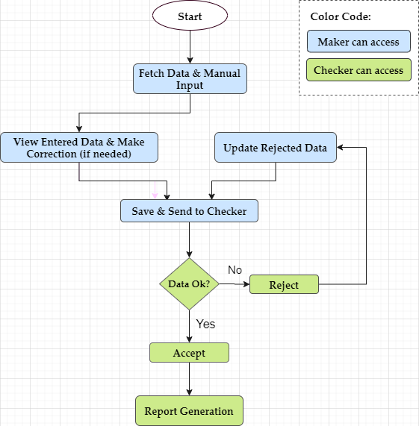

Figure 1: Data Flow Diagram

## External Interface Requirements

N/A

## Data Requirements

All input data will be provided through either manual entry or data fetching from input file or from FRS schedules.

## Look and Feel Requirements

Through this menu two output files will be generated and from maker end to report generation stage all processes will be same.

Prototype of interface design for the new application is given below:

### Data Fatching for 42 File (Maker):

Maker will get the for 42 file from GLTRN through this page.(How? Please describe)

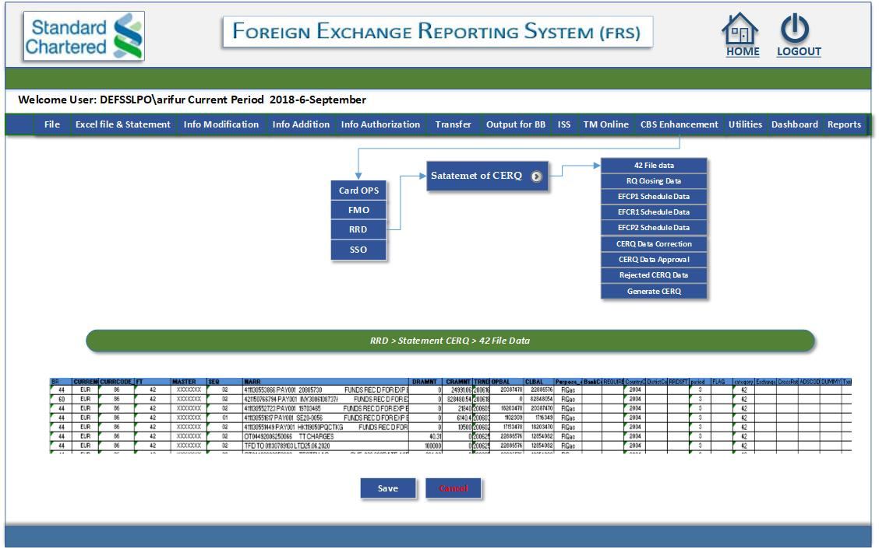

* Image seems not correct. From where and how the data in the grid comes from (Please describe)
* Draw every control of the page like calendar(if any), file uploder(if any)etc. if it comes from any entry page include that before this image
* It seems that all control of this page is not showing here. Please show each and every control of this page.
* Describe detail functionality and work process of this page point by point
* Describe detail functionality of every control like the work of save button and cancel button
* Describe necessary DB tables design needed for this module and describe how they will be used
* Please include all necessary details that are necessary to develop this module. User should not have to implement any logic (Like data validation) that is not written in the SRS
* Please follow the above instruction for every figure.

Figure 2: 42 File Data

### Data Fatching for 42 File (Maker):

Maker will get the for RQ Closing from BDDB2 through this page.

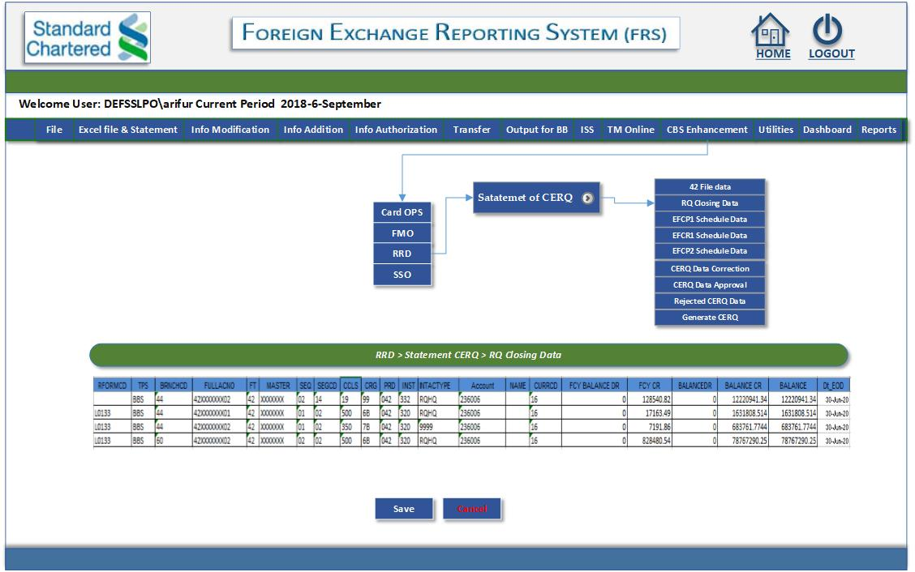

Figure 3: RQ Closing Data

### UPload Data to Schedule EFCP1 (Maker):

Maker will upload the EFCP1 data from Trade to make the schedule EFCP1

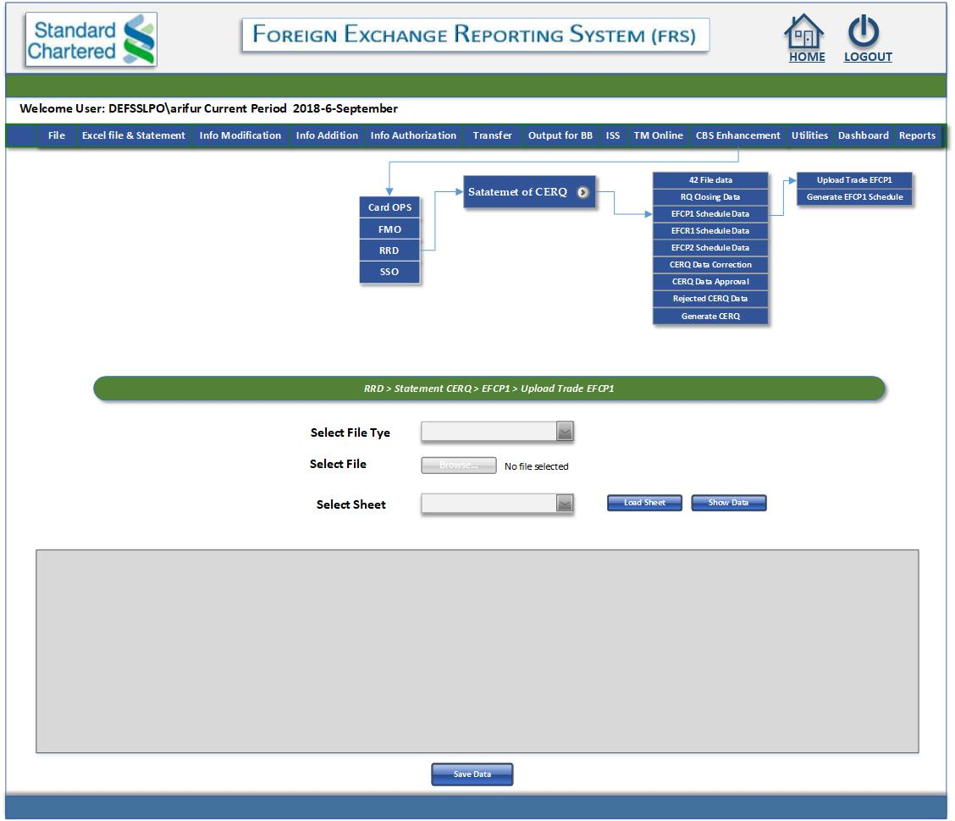

**Figure 4: Upload EFCP1 Data**

### See the EFCP1 Schedule (Maker):

Maker can see the EFCP1 Schedule data through this page.

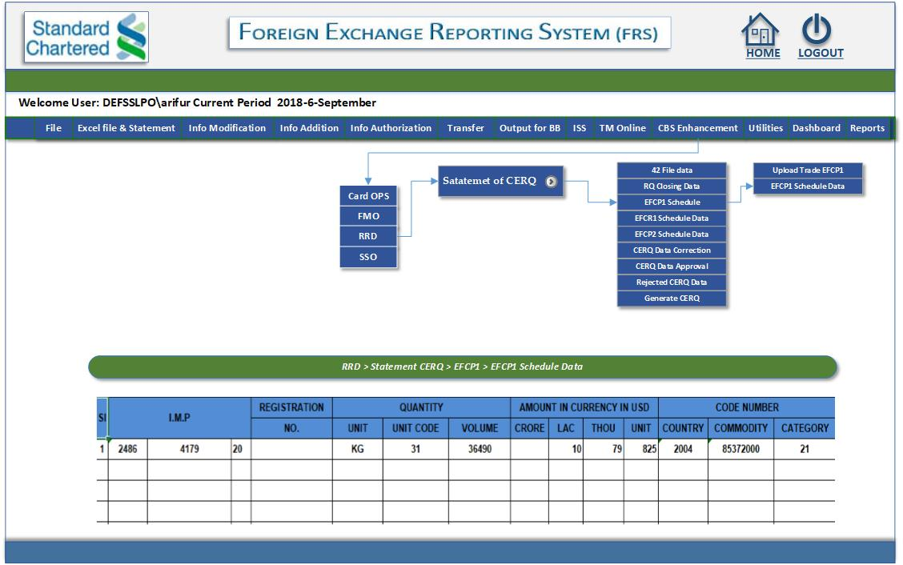

**Figure 5: EFCP1 Schedule data**

### Data Fatching EFCR1 File (Maker):

Maker will get the for EFCR1 through this page.

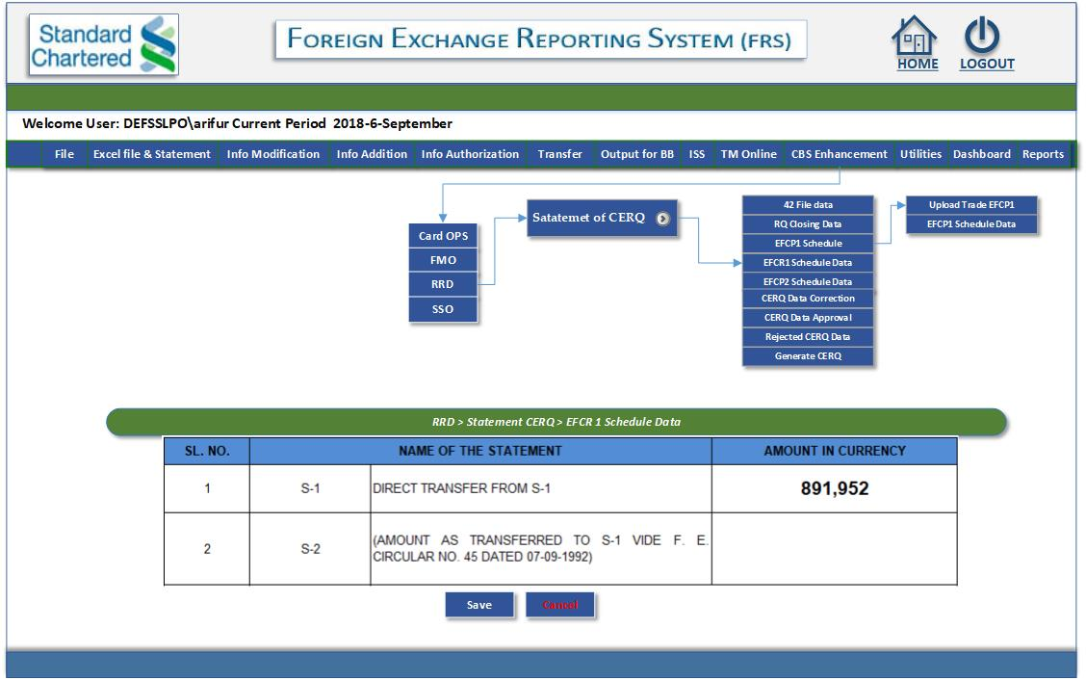

### Figure 6: EFCR1 Data Saving

### Data Fatching for EFCP2 File (Maker):

Maker will get the for EFCP2 through this page.

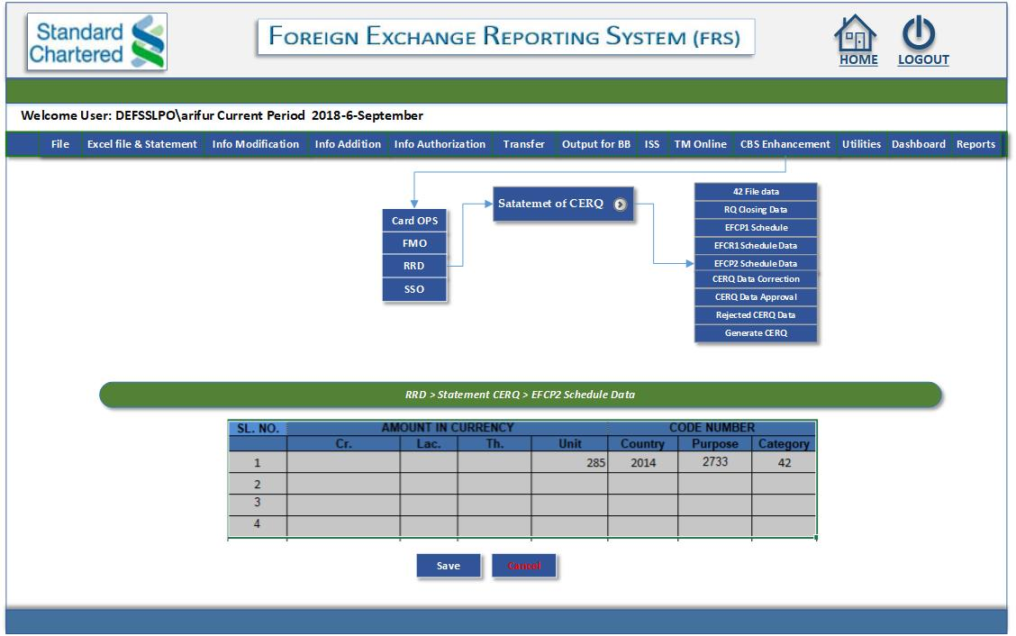

### Figure 7: EFCP2 Data Saving

### Data Correction for CERQ (Maker):

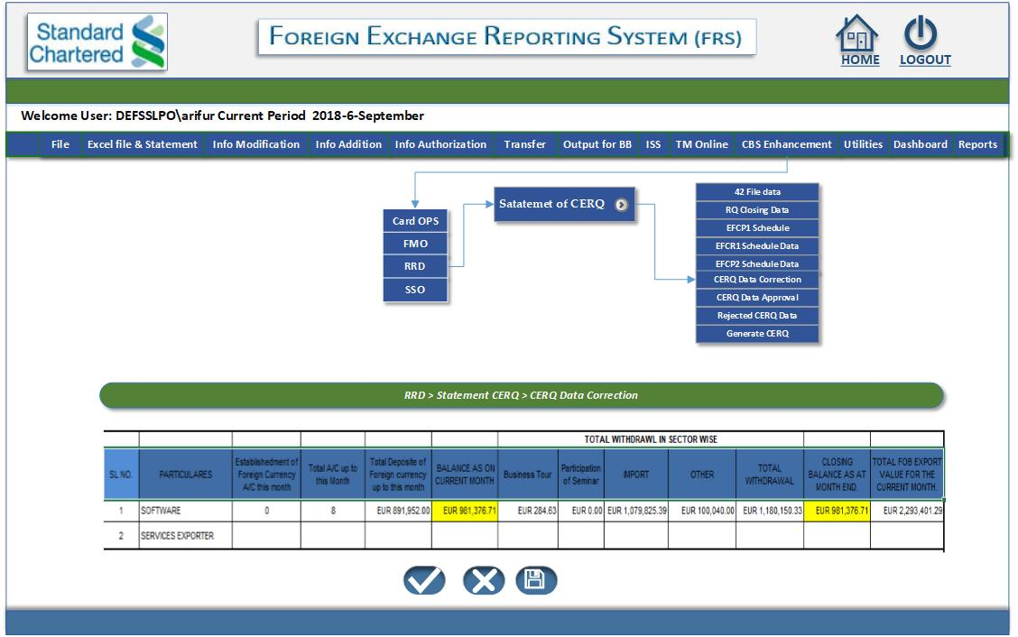

### Figure 8: CERQ Data Correction Page

### Data Approval CERQ (Checker):

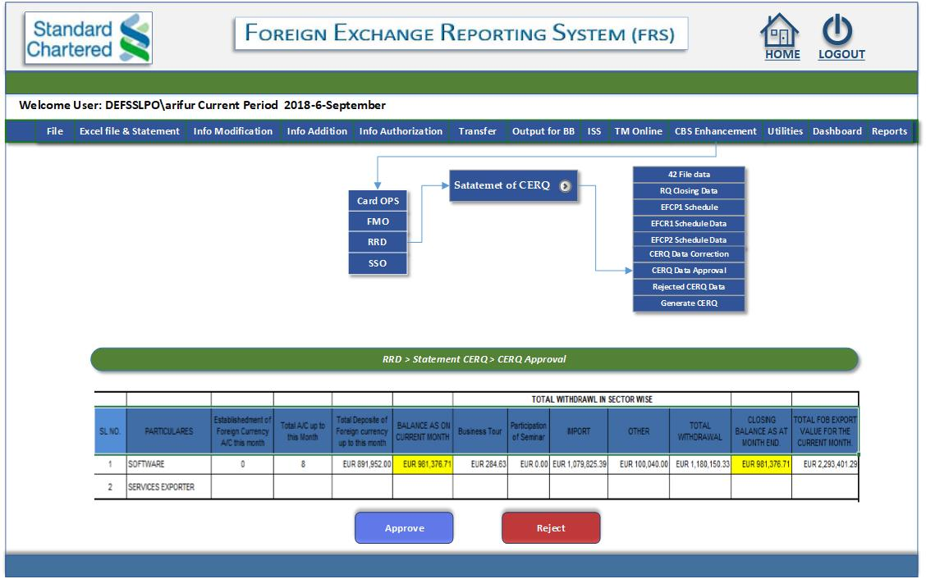

### Figure 9: CERQ Data Approval Page

### Rejected Data CERQ (Maker):

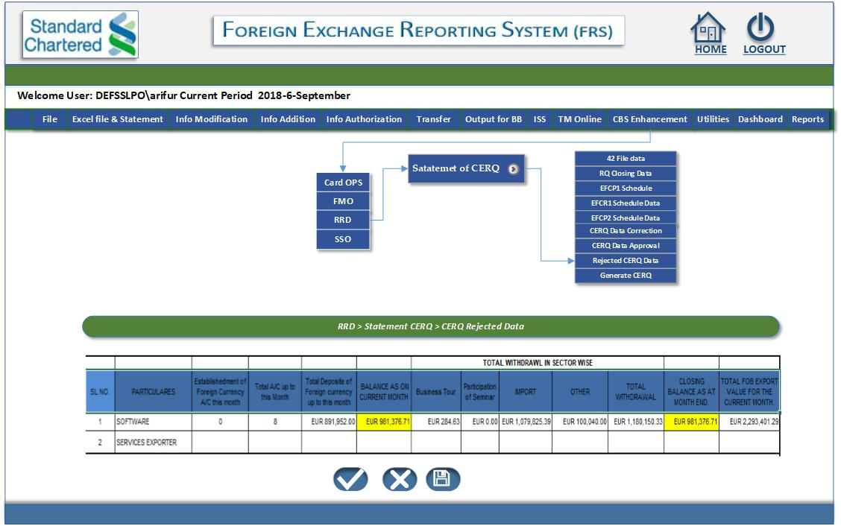

### Figure 10: CERQ Rejected Data

### Report Generation:

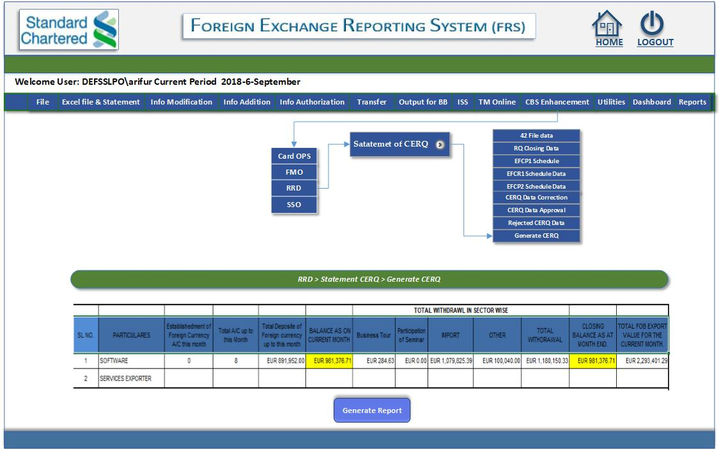

Figure 11: CERQ Report Generation

## Security Requirements

**Implement Role in User Management Module:**

**RRD** module will use FRS authentication and authorization system. User’s role will be set according to user’s operation like files upload, approval and viewing different types of reports. An Administrator has all privileges to maintain user management module, role management and other security issues.

**Application Architecture:**

The Module Called “RRD” will be added into the existing FRS system which is already running at SCB Bangladesh. So, the application architecture bases on the existing FRS system.

## Environment Requirements

### Hardware Requirements

As a part of FRS system **RRD** will use same hardware and network facilities as FRS system currently using.

### Software Requirements

**RRD** module is developed in ASP.Net technology using MS Visual Studio IDE which is same as current FRS system. So the software environment will be same as FRS for **RRD** module.

## Performance Requirements

### Response Time

|  |  |  |  |
| --- | --- | --- | --- |
| Job / Task / Event Name | Response Time (Range of Values) | | Unit of Measurement |
| Upper Range | Lower Range |
| Upload excel file | 12 seconds | 3 seconds | 1000 records |
| Report Generation | 60 seconds | 2 seconds | 1 report |

### Recovery Time

If network, database and application server stay ready then the recovery time of application is two hours.

## Generic Constraints

The **RRD** Module always has to interact with the FRS System. Also net working should be available.

## Statutory & Regulatory Requirements

The rules and regulations will be maintained as per SCB suggestions.

## Other Requirements

N/A

# RISKS, ASSUMPTIONS AND DEPENDENCIES

| **#** | **Risk** | **Explanation** | **Solution** | **Practise** |
| --- | --- | --- | --- | --- |
| 1 | Requirement  Deviation | As the project progresses features that were not identified at the beginning of the project may emerge that can change estimates and timelines. | We will follow  Signed Off –  Requirement  Specification  Document. Any change beyond Signed- off document will be managed thru change management Procedure. | dataedge has started to follow CMMI processes which will help to manage and deliver quality products to client. |
| 2 | Missing  Delivery  Scheduled | Missing the project delivery deadlines and milestones. | Stakeholders’ will be informed periodically about the project status including issues, concerns and risks. | dataedge team will follow work breakdown structure schedule (WBS Schedule). For any kind of variance team will overwork to maintain schedule. |
| 3 | Integration with FRS System | RRD will be developed within existing FRS System architecture. Existing Authorization System may not fulfill FMO requirements more over conflict may emerge for different functional and technical requirements of two projects. | RRD and FRS team will work together to overcome all technical and functional difficulty. | Testing team will test the whole application and correlate with the development teams about issues or concerns. |

# USER DOCUMENTATION AND TRAINING

**Documentation List:**

|  |  |
| --- | --- |
| **SL.No#** | **Particular** |
| 1 | SRS for RRD |

**Training Schedule:**

N/A

# ABBREVIATIONS AND ACRONYMS

|  |  |  |
| --- | --- | --- |
| Sr. No. | Abbreviations  /Terms | Elaboration |
| 1 | SRS | System Requirement Specification |
| 2 | BRD | Business Requirements Definition |
| 3 | FRS | Foreign Exchange Reporting System |
| 4 | RRD | Securities Services Operation |

# APPENDIX (ADDITIONAL DATA)

N/A

# Sign off