Department of Computer Science and Engineering
CSA0607 – Design and Analysis of Algorithms

CO1 – Assessment Tool 1
IT Application-Based Problem Solving
Scalability Audit of an E-Commerce Platform (ShopSphere)

Detail | Information
Student Name | Shaik Abdul Azeez
Student Reg. No. | 192472015
Course Outcome Assessed | CO1 – Determine algorithm efficiency using asymptotic notations, the Master Theorem and the substitution method
Duration / Mode | 3 Days / Individual
Programming Language | Python 3 (run in VS Code)

About This Report

ShopSphere is an online shop. Its catalogue has 100,000 products today and will grow to 1,000,000 products within a year. As the algorithm engineer, I checked five back-end modules (M1 to M5) to find out which ones will become too slow, and which must be redesigned.
Rules used in every calculation
  - The servers do 10^8^ basic operations per second (100 million per second).
  - The nightly job must finish in 10 minutes = 600 seconds = 6 × 10^10^ operations.
  - Time in seconds = number of basic operations ÷ 10⁸.

n always means the number of products (or records) the module works on.
How the work was done
  - First I worked out each answer by hand using simple maths (shown step by step).
  - Then I wrote small Python programs that count the real operations and check that the counts match my formulas.
  - Every part below shows: the maths, the Python code, the program output, and what the result means for ShopSphere.

Part (a) – Understand the Problem

Module | Input size n | Basic operation | Where it happens | How it grows
M1 | Number of products | Comparing the title and seller of two products | The IF line inside the inner FOR loop | Like n². Double n → 4 times the comparisons
M2 | Upper limit of the request window | Audit(Request[j]) | The inner FOR loop | Like n (about 2n). Double n → about double the work
M3 – S1 | Products in the unsorted catalogue | Comparing the key with one product | Each step of the scan | Like n. Double n → double the comparisons
M3 – S2 | Entries in the sorted index | Comparing the key with the middle entry | Each halving step | Like log n. Double n  → only 1 more comparison
M4 | Size of the customer–product data | Merging partial results (the “+ n” part) | After the recursive calls return | Current: like n². Redesign: like n log n
M5 | Number of sales records | Comparing revenues while sorting | Every level of the recursion | Like n log² n
Report generator | Number of records in the report | One step of the 3n² main work | The biggest term of f(n) | Like n². Double n → 4 times the work

Why these choices
  - M1: two loops, one inside the other. The IF test is the deepest, most repeated step.
  - M2: the Audit call is the only real work. Counting Audit calls tells the whole cost.
  - S1 and S2: a search is only a series of key comparisons, so the comparison count is the cost.
  - M4 and M5: a divide-and-conquer algorithm splits the problem, solves the parts, then combines. The combine step (merge or sort) is the work done at every level.
  - Report generator: f(n) is given. The n² term grows fastest, so it controls the cost.

Part (b) – Analyse the Iterative Modules
M1 – Duplicate-Listing Detector
Basic operation: one comparison of Product[i] with Product[j] (the IF line).
Step 1 – count the inner loop. For one fixed i, j goes from i + 1 to n − 1:
Number of j values = (n − 1) − (i + 1) + 1 = n − 1 − i
Step 2 – add up over all i (i goes from 0 to n − 2):
Total = (n − 1) + (n − 2) + (n − 3) + … + 2 + 1
This is the sum of the first (n − 1) numbers: 1 + 2 + … + m = m(m + 1)/2, with m = n − 1
Total = (n − 1)·n / 2 = n(n − 1)/2 = (n² − n)/2
Exact comparisons = n(n − 1)/2. Time complexity = Θ(n²). Space complexity = Θ(1).

  - Time: the loops never stop early, so best, average and worst case are all the same: Θ(n²).
  - Space: only the variables i, j and n are used. No extra list is created, so extra space is Θ(1).
  - Meaning: n = 100,000 gives 4,999,950,000 comparisons. n = 1,000,000 gives 499,999,500,000. Ten times more products means about 100 times more work.
M2 – API Rate Limiter
Basic operation: one Audit(Request[j]) call.
Step 1 – what values does i take? i starts at 1 and doubles while i < n:
i = 1, 2, 4, 8, …, 2^{m}
n)
(the last one is the largest power of 2 below
Step 2 – the inner loop runs i times for each value of i, so the Audit count is:
Total = 1 + 2 + 4 + 8 + … + 2^{m}
Using the geometric series 1 + 2 + … + 2^{m} = 2^{m+1} − 1
Total = 2^{k} − 1, where k = ceil(log₂ n) is the number of rounds
Step 3 – find the tight bound. For any n, n ≤ 2^{k} < 2n. So:

n − 1 ≤ Total < 2n − 1
Total is between n and 2n, so Total = Θ(n)
Exact Audit operations = 2^{k} − 1 with k = ceil(log₂ n). Tight
bound = Θ(n). Space = Θ(1).
Is the team member right?
No, the claim Θ(n log n) is incorrect. The team member assumed the inner loop runs n times in each round. It does not. In round one it runs 1 time, then 2, then 4, and so on. Only the last rounds are big, and everything before them adds up to about the same size as the last round (1 + 2 + … + n/4 ≈ n/2). So the total is only about 2n.
O(n log n) is still a true upper bound, but it is not tight. The tight bound is Θ(n).
Verification for n = 1,024
Values of i below 1024: 1, 2, 4, 8, 16, 32, 64, 128, 256, 512 (10
rounds)
Total = 1 + 2 + 4 + 8 + 16 + 32 + 64 + 128 + 256 + 512 = 1023 = 2¹⁰
– 1
The n log n claim would give 1024 × 10 = 10,240, which is about 10 times too large
Meaning: at n = 1,000,000 M2 does only 1,048,575 audits, which takes about 0.01 seconds. M2 is safe.

Source code
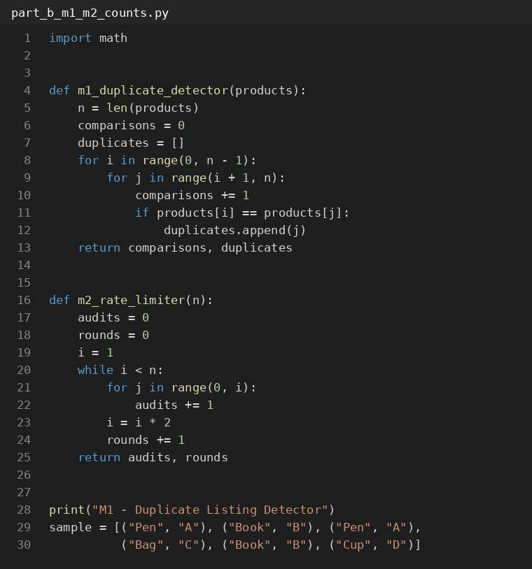
Figure 1: part_b_m1_m2_counts.py (1 of 2)

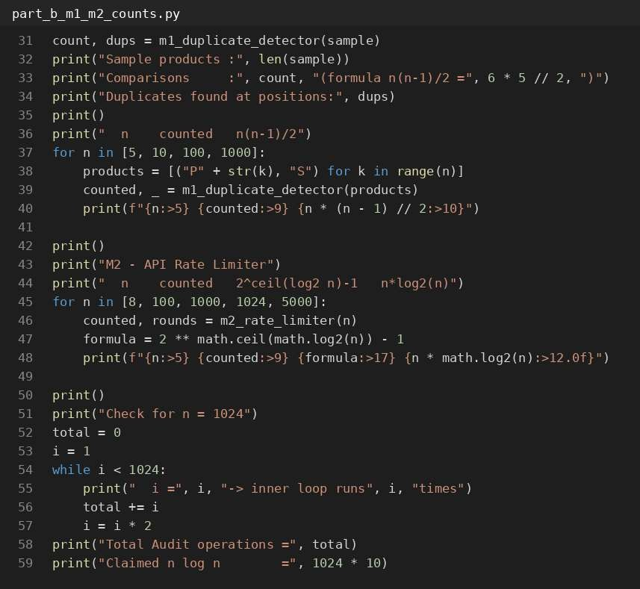
Figure 1: part_b_m1_m2_counts.py (2 of 2)

Output
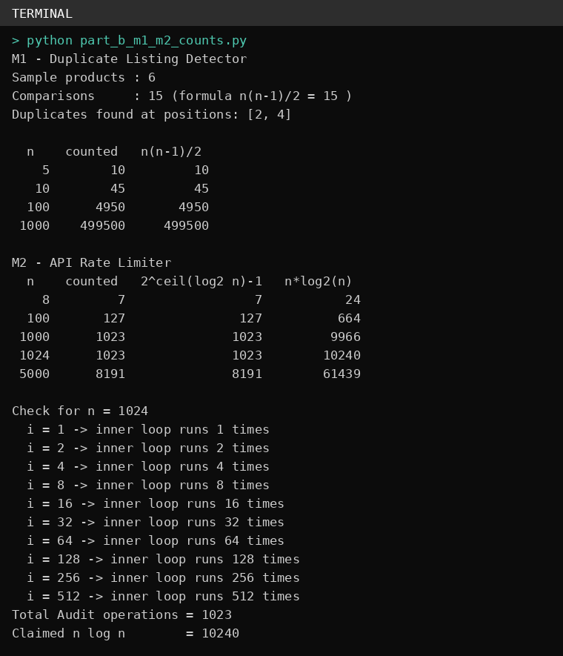
Figure 2: Output of part_b_m1_m2_counts.py
The output shows the counted values equal the formulas n(n − 1)/2 and 2k − 1 for every n tested, and that M2 gives 1023 for n = 1024.

Part (c) – Solve a Recurrence by Substitution
Binary search (S2) compares the key with the middle entry, then throws away half. Its comparison count is:
T(n) = T(n/2) + 1, T(1) = 1

Backward substitution – step by step
Step 1: T(n) = T(n/2) + 1
Step 2: Put T(n/2) = T(n/4) + 1 → T(n) = T(n/4) + 1 + 1 = T(n/4) + 2 Step 3: Put T(n/4) = T(n/8) + 1 → T(n) = T(n/8) + 1 + 1 + 1 = T(n/8) + 3
Step 4: Put T(n/8) = T(n/16) + 1 → T(n) = T(n/16) + 4
Spot the pattern. After k steps:
T(n) = T(n / 2k) + k
Stop at the base case. The recursion stops when n / 2k = 1:
n / 2k = 1 → 2k = n → k = log₂ n T(n) = T(1) + log₂ n = 1 + log₂ n
Exact closed form: T(n) = log₂ n + 1 (n a power of 2). For any n: floor(log₂ n) + 1. Quick check, n = 8: T(8) = T(4) + 1 = T(2) + 2 = T(1) + 3 = 1 + 3 = 4, and log₂ 8 + 1 = 3 + 1
= 4. ✓

Time and space complexity

Version | Time | Space | Why
Iterative | Θ(log n) | Θ(1) | Only low, high and mid are stored. The loop runs about log₂ n times.
Recursive | Θ(log n) | Θ(log n) | Each call waits on the call stack. The stack gets about log₂ n calls deep.

Meaning: for 1,000,000 products binary search needs only 20 comparisons. Doubling the catalogue adds just one more comparison. The program confirms 20 comparisons and a recursion depth of 20.

Source code
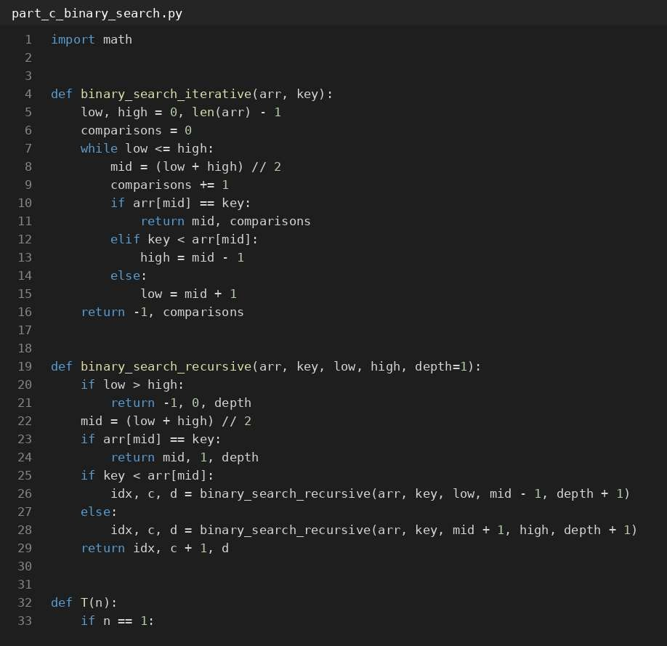
Figure 3: part_c_binary_search.py (1 of 2)

Figure 3: part_c_binary_search.py (2 of 2)
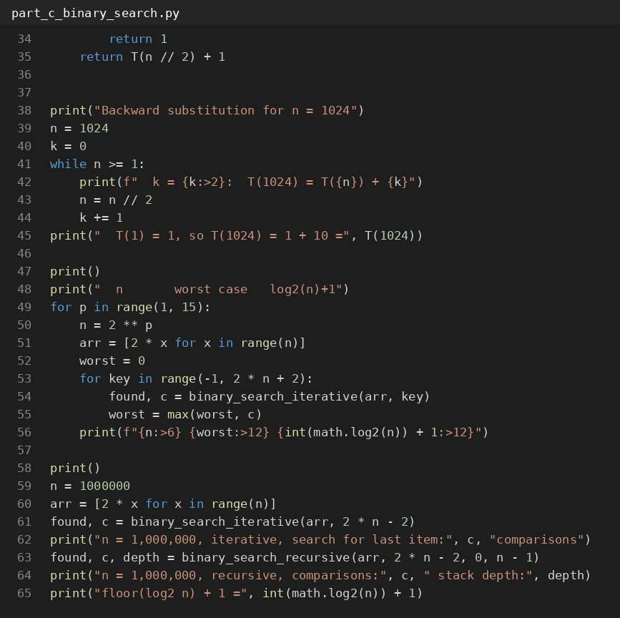

Output
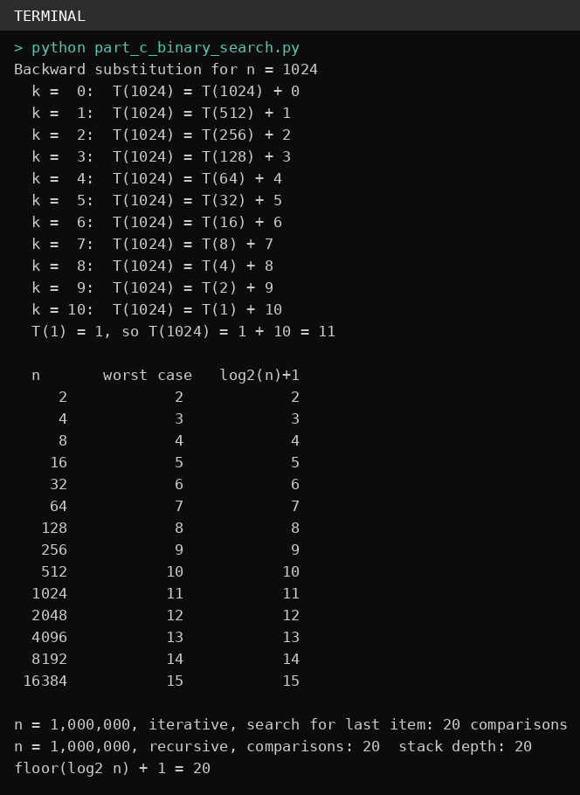
Figure 4: Output of part_c_binary_search.py
The table in the output tries every possible key for n = 2 up to 16,384. The worst case always equals log₂ n + 1, as the formula says.

Part (d) – Apply the Master Theorem
For T(n) = a·T(n/b) + f(n), compare f(n) with np, where p = log_{b} a:
  - Case 1: f(n) is smaller than np (by a power of n) → T(n) = Θ(np)
  - Case 2: f(n) is the same size as np → T(n) = Θ(np log n)
  - Case 3: f(n) is bigger than np (by a power of n) → T(n) = Θ(f(n))

M4 – Recommendation Engine

 | Current design | Proposed redesign
Recurrence | T(n) = 4T(n/2) + n | T(n) = 2T(n/2) + n
a | 4 | 2
b | 2 | 2
f(n) | n | n
n^{p} (p = logb a) | p = log2 4 = 2, so n^{p} = n² | p = log2 2 = 1, so n^{p} = n
Compare | n is smaller than n² (n = O(n^{2−ε}), with ε = 1) | n is the same as n
Case used | Case 1 | Case 2
Result | T(n) = Θ(n²) | T(n) = Θ(n log n)

What happens when the data doubles?
Current: T(2n) / T(n) ≈ (2n)² / n² = 4 → double the data, 4 times the time
Redesign: T(2n) / T(n) ≈ 2n·log(2n) / n·log n = 2·(1 + 1/log₂ n) ≈ 2.1 for n near a million
Meaning: removing the replicated partitions changes M4 from Θ(n²) to Θ(n log n). At n = 1,000,000 that is 2 × 1012 operations down to 2 × 107, which is about 95,000 times less work.
M5 – Sales Analytics Engine: T(n) = 2T(n/2) + n log n
a = 2, b = 2, f(n) = n log n, p = log₂ 2 = 1, so np = n
Is any standard case a fit?
  - Case 1 needs f(n) smaller than n by a power of n. But n log n is bigger than n. ✗
  - Case 2 needs f(n) = Θ(n). But n log n has an extra log n factor. ✗
  - Case 3 needs f(n) bigger than n by a power of n (like n1+ε). But log n grows slower than any power of n. ✗
No standard case applies. I solve it in two ways.

Method 1: Extended Master Theorem
If f(n) = Θ(np · logk n) with k ≥ 0, then T(n) = Θ(np · logk+1 n) Here p = 1 and f(n) = n · log1 n, so k = 1
T(n) = Θ(n · log2 n)

Method 2: Recursion tree
Level 0: 1 problem of size n Level 1: 2 problems of size n/2 Level 2: 4 problems of size n/4
Level i: 2i problems of size n/2i
→ cost n log n
→ cost 2 · (n/2) log(n/2) = n(log n − 1)
→ cost n(log n − 2)
→ cost n(log n − i)
Number of levels: L = log₂ n (levels 0 to L−1), plus n leaves of cost 1 each
T(n) = n·[L + (L−1) + … + 2 + 1] + n
= n · L(L + 1)/2 + n
≈ ½ · n log² n → Θ(n log² n)
M4 current = Θ(n²). M4 redesign = Θ(n log n). M5 = Θ(n log² n) (both methods
agree).

Meaning: M5 grows only a little faster than n log n. At n = 1,000,000 it needs about 2.1 × 108 operations (2.1 seconds), which is fine.

Source code
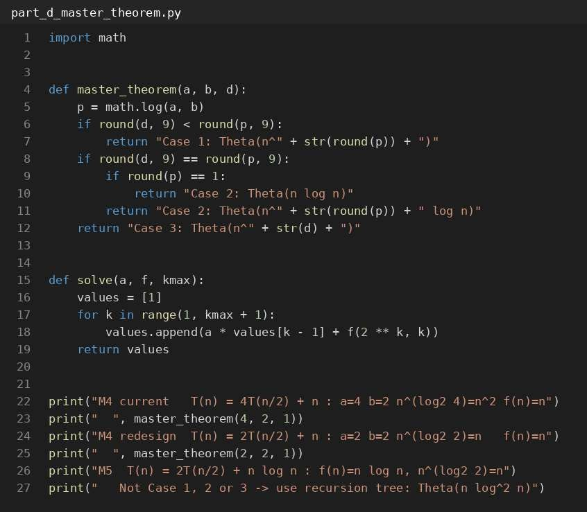
Figure 5: part_d_master_theorem.py (1 of 2)

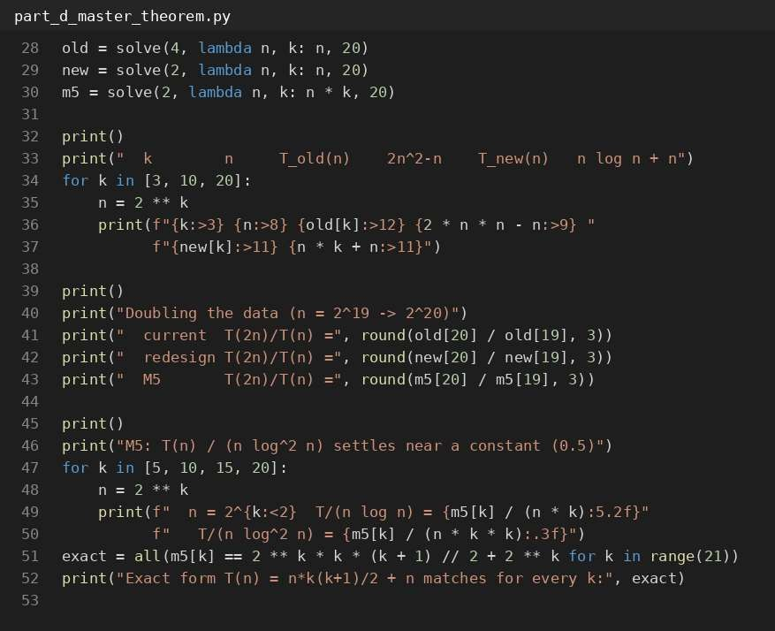
Figure 5: part_d_master_theorem.py (2 of 2)

Output
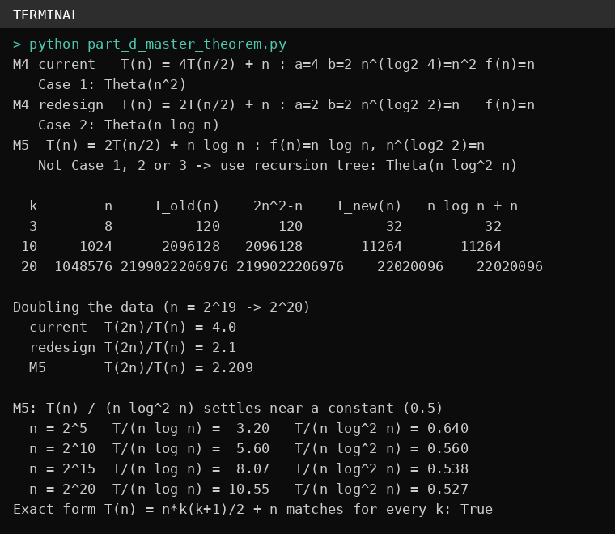
Figure 6: Output of part_d_master_theorem.py
The program builds T(n) from the recurrences up to n = 220. The exact formulas 2n² − n and n log n + n match for M4, and for M5 the ratio T(n)/(n log² n) settles near 0.5.

Part (e) – Best, Average and Worst Cases

Case | S1 – condition | S1  comparisons | S2 – condition | S2 comparisons
Best | Product is the first one in the list | 1 | Product is exactly the middle entry | 1
Worst | Product is the last one, or is not in the catalogue | n | Product is at the deepest level, or is missing | floor(log2 n) + 1 = 20 for n = 10⁶
Average | Each position equally likely (product found) | (n + 1)/2 | Each position equally likely (product found) | about log2 n − 1 =  18.95 for n = 10⁶
S1 – average comparisons with probability p
Let p be the chance that the product exists. If it exists, every position 1…n is equally likely. If it does not exist (chance 1 − p), all n products are checked.
If found:
average = (1 + 2 + … + n) / n = (n + 1) / 2
If not found: comparisons = n A(n) = p · (n + 1)/2 + (1 − p) · n
= p(n + 1)/2 + n − pn
= n(1 − p/2) + p/2
Evaluate for n = 1,000,000 and p = 0.5:
A = 0.5 × (1,000,001 / 2) + 0.5 × 1,000,000
= 0.5 × 500,000.5 + 500,000
= 250,000.25 + 500,000
= 750,000.25 comparisons
S1 average = 750,000.25 comparisons (about 0.0075 s). S2 needs at most 20.

Meaning: sequential search needs about 37,500 times more comparisons than binary search on a million products. ShopSphere should keep a sorted index and use S2 for product search.

Source code
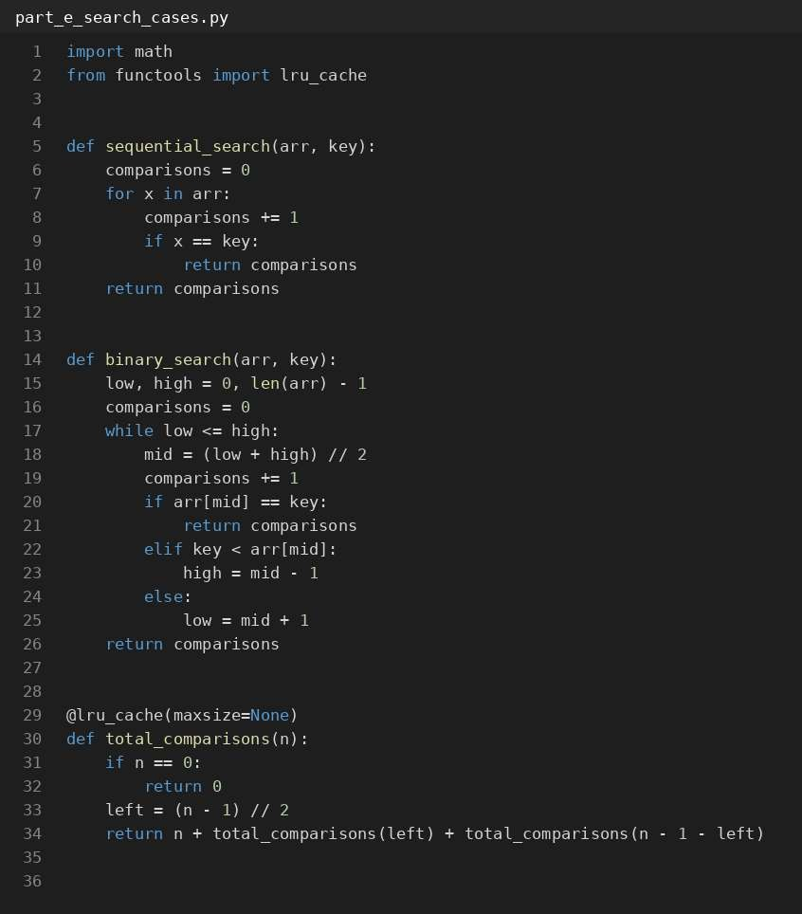
Figure 7: part_e_search_cases.py (1 of 2)

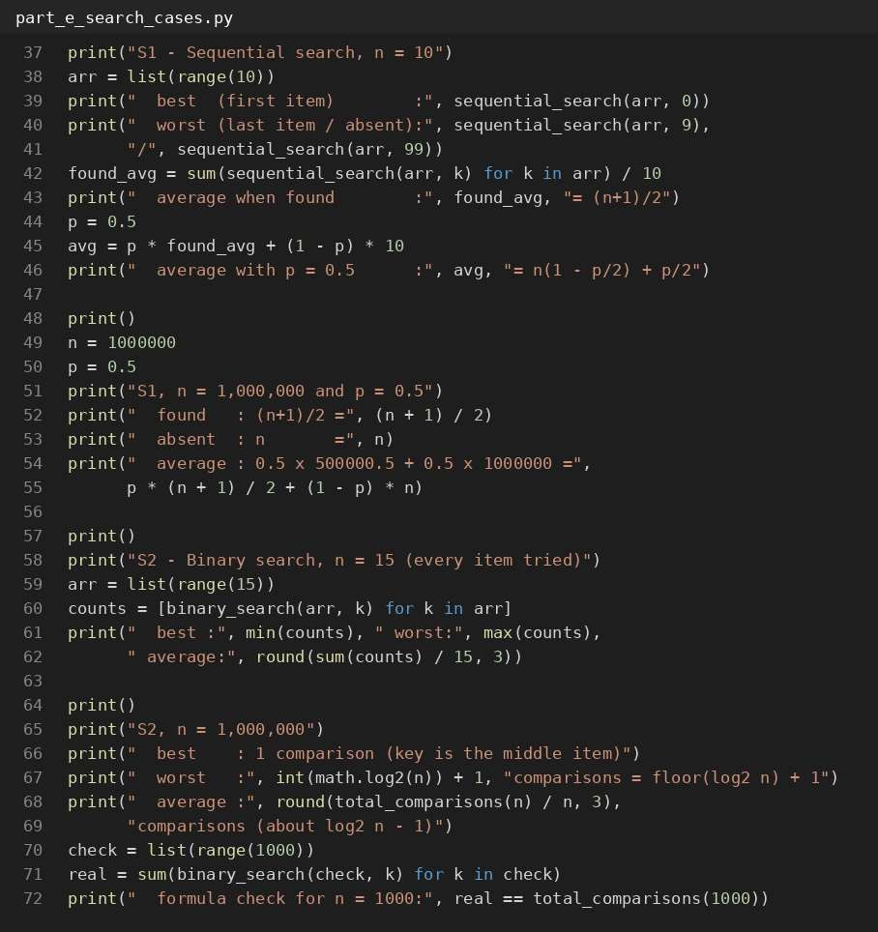
Figure 7: part_e_search_cases.py (2 of 2)

Output
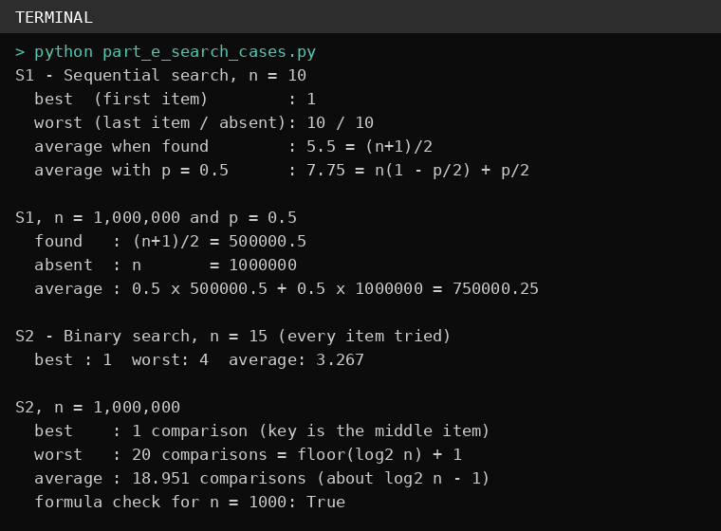
Figure 8: Output of part_e_search_cases.py

Part (f) – Prove an Asymptotic Bound
Definition. f(n) = Θ(n²) means there are positive constants c₁, c₂ and n₀ such that:
c₁ · n² ≤ f(n) ≤ c₂ · n² for every n ≥ n₀
Here f(n) = 3n² + 10 n log₂ n + 50.

Lower bound
For n ≥ 1, the terms 10 n log₂ n and 50 are not negative.
So f(n) ≥ 3n² → take c~1~ = 3

Upper bound
For n ≥ 1 we know log₂ n ≤ n, so 10 n log₂ n ≤ 10 n · n = 10n² For n ≥ 1 we know n² ≥ 1, so 50 ≤ 50n²
f(n) ≤ 3n² + 10n² + 50n² = 63n² → take c~2~ = 63
3n² ≤ f(n) ≤ 63n² for all n ≥ 1. So c₁ = 3, c₂ = 63, n₀ = 1, and f(n) = Θ(n²).

Show that f(n) is not O(n)
Use proof by contradiction. Suppose f(n) = O(n). Then some constant c and some n₀ exist with f(n) ≤ c·n for all n ≥ n₀.
We already know f(n) ≥ 3n².
So 3n² ≤ f(n) ≤ c·n → 3n² ≤ c·n → n ≤ c/3
This would have to be true for every n ≥ n₀, including n larger than c/3. That is impossible. So f(n) is not O(n).
Example: for c = 1000 the inequality f(n) ≤ 1000n fails as soon as n = 306. For c = 100,000 it fails at n = 33,284. Bigger c only delays the failure.
Meaning: the report generator cost is really quadratic. At n = 1,000,000 it needs about 3 × 1012 operations, which is far beyond the 10-minute window.

Source code
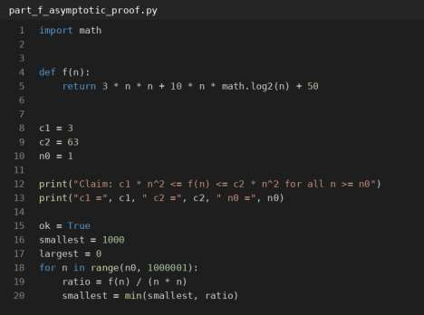
Figure 9: part_f_asymptotic_proof.py (1 of 2)
Output
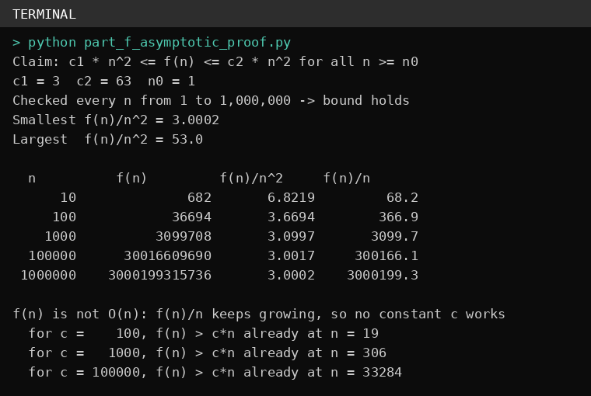
Figure 10: Output of part_f_asymptotic_proof.py
The program checked every n from 1 to 1,000,000. The bound 3n² ≤ f(n) ≤ 63n² held every time, and f(n)/n² moves towards 3.

Part (g) – Scalability Decision
Operation counts come from the exact formulas found earlier. Time = operations ÷ 108. The limit is 600 seconds (6 × 1010 operations).
Estimates for n = 1,000,000

Module | Complexity | Operations | Time
M1 | Θ(n²) | 499,999,500,000 | 83.3 minutes
M2 | Θ(n) | 1,048,575 | 0.010 seconds
S2 | Θ(log n) | 20 | 0.2 microseconds
M4 current | Θ(n²) | 1,999,999,000,000 | 5.6 hours
M4  redesign | Θ(n log n) | 20,931,569 | 0.209 seconds
M5 | Θ(n log² n) | 209,599,497 | 2.1 seconds
Report generator | Θ(n²) | 3,000,199,315,736 | 8.3 hours

Today (100,000) compared with next year (1,000,000)

Module | Time at n = 100,000 | Time at n = 1,000,000 | Growth for 10× more products
M1 | 50.0 seconds | 83.3 minutes | 100 times
M2 | 0.001 seconds | 0.010 seconds | 8 times
S2 | 0.17  microseconds | 0.20  microseconds | +3 comparisons
M4 current | 3.3 minutes | 5.6 hours | 100 times
M4 redesign | 0.018 seconds | 0.209 seconds | about 12 times
M5 | 0.147 seconds | 2.1 seconds | about 14 times
Report generator | 5.0 minutes | 8.3 hours | 100 times

Important point: all modules pass today. M1, the current M4 and the report generator pass only because n is small. When ShopSphere grows ten times, their time grows a hundred times, and they fail.

Which modules must be redesigned?

Module | Problem | Recommended redesign
M1 Duplicate detector | Θ(n²). Takes 83 minutes at n = 10⁶. | Use a hash set (Python set) of (title, seller). Go through the products once; if the pair is already in the set it is a duplicate. This is about Θ(n) time. (Other option: sort by title and seller, then compare neighbours, Θ(n log n).)
M4 Current design | Θ(n²). Takes 5.6 hours. | Adopt the proposed redesign (no replicated partitions). It becomes Θ(n log n) and takes 0.2 seconds.
Report generator | Θ(n²). Takes 8.3 hours. | Find the nested loop behind the 3n² term. Replace it with sorting or hash-based grouping so the work is about n log n. (The exact fix depends on the report code, which is not given here.)

Modules that can stay as they are
  - M2: Θ(n), 0.01 seconds. Fine.
  - S2: 20 comparisons. Fine. Use S2 and keep a sorted index; S1 would need about 750,000 comparisons per search on average.
  - M4 redesign: 0.2 seconds. Fine.
  - M5: 2.1 seconds. Fine. (Optional: sort once instead of at every level to reach Θ(n log n).)
Proof that the M1 redesign works
I ran the old nested-loop method and the hash-set method on 4,000 sample products. Both found the same 1,060 duplicates, but the hash set was about 500 times faster even at this small size, and the gap grows with n.

Source code
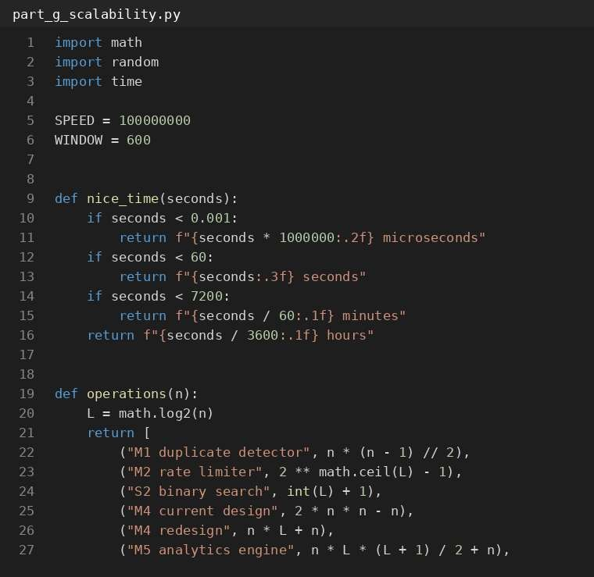
Figure 11: part_g_scalability.py (1 of 3)

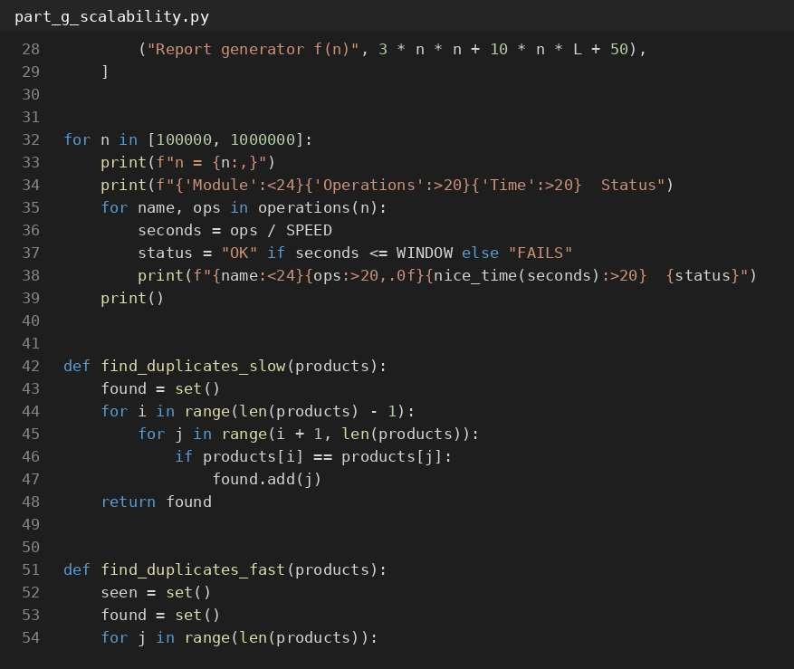
Figure 11: part_g_scalability.py (2 of 3)

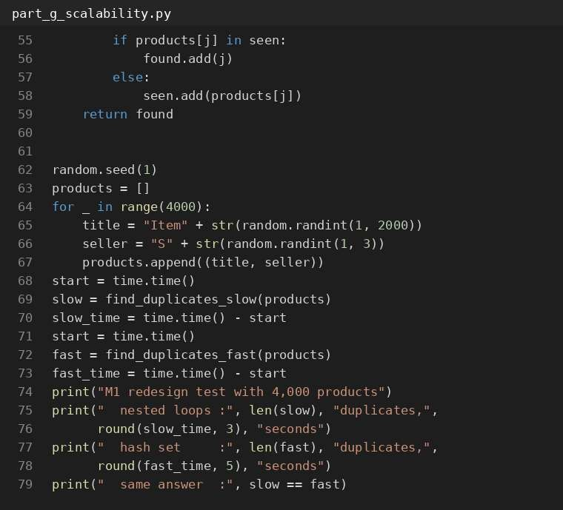
Figure 11: part_g_scalability.py (3 of 3)

Output
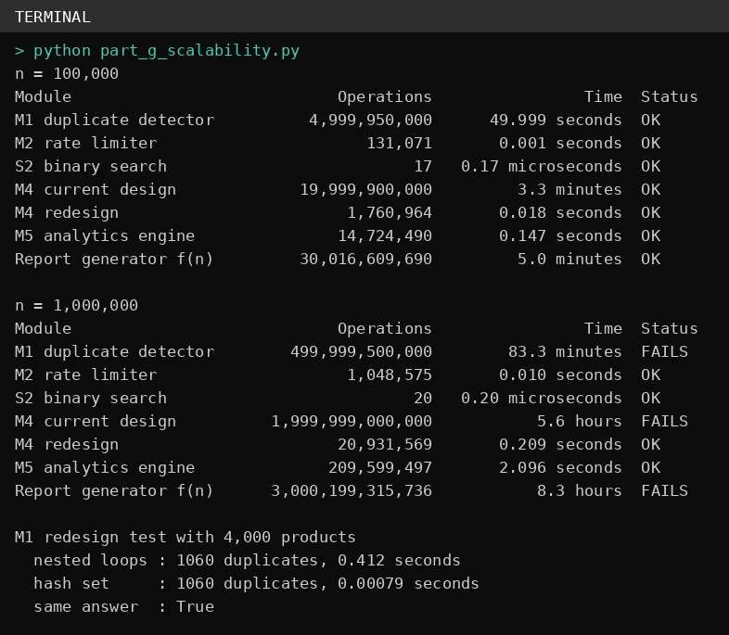
Figure 12: Output of part_g_scalability.py
The measured seconds for the 4,000-product test depend on the computer, so your own run may show slightly different times. The duplicate counts will be the same.

Quick Viva Answers

Question | Short answer
What is a basic operation? | The step repeated the most, which decides the running time (for example the comparison in the inner loop).
Why is M2 Θ(n) and not Θ(n log n)? | The inner loop runs i times, not n times, and i doubles each round. 1 + 2  + 4 + … + n/2 is about n, so the total is about 2n.
What is the formula for M1? | n(n − 1)/2 comparisons, which is Θ(n²).
What do O, Ω and Θ mean? | O is an upper bound, Ω is a lower bound, Θ is both (a tight bound).
State the three Master Theorem cases. | Compare f(n) with n^{p}, where p = log_{b} a. Smaller → Θ(n^{p}). Equal → Θ(n^{p} log n). Bigger → Θ(f(n)).
Why can’t the Master Theorem solve 2T(n/2) + n log n? | n log n is bigger than n but not by a power of n, and it is not equal to n either. So none of the 3 cases fit; use the extended theorem or a recursion tree. Answer Θ(n log² n).
Why does recursive binary search use Θ(log n) space? | Each recursive call stays on the stack until the call below it finishes, and there are about log₂ n calls.
How did you choose c₁ and c₂ in part (f)? | c₁ = 3 by dropping the other positive terms. c₂ = 63 by using log n ≤ n and 50 ≤ 50n² so everything is at most a multiple of n².
Why does a hash set fix M1? | Looking up an item in a hash set takes about constant time, so one pass over n products costs about n, instead of comparing all pairs.

Repository Structure and How to Run

CO1_AT1/
│
├── Question_1/
│
│
│
│
│
│
│
│
│
│
│
├── Source_Code/
│
│
│
│
│
│
│
├── part_b_m1_m2_counts.py
├── part_c_binary_search.py
├── part_d_master_theorem.py
├── part_e_search_cases.py
├── part_f_asymptotic_proof.py
├── part_g_scalability.py
└── run_all.py
└── Report/
├── CSA06_CO1_AT1_Report.docx
├── screenshots/
(code and output
images)
│ └── outputs/(program output as text files)
└── README.md

Code of Conduct

I SHAIK SHAHID (192424311) certify that this submission is my original work and that I have adhered to the guidelines specified for this assessment. I understand that any violation of academic integrity rules will result in disciplinary action.

Signature of the Student:
Shaik Abdul Azeez
Date:11-10-2026

