ASSIGNMENT 3: PART B- REVIEW

TABLE OF CONTENTS
Introduction 3
Application Interface Evaluation and Annotated Screenshots 3
Conclusion 7
References 9

Introduction
The ReLoop community reuse & donation application is reviewed from an end user perspective. It looks at the login screen, the donor information form, details of the item, handover and submission confirmation. The review will go over visual design, usability, functionality and privacy; they will find strengths and practical suggestions on how to make this better for the users.

Application Interface Evaluation and Annotated Screenshots
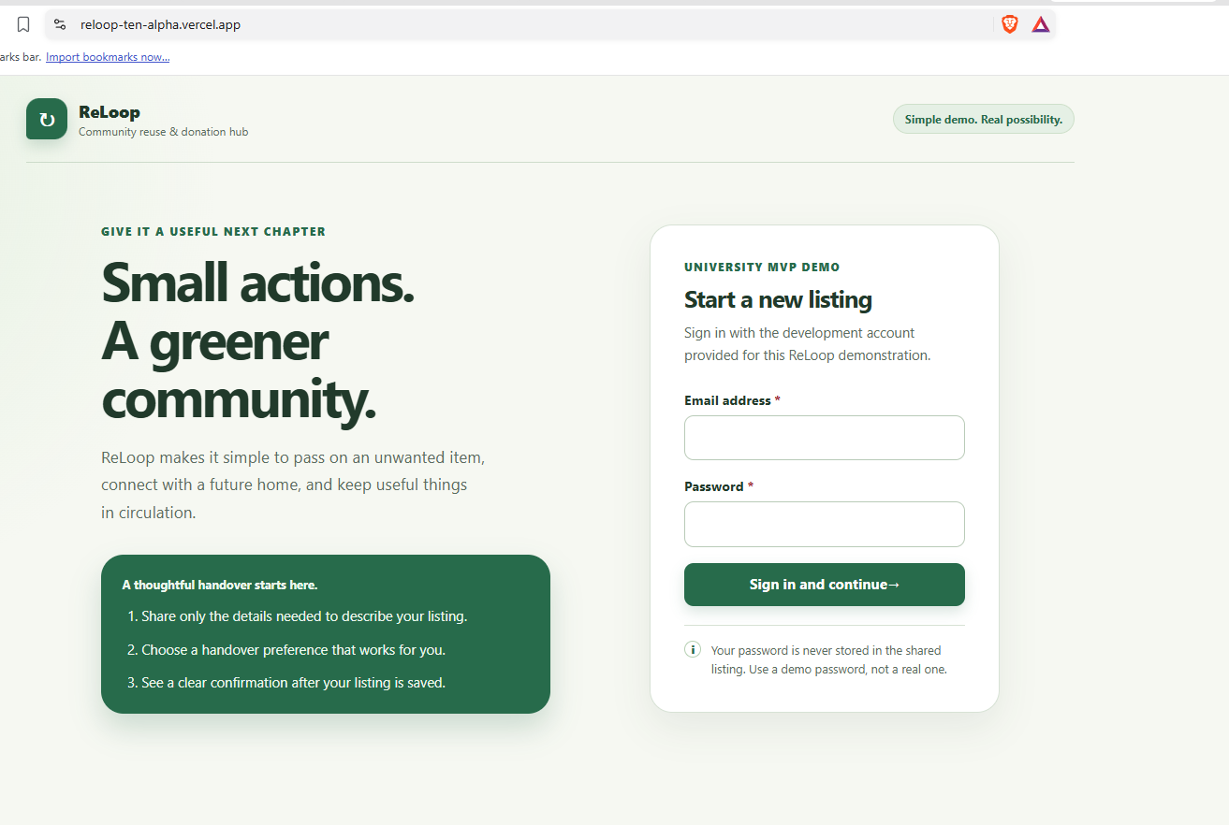
Figure 1: ReLoop Login Interface
ReLoop is presented as a community reuse and donation place while logging in into the system. Green color scheme, heading, and well-organized 2 column layout, which offers a consistent and inviting look. Clear email and password field labelling, and easy-to-identify sign-in button. But the development-account instructions can be confusing to first- time users. Toggle between showing/hiding the password, better usage instruction on how to get an account, better error messages would make it more accessible and easier to use.
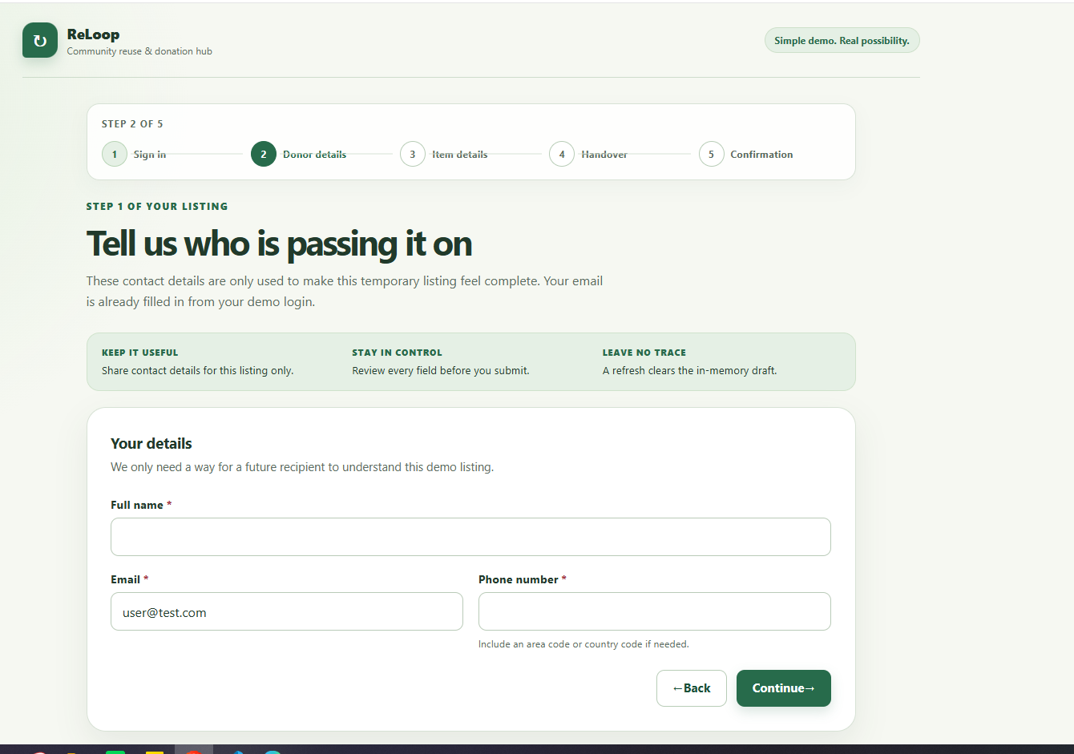
Figure 2: Donor Information Form
The donor details screen requests the information necessary to identify the donor for the item. The progress indicator lets the user know where they are in the 5-step process and clearly labeled fields and required-field markers facilitate the filling out of the form. Reinforces the privacy conscious data input with the green information panel. But the idea of clearing the draft with a refresh might be worrisome to users. Having in-line validation, privacy information and warning if one accidentally navigates out would make the website more usable and instill more confidence by the user.

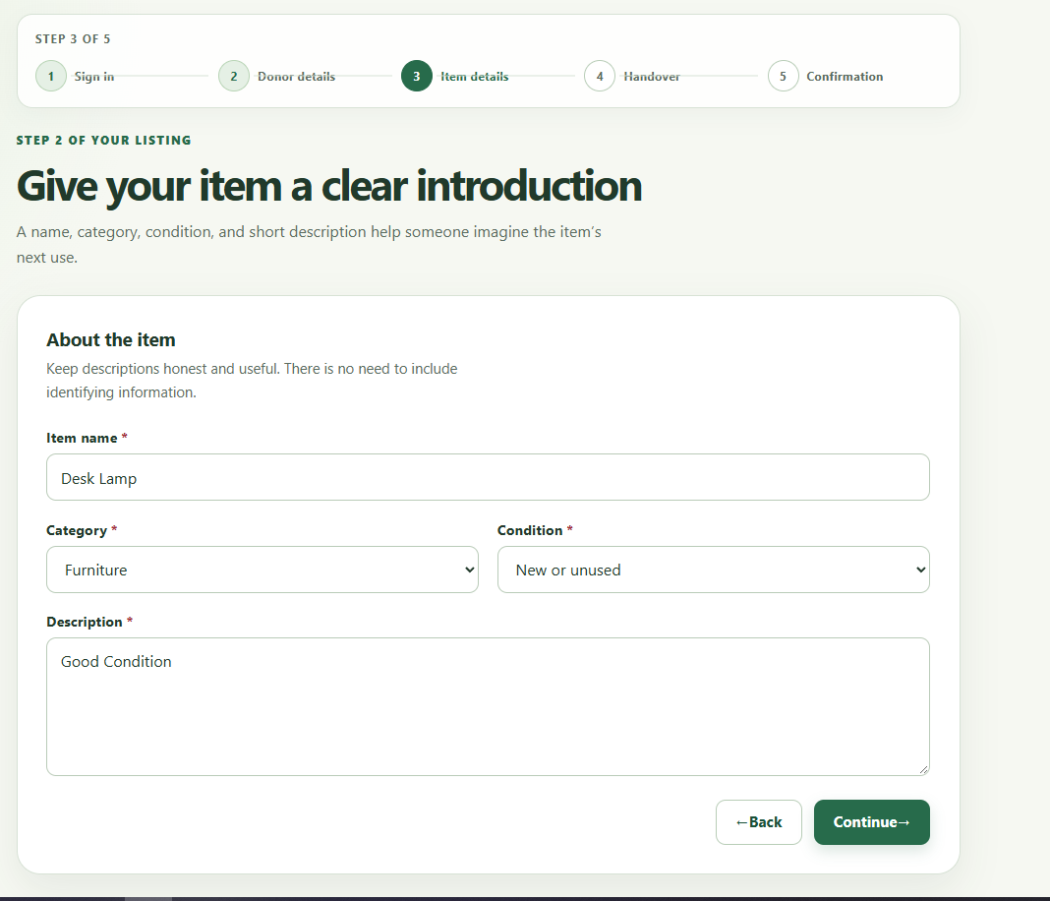
Figure 3: Item Information Form
Users can fill in an item name, category, condition and description in the item details screen. The form is organized logically, has easy-to-read typography, and features green colors throughout. The category and condition are made easy to choose with dropdown menus and the large description box can be filled with more information. But the interface could offer some examples of helpful descriptions and show what item conditions are acceptable. Validation messages should be more informative and provide some guidance to the user so that they can put in a complete listing, and minimize confusion to the potential recipients.
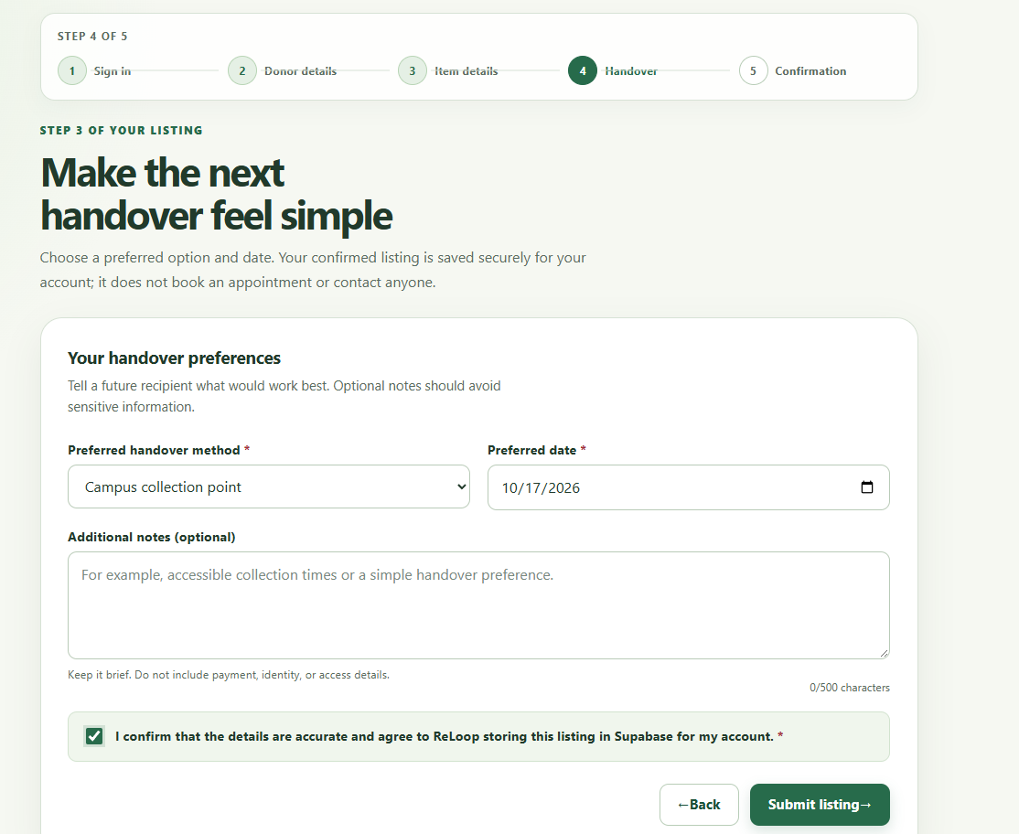
Figure 4: Handover Preferences and Consent Form
The handover screen allows users to pick their favorite handover method, time-date, as well as optional notes. The date picker and the character counter give good hints for interaction and the consent checkbox makes the contract for data storage clear. The design is well structured and follows through with previous screens. But, there could be greater clarity in how the consent statement explains access and retention of data. Concise privacy notice, guidelines on the date selection and a stronger confirmation of required submission fields would help to make things clear and eliminate submission mistakes.
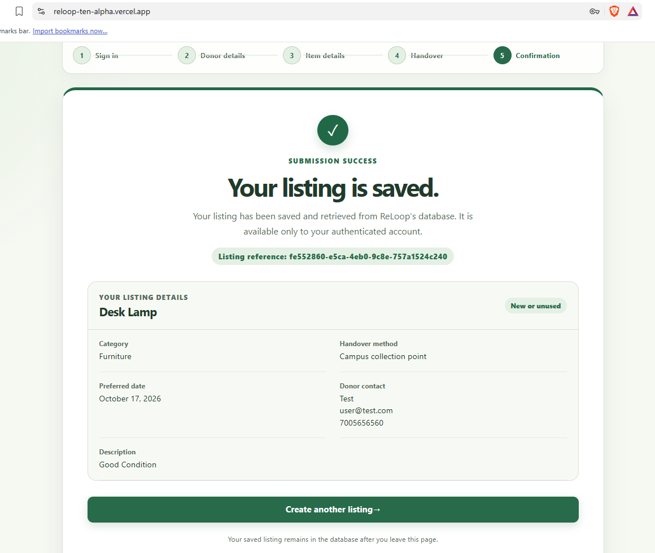
Figure 5: Successful Listing Submission and Confirmation
Successful submission of listing is unequivocally labelled with a checking mark, large instructions and a dedicated listing reference. A listing of the handover method, date, donor contact details, and category and condition details about the saved item helps users to verify their submission. The way the screen is arranged is the same as what it is in the previous screens. But having contact details on a personal level could raise privacy issues, especially for devices that are shared. Minimizing certain information – where it is appropriate – would improve privacy and usability, and having a safe sign out button along with an easy-to-view or manage saved listings button would be useful as well.

Conclusion
ReLoop offers an easy-to-use interface that makes the listing submission process logical, visually consistent and structured. Usability is enabled by clear labels, progress indicators, confirmation feedback. Enhancements to the communication of privacy, guidance for validation, instructions to account holders and the handling of personal information, however, could increase user trust, access, and app effectiveness.

References
Aksionova, N.A., Lahvinets, V.A. and Varuyeu, A.V., 2023. Deploying automated knowledge control system project to Vercel.
Arawjo, I., Vaithilingam, P., Wattenberg, M. and Glassman, E., 2023, October. ChainForge: An open-source visual programming environment for prompt engineering. In Adjunct proceedings of the 36th annual ACM symposium on user interface software and technology (pp. 1-3).
Hertzum, M., 2022. Usability testing: A practitioner's guide to evaluating the user experience. Springer Nature.
Johnson, R., 2025. The Supabase Handbook: Scalable Backend Solutions for Developers. HiTeX Press.
Keshari, P., Maurya, P., Kumar, P. and Katiyar, A., 2023, December. Web development using reactjs. In 2023 5th International Conference on Advances in Computing, Communication Control and Networking (ICAC3N) (pp. 1571-1575). IEEE.
Pant, P., Rajawat, A.S., Goyal, S.B., Bedi, P., Verma, C., Raboaca, M.S. and Enescu, F.M., 2022. Authentication and authorization in modern web apps for data security using Nodejs and role of dark web. Procedia Computer Science, 215, pp.781-790.

Appendix : App Link
https://reloop-ten-alpha.vercel.app/

