ASSIGNMENT 3: PROMPT DOCUMENT

TABLE OF CONTENTS
Prompt 1: Existing Project Inspection and Technical Gap Analysis 3
Prompt 2: Database Schema and Backend Architecture Planning 3
Prompt 3: Free-Tier Implementation and Security Requirements 4
Prompt 4: API Submission Failure Diagnosis and Debugging 4
Prompt 5: HTTP 502 Error and Backend Availability Troubleshooting 5

Prompt 1: Existing Project Inspection and Technical Gap Analysis
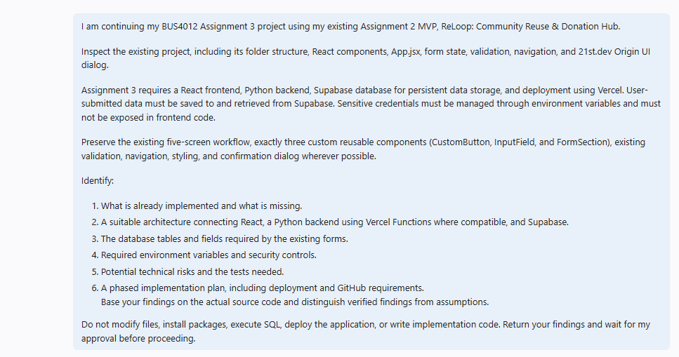
Purpose
This prompt was used for post implementation review of existing MVP of ReLoop, understand what functionalities have been developed and what functionality was still needed, make sure that the architecture proposed is suitable for the project and agree on a ‘phased' implementation of it, without the need for changes to the project.

Prompt 2: Database Schema and Backend Architecture Planning
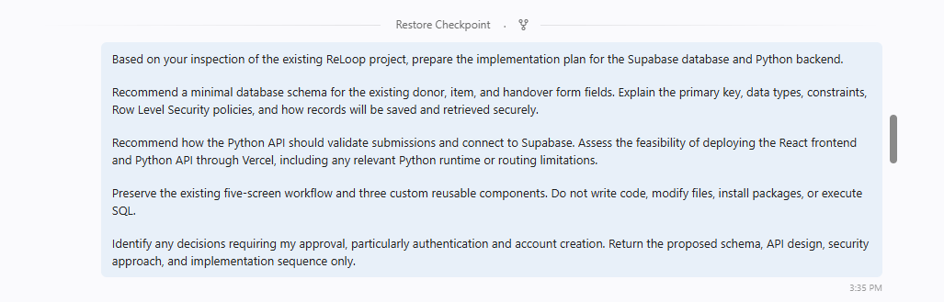
Purpose
The prompt was utilized to create a suitable Supabase Data Base schema, set up limitations for fields and policies for Row Level Security, plan Python API validations and secure data retrievals, and evaluate compatible deployments on Vercel in preparation for implementation.

Prompt 3: Free-Tier Implementation and Security Requirements
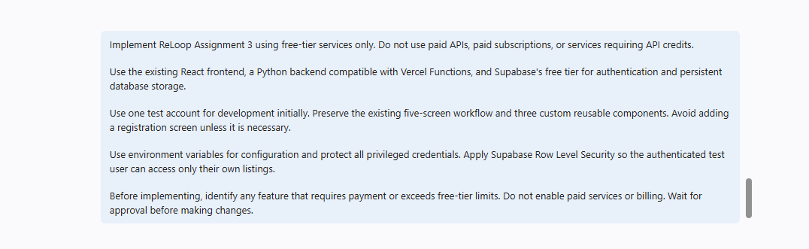
Purpose
This prompt was helpful for implementing ReLoop with free-tier services and Supabase authentication, persistent database storage, and a Python backend. It also set the rules for maintaining screens as they were, ensuring that no screens are compromised, that user-based access is implemented and the avoidance of paid services.

Prompt 4: API Submission Failure Diagnosis and Debugging
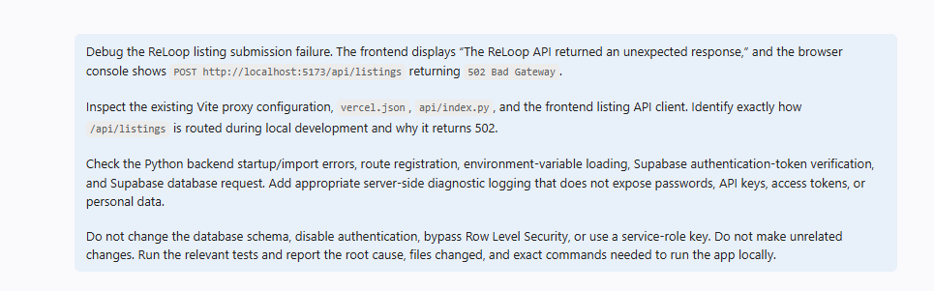
Purpose
This prompt was applied to research the issue of the HTTP 502 error when attempting list submission by analyzing Vite proxy routing, Vercel setup, startup of the Python API, authentication, and database connection with Supabase, with a focus on secure diagnostic logging and pertinent testing.

Prompt 5: HTTP 502 Error and Backend Availability Troubleshooting
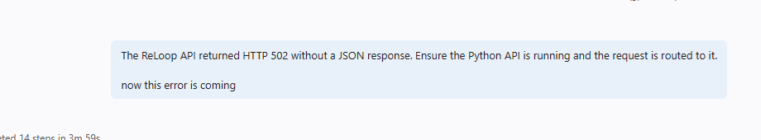
Purpose
This was a follow up prompt to the same repeated HTTP 502 response where there was no json return. It was aimed at verifying availability of any Python API and route the requests to understand the issues on why the frontend could not get a proper backend response.

