LearnHub: Full Stack MERN Project Documentation
1. Introduction
Project Title: LearnHub: Your Skill Enhancement Center
Team ID: LTVIP2026TMIDS56001
Team Members:
Team Leader : Shaik Farzana
Team member : Vangimalla Bharathi
Team member : Tappeta Sujitha
Team member : Thota Mounika
Team member: Sunkesula Lakshmi Divya
2. Project Overview
Purpose:
To create a comprehensive online learning platform where learners can enroll in courses, track their progress, and receive certifications, while educators can create and manage courses.
Features:
- User registration and login for educators and learners
- Course creation and management by educators
- Course enrollment and tracking by learners
- Certification upon completion
- Admin dashboard for platform management
- Multilingual content support
3. Architecture
Frontend:
Developed using React.js with Vite for faster build and performance. Styled using Material UI and Bootstrap for responsive design.
Backend:
Node.js with Express.js to build RESTful APIs for user auth, course management, and content handling.
Database:
MongoDB with Mongoose ODM. Collections include users, courses, and enrollments. Schemas maintain relations between learners and their courses.
4. Setup Instructions
Prerequisites:
- Node.js and npm
- MongoDB Community Server
Installation:
# Clone the repository
git clone :- https://github.com/NARENDRA-504/LEARNHUB.git

# Frontend setup
cd frontend
npm install

# Backend setup
cd ../backend
npm install

# Create .env in backend with:
PORT=5000
MONGODB_URI=<your_mongo_uri>
JWT_SECRET=<your_jwt_key>
5. Folder Structure
Client (frontend):
- /src/components: Reusable components (e.g., Navbar, CourseCard)
- /src/pages: Registration, Dashboard, CoursePage, etc.
- /src/services: API call files using Axios
Server (backend):
- /models: Mongoose schemas (User.js, Course.js)
- /routes: Express routes (auth, courses, admin)
- /middleware: Auth middleware (JWT verification)
- /controllers: Business logic for API requests
6. Running the Application
# Frontend
cd frontend
npm run dev

# Backend
cd backend
npm start
7. API Documentation
Method | Endpoint | Description
POST | /api/auth/register | Register a new user
POST | /api/auth/login | Login a user
POST | /api/courses | Create a new course
GET | /api/courses | Get list of courses
POST | /api/enroll | Enroll in a course
GET | /api/progress/:id | Get learner progress
8. Authentication
- JWT-based authentication used for securing protected routes.
- Tokens stored in localStorage for session handling.
- Role-based authorization (admin, educator, learner).
9. User Interface
- Simple and intuitive UI using Material UI and Ant Design.
- Dashboards for learners, educators, and admin.
- Certificate and course progress views.
10. Testing
- Unit testing using Jest (backend)
- Manual testing using Postman for API validation
- UI testing for all user roles
11. Screenshots or Demo

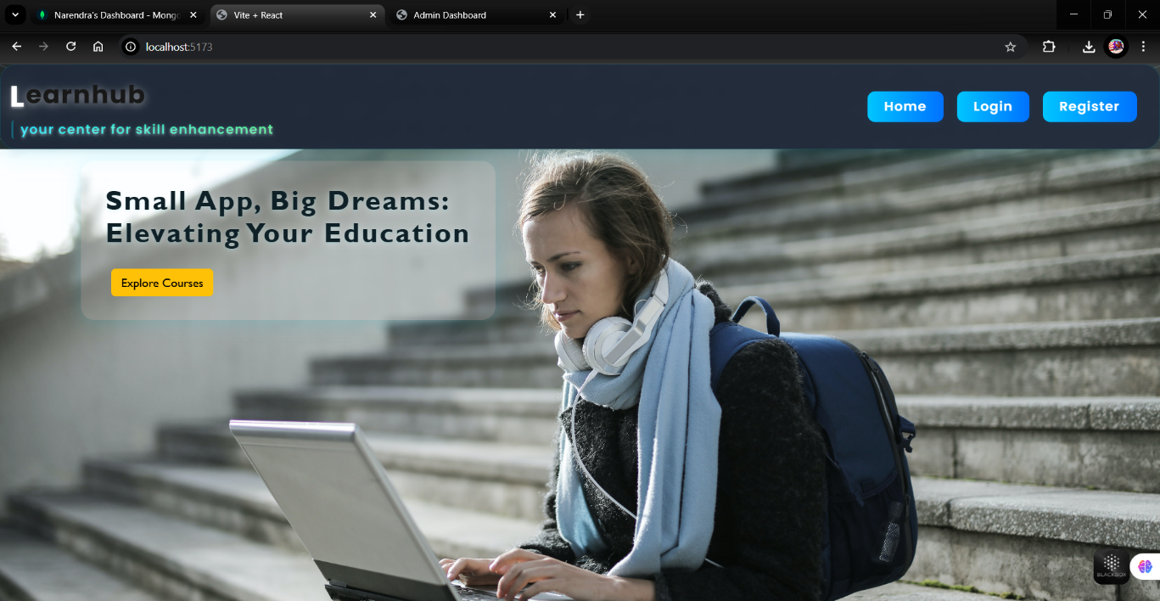
- Registration page

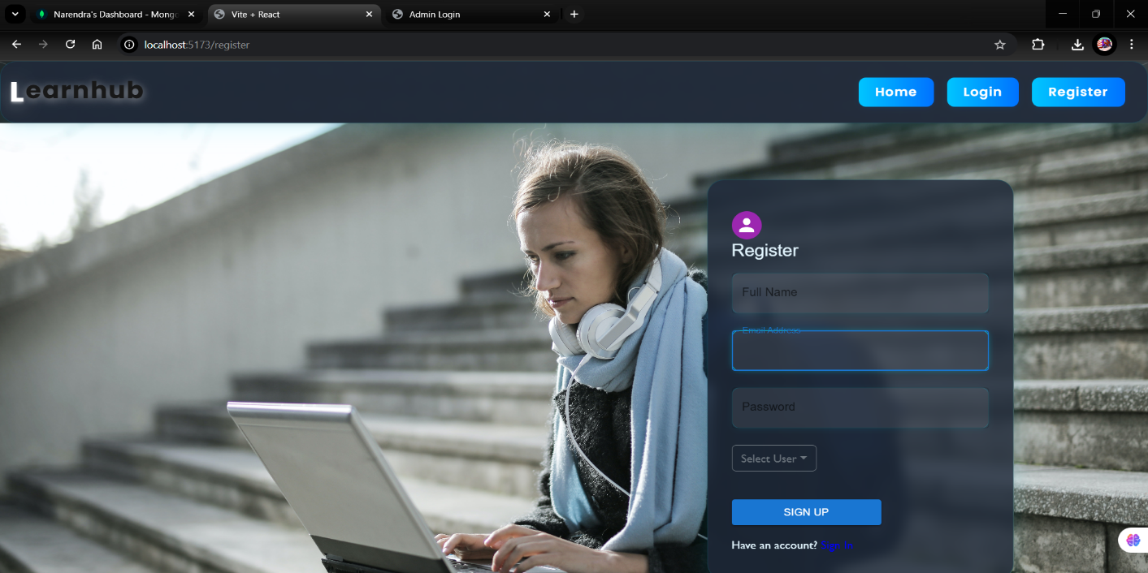
- Educator Course Creation Page
––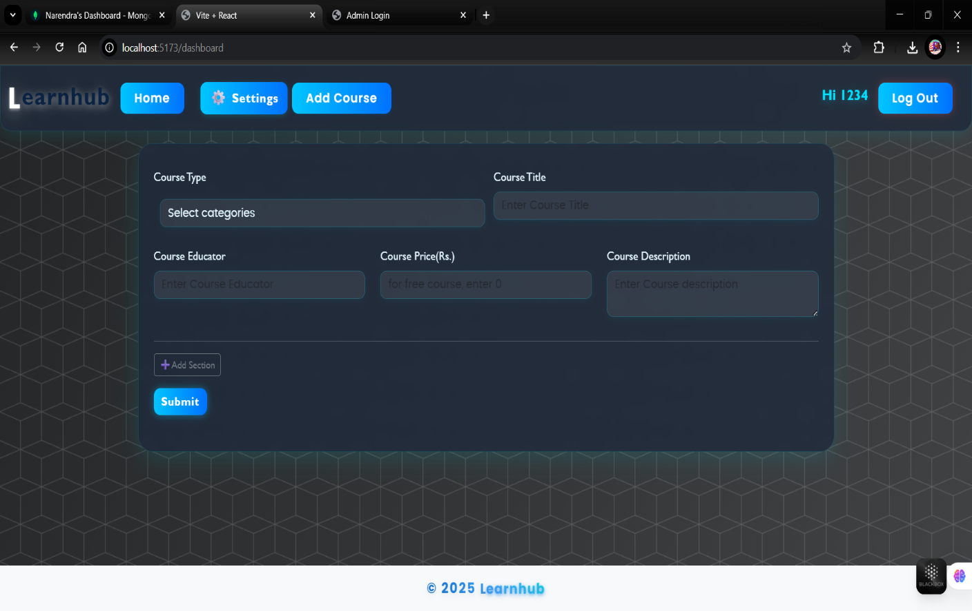
- Enrolled courses Dashboard
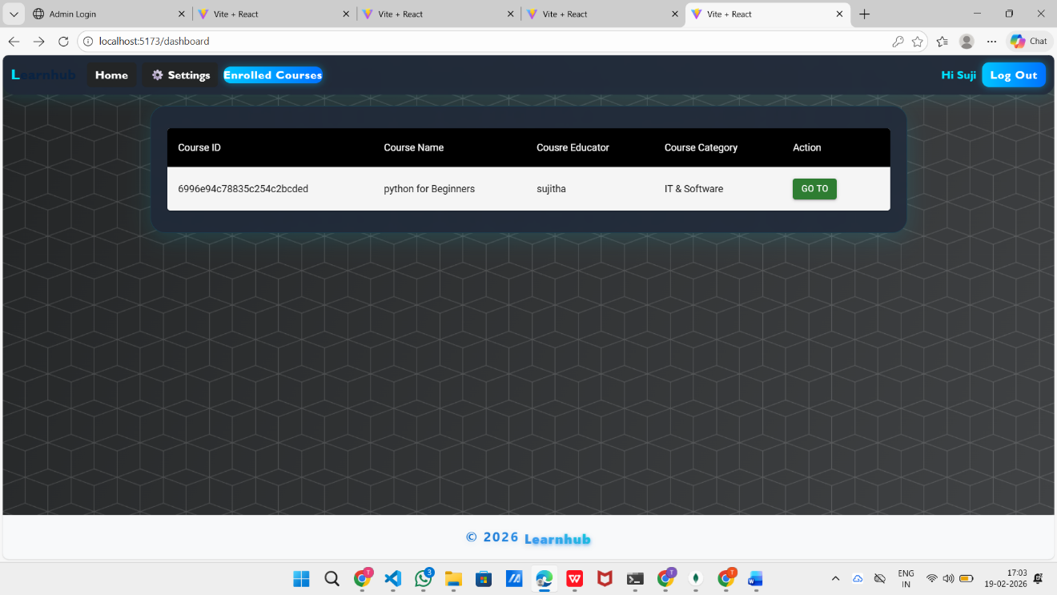
- Admin Overview Panel
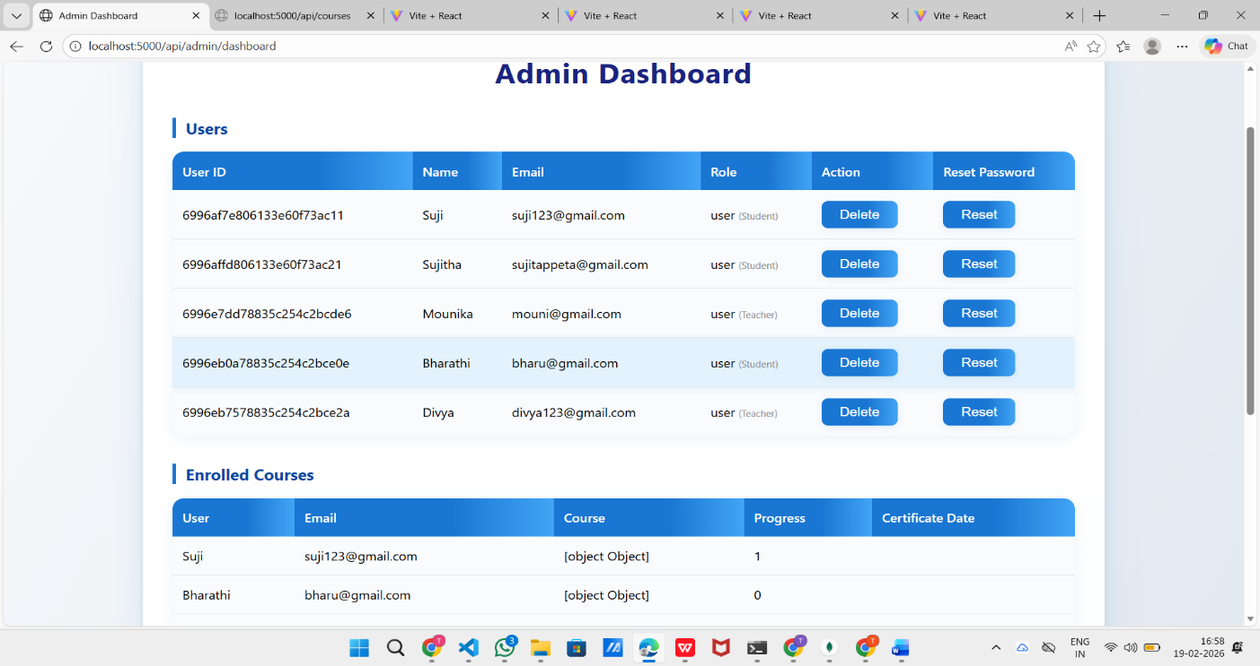
- Mongodb compass database
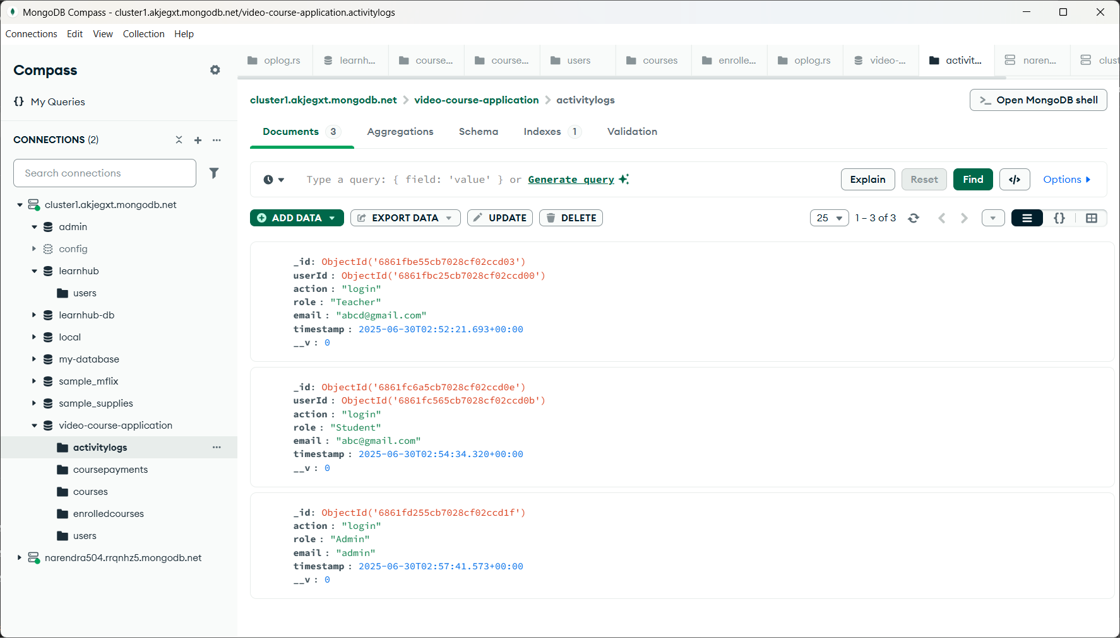

12. Known Issues
- No video compression during upload
- Limited analytics in admin dashboard
- No notification system (yet)
13. Future Enhancements
- Real-time classroom/live video sessions
- Mobile application for learners
- Gamification features for learners
- Educator rating and review system

