PHISHING EMAIL ANALYSIS REPORT
Incident ID | PHISH-2026-001
Sample Source | Captured phishing sample (phishing_pot archive)
File Hash (SHA-256) | 8c52fab4156e1f36b6147dfa43e2ef0d1071e044379be3c1a96808c508213af9
Severity | High
Status | Confirmed Phishing — Credential Harvesting

1. Executive Summary
A phishing email impersonating the MetaMask Support Team was identified. The message was sent through a legitimate Zendesk help-desk account registered by the attacker, which allowed it to pass all standard email authentication checks (SPF, DKIM, DMARC). The email uses a fabricated security alert and urgency-based language to pressure the recipient into clicking a “Reset Password” link. This link routes through a legitimate Bing click-tracking redirector before landing on an unrelated third-party domain assessed to be a credential-harvesting page. No user interaction with this specific archived sample has been confirmed; the email is classified as malicious based on technical and content analysis independent of current blocklist status.
Attack Type | Credential Harvesting (Brand Impersonation)
Verdict | Malicious
Confidence Level | High
User Interaction | None confirmed (archived sample)
Business Impact | Potential cryptocurrency wallet credential compromise if acted upon

2. Scope & Affected Recipients
This sample was obtained from a public phishing-sample archive for analysis purposes; no specific organizational mailbox or live victim has been confirmed as a recipient. In a live incident, this section would list every mailbox that received the message and whether each user interacted with it.
Recipient | Interacted? (Y/N) | Action Taken
[Not applicable — archived sample] Sample-2075 | N/A | N/A

3. Technical Analysis

3.1 Header Analysis
From (Display Name) | Liam From Metamask TS
From (Actual Address) | support@vvauc.zendesk.com
Reply-To | support+id177949@vvauc.zendesk.com
Return-Path | support@vvauc.zendesk.com
Originating / Sending IP | 192.161.151.2
SPF Result | Pass
DKIM Result | Pass
DMARC Result | Pass
X-Mailer | Zendesk Mailer
Message-ID Anomalies | None — consistent with legitimate Zendesk-generated format
Analysis Note: All three authentication checks pass. This does not indicate the message is legitimate. The sending domain (vvauc.zendesk.com) is a free, self-service Zendesk help-desk subdomain registered by the attacker. SPF/DKIM/DMARC validate that Zendesk's mail servers genuinely sent the message — they do not validate the trustworthiness of the account holder or the message content. This is a case of legitimate-infrastructure abuse rather than header forgery, and is the central technical finding of this report.
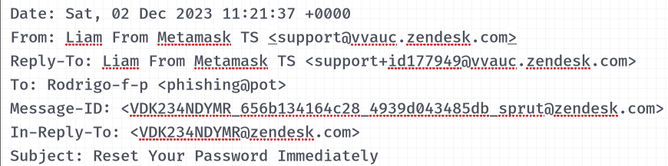

3.2 Body & Social Engineering Analysis
- Pretext: Fabricated security alert claiming an unrecognized login attempt from an Android device
- Brand impersonated: MetaMask (“MetaMask Support Team” signature)
- Greeting type: Generic (“Dear Valued Customer”) — consistent with a mass campaign rather than targeted spear-phishing
- Urgency mechanism: “Immediate Action Required,” “Do Not Delay” — time-pressure framing
- Loss aversion mechanism: Threat that “wallet and assets” are at risk — fear of financial loss used to override careful evaluation
- Sender mismatch: Body claims to be from MetaMask; actual sending address is a Zendesk subdomain unrelated to MetaMask's official domain
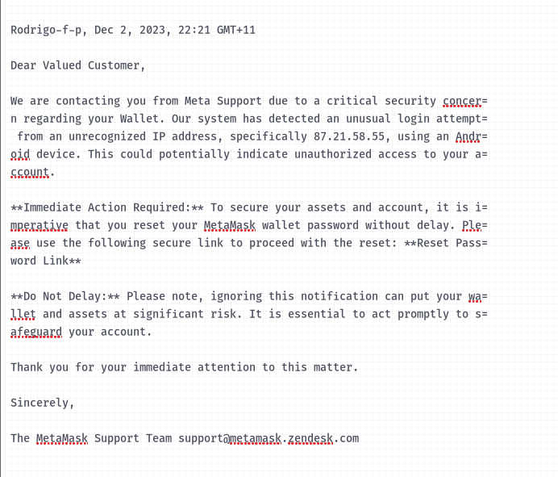

3.3 URL & Redirect Chain Analysis
The “Reset Password” button's href attribute (not the display text) was extracted from the raw HTML body.
Hop | Value (Defanged) | Role
1 (display) | "Reset Password Link" | Visible anchor text shown to victim
2 (redirector) | hxxps[://]www[.]bing[.]com/ck/a?... | Legitimate Bing click-tracking endpoint, abused to obscure final destination
3 (final landing page) | safe-trezor-login-io[.]pages[.]dev | Assessed credential-harvesting landing page
The final destination was recovered by isolating the base64-encoded value of the redirector's u= parameter and decoding it with CyberChef, confirming the decoded value matches the domain referenced in the redirector's own psq= (search/tracking) parameter — both independently point to nebbiashop.co.il, corroborating the finding.
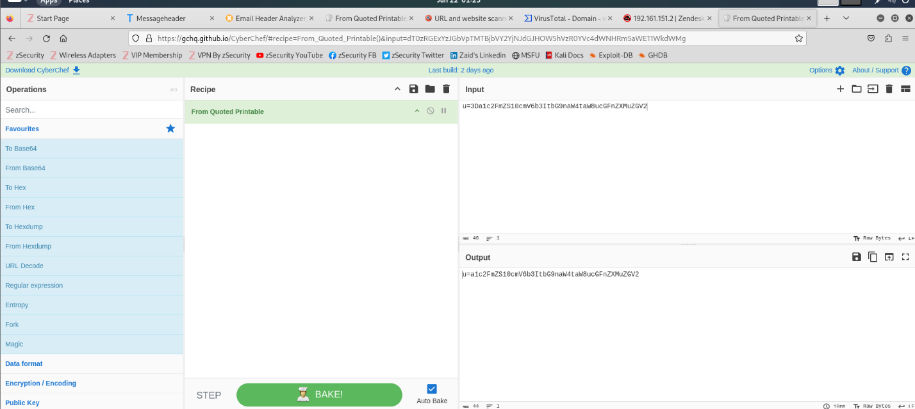
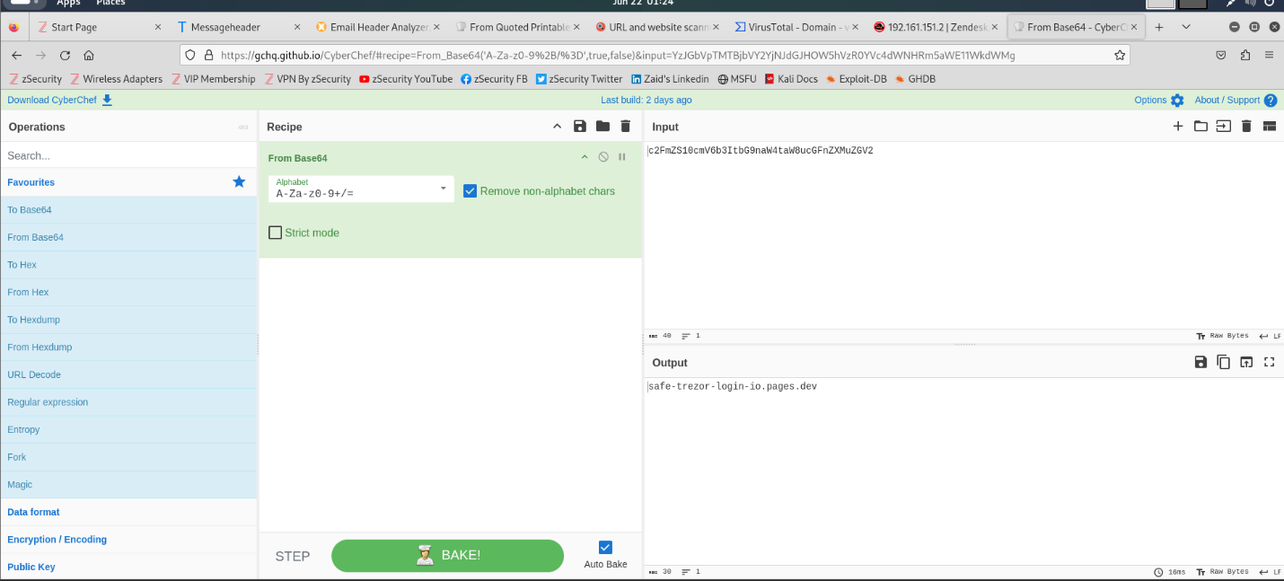

3.4 Attachment Analysis
No attachment is present in this sample. The phishing payload is delivered entirely via the embedded redirect link.

4. Indicators of Compromise (IOC) Summary
IOC Type | Value | Source | Notes
Sending IP | 192.161.151.2 | Email headers | Legitimate Zendesk infrastructure — not independently malicious; do not blanket-block Zendesk's shared IP ranges
Abused sender subdomain | vvauc.zendesk.com | From / Return-Path | Attacker-registered free help-desk account; report to Zendesk Trust & Safety for takedown
Redirector (abused, not malicious itself) | bing.com/ck/a | Email body href | Legitimate Microsoft service; the actionable block target is the final landing domain, not Bing
Final landing domain | nebbiashop.co.il | Decoded redirect parameter | Primary blocklist candidate — assessed credential-harvesting page
File Hash (sample-2075) | 8c52fab4156e1f36b6147dfa43e2ef0d1071e044379be3c1a96808c508213af9 | Evidence preservation | SHA-256 of raw .eml for chain of custody

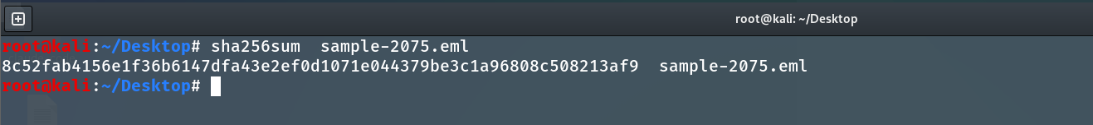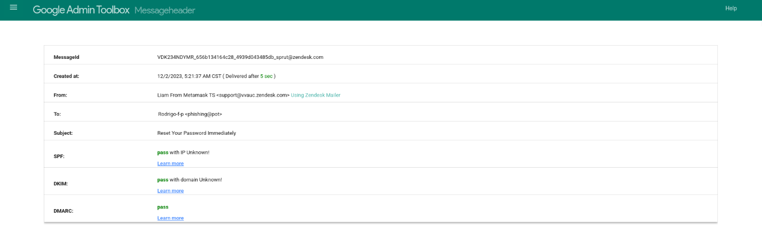

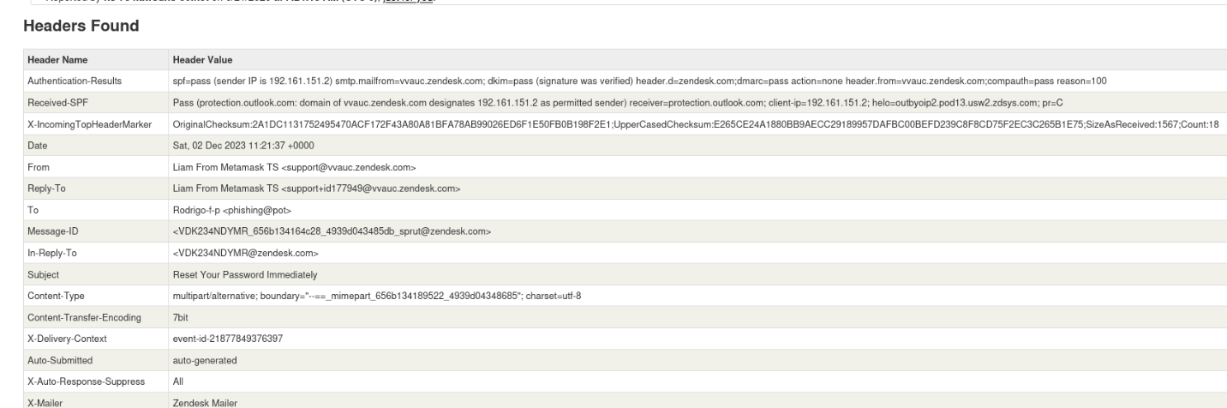

5. Verdict Rationale & Reputation Check Results
Third-party reputation lookups (VirusTotal, AbuseIPDB) for the sending IP and final landing domain returned low/clean results at the time of this analysis. This is consistent with the landing infrastructure having since been remediated or taken down, which is the expected and typical outcome for archived phishing samples rather than a sign the threat assessment is incorrect.
The malicious verdict in this report is supported by the totality of the following independent findings, not by blocklist status:
- Brand impersonation combined with a sender domain that has no relationship to the claimed brand
- Abuse of legitimate, free-tier infrastructure (Zendesk) specifically to pass authentication checks
- A multi-hop, obfuscated redirect chain (display text → legitimate redirector → unrelated third-party domain)
- Manufactured urgency and loss-aversion social engineering language consistent with known credential-phishing templates
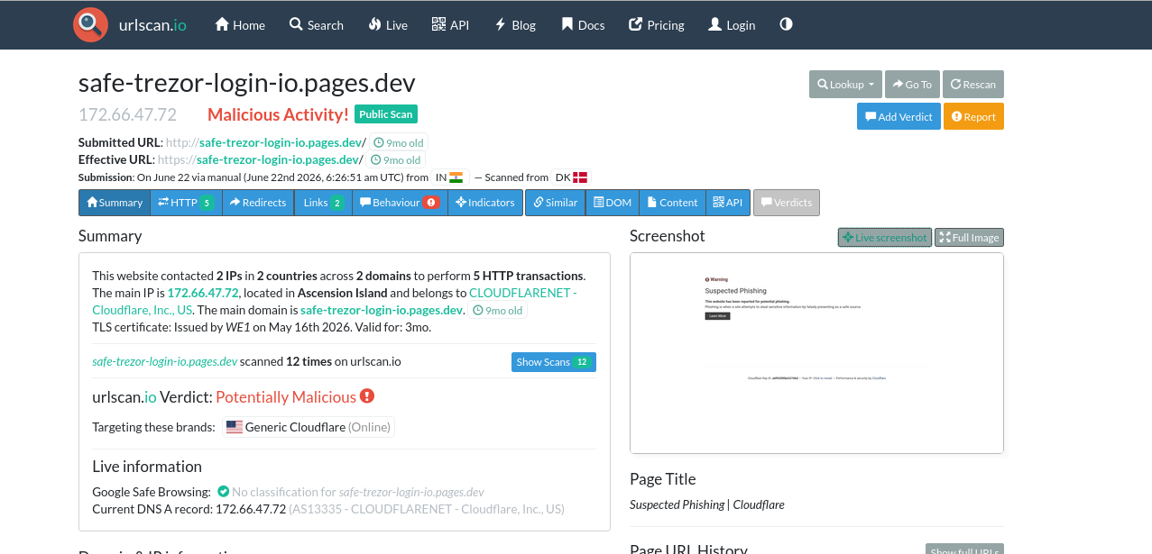
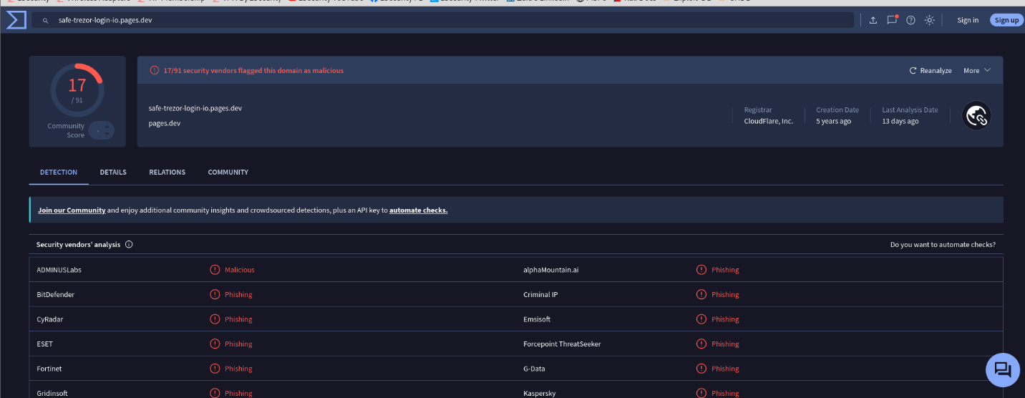
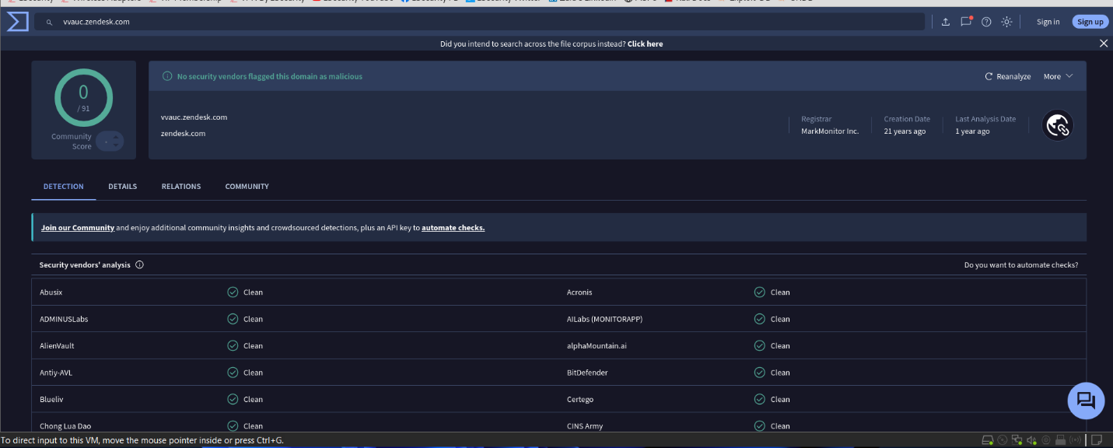
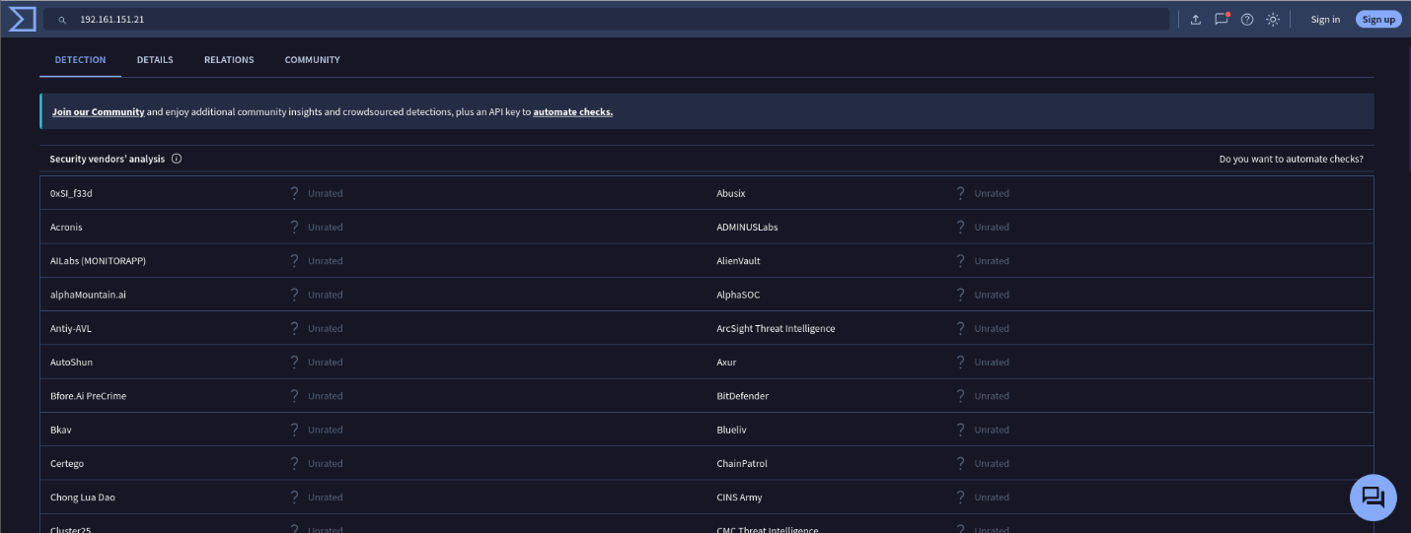
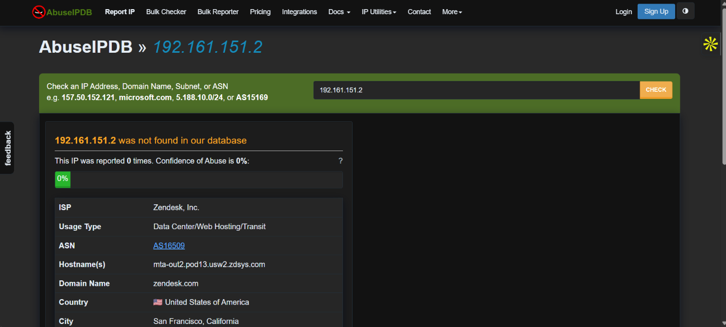
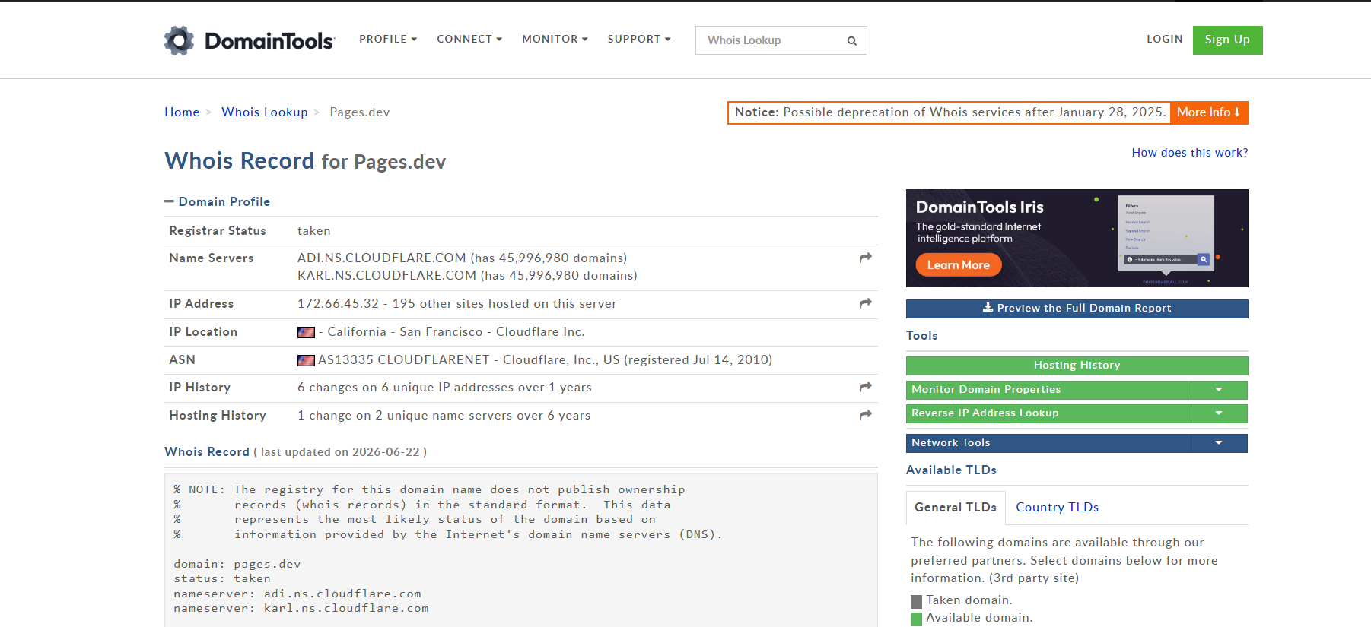
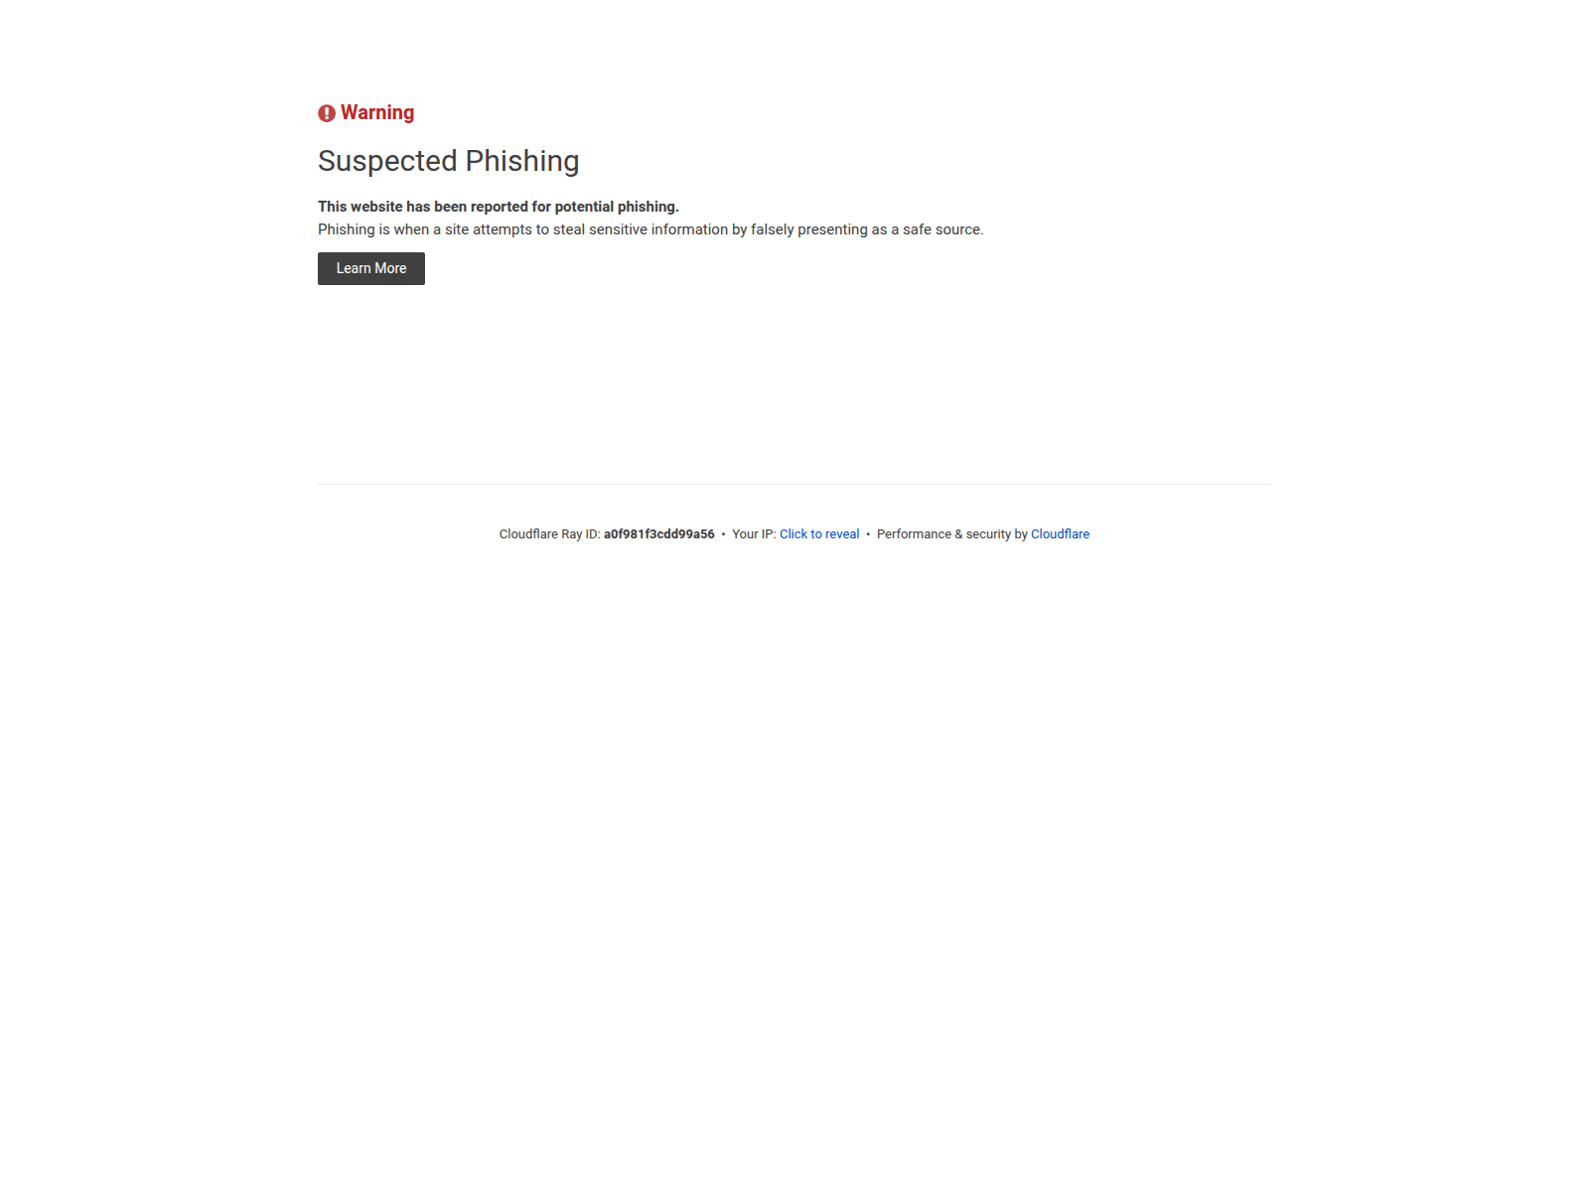

6. MITRE ATT&CK Mapping
Tactic | Technique | Observed Behavior
Initial Access | T1566.002 — Phishing: Spearphishing Link | Email delivers a password-reset hyperlink that redirects to an external, unrelated domain; relies entirely on the victim clicking to initiate the attack
Defense Evasion | T1036.005 — Masquerading: Match Legitimate Name or Location | Sender impersonates MetaMask Support while using a legitimately-registered Zendesk subdomain, allowing the message to pass SPF/DKIM/DMARC
Execution (Victim-side) | T1204.001 — User Execution: Malicious Link | Attack is entirely dependent on the recipient manually clicking the embedded reset-password link
Credential Access | T1056 — Input Capture (assessed) | Final landing page is assessed to be a credential-harvesting form designed to capture account/wallet authentication details
Note: T1056 (Input Capture) is included as the assessed intent of the final landing page based on its phishing-page classification; this technique formally describes on-host input capture and is applied here by analyst convention to represent the credential-harvesting objective of the external page, since MITRE ATT&CK Enterprise does not have a dedicated technique solely for third-party phishing-page credential capture.

7. Containment & Remediation Actions
- Block the final landing domain (nebbiashop.co.il) at the email gateway, web proxy, and DNS filtering layer
- Report the abused Zendesk subdomain (vvauc.zendesk.com) to Zendesk Trust & Safety for account suspension
- If any user clicked the link or entered information: immediately reset their credentials and revoke active sessions/tokens
- If any user interaction is confirmed: initiate containment of the affected endpoint pending further investigation
- Add all confirmed IOCs (Section 4) to the organization's blocklist / threat intelligence platform
- Purge the message from any mailboxes it was delivered to
- Report the incident internally per organizational policy and, if applicable, to the impersonated brand (MetaMask) and relevant ISAC/CISA channels

8. Recommendations
- Flag to email security administrators that authentication-passing alone is an insufficient phishing indicator when free/self-service platforms (Zendesk, SendGrid, Mailgun, etc.) can be abused to send authenticated mail
- Consider a detection rule flagging external mail from help-desk/ticketing platform domains that reference financial or cryptocurrency brands in the subject or body
- Provide a targeted awareness reminder on redirect-chain abuse (legitimate redirectors used to mask malicious final destinations)

