Cloud Security Project

T-POT HONEYPOT
DEPLOYMENT ON MICROSOFT AZURE

Complete Step-by-Step Technical Documentation
Platform | Microsoft Azure (Free Tier)
OS | Ubuntu Linux
Honeypot | T-Pot (All-In-One Multi Honeypot)
Source | github.com/telekom-security/tpotce
SSH Port | tcp/64295 (changed by installer)
Web UI Port | tcp/64297

⚠️ For Educational & Research Purposes Only

Table of Contents

1. Project Overview 3
2. Prerequisites 3
3. Phase 1 – Azure Account Setup 4
4. Phase 2 – Virtual Machine Creation 5
5. Phase 3 – Network Security Configuration 8
6. Phase 4 – Connecting to the VM via SSH 9
7. Phase 5 – System Update 10
8. Phase 6 – T-Pot Installation 11
9. Phase 7 – Accessing the T-Pot Web Interface 15
10. Architecture Overview 16
11. Troubleshooting 17

1. Project Overview
This documentation covers the complete end-to-end deployment of T-Pot — the All-In-One Multi Honeypot Platform — hosted on a Microsoft Azure Virtual Machine running Ubuntu Linux. The project demonstrates cloud infrastructure setup, network security configuration, and cybersecurity threat intelligence collection.

What is T-Pot?
T-Pot is an open-source honeypot platform developed by Deutsche Telekom Security. It bundles over 20 different honeypots in a single Docker-based deployment, combined with a powerful ELK stack (Elasticsearch, Logstash, Kibana) for visualization and analysis of attack data.

What is a Honeypot?
A honeypot is a security mechanism designed to detect, deflect, and study unauthorized access attempts. It mimics a legitimate target to attract attackers, capturing their tactics and techniques without exposing real systems.

Key Benefits of this Project
• Real-time visibility into global attack patterns and threat actors
• Hands-on experience with Azure cloud infrastructure
• Practical exposure to Docker containerization and Linux administration
• Free-tier Azure deployment (using $200 credit) — no cost to start
• Rich Kibana dashboards for attack data visualization

2. Prerequisites
Before beginning, ensure you have the following:

Requirement | Details
Microsoft Account | Required to create an Azure free account
Credit/Debit Card | Needed for Azure free account verification (not charged)
Windows Terminal / PuTTY | SSH client to connect to the Azure VM
Internet Connection | Stable broadband recommended
Basic Linux Knowledge | Familiarity with terminal commands

3. Phase 1 – Azure Account Setup
STEP 1 | Create a Free Azure Account

Microsoft Azure offers a free account with $200 USD in credits valid for 30 days, plus always-free services. This is sufficient to run the T-Pot honeypot for the project duration.

- Navigate to https://azure.microsoft.com/free in your web browser.
- Click Start free and sign in with your Microsoft account (or create one).
- Complete the identity verification — enter your phone number for SMS verification.
- Enter your credit/debit card details for verification. You will NOT be charged unless you upgrade to a paid plan.
- Agree to the terms and click Sign up.
- Once the account is created, you will receive $200 in credits and access to the Azure Portal at https://portal.azure.com.

💡 Note
The $200 credit is valid for 30 days from account creation.
The VM used in this project (Standard B2s or similar) will comfortably run within the free credit allocation.

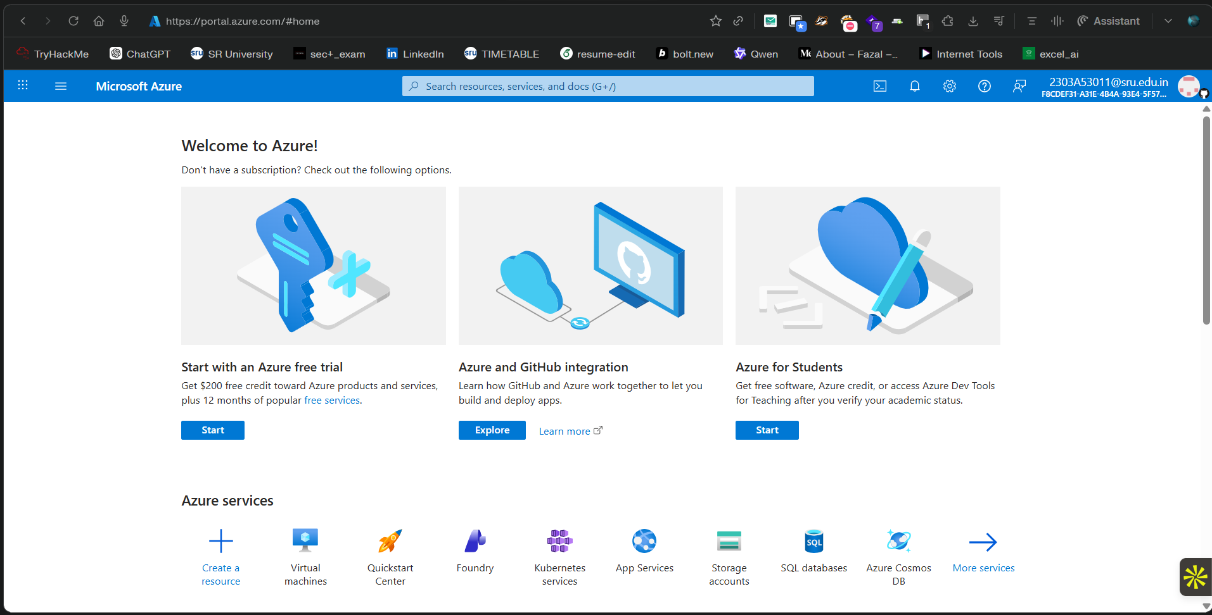

4. Phase 2 – Virtual Machine Creation
STEP 2 | Create a New Resource Group

A Resource Group is a container that holds related Azure resources. All components of this project (VM, disk, network interface, public IP, etc.) will be placed in this group for easy management.

- In the Azure Portal, click Create a resource in the top-left.
- Search for Virtual Machine and select it.
- Click Create → Azure virtual machine.
- Under Resource group, click Create new and enter a name (e.g., HoneypotRG). Click OK.
- Enter a VM name (e.g., tpot-vm).
- Select your preferred Region (choose one geographically close for lower latency).

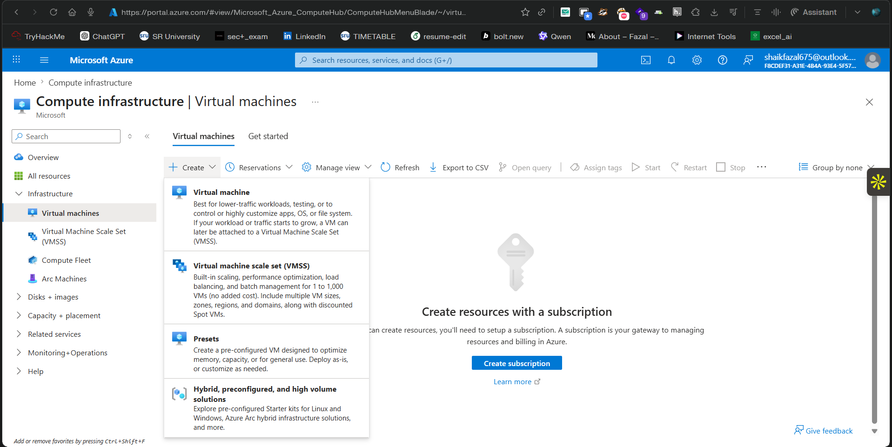
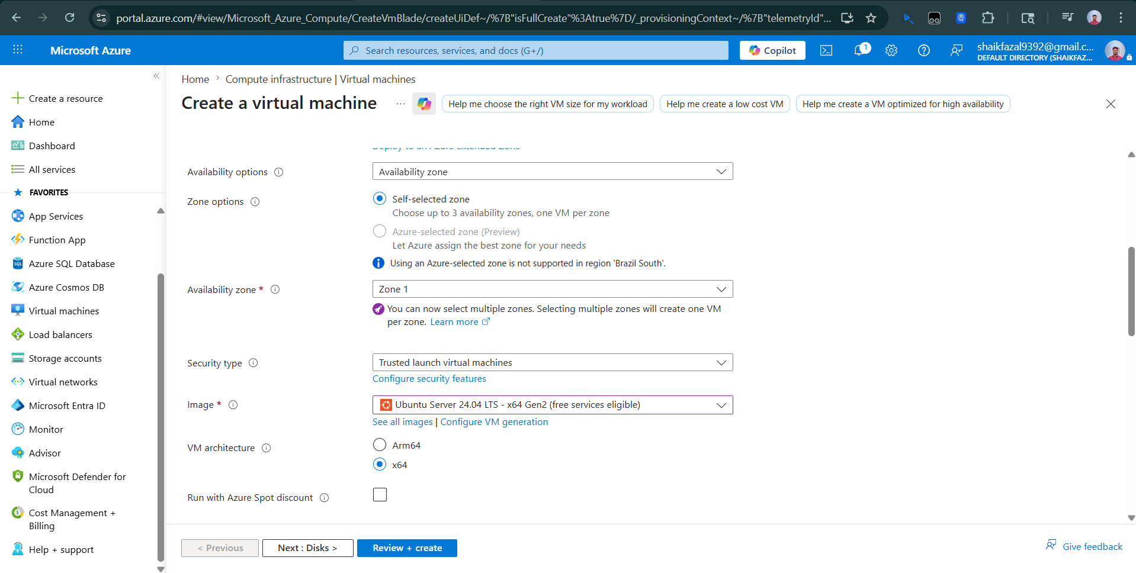

STEP 3 | Configure VM Settings

Configure the operating system, size, and authentication settings for the Virtual Machine.

Image (Operating System)
- Image: Ubuntu Server 22.04 LTS - x64 Gen2
- Architecture: x64

VM Size
- Recommended: Standard_B2s (2 vCPUs, 4 GB RAM) or higher
- T-Pot requires at least 8 GB RAM for optimal performance — Standard_B2ms (2 vCPUs, 8 GB RAM) is preferred

Administrator Account (Authentication)
- Authentication type: Password
- Username: Choose a secure username (e.g., azureuser)
- Password: Set a strong password and note it down safely

⚠️ Security Note
Use a strong password with a mix of uppercase, lowercase, numbers, and symbols.
This password will be used to SSH into the VM and also set as the T-Pot web UI credential.

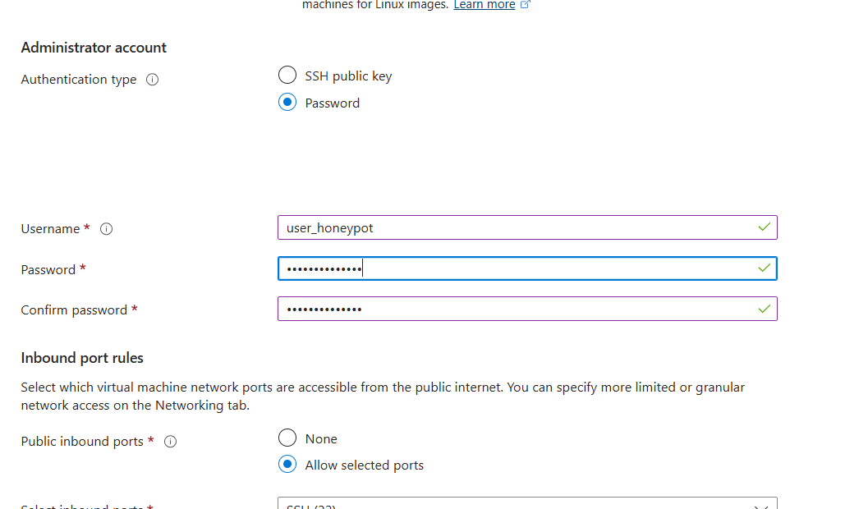

STEP 4 | Configure OS Disk Size

T-Pot stores considerable log data from honeypot activity. A larger OS disk is recommended to prevent storage issues during operation.

- Navigate to the Disks tab in the VM creation wizard.
- Under OS disk size, click Change size.
- Select 256 GiB (or larger) from the dropdown.
- Leave the OS disk type as Premium SSD or Standard SSD.
- Leave all other disk settings at their defaults.

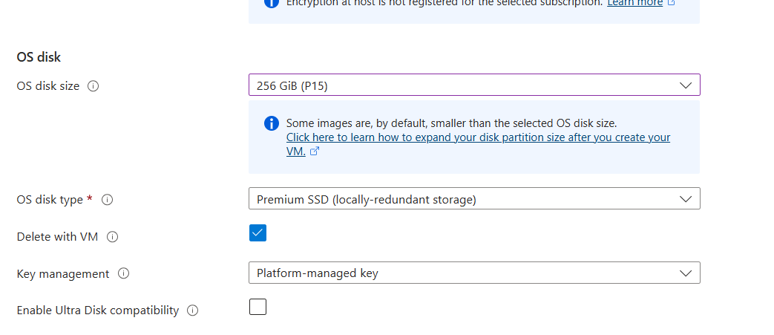

STEP 5 | Review and Create the VM

- Leave all other tabs (Networking, Management, Monitoring, etc.) at their default settings.
- Click the Review + create tab.
- Azure will validate the configuration. Wait for the "Validation passed" message.
- Review the summary and estimated cost.
- Click Create to begin the deployment.
- Deployment takes approximately 2–5 minutes. You will see a "Your deployment is complete" message when done.
- Click Go to resource to navigate to your new VM.

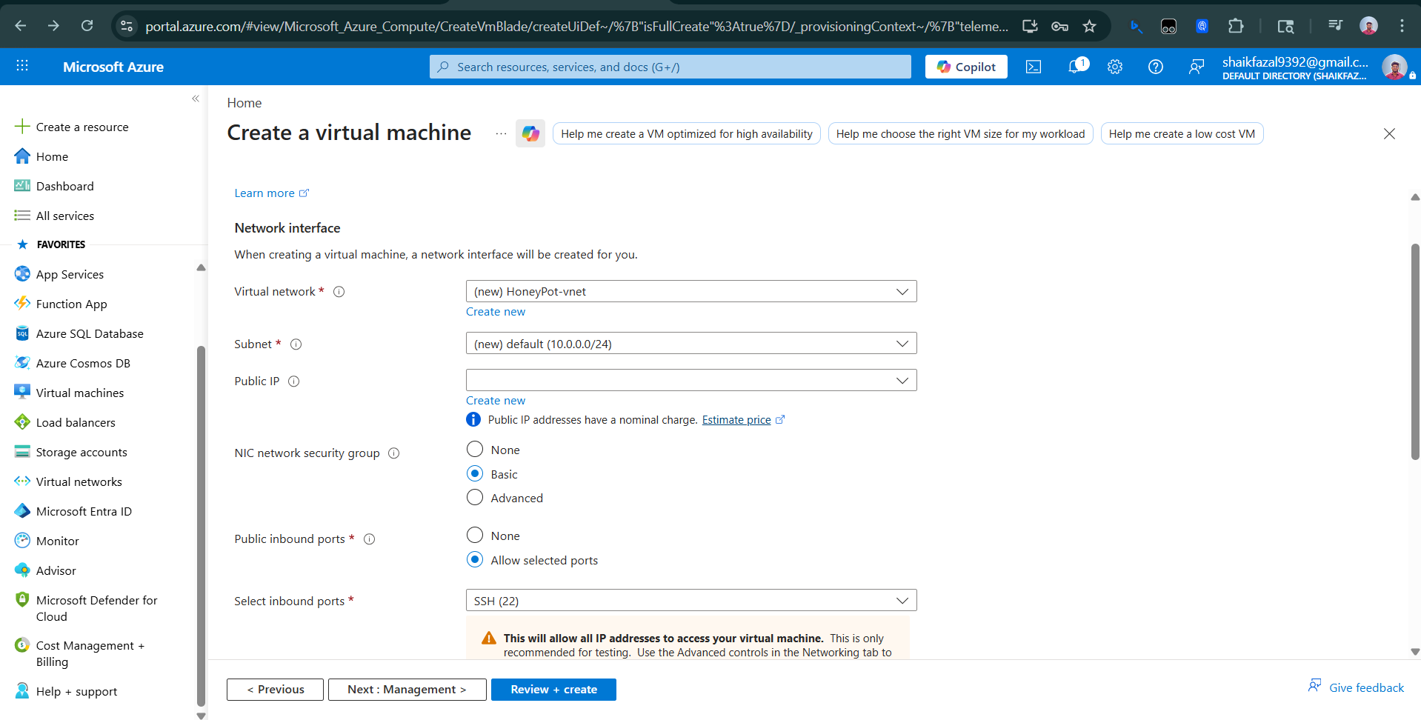

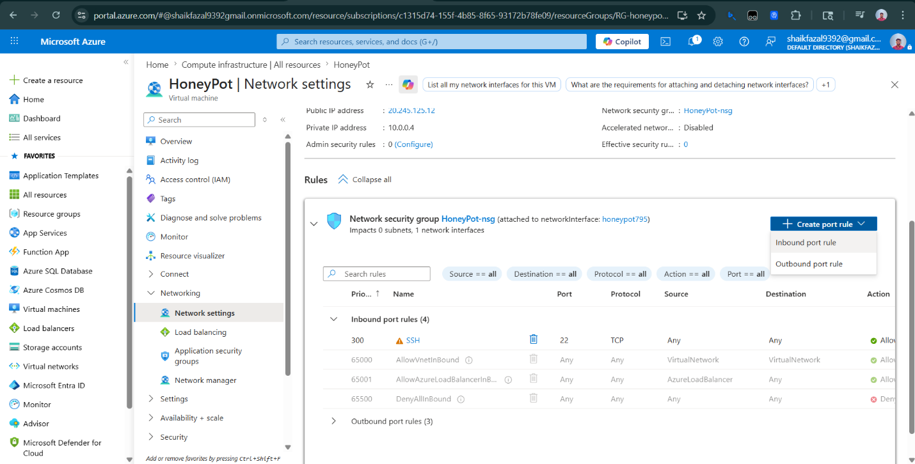

5. Phase 3 – Network Security Configuration
STEP 6 | Configure Inbound Network Rules

T-Pot uses a wide range of ports to simulate various services that honeypots listen on. To capture attacks from all directions, we configure Azure's Network Security Group (NSG) to allow all inbound traffic on all ports.

⚠️ Important Security Warning
Opening all ports is intentional for a honeypot deployment — it maximizes attack surface for research.
NEVER do this on a production system. This VM contains no real data or services.
The VM is isolated within its own Resource Group for containment.

Steps to Add the Inbound Rule
- From the VM overview page, click Networking in the left sidebar (under Settings).
- Click on the Network security group name (e.g., tpot-vm-nsg).
- In the NSG page, click Inbound security rules in the left menu.
- Click + Add to create a new rule.
- Configure the rule with these settings:

Setting | Value
Source | Any
Source port ranges | * (all)
Destination | Any
Service | Custom
Destination port ranges | * (all 65535 ports)
Protocol | Any
Action | Allow
Priority | 100
Name | Allow-All-Inbound

- Click Add to save the rule.

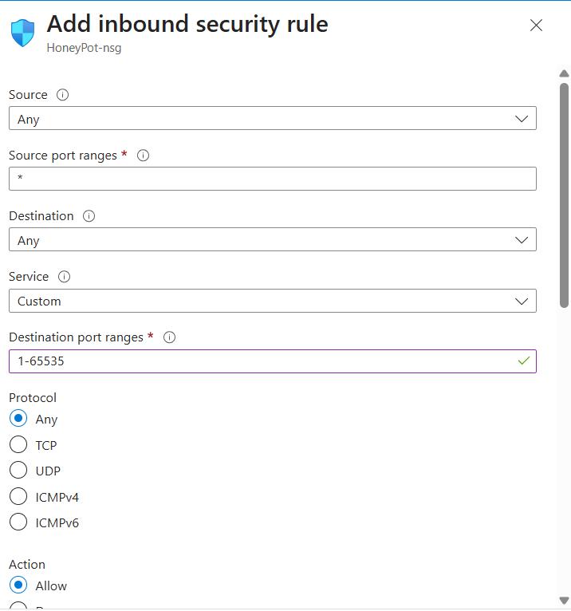

6. Phase 4 – Connecting to the VM via SSH
STEP 7 | Connect to Azure VM Using Windows Terminal

With the VM running and the network rule configured, we can now SSH into the VM using its public IP address.

Finding the Public IP Address
- Navigate to your VM in the Azure Portal.
- On the VM Overview page, locate the Public IP address field on the right side.
- Copy the IP address (e.g., 20.x.x.x).

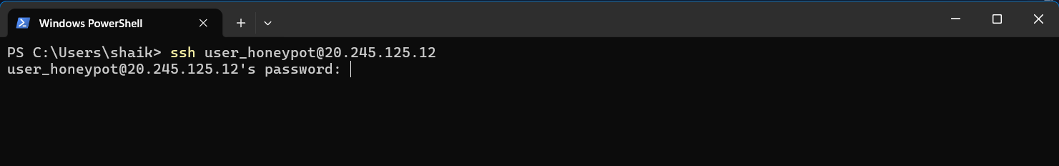

Connecting via SSH
- Open Windows Terminal (or Command Prompt / PowerShell).
- Type the following SSH command, replacing the values with your own:

$ ssh <your-username>@<public-ip>

# Example:
$ ssh azureuser@20.123.45.67

- When prompted "Are you sure you want to continue connecting?", type yes and press Enter.
- Enter your VM password when prompted.
- You are now connected to your Azure Ubuntu VM.

7. Phase 5 – System Update
STEP 8 | Update Ubuntu to the Latest Version

Before installing T-Pot, it is critical to update all system packages to ensure compatibility and security. Run the following commands in your SSH session:

# Update package list
$ sudo apt update

# Upgrade all installed packages to latest versions
$ sudo apt upgrade -y

# Optional: Remove unnecessary packages
$ sudo apt autoremove -y

Wait for the update process to complete. This may take 3–10 minutes depending on the number of packages and network speed.

💡 Tip
If prompted during upgrade about configuration files (e.g., /etc/ssh/sshd_config),
select 'keep the local version currently installed' unless you have specific requirements.

8. Phase 6 – T-Pot Installation
STEP 9 | Clone the T-Pot Repository

T-Pot is distributed via GitHub. Clone the official repository to the VM:

# Clone the T-Pot repository
$ git clone https://github.com/telekom-security/tpotce

# Navigate into the cloned directory
$ cd tpotce

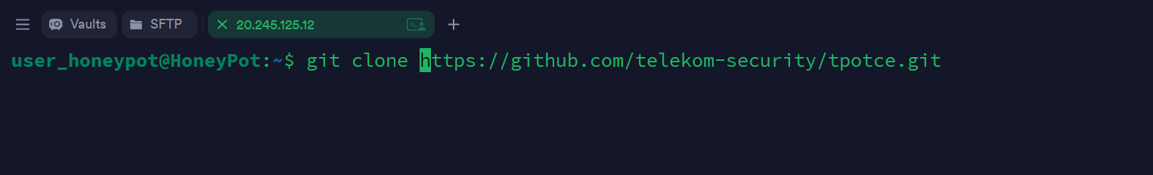

STEP 10 | Run the T-Pot Installer

Execute the installer script as a non-root user (with sudo privileges):

$ ./install.sh

What the Installer Does Automatically
The install.sh script performs the following actions on your Ubuntu system:

1 | Changes the SSH port from 22 to tcp/64295 (to avoid conflicts with honeypots)
2 | Disables the DNS Stub Listener to prevent port conflicts
3 | Sets the firewall target for the public zone to ACCEPT
4 | Adds Docker's official repository and installs Docker Engine
5 | Installs all recommended packages (grc, exa, micro, etc.)
6 | Removes packages known to cause conflicts
7 | Adds the current user to the docker group (allows Docker without sudo)
8 | Creates dps and dpsw aliases for docker ps monitoring
9 | Creates la, ll, ls aliases using exa (improved ls command)
10 | Creates mi alias for micro text editor
11 | Displays open ports on the host for conflict checking
12 | Adds and enables tpot.service in systemd for auto-start on boot

STEP 11 | Follow the Installer Prompts

During the installation, you will be prompted to make several choices:

- Enter your sudo password when requested (at least once during the process).
- Select the T-Pot edition when prompted. Options include:
- Standard — Full installation with all honeypots and dashboards (recommended)
- Sensor — Only honeypots, no web interface
- Industrial — SCADA/ICS focused honeypots
- Collector — Log shipping only
- Create a T-Pot username and password for the web interface (Kibana / Attack Map).
- Monitor the installation output for any errors. The process may take 10–20 minutes.

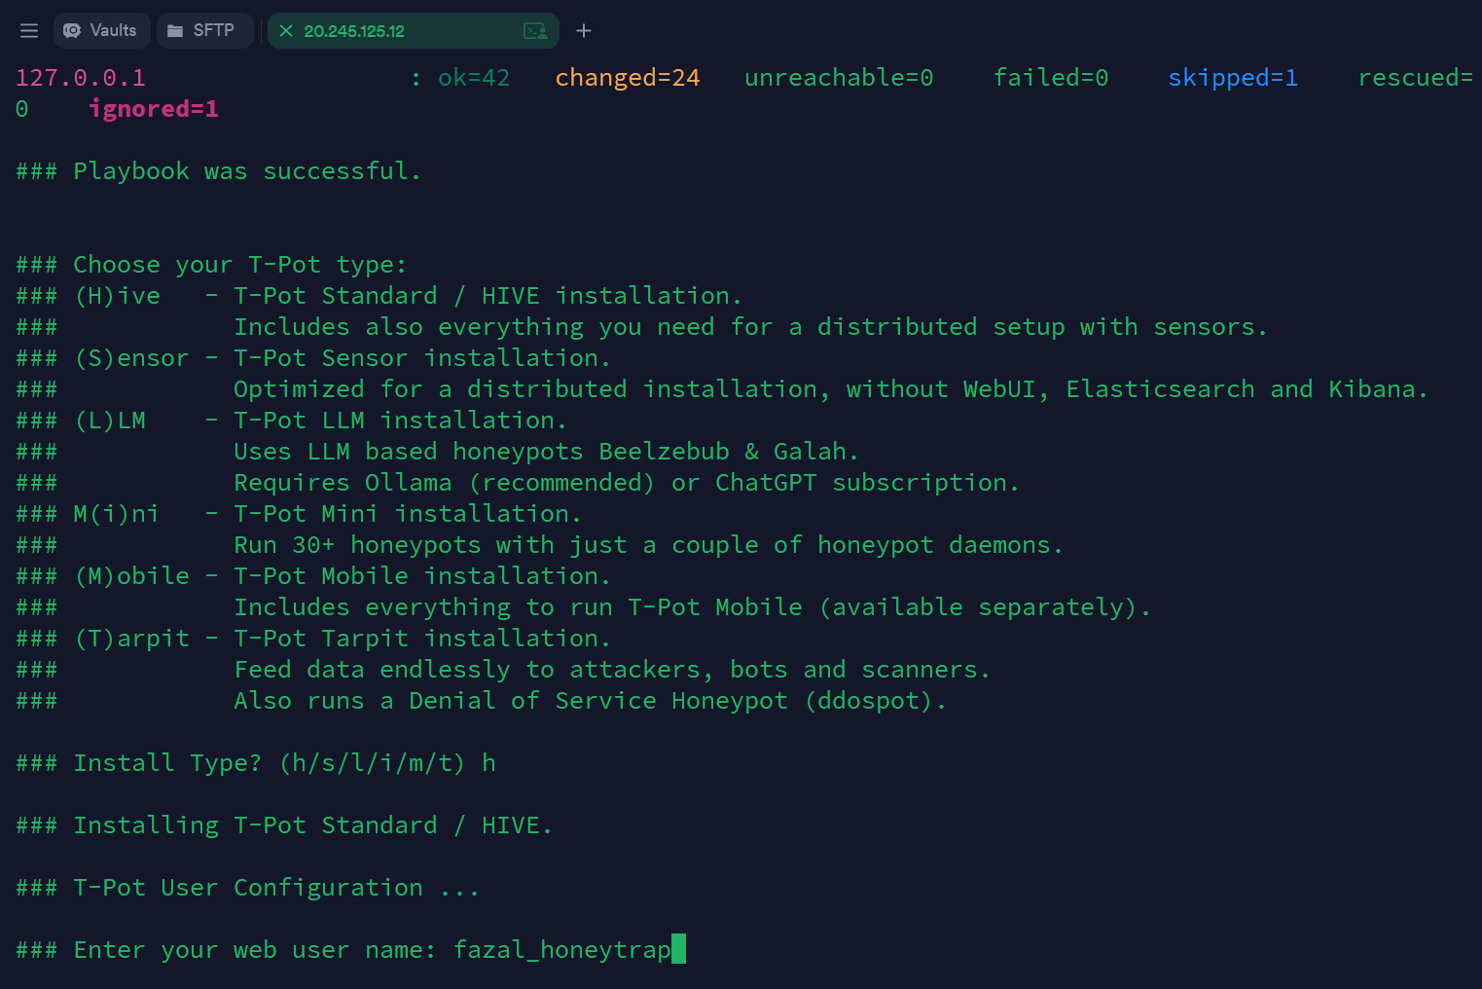

STEP 12 | Reboot the Virtual Machine

After installation completes, reboot the VM to apply all changes and start T-Pot services:

$ sudo reboot

The SSH connection will drop immediately as the system restarts. Wait approximately 2–3 minutes for the VM to fully restart and all Docker containers to initialize.

💡 After Reboot
SSH will now be available on port 64295 (not the default port 22).
To reconnect after the reboot:
$ ssh -p 64295 <your-username>@<public-ip>
Note: The Azure NSG all-ports-open rule allows this new port without any changes.

9. Phase 7 – Accessing the T-Pot Web Interface
STEP 13 | Access the T-Pot Dashboard

Once the VM has rebooted and T-Pot services have started, you can access the web interface from any browser.

Opening the T-Pot Web UI
- Open a web browser on your local machine.
- Navigate to the following URL (replace with your VM's actual public IP):

https://<your-public-ip>:64297

# Example:
https://20.123.45.67:64297

- The browser will show a security warning because T-Pot uses a self-signed SSL certificate. This is normal and safe in this context.
- Click Advanced → Proceed to <IP> (or similar, depending on your browser) to continue.
- A login dialog box will appear. Enter the T-Pot username and password you created during installation.
- You will be presented with the T-Pot landing page with links to all available dashboards.

Available Dashboards & Tools
Tool | Description
Kibana | Primary dashboard for log analysis, attack patterns, and geolocation maps
Attack Map | Real-time live visualization of incoming attacks on a world map
Cyberchef | Data encoding/decoding and analysis tool
Elasticvue | Elasticsearch cluster management and data browser
Spiderfoot | OSINT and threat intelligence aggregation tool

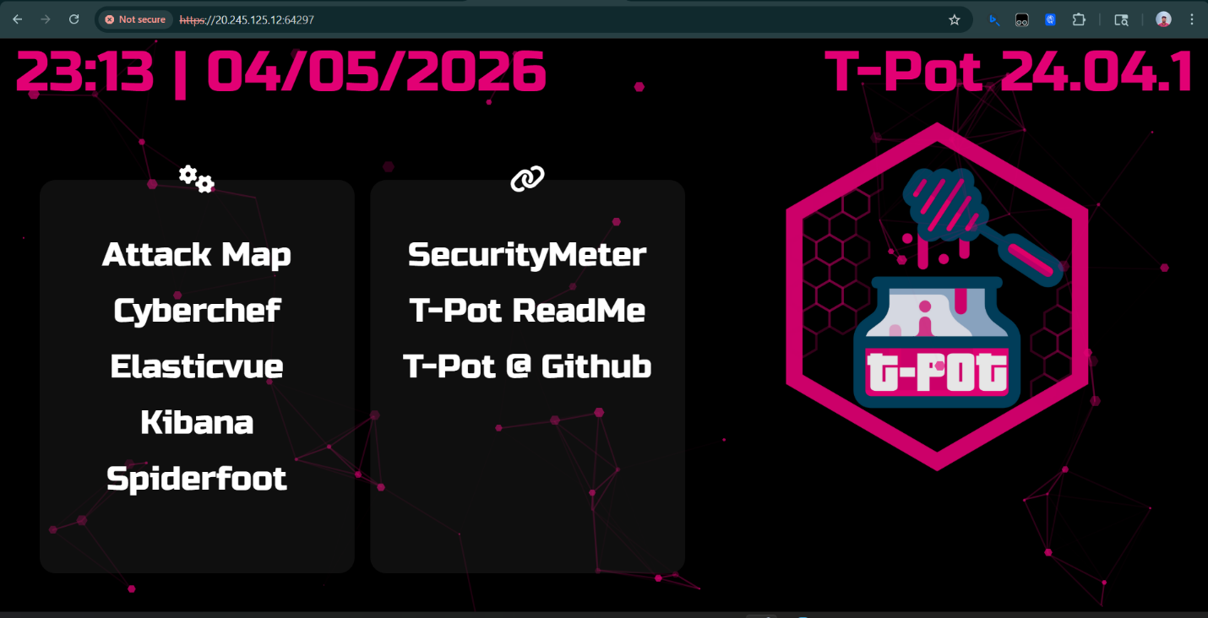

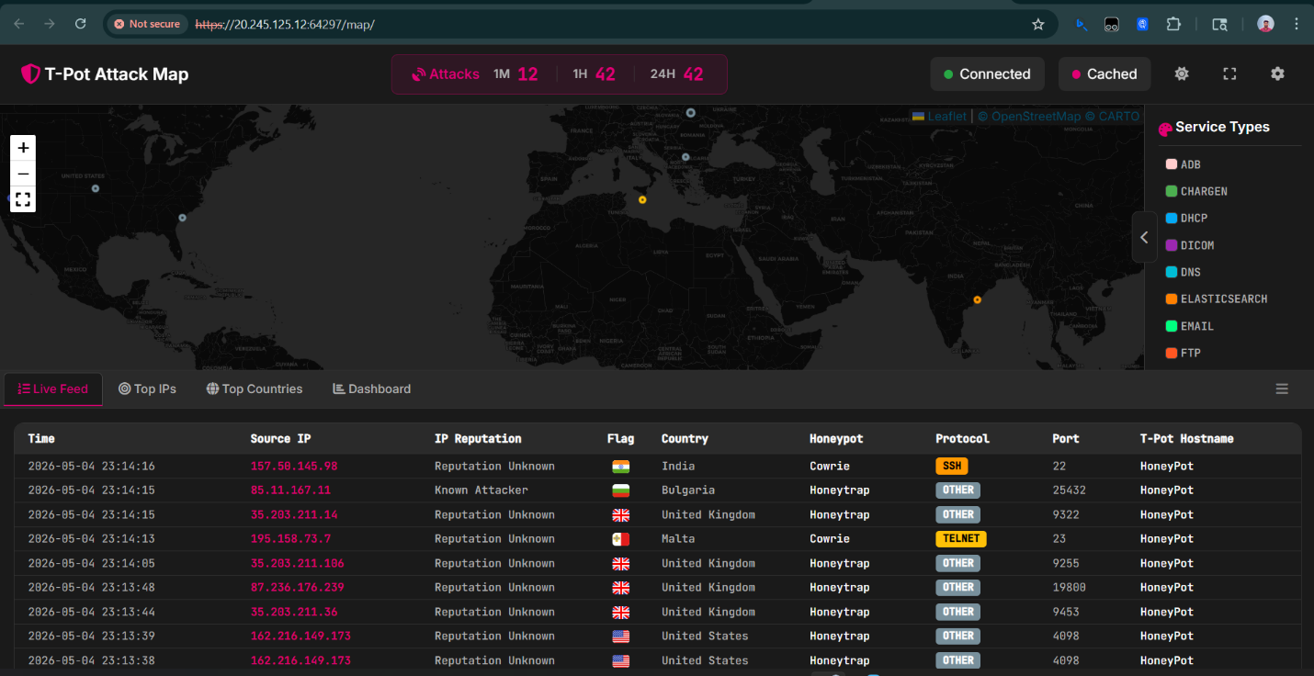
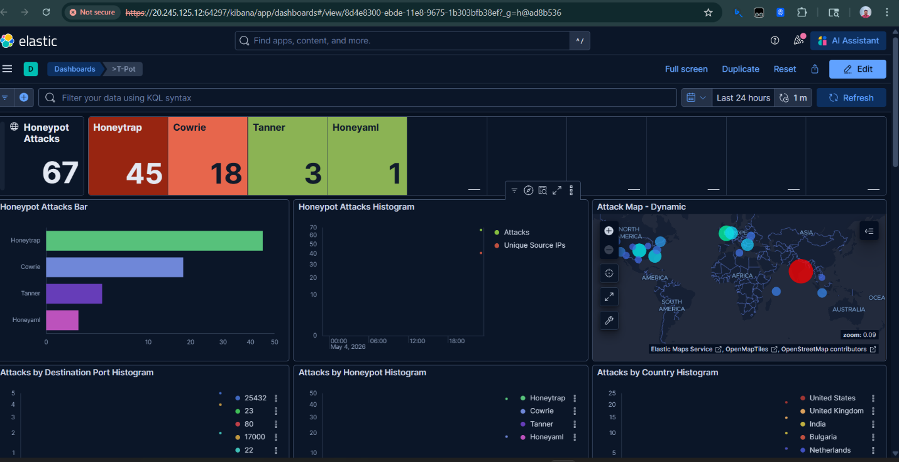

10. Architecture Overview
The following diagram illustrates the complete architecture of the T-Pot honeypot deployment on Azure:

Internet (Global Attackers)
↓ (All ports / All protocols)
Azure Network Security Group (NSG)
[ Inbound: Allow All Ports 0–65535 ]
↓
Azure Virtual Machine (Ubuntu 22.04 LTS)
256 GB OS Disk | Public IP Address
↓ (Docker Engine)
T-Pot Platform (20+ Honeypots in Docker Containers)
Cowrie | Dionaea | Honeytrap | Mailoney | RDPy | Elasticpot | ...
↓ (Log collection via Logstash)
ELK Stack: Elasticsearch + Kibana
Accessible via https://<public-ip>:64297 (Admin Browser)

Key Ports Reference
Port | Protocol | Purpose
64295 | TCP | SSH access to VM (changed from default 22)
64297 | TCP (HTTPS) | T-Pot Web UI / Kibana Dashboard
0–65535 | All | Honeypot listener ports (all open for attack capture)

11. Troubleshooting

Issue | Solution
Cannot SSH after reboot | Use port 64295: ssh -p 64295 user@<ip>. T-Pot changes SSH from port 22.
Web UI not reachable | Wait 3–5 minutes after reboot. All Docker containers need time to start.
SSL certificate warning in browser | Normal for self-signed cert. Click Advanced → Proceed to continue.
Installation failed midway | Check disk space (df -h). Ensure at least 50 GB free. Retry ./install.sh.
Docker containers not starting | Run: sudo systemctl status tpot to see error details and logs.
Cannot clone git repo | Ensure git is installed: sudo apt install git -y
Azure credits running low | Stop the VM when not actively monitoring to save credits.

